|  |  |  |  |
| --- | --- | --- | --- |
| **0** | **1** |  |  |

This question is about factors affecting the rate of a chemical reaction.

Draw one line connecting each factor that increases the rate of a reaction with the **most complete** explanation. (3 marks)

|  |  |  |
| --- | --- | --- |
| **Factor** |  | **Explanation** |
|  |  |  |
|  |  | greater surface area |
| increasing solution temperature |  |  |
|  |  | more collisions every second **and** more collisions with enough energy to break bonds |
| adding a catalyst |  |  |
|  |  | particles have less energy |
|  |  |  |
| increasing gas pressure |  | more collisions every second |
|  |  |  |
|  |  | more collisions every second with enough energy to break bonds |

|  |  |  |  |
| --- | --- | --- | --- |
| **0** | **2** |  |  |

This question is about the effect of concentration on the rate of a reaction.

When hydrochloric acid is added to sodium thiosulfate solution, it slowly becomes cloudy. The time taken for a cross under the solution to disappear can be used to monitor the rate of the reaction.

**Figure 1**

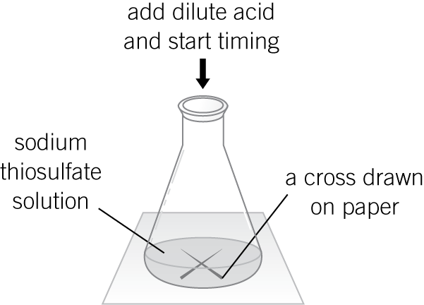

A student:

**1** Measured 50 cm3 of sodium thiosulfate into a flask.

**2** Added 10 cm3 of dilute hydrochloric acid and started a stopwatch.

**3** Stopped the clock when the cross disappeared and recorded the time taken.

**4** Repeated the experiment using different concentrations of sodium thiosulfate.

The results are shown in **Table 1**.

**Table 1**

|  |  |
| --- | --- |
| Concentration of sodium thiosulfate solution in g/dm3 | Time taken for cross to disappear in s |
| 5 | 85 |
| 10 | 45 |
| 15 | 29 |
| 20 | 21 |
| 25 | 13 |
| 30 | 15 |
| 35 | 14 |

|  |  |  |  |
| --- | --- | --- | --- |
| **0** | **2** | **.** | **1** |

Plot these results on the grid below. Draw a line of best fit. (3 marks)

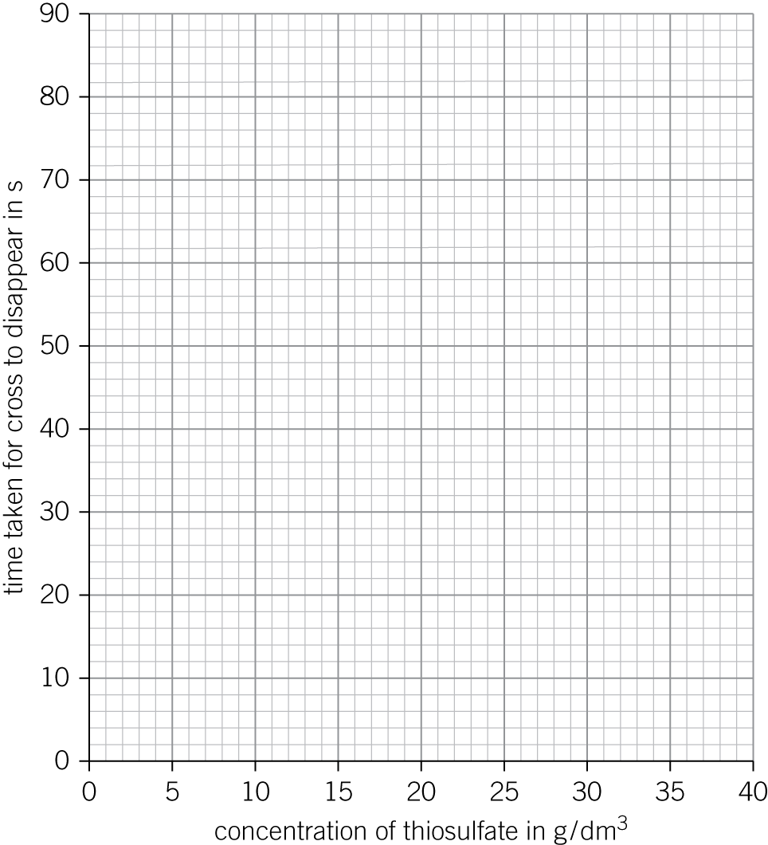

|  |  |  |  |
| --- | --- | --- | --- |
| **0** | **2** | **.** | **2** |

One of the points is anomalous.

Describe an error in the experiment which could have caused this anomalous result.

(*1 mark*)

|  |  |  |  |
| --- | --- | --- | --- |
| **0** | **2** | **.** | **3** |

Describe **and** explain, in terms of particles, the pattern in the results obtained.

(*3 marks*)

|  |  |  |  |
| --- | --- | --- | --- |
| **0** | **3** |  |  |

Not part of this Winter Prelim assessment.

|  |  |  |  |
| --- | --- | --- | --- |
| **0** | **4** |  |  |

A student investigates the rate of reaction between marble chips (calcium carbonate) and dilute hydrochloric acid.

The equation for the reaction is:

CaCO3(s)  2HCl(aq) → CaCl2(aq)  H2O(l)  CO2(g)

Their results are shown in **Table 2**.

**Table 2**

|  |  |
| --- | --- |
| Time in s | Volume of carbon dioxide in cm3 |
| 0 | 0.0 |
| 20 | 45.0 |
| 40 | 62.0 |
| 60 | 70.5 |
| 80 | 75.0 |
| 100 | 78.0 |
| 120 | 79.5 |
| 140 | 80.0 |
| 160 | 80.0 |
| 180 | 80.0 |

|  |  |  |  |
| --- | --- | --- | --- |
| **0** | **4** | **.** | **1** |

Complete the diagram below to show how the carbon dioxide is collected.

Label the apparatus the gas is collected in with its name. (2 marks)

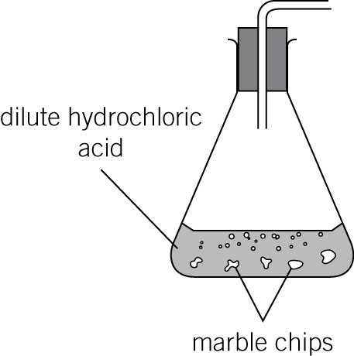

|  |  |  |  |
| --- | --- | --- | --- |
| **0** | **4** | **.** | **2** |

The results were plotted as a line graph in **Figure 2**.

**Figure 2**

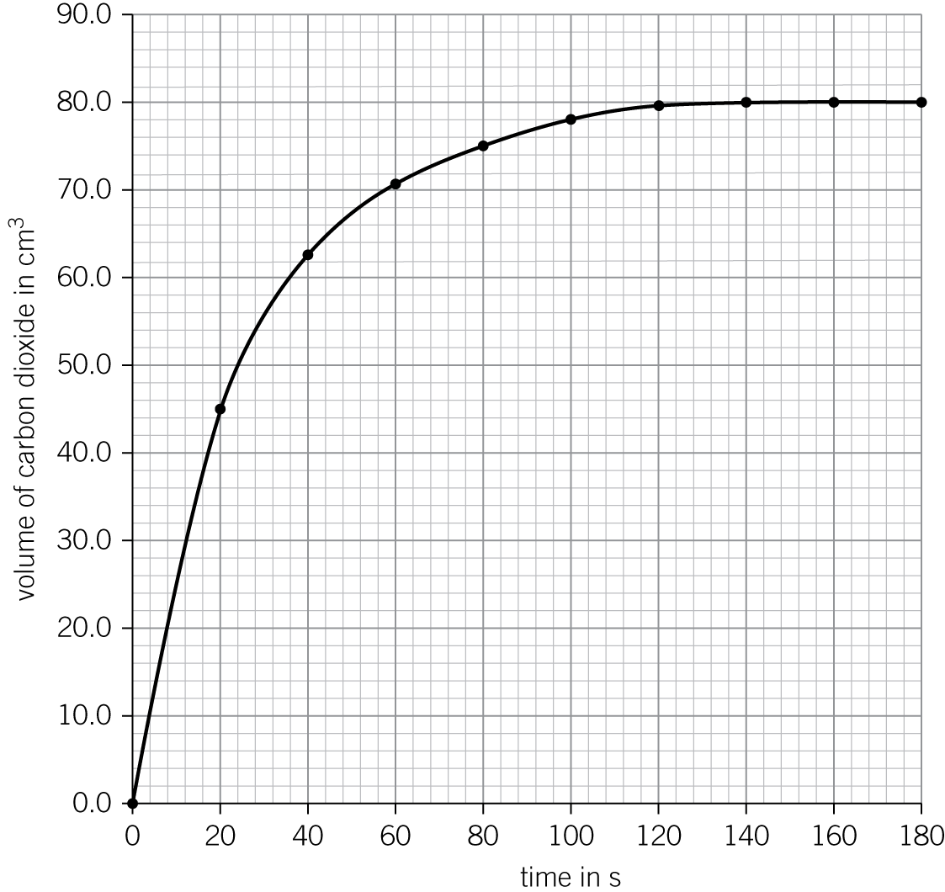

Use **Figure 2** to identify the 20-second time interval at which the rate of reaction is fastest.

(*1 mark*)

|  |  |  |  |
| --- | --- | --- | --- |
| **0** | **4** | **.** | **3** |

Calculate the mean rate of reaction during this 20-second time interval.

(*2 marks*)

|  |  |  |  |
| --- | --- | --- | --- |
| **0** | **4** | **.** | **4** |

On **Figure 2**, sketch the results the student would obtain if they used the same mass of powdered marble instead of marble chips. (2 marks)

|  |  |  |  |
| --- | --- | --- | --- |
| **0** | **5** |  |  |

Not part of the Winter Prelim assessment.