A new approach to heart dissection
Traditionally, heart dissection has involved opening the chambers of the heart longitudinally.

This approach is a very good learning experience if it is carried out on intact hearts. However, many schools now dissect hearts that are obtained from abattoirs or butchers and these are often incomplete. In particular, the tops of the hearts are often cut away, removing the atria and blood vessels.

This dissection technique described here can be used on incomplete hearts obtained from butchers.
1. Examine the outside of the heart, to identify as many structures as possible. |  | 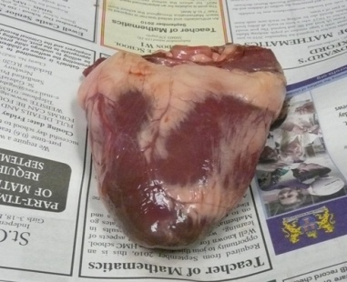  Right ventricle  Left ventricle  Coronary blood vessel
2. Hold the heart with the tip pointing downwards, and identify as many of the structures at the top of the heart as possible.  Tip:  Part of atrium  If a syringe is used to squirt water through the heart you may be able to identify the structures more easily. |  | 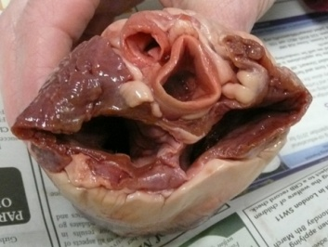  Aorta  Pulmonary artery
3. Use a pair of scissors to cut a slice from the top of the heart.  The slice should be about 1cm thick, and as close as possible to where the atria meet the ventricles. |  | 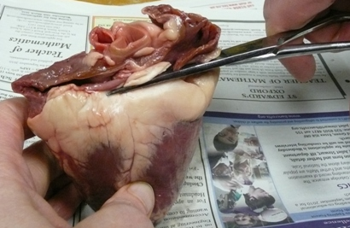
4. Then examine the cut surface, naming as many structures as possible. This is similar to a CT scan view of the heart. |  | 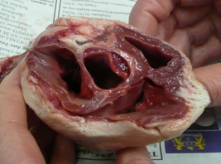  Semi-lunar valve
5. Continue cutting slices horizontally through the heart, identifying features on the cut surface as you proceed | 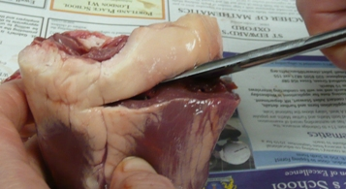
6. When only two chambers are visible, then the ventricles have been reached. The obvious difference between the thicknesses of the two ventricle walls can now be seen. The diameter of the wall can be measured with a ruler, to quantify the comparison.  Left ventricle  Extension:  Try filling the ventricles with water from a syringe to measure their volumes. | 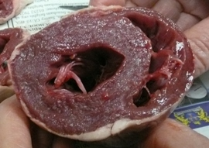  Right ventricle  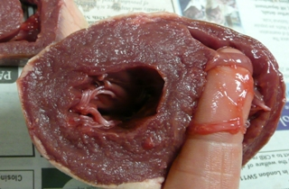  The atrio-ventricular valves can be clearly seen, and felt.
7. If the ventricles are cut along their length and opened out, a clearer view of the  atrio-ventricular valves can be seen. | 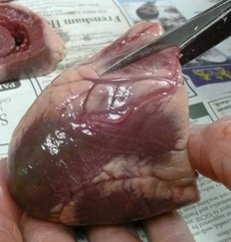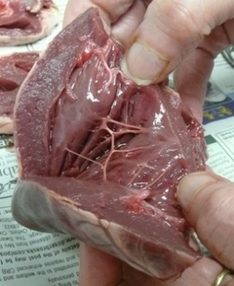
Extension: If the ventricle walls are cut away entirely, they can then be weighed. | 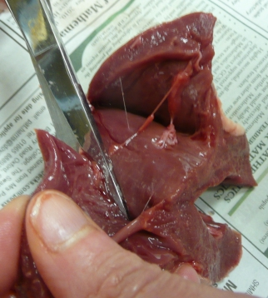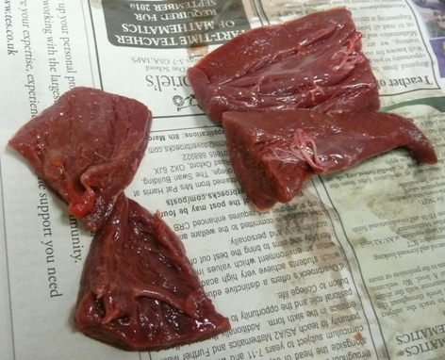  left ventricle wall weighs 41.4g  Right ventricle wall weighs 14.1g

