**Immunology**

**The Immune System**

The **immune system** is a group of cells, tissues, organs and mechanisms that defend an organism against …………… (disease-causing organisms) and other foreign substances.

An **immune response** is a complex series of …………… and ……. - …………… processes involving a range of …………… and …………….

If the body successfully fights an infection, it will respond more quickly and effectively if the same pathogen is re-encountered.

**Physical Barriers to Infection**

**Skin:** Theskin’s…………… layer forms an outer barrier to infection.

Large numbers of ……… ……… (harmless bacteria or **commensals**) live on the skin.

They help to prevent colonisation by other bacteria (by **out-competing** them).

[*Secretions from …………… and …………… glands give the skin a* ***pH*** *……….*

*This* ***acidity*** *also helps prevent colonisation by pathogens*].

|  |  |
| --- | --- |
| **Respiratory System:** Surfaces of the respiratory system, such as the nose, trachea and bronchi, are lined with …………… **membranes**. These contain …………… **cells**, which secrete sticky …………… that traps microbes. | http://www.dkimages.com/discover/previews/967/50011582.JPG |
| …………… …………… **cells** sweep out the mucus, preventing pathogens from entering the lungs. |

**Digestive System:** The secretion of **hydrochloric acid** makes stomach a highly …………… environment, which can destroy ingested pathogens.

In addition, there are many different species of **commensals** (see above) in the intestines. These competitively exclude pathogenic bacteria and secrete chemicals, such as …………… **acid**, which are useful in the defence against pathogens.

**How does the Body Respond to an Antigen?**

Each of these will be considered in turn below…..

antigen

immune response

specific

T cells

B cells

(antibodies)

non-specific

inflammation

interferons

phagocytosis

lysozyme

*skin or mucous membrane*

**Non-Specific Immunity**

The **non-specific** or …………… **immune response** quickly targets a …………… **range** of pathogens and foreign substances.

**Phagocytosis**, **inflammation** and the antimicrobial proteins …………… and …………… are all part of this immune response.

* **Lysozyme** is an enzyme that disrupts the ……… ……….. of bacteria by digesting the ……………………..….

It is found in human ……………, …………… and …………….

Lysozyme is also found in the **mucus** which lines the respiratory, digestive and   
 reproductive systems – all interfaces with the environment.

* [***Interferons*** *are proteins produced by ……………* ***-****…………… body cells in response to the virus. Interferons trigger the production of a second protein that …………… viral …………… by binding to mRNA coded by the virus*].

[**Inflammation**

Inflammation is a localised response to injury or infection characterised by ……………, ……………, …………… and …………….

It helps to **reduce** …………… and …………… **pathogens**.

Stage 1: When the tissue is damaged pathogens may enter the body. Damaged cells will release chemicals, such as ……………, which act as **inflammatory** …………….

Stage 2: These chemicals cause an **increase** in …………… …………and …………… of the ……………. The area becomes flooded with …………… and **blood**-**clotting** elements, causing …………… and …………….

Stage 3: The tissue cells also release chemicals (e.g. ……………) ] that attract **phagocytic** white blood cells such as ………………… and …………….…… .

**Phagocytosis**

Stage 4: **Phagocytosis** (lit ‘cell eating’) begins when macrophages or neutrophils recognise invading bacteria as pathogens.

Stage 5: The cell membrane of the macrophage fuses around a single bacterium, trapping it inside a cellular compartment called a ……………… .

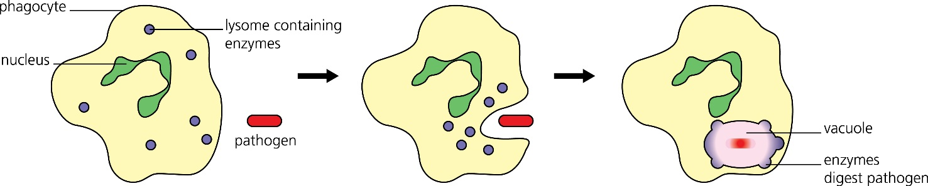

Stage 6: The phagosome fuses with a ………………, which contains lyozyme and toxic chemicals, to form a …………………….

The bacterium is broken down and digested, killing it.

Stage 7: After the bacterium has been destroyed, the macrophage **absorbs** any useful material and expels the rest.

Stage 8: As the pathogens are destroyed, **anti-inflammatory** factors begin to work so inflammation does not continue longer than is necessary.

The swelling will reduce and the skin will eventually heal.

**Specific Immune Response**

The **specific** or …………… immune response can target a …………… pathogen, although it is …………… to act than the non-specific response.

It features two main types of response to pathogens:

* the …………… or…………… **-mediated** response involves highly-specialised cells that target pathogens …………… cells.
* the …………… or…………… **-mediated** response targets pathogens in **body** …………… with …………….

**Lymphocytes**

**Lymphocytes** are a type of white blood cell (**leukocyte**) found in the …………… and …………… nodes.

Lymphocytes recognise …………… molecules on the …………… of pathogens, and

co-ordinate the immune response against that pathogen.

Collectively, lymphocytes can recognise …………… of different antigens, due to the large variation of lymphocytes produced.

**Different Types of Lymphocytes**

Lymphocytes are a type of white blood cell found in the **blood** and **lymph** **nodes**. They are produced by **stem** **cells** in bone marrow. The two main types are ….. **cells** and ….. **cells**.

**Helper T cell:** Act as ‘co-ordinators’ of the immune response. When a pathogen is detected, helper T cells produce a chemical signal.

This results in the proliferation of specific …………… **T cells** and …………… **B cells**.

Helper T cells also activate B cells and help to produce …………… **cells**.

**Cytotoxic T cell:** Recognise …………… cells or …………… cells and destroy them by secreting proteins (e.g. **perforin**) that rupture their membranes, causing the cell to ……….

**Effector B cells**: Multiply and give rise to …………… **cells** when activated by **helper T cells**. Some effector B cells will become …………… **B cells**.

**Plasma cell:** Develop from **effector B cells** that have been activated by **helper T cells**. Plasma cells produce large amounts of ……………, which bind to a pathogen and cause it to be …………… or …………….

**Memory cells:** Circulate in the blood …………… the pathogen has been removed.

If stimulated, they divide rapidly to produce a …………… **immune response**.

**Cellular Immune Response**

Once a pathogen is detected the immune system mounts a …………… response against it.

Stage 1: When a …………… destroys a pathogen by …………… it will display the pathogen’s …………… on its own **cell** **surface** ……………. The cell is now called an …………… **-** ……………  **cell** (APC).

Stage 2: The APC interacts with a …………… **helper****T** (Th) **cell**, and releases a chemical substance called ……………. **-** .. This is a …………… a chemical involved in cell signalling.

Stage 3: Interleukin-1 stimulates the Th cell to release another cytokine ……………. **-** .., which stimulates the growth and development of *antigen-specific* ……………. **T** (Tc) **cells**.  
This is by **mitosis** so the daughter cells are **clones**. The receptor proteins will have the same **primary** therefore **tertiary** structure and all be **complementary** to the antigen.

Stage 4: Tc cells detect the antigen on the surface of ……………. **body cells** and produce …………….. This protein forms pores in the target cell’s surface membrane, allowing ……………. and ……………. in and causing ……………. of the cell.

Stage 5: Exposure to a specific antigen also results in ……………. **T** (Tm) **cells** being produced. These are ready to initiate a response* to the **same** **shaped antigen** if the body becomes infected again in the future. * i.e. very rapid division by mitosis

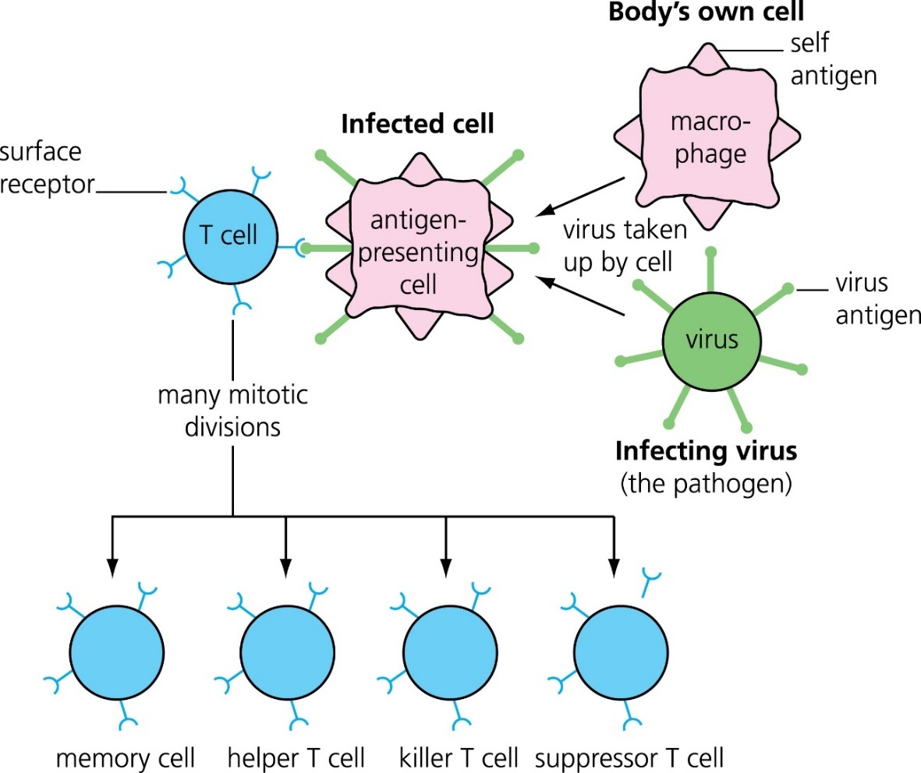

NB these show the **types** of cells produced, not their relative number.

**Humoral Immune Response**

Once a pathogen is detected the immune system mounts a **specific** response against it.

Stage 1: When a **macrophage** destroys a pathogen by **phagocytosis** it will display the pathogen’s **antigen** on its own **cell** **surface** **membrane**. The cell is now called an **antigen-presenting cell** (APC).

Stage 2: The APC interacts with a *specific* **helper****T** (Th) **cell**, and releases a chemical substance called **interleukin-1**. This is a **cytokine** a chemical involved in cell signalling.

NB – so far this is *exactly* what happens with the cellular response.

Stage 3: Interleukin-1 stimulates the Th cell to release another cytokine **interleukin-2**, which stimulates the ……………. of ……………. **B cells** into ……………. **cells**.

Stage 4: The plasma cells divide by mitosis therefore are clones and produce large quantities of *antigen-specific* …………….. These attach to the pathogen and destroy it by [……….…………. or] …………………... (see below)

Stage 5: Exposure to a specific shaped antigen also results in ……………. **B** **cells** being produced. These are ready to initiate a response* to the **same shaped** **antigen** if the body becomes infected again in the future. * i.e. very rapid division by mitosis

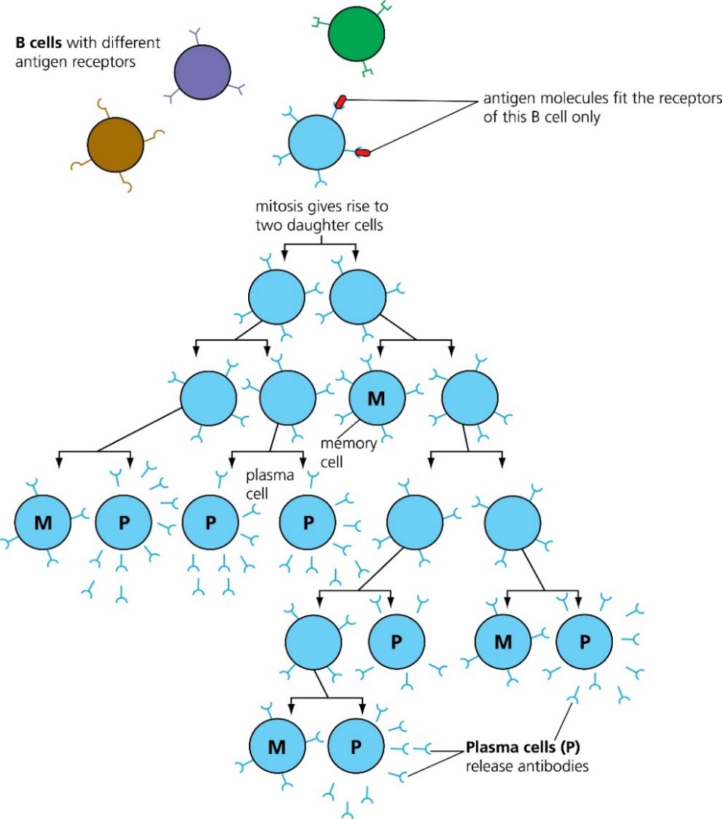

**Antibody Structure**

Each antibody molecule consists of four* ……………. chains – two identical ……………. chains and two identical ……………. chains. * i.e. it has a **quaternary** structure.

……………. **bonds** hold the four polypeptide chains of the antibody together. [They are strong ……………. bonds that occur between two cysteine amino acids.]

The amino acid sequence in the ……………. **regions** of the polypeptide chains varies only slightly between different antigen-specific antibodies.

NB the same primary structure = the same tertiary structure.

The amino acid sequence of the ……………. **regions** of the polypeptide chains are different in each specific **type** of antibody. These form the unique ……………. and ……………. of the antibody’s antigen-binding site.

NB different primary structure = different tertiary structure.

The ……………. **-** …………….  **site** enables the antibody to bind to a *specific* antigen on a pathogen. This results in the pathogen being destroyed by the cells of the immune system.

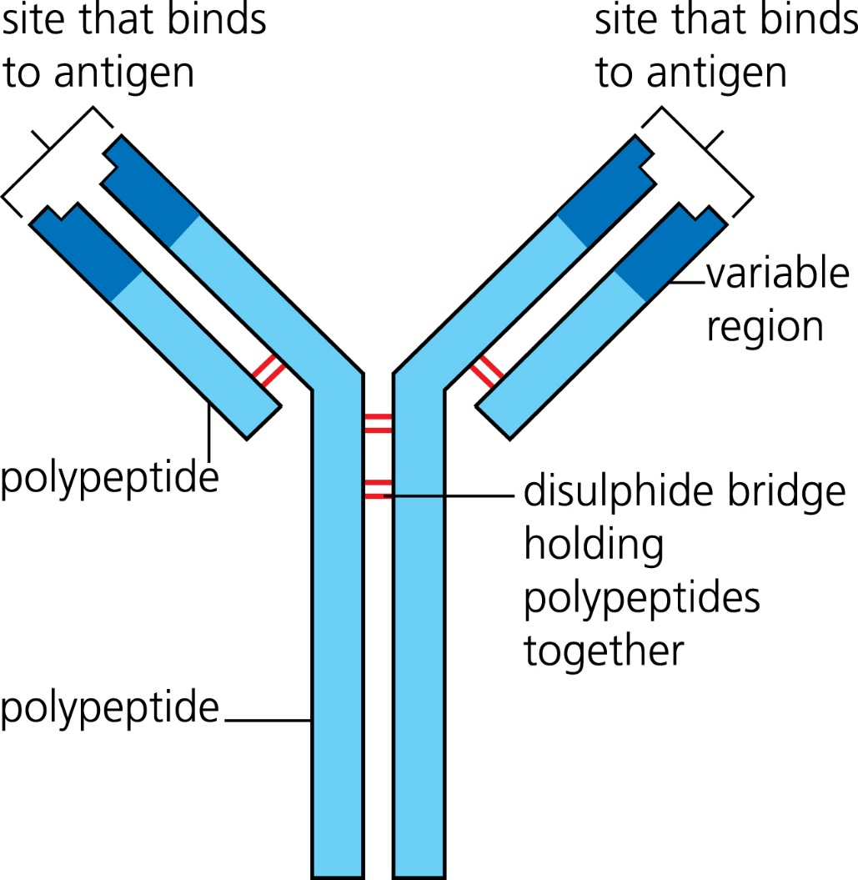

**How Antibodies Inactivate Pathogens**

Antibodies can inactivate pathogens in several different ways, including by [**neutralisation** or] **agglutination**.

[**Neutralisation:** Antibodies can ……………. to the antigens on the pathogen’s ……………. membrane and **prevent** it from ……………. to and therefore ……………. host cells.]

The antibodies encourage …………….…. to …….…………. the pathogen.

**Agglutination:** Antibodies bind to the antigens on the surface membranes of several pathogens, ……………. them together.

Macrophages can then recognise and more easily destroy the pathogens by phagocytosis.

**Immunological Memory**

When a person is subject to a ……………. infection by the ……………. **shaped** **antigen**, the immune response is much ……………. and more ……………. .

Antibodies are produced several days after the initial exposure to the **antigen**. The immune response is relatively small. This is the ……………. **immune response** (A).

The ‘lag’ is because stages 1-3 of the humoral response take time and the initial numbers of plasma cells are low so mitosis (doubling) only increases the actual number slightly.

A second exposure to the **same shaped antigen** activates *antigen*-*specific* ………. **cells**.

These stimulate a …………….**,** …………….* and ……………. **-**……………. **secondary** immune response (B).

* faster = **shorter** (almost no) **lag** time and greater **rate** of production.

If the body is also exposed to a different **shaped** antigen, it will produce another **primary** response.

This shows that a secondary response, initiated by long-lived memory cells, is **antigen specific**.

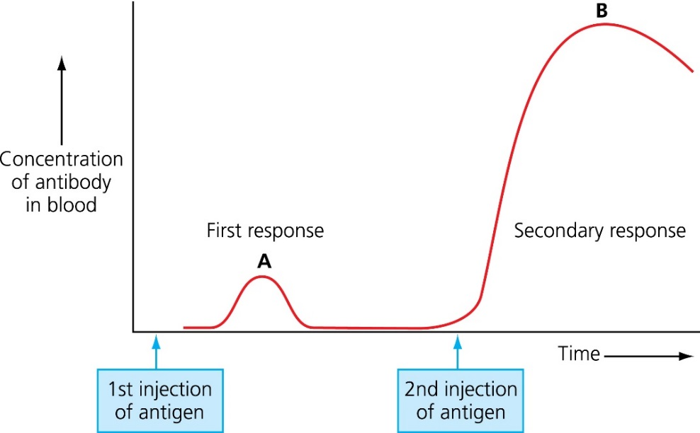

**Monoclonal Antibodies**

………………. **antibodies** are naturally produced in an immune response.

Different plasma cells secrete antibodies, resulting in a variety of different **shaped** antibodies which are **complementary** to a specific **shaped** antigen.

………….……. **antibodies** (**mAbs**) are antibodies produced from ……………. of a single plasma cell and are therefore all …………….. They have many important uses, such as:

* the treatment of ……………. and other diseases drug …………….
* home ……………. kits ……………. research.

**Examples* of medical uses include:**

***Direct Therapy*** - Monoclonal antibodies that are ……………., ……………. shapes to antigens found on the surface of ……………. cells can be used to target and then destroy the cells as part of an immune response. e.g, **herceptin** targets ……………. cancer cells.

***Indirect therapy*** - Drugs can be …………. to monoclonal antibodies such as a ……………. **drug**. The antibody then is used to ……………. the drug towards the cells displaying a particular antigen (usually a …… …………. …………….. associated with the disease) rather than towards other, healthy cells.

***Diagnosis*** - Particular ………………. are targeted by monoclonal antibodies to measure levels of that antigen in the body. e.g HIV or a …..…………. associated with the disease.

***Pregnancy testing*** - Monoclonal antibodies in home pregnancy kits are specific to the hormone **human chorionic gonadotrophin**.

* these examples do not need to be learnt but you **do** need to be alert to the various strategies and the importance of specifically shaped antibodies only forming an antibody-antigen complex with the complementary shaped antigen.

**ELISA**

Monoclonal antibodies are used in ……………. tests

[enzyme-linked immunosorbent assay]

Again, there are several techniques but all rely on specifically ……………. antibodies only forming an antibody-antigen complex with the ……………………….. shaped antigen.

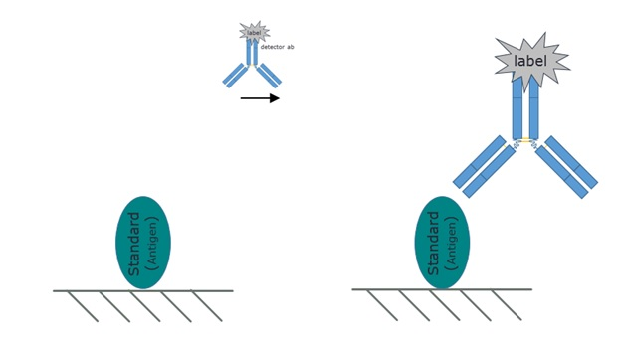

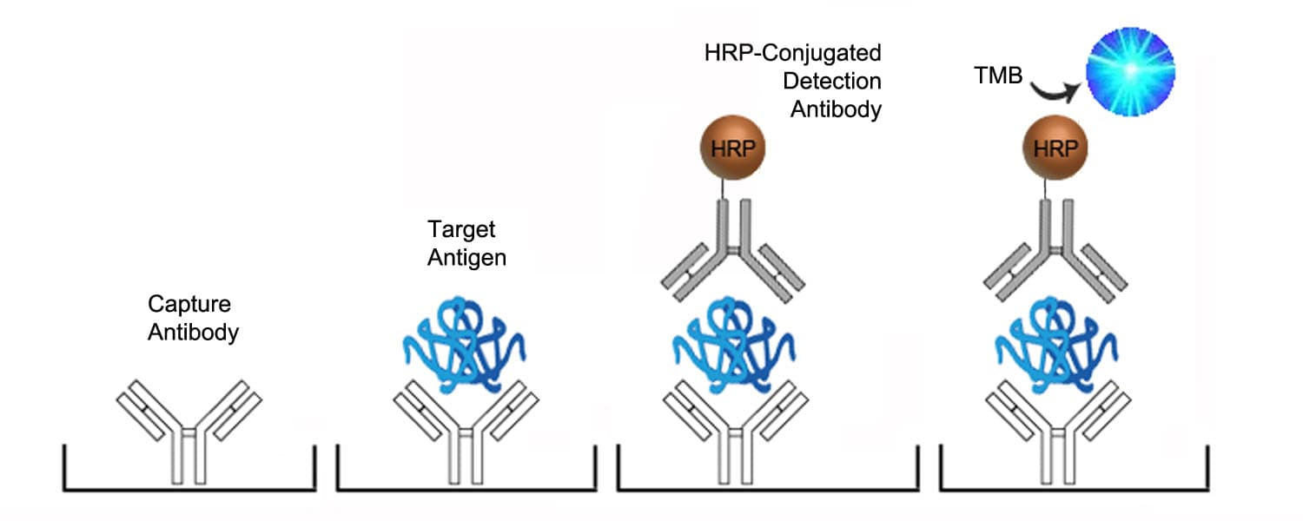

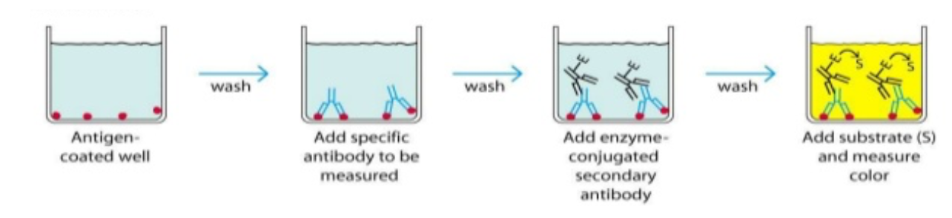

**Artificial Immunity:** How is Immunity Acquired?

immunity

innate immunity

adaptive immunity

natural

artificial

active

(infection)

passive

(maternal)

active

(vaccination)

immunity

(antibody transfer)

**Active vs Passive Immunity**

……………. immunity results from the body making its own …………….. Not only do these remain in circulation but the process also results in ……………. cells which respond by dividing ……… rapidly by mitosis to produce ………. quantities of antibodies if the same ……………. antigen is encountered again. Active immunity provides ……… - ……. protection**.**

……………. immunity is when the antibodies are given to the recipient. There is no ……………. ……………. so no memory cells. The antibodies administered are eventually ……………. against the antigen or are ………… ………. over time. Passive immunity only provides ………- …..…. protection.

**Vaccination**

**Vaccines** stimulate the production of ……………. and ……………. cells against the target pathogen without causing …………… . Why don’t vaccines cause illness?

* They may contain an ……………. **form** of the pathogen, killed by ……………. treatment (which leaves the immune-stimulating antigens …………….).
* They may contain an ……………. (less virulent) form of the pathogen.
* They may contain ……………. antigens, such as cell surface proteins, from the pathogen.

**Herd Immunity**If a large enough ………………. of the population is vaccinated all members (even unvaccinated) are protected because of ………… ……………..  
This is because the ………..……. of an infectious individual encountering a susceptible (non-vaccinated) individual is so remote the pathogen can not be transmitted.  
The more ……………. a pathogen the ………….. the proportion of vaccination needs to be.

**Ethical** **issues** surrounding vaccines include:

1. All vaccines are tested on …………. before being tested on humans. Also, animal-based substances may be used to ……………. a vaccine. (also true of monoclonal antibodies).

2. Testing vaccines on ……………. can be tricky e.g. volunteers may put themselves of at unnecessary risk of unknown ……… - ………., ……… - ………., harm or even contracting the disease (but only if the pathogen is used in the vaccine).

3. Is it fair to expect healthy volunteers to risk their health? Should volunteers be ………?

4. …………. should testing happen? Countries with the most to gain may be those with the most vulnerable population. e.g. LDCs

5. Given …………. ….…………. protects the entire population should vaccinations be compulsory? Does the welfare of the population …………. individuals’ rights?

6. Vaccination programmes are …………. . Could this money be better spent elsewhere?

**Influenza Vaccines**

New strains of the influenza virus are constantly emerging. This is because antigens displayed on the virus ……………. due to ……………….. ……………..   
This causes **antigenic** …………….. Antigenic variation makes it hard to immunise a patient against the influenza virus for life with just a ……………. vaccine.

The government works with other organisations to identify current ……………. of influenza. An effective vaccine is developed each year.