A PICTURE IS WORTH… 300 – 600 WORDS?
Use the images below to practise your descriptive and creative writing skills ahead of the exam (and beyond).
Look to include:
- A well-chosen perspective and narrator (Who sees? Who speaks?);
- A well-judged plot with a central event or two (not lots!) – four to six paragraphs;
- Vivid description of the setting / experience (try to use all five senses);
- Intriguing characters (consider actions / description / dialogue);
- Stylish techniques, varied sentence lengths and use of punctuation.
Proofread (PUPS) for accuracy as well as to edit your piece for greater impact.

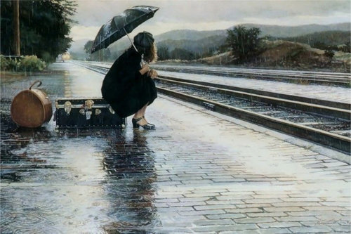 | 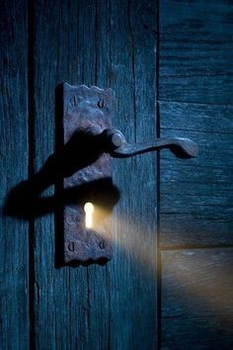 | 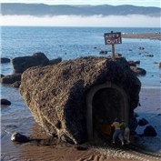
A. Waiting for the Train | B. The Light in the Room | C. Crab Cove
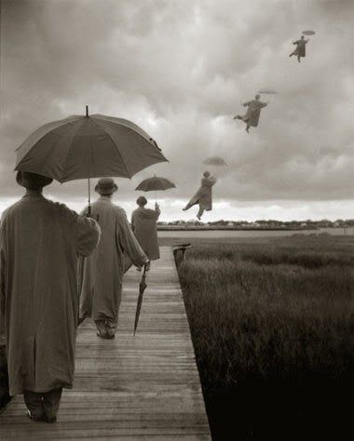 | 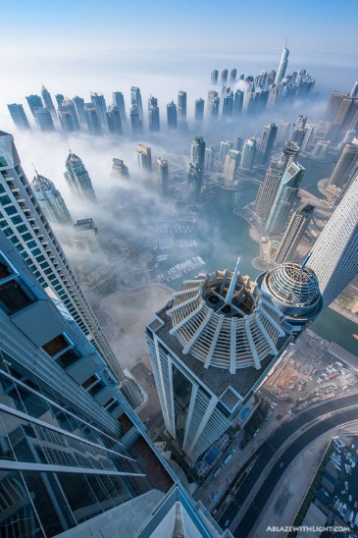 | 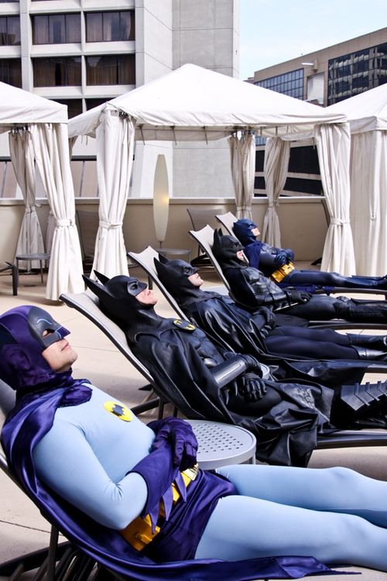
D. The Curious Case of the Umbrella | E. On Top of the World | F. The Superhero Hotel

These are just suggested titles / themes and images. Feel free to find your own (or use a short segment of one of your favourite films for practice too!)…

