You will need graph paper for this test.

|  |  |  |  |
| --- | --- | --- | --- |
| **0** | **1** |  |  |

Some students set up an experiment using nails to investigate the conditions needed for iron to rust (**Figure 1**).

**Figure 1**

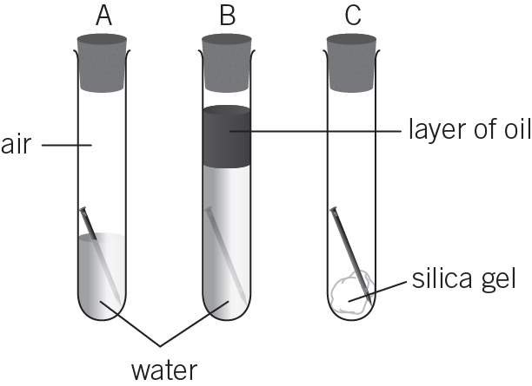

* all the tubes contain air
* tube **A** contains tap water
* tube **B** contains boiled water.

|  |  |  |  |
| --- | --- | --- | --- |
| **0** | **1** | **.** | **1** |

Iron rusts when it is exposed to which substance?

Tick (✓) **one** box.

air

water and oxygen

oxygen

water (*1 mark*)

|  |  |  |  |
| --- | --- | --- | --- |
| **0** | **1** | **.** | **2** |

What is the purpose of the silica gel?

(*1 mark*)

|  |  |  |  |
| --- | --- | --- | --- |
| **0** | **1** | **.** | **3** |

Name **two** elements which could be wrapped around nails to protect them from rust.

(*2 marks*)

|  |  |  |  |
| --- | --- | --- | --- |
| **0** | **2** |  |  |

Glue guns use rods of polymer as the glue which melt when they are heated in the gun. The melted polymer gets squeezed out of the gun’s nozzle. When the polymer cools, it solidifies and sticks objects together.

The bodies of some kettles are also made from polymers.

Using your knowledge of polymer structures, compare the two types of polymer needed to do these jobs.

(*6 marks*)

|  |  |  |  |
| --- | --- | --- | --- |
| **0** | **3** |  |  |

Phosphates are used in fertilisers to improve plant growth and respiration.

|  |  |  |  |
| --- | --- | --- | --- |
| **0** | **3** | **.** | **1** |

Give **one** reason why mined phosphate rock cannot be used as a fertiliser.

(*1 mark*)

|  |  |  |  |
| --- | --- | --- | --- |
| **0** | **3** | **.** | **2** |

Name an acid that can change phosphate rock into useful fertiliser salts. Give the name of a salt produced by it.

**Acid:**

**Salt:**  (*2 marks*)

|  |  |  |  |
| --- | --- | --- | --- |
| **0** | **3** | **.** | **3** |

Ammonium nitrate is also used in fertilisers. It can be made in the laboratory or in chemical factories.

**Table 1**

|  |  |
| --- | --- |
| Laboratory process | Factory process |
| * carried out with dilute reactants at room temperature * uses glass containers * makes a few grams of product in batches over several days * allows the heat energy from the reaction to be lost into the surroundings. | * uses concentrated reactants at 60°C * uses stainless steel reaction vessels and pipework * makes many tonnes of product each day in a continuous process * transfers the heat energy from the reaction to other processes in the factory. |

Evaluate the two processes in terms of their suitability for fertiliser production.

(*4 marks*)

|  |  |  |  |
| --- | --- | --- | --- |
| **0** | **4** |  |  |

Concrete is a composite material. It is made when water is added to a mixture of cement, sand, and gravel.

Some students investigate the strength of concrete bars (**Figure 2**).

They used the following method:

**1** Make blocks of concrete with different masses of cement.

**2** Allow the concrete to dry.

**3** Add masses to the supported blocks until they break.

**4** Record the results in a table.

**Figure 2**

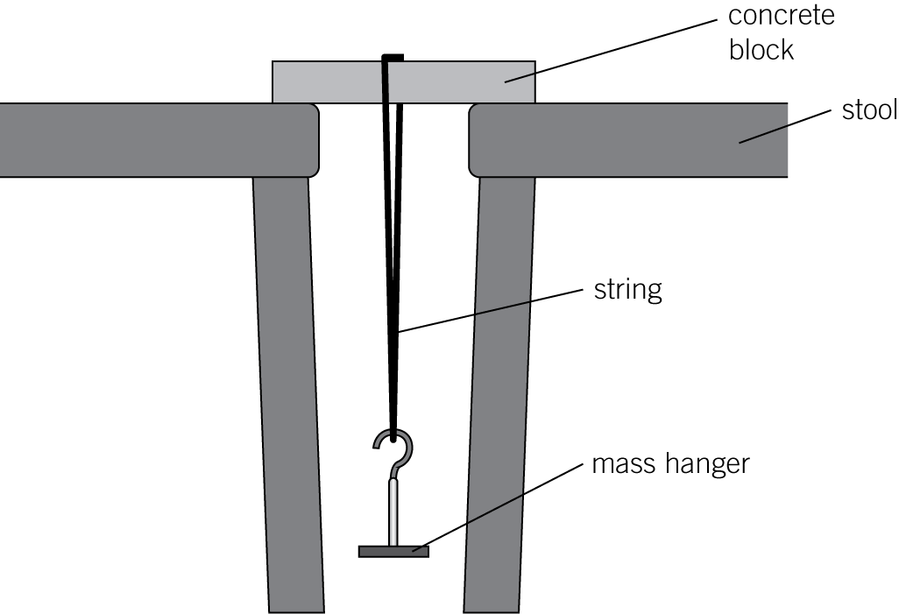

They record their results in **Table 2**.

**Table 2**

|  |  |  |  |  |  |  |
| --- | --- | --- | --- | --- | --- | --- |
| Concrete mixture in g | | | Mass added to break the concrete block in g | | | |
| Cement | Sand | Gravel | Test 1 | Test 2 | Test 3 | Mean |
| 10 | 70 | 20 | 1200 | 1100 | 1300 | 1200 |
| 20 | 60 | 20 | 3400 | 2600 | 2400 |  |
| 30 | 50 | 20 | 3300 | 3300 | 3300 | 3300 |
| 40 | 40 | 20 | 3900 | 3700 | 3300 | 3800 |
| 50 | 30 | 20 | 4200 | 4600 | 4400 | 4400 |

|  |  |  |  |
| --- | --- | --- | --- |
| **0** | **4** | **.** | **1** |

Give one control variable in this investigation.

(*1 mark*)

|  |  |  |  |
| --- | --- | --- | --- |
| **0** | **4** | **.** | **2** |

Calculate the mean mass needed to break a block containing 20 g of cement.

mean mass  g (*2 marks*)

|  |  |  |  |
| --- | --- | --- | --- |
| **0** | **4** | **.** | **3** |

The students want to show the relationship between the mass of cement used and the mean mass needed to break the block. They decide to plot a graph of their results.

On graph paper, create a suitable number scale and label for each axis to enable the students to plot the graph. (*3 marks*)

|  |  |  |  |
| --- | --- | --- | --- |
| **0** | **5** |  |  |

In 1909 Fritz Haber invented a process to produce ammonia from nitrogen and hydrogen.

|  |  |  |  |
| --- | --- | --- | --- |
| **0** | **5** | **.** | **1** |

Complete and balance the chemical equation for the production of ammonia from nitrogen and hydrogen.

N2  3H2 ⇌ (*2 marks*)

|  |  |  |  |
| --- | --- | --- | --- |
| **0** | **5** | **.** | **2** |

**Figure 3** shows how the equilibrium yield of ammonia changes with pressure at different temperatures.

**Figure 3**

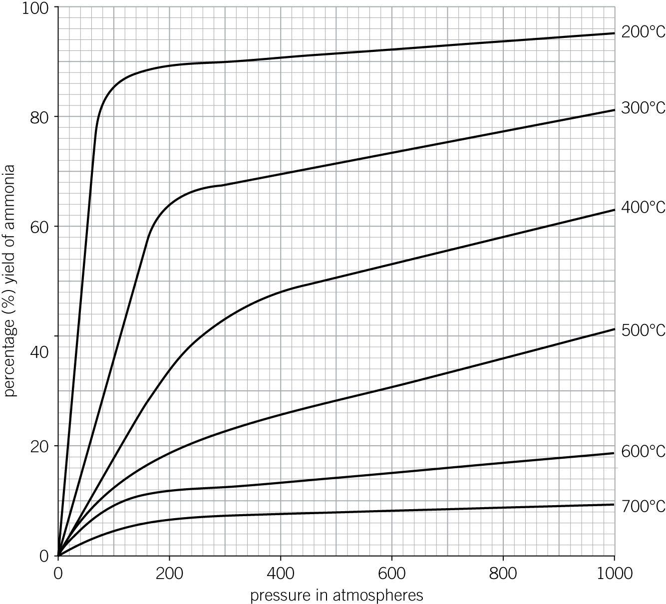

Use **Figure 3** to determine which temperature gives the highest yield of ammonia.

°C (*1 mark*)

|  |  |  |  |
| --- | --- | --- | --- |
| **0** | **5** | **.** | **3** |

The temperature used in the Haber process for the production of ammonia is 450°C.

Why is a temperature much lower than 450°C **not** used for the Haber process?

(*1 mark*)

|  |  |  |  |
| --- | --- | --- | --- |
| **0** | **5** | **.** | **4** |

The pressure used in the Haber process for the production of ammonia is 200 atmospheres.

Why is a pressure lower than 200 atmospheres **not** used for the Haber process?

(*1 mark*)

|  |  |  |  |
| --- | --- | --- | --- |
| **0** | **5** | **.** | **5** |

Explain how ammonia is separated from unreacted nitrogen and hydrogen in the Haber process.

(*2 marks*)

*AQA, 2014*