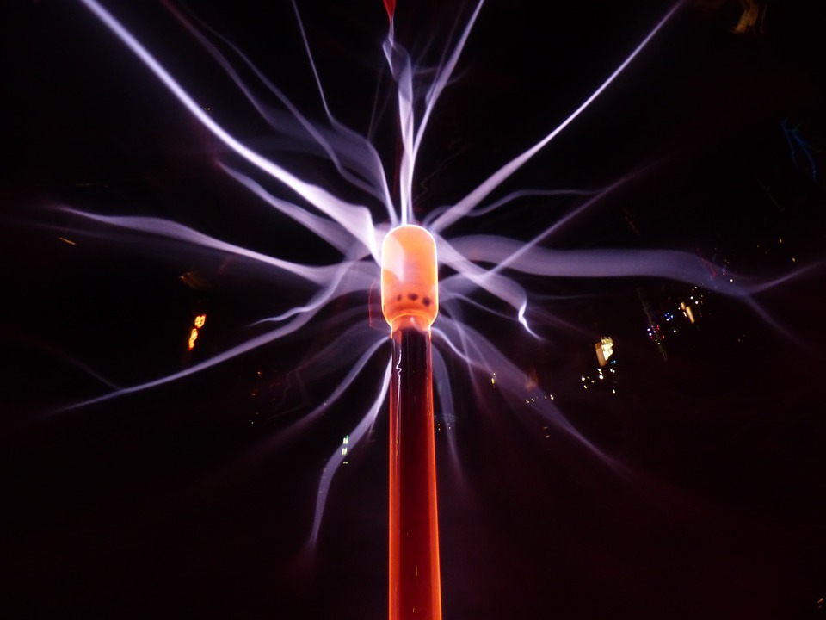

Photocopiable/digital resources may only be copied by the purchasing institution on a single site and for their own use

2016 specification

first exams in 2018

Topic Tests

for GCSE AQA Physics Paper 1:   
Topics 1–4

Physics GCSE (9–1) | AQA | 8463



zigzageducation.co.uk

Publish your own work... Write to a brief...

Register atpublishmenow.co.uk

POD

7078

eacher Feedback OppWrite-on Topic Tests

Topic Test 1: Energy changes in a system

1. Energy can be stored by systems in different ways

a) State what is meant by a ‘system of objects’

*1 mark*

b) Complete the sentences below to show the energy changes during the following situations.

i) A ball shoots up into the air. ____________________ energy is converted into ____________________ energy. *2 marks*

ii) Water is brought to a boil in an electric kettle. ____________________ energy is converted   
into ____________________ energy. *2 marks*

2. Which of the following energies is stored in a system if a system is compressed?

**A** □ Kinetic energy

**B** □ Electrical energy

**C** □ Thermal energy

**D** □ Elastic energy *1 mark*

3. A 939 kg car is travelling at 11.1 m/s.

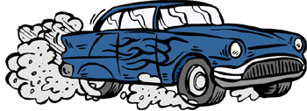

Calculate the kinetic energy of the car.

*2 marks*

4. Which of the following is the true definition of specific heat capacity?

**A** □ The amount of energy required to raise the temperature of 10 kilograms of the substance by one degree Celsius

**B** □ The amount of power required to raise the temperature of one kilogram of substance by one degree Celsius

**C** □ The amount of energy required to raise the temperature of one kilogram of substance by one degree Celsius

**D** □ The amount of power required to raise the temperature of 10 kilograms of the substance   
by one degree Celsius *1 mark*

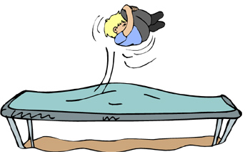5. A 45 kg child is jumping on a trampoline that is made of springs with spring constant 5000 N/m.

a) Describe the energy transfer occurring as the child jumps up and down on the trampoline.

3 *marks*

b) Use the equation for elastic potential energy, , to calculate the elastic potential energy stored in one spring as it is extended by 0.3 m as the child lands on the trampoline.

*2 marks*

6. A 55 kg diver is standing at the end of a 2.5 metre diving board.

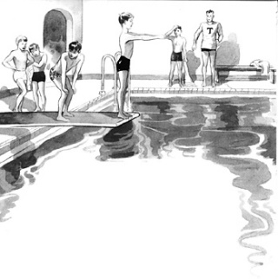

**2.5 m**

*Use g = 9.8* m/s2

a) Calculate the gravitational potential energy of the diver.

*2 marks*

b) Calculate the kinetic energy of the diver when he is 1 m above the water. Assume all gravitational potential energy is converted to kinetic energy.

*2 marks*

7. A GCSE student is doing an experiment to determine the specific heat capacity of water.

She is going to use an electric heater to heat the water. The energy supplied to this heater is calculated using

a) Describe an experiment, including required apparatus that the student could carry out in order to determine the specific heat capacity of water.

Ensure you include the measurements the student will need to take to complete the experiment.

6 *marks*

The student heats up 3.0 kg of water.

b) Using the correct equation from the data sheet, calculate the thermal energy required to bring the water to 100 °C from 20 °C.

*Use the specific heat capacity of water as C = 4180* J/kg°C

*2 marks*

c) The specific heat capacity of olive oil is 1790 J/kg°C. Explain whether it takes more or less energy to heat the same mass of oil to 100 °C.

***Note****: the initial temperature of the olive oil is also 20*°C.

*1 mark*

8. Two cranes each lift a box the same distance.

Crane 1 lifts a box weighing 80 kg in 30 s. Crane 2 lifts a box weighing 40 kg in 10 s.

Which crane has the greater power? Show your working.

3 marks

***Total: 30 marks***

Topic Test 2: Conservation and dissipation of energy & energy resources

1. a) State the difference between renewable and non-renewable energy.

*2 marks*

b) Which of the following table rows is correct?

|  |  |  |  |
| --- | --- | --- | --- |
|  | Renewable energy resource | Non-renewable energy resource |  |
| A | Coal | Oil | □ |
| B | Wind | Hydroelectricity | □ |
| C | Gas | Water waves | □ |
| D | Geothermal | Coal | □ |

*1 mark*

2. Which of the following statements is true?

**A** □ The higher the thermal conductivity of a material the **lower** the rate that heat is transferred

**B** □ The higher the thermal conductivity of a material the **higher** the rate that heat is transferred

**C** □ The thermal conductivity of a material doesn’t affect the rate that heat is transferred

*1 mark*

3. Explain what is meant by the term ‘wasted energy’.

*1 mark*

4. A television transfers 1215 J of electrical energy into light energy in a time of 4.5 seconds.

Calculate the power of the television.

*2 marks*

5. Which of the following statements are true about energy?

**A** □ Energy can be transferred usefully and stored. Energy cannot be dissipated.

**B** □ Energy can be transferred usefully, stored or dissipated. Energy cannot be created or destroyed.

**C** □ Energy can be transferred usefully. It can also be stored, dissipated, created or destroyed.

**D** □ Energy can be created. Energy cannot be destroyed.

*1 mark*

6. A fossil-fuel power plant has been threatened with closure due to significant protests from members of the scientific community.

a) Give the potential arguments the scientific community would have to support the closure of the fossil-fuel plant, and explain why some people would want the plant to stay open.

*6 marks*

7. A student is investigating the effectiveness of different materials as thermal insulators using the equipment in Figure 1.

Beaker lid

Insulating material

Beaker with water



Thermometer

**Figure 1**

The student uses boiling water to fill the beaker.

The student covers the beaker with an insulating material and uses a thermometer to measure the decrease in temperature over a given time.

The student repeats the experiment to compare different insulating materials.

a) State two variables that the student should control during the experiment.

1

2

*2 marks*

The student only takes one set of measurements for each material.

b) Explain a problem this may cause with the student’s results.

*1 mark*

The graph of a second student, who takes a range of measurements for each material, is displayed below.

**Temperature/°CC**

**Time/s**

100

500

Material 1

Material 2

Material 3

c) Give your conclusions on the effectiveness of each material as an insulator by comparing all three insulators.

*3 marks*

8. An electric motor is used in various mechanical systems, such as hair dryers, to generate movement.

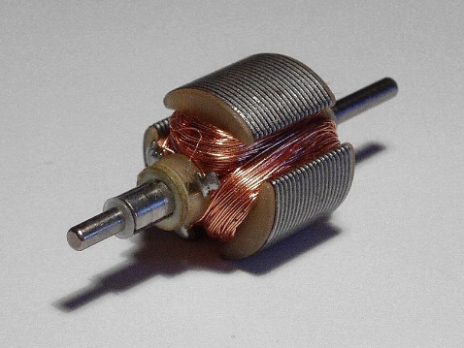

A hair dryer’s electric motor is supplied with 900 kJ of electrical energy but only has an output of 700 kJ of rotational energy.

a) Explain why the input energy is not equal to the output energy of the electric motor.

*3 marks*

b) Calculate the efficiency of the motor. Give your answer as a decimal to 1 decimal place.

*2 marks*

c) **(HT Only)** Suggest a method for improving the efficiency of the electric motor.

*1 mark*

***Totals***

***FT: 25 marks***

***HT: 26 marks***

Topic Test 3: Current, potential difference, resistance and circuits

1. Complete the following table.

|  |  |
| --- | --- |
| Circuit symbol name | Circuit symbol |
| Switch (open) |  |
|  |  |
| Cell |  |
| Battery |  |
| Diode |  |
|  |  |
|  |  |
| Light-emitting diode (LED) |  |
|  |  |
| Fuse |  |
|  | **V** |
| Ammeter |  |
|  |  |
|  |  |

*6 marks*

2. a) Match the following quantities to their units and to the unit’s symbol.

|  |  |  |  |  |
| --- | --- | --- | --- | --- |
| Current |  | Seconds |  | Q |
|  |  |  |  |  |
| Charge |  | Amperes |  | I |
|  |  |  |  |  |
| Time |  | Coulombs |  | t |

*3 marks*

b) Write down the equation relating charge, current and time.

*1 mark*

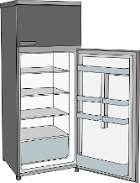3. a) An engineer is creating an electrical circuit to be used in a fridge.

The circuit must include a component that changes resistance as the temperature in the fridge increases and becomes too high.

What component could the engineer use?

*1 mark*

b) An electrical circuit is set up by the engineer to investigate the current in a circuit. The circuit is set up as follows:





State the relationship between the two current readings *I*1 and *I*2.

*1 mark*

4. A Physics teacher is demonstrating the potential difference in a series circuit.

The teacher sets up an electrical circuit with a resistor, voltmeter and ammeter.

0.50 A

V

7.0 Ω

a) What reading would you expect on the voltmeter?

*2 marks*

b) Explain what would happen to the reading on the voltmeter if the 7 Ω resistor was replaced with a   
10 Ω resistor.

***Note****: the current reading remains the same.*

*1 mark*

5. The following statements were made by a group of GCSE students in a Physics lesson on series and parallel circuits.

|  |  |
| --- | --- |
| A: ‘There is the same current through each component’ | B: ‘The total current equals the sum of currents through each component’ |
| C: ‘The total potential difference of the power supply is split between each component in the circuit’ | D: ‘The potential difference drop across each component is equal to the potential difference supplied by the battery’ |

a) For each phrase identify whether the students were talking about a series circuit or a parallel circuit by writing each letter in the table below.

|  |  |
| --- | --- |
| Parallel Circuit | Series Circuit |
|  |  |

*2 marks*

A sound engineer is setting up an electrical circuit to use for a set of speakers.

The sound engineer uses two resistors in series.

b) What equation could the engineer use to calculate the total resistance of the two resistors in series?

*1 mark*

c) If the engineer was to set up the two resistors in parallel instead, what would happen to the total resistance measured?

*1 mark*

6. A student is investigating the factors that affect resistance in electrical circuits.

The student wants to determine the total resistance of four 5 Ω resistors in series and compare the value to the total resistance of the four 5 Ω resistors in parallel.

a) Sketch two circuit diagrams, one with four resistors in parallel and one with four resistors in series.

2 *marks*

b) Describe how the student could use each electrical circuit to compare the resistance across each resistor in each circuit.

4 *marks*

7. An electrician is testing the electrical output of components to ensure they are working correctly and are safe for use.

The electrician completes a number of tests and produces the following graph for a resistor kept at constant temperature:

**Potential difference/V**

**Current/A**

a) From the graph, is the I-V relationship of a resistor linear or non-linear?

*1 mark*

b) Draw similar graphs to the one above for a filament lamp and a diode, and explain their shape.

*6 marks*

c) Light-dependent resistors have various practical applications in electrical circuits.

Which of the following statements is true?

**A** □ An LDR can be used in a circuit to switch on lights when it gets dark

**B** □ An LDR can be used in a circuit to alert customers as to when the temperature in their fridge has become too high

**C** □ An LDR can be used in a circuit to ring an alarm when noise levels are too high

**D** □ An LDR can be used in a circuit to indicate when current in the circuit is too low

*1 mark*

***Total: 33 marks***

Topic Test 4: Energy transfers and domestic uses

1. An extract of a GCSE student’s classwork in given below:

The unit for power is volts, the unit for resistance is ohms and the unit for voltage is amperes.

a) There are some errors in this extract. Rewrite the extract to correct these errors.

*2 marks*

b) Write down the equation which links power, resistance and voltage.

*1 mark*

2. Complete the following sentence.

‘Work is done when…’

**A** □ ‘… there is potential difference across a circuit component’

**B** □ ‘… charge flows in a circuit’

**C** □ ‘… there is no current in a circuit’

**D** □ ‘… there is sufficient amount of charge in a circuit’ *1 mark*

3. Match up the following energy transfers and uses.

|  |  |  |
| --- | --- | --- |
| Electrical energy to kinetic energy |  | The energy transfer occurring in the electric motor in a washing machine |
| Electrical energy to heat energy |  | The energy transfer occurring in the bulb of a lamp |
| Electrical energy to light energy |  | The energy transfer occurring in a kettle |
| Electrical energy to sound energy |  | The energy transfer occurring in a loudspeaker |

*3 marks*

4. a) Fill in the missing labels on the plug.

**A**

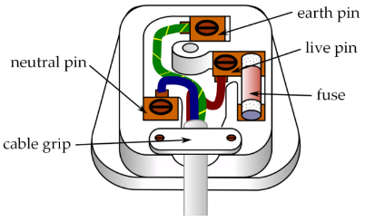

Neutral pin

**B**

**C**

Cable grip

*3 marks*

b) Explain the role of the live, earth and neutral wires seen in an appliance plug.

*3 marks*

5. Identify which of the following signals indicates

• an alternating current

**Time/s**

**Current/A**

**Time/s**

**Current/A**

***Graph A***

***Graph B***

• a direct current

**Graph A**

**Graph B**

*1 mark*

6. A Physics teacher is called upon by the head teacher to determine the power output of their back up electricity generator.

The head teacher gives the Physics teacher the following quantities:

• Current through the generator (I)

• Potential difference supplied to the generator (V)

• The resistance of the electrical system of the generator (R)

Give two equations the teacher could use to determine the power output of the generator, using the above quantities.

*2 marks*

7. Calculate the potential difference across a component using 390 W of power with 8.0 A flowing through it.

*2 marks*

8. 11.5 C of charge flows through a component which has a potential difference of 170 V across it.

How much energy is transferred to the component?

*2 marks*

9. An exchange student from the Bahamas is visiting an English secondary school.

During a Physics class, the students are learning about mains electricity.

The students are asked to calculate the current through a hairdryer with resistance 30 Ω when plugged into the mains supply.

The exchange student from Bahamas uses the value for mains supply for the Bahamas of 150 V.

Explain how the exchange student’s answer will be different.

3 marks

10. A student is using a kettle in the school common room.

The kettle has a power output of 1800 W and it takes 180 seconds for the kettle to boil

a) How much energy has been transferred in boiling the kettle?

*2 marks*

The heating element of the kettle has a resistance of 28 Ω.

b) What is the current through the kettle?

*2 marks*

The student finds another kettle that has a power rating of 2000 W and also takes only 180 seconds to bring water to the boil.

c) Which kettle will transfer energy at a faster rate? Explain your answer.

*2 marks*

11. The electricity that enters our homes is transferred to us using the national grid.

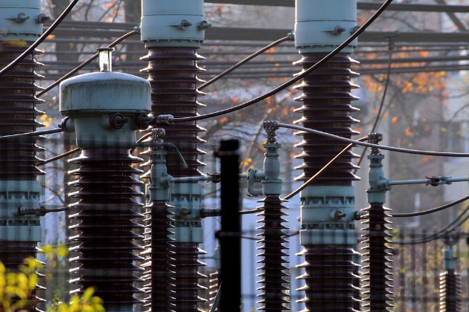

Explain how transformers are used in the national grid and why using step-up transformers in the national grid makes the transfer of energy more efficient.

*6 marks*

***Total: 35 marks***

Topic Test 5: Static electricity

1. Complete the following statement.

An object with a net positive charge will definitely have….

**A** □ More electrons than protons

**B** □ More protons than electrons

**C** □ More protons than neutrons

**D** □ Equal amounts of protons and electrons *1 mark*

2. Match the following statements.

|  |  |  |
| --- | --- | --- |
| ‘Two objects that carry the same charge…’ |  | ‘… will exert a force on each other’ |
| ‘Two objects that carry different charge…’ |  | ‘… will repel each other’ |
| ‘Two electrically charged objects brought close together…’ |  | ‘… will attract each other’ |

*2 marks*

3. a) Draw an electric field pattern for an isolated positively charged sphere.

*1 mark*

b) What would happen if an identical charged sphere was brought close to the sphere you have drawn?

*1 mark*

4. The following boxes contain examples of contact and non-contact forces.

Identify which of the following forces are contact forces and which are non-contact forces by writing ‘contact’ or ‘non-contact’ next to them.

|  |
| --- |
| Magnetic force: |
| Tension: |
| Gravitational force: |
| Lift force from a crane: |

*4 marks*

5. A Physics teacher uses a balloon to demonstrate the concept of static electricity. She rubs the balloon across her jumper for 30 seconds.

a) Explain how rubbing the balloon on her jumper results in the teacher’s jumper and the balloon both becoming electrically charged.

*3 marks*

b) What property of the balloon and the jumper allows them to become electrically charged?

*1 mark*

6. Some students are conducting an experiment with a Van de Graaff generator.

The students see sparks jump across the gap in the Van de Graaff generator.

a) Why are the students seeing these sparks?

*2 marks*

A student stands on a rubber mat and places her hand on the generator. Her hair stands on end.

b) Explain why the student’s hair stands on end

*2 marks*

Another student touches the first student. He is not standing on a rubber mat. Both students experience a static shock.

c) Why do both students experience a static shock?

*1 mark*

7. Two objects are arranged below:

+

+

+

+

+

+

+

+

+

+

+

+

+

+

+

+

–

a) On the diagram, draw electric field lines for each of the objects.

*4 marks*

b) Will there be a repulsive or attractive force between the two objects?

*1 mark*

c) Explain why the objects do not need to be in contact in order to exert a force on one another.

*2 marks*

The two objects are brought closer together.

+

+

+

+

+

+

+

+

+

+

+

+

+

+

+

+

–

d) Explain what happens to the force felt between each object.

*2 marks*

***Total: 27 marks***

Topic Test 6: The particle model and energy transfers

1. a) State whether each of the following diagrams represents a solid, a liquid or a gas.

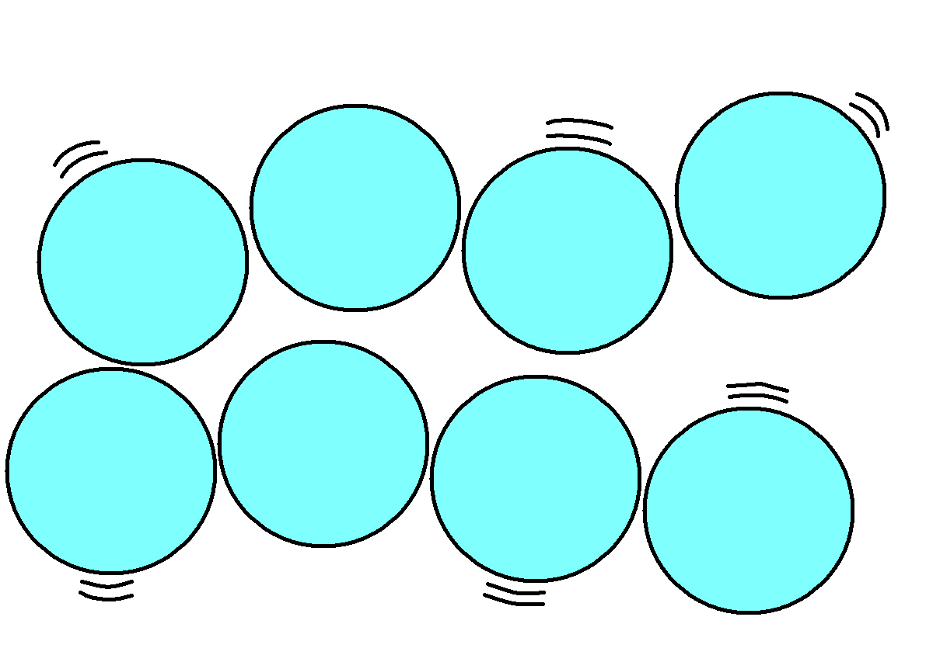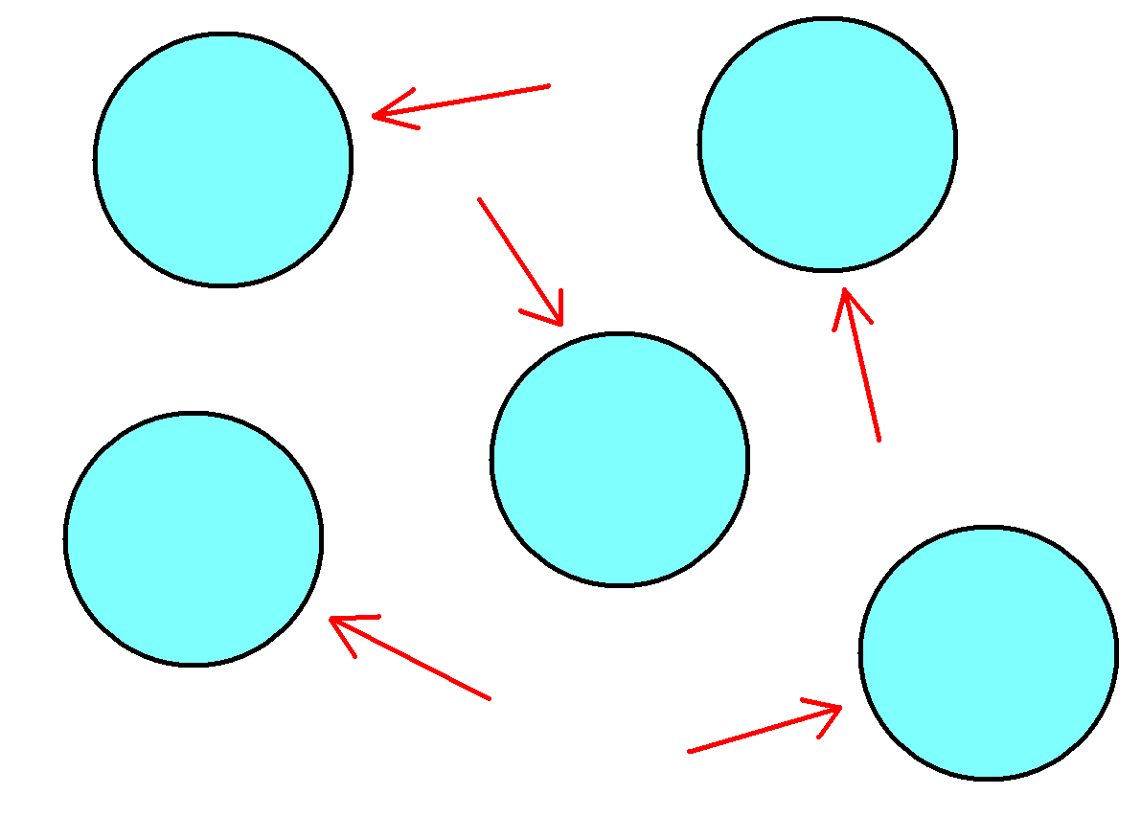

**Diagram A**

**Diagram B**

**Diagram C**

*3 marks*

b) If a metal were to change from the state in diagram A to the state in diagram B, explain how its density would change.

*2 marks*

2. Match the following physical quantities to their units.

|  |  |  |
| --- | --- | --- |
| Density |  | Kg |
| Mass |  | Kg/m3 |
| Volume |  | m3 |

*3 marks*

3. Which of the following statements is true?

**A** □ Changes of state are physical changes and not chemical changes

**B** □ As a substance changes from a liquid to a solid during freezing its mass will increase

**C** □ When a substance changes state, the substance cannot recover its original properties if the change is reversed

**D** □ When a substance changes state, its temperature also changes *1 mark*

4. Complete the following sentence.

‘The required energy for a substance to change state is called…’

**A** □ Thermal energy

**B** □ Latent heat

**C** □ Internal energy

**D** □ Potential energy *1 mark*

5. A group of GCSE students are taking part in an after-school study group. They are discussing the concept of specific heat capacity. The students are in disagreement over the definition of specific heat capacity.

**Student A:** ‘specific capacity of a substance is the amount of energy required to raise the temperature of one kilogram of the substance by one degree Celsius’

**Student B:** ‘specific capacity of a substance is the amount of energy required to raise the temperature of 10 kilograms of the substance by one degree Celsius’

**Student C:** ‘specific capacity of a substance is the amount of power required to raise the temperature of one kilogram of the substance by one degree Celsius’

**Student D:** ‘specific capacity of a substance is the amount of power required to raise the temperature of 10 kilograms of the substance by one degree Celsius’

Which one of the students is correct?

*1 mark*

6. a) Two Year 10 students are carrying out an experiment to investigate the energy required to change state.

• **Student 1** boils ethanol to change it from a liquid to a gas

• **Student 2** cools water to change it from a liquid to a solid

State which student will use **specific latent heat of fusion** and which student will use **specific latent heat of vaporisation** when determining the energy required to change state.

*2 marks*

b) A Physics student is asked to identify the factors that affect latent heat.

The student identifies the following variables:

• Mass

• Temperature

• Volume of the material

• Specific latent heat

Identify which of the factors indicated by the student are correct.

*2 marks*

7. A Physics student is given the task of investigating the density of different regular and irregular objects.

The student is asked to determine the density of a solid cube. The 2.3 kg cube has a length of 0.3 m.

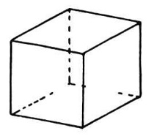

**0.3 m**

a) Calculate the value of density the student will obtain for the solid cube.

*2 marks*

The student is also given an irregular object. The student cannot determine the dimensions of the object.



b) Explain how the student could determine the density of the irregular-shaped object.

*4 marks*

8. A physicist is investigating how different substances change state.

The physicist uses the experimental data of two substances to sketch graphs relating the temperature of the substance and the heat absorbed by each substance.

**Temperature/°C**

**Heat absorbed/J**

**Graph A**

**A**

**B**

**Temperature/°C**

**Heat absorbed/J**

**Graph B**

**C**

**D**

a) Identity the following changes of state denoted by each letter: **A**, **B**, **C** and **D**.

**A**

**B**

**C**

**D**

4 *marks*

b) From the graph, identify what variable remains constant during each of the four changes of state.

*1 mark*

9. On a trek in Iceland a school group are attempting to fill up their water bottles using ice from their surroundings.

Their water bottle can hold 0.5 kg of ice. The specific latent heat of fusion of ice is 334 J/kg.

How much energy is required to melt the ice collected by the students?

*2 marks*

10. A chef places a pan of water on the hob to boil.

As the pan of water is brought to the boil some of the water evaporates and becomes steam.

a) Explain what happens to the internal and kinetic energy of the water particles as they are heated.

*2 marks*

b) Identify the different factors which will affect how much the temperature of the water can increase.

*3 marks*

The pan holds 2 kg of water. The specific heat capacity of water is 4181 J/kg°C.

The water in the pan is initially at 21 °C and is brought to the boil at 100 °C.

c) Determine the change in thermal energy that occurs as the pan of water is brought to the boil.

*2 marks*

***Total: 35 marks***

Topic Test 7: Gases and pressure

1. Tick the correct box to complete the statement.

In a gas, molecules have...

**A** 🞎 linear motion

**B** 🞎 zero motion

**C** 🞎 random motion

**D** 🞎 oscillating motion

*1 mark*

2. a) Describe how the motion of the molecules in a gas is affected when the temperature of the gas increases.

2 marks

b) Describe how decreasing the average kinetic energy of molecules in a gas affects the pressure of the gas.

2 marks

3. A pressure cooker is a sealed container in which food is cooked.

The temperature of the air in the pressure cooker increases with no change in volume.

Explain how this affects the pressure of the air in the cooker.

3 marks

4. a) A closed box with adjustable walls is used by a national laboratory to study the properties of gases.

The box is filled with a gas of fixed mass and temperature. The box’s walls are then adjusted to increase the volume of the box, as seen below.

***Box before***

***Box after***

Compare the pressure exerted on the walls of the box before and after the walls are adjusted.

*2 marks*

b) The volume of the box increases from 0.30 m3 to 0.40 m3.

Before the change in volume, the pressure exerted on the walls is 1600 N/m2.

What is the pressure exerted on the walls of the box after the adjustment?

*3 marks*

c) Another box has length 0.75 m, width 0.40 m and height 0.60 m.

The box is expanded so that it has length 0.80 m, width 0.55 m and height 0.85 m.

Calculate the change in volume of the box.

*3 marks*

5. Oxygen-filled gas canisters are used frequently in hospitals to supply oxygen to patients with difficulty breathing.

The oxygen is contained in a canister of fixed volume.

The canisters must be stored in places where the temperature can be controlled.

Use the particle model to explain what would happen if the gas in the canister was heated to high temperatures.

*3 marks*

6. **(HT Only)** A cyclist obtains a puncture during a race. The cyclist replaces the inner tube and uses a bike pump to inflate the wheel.

Explain why the temperature of the gas inside the inner tube increases as the cyclist uses the pump to inflate the wheel.

*2 marks*

7. **(HT Only)** A refrigerator contains a coolant gas which is compressed and expands around a series of tubes.

a) Explain how the gas expanding cools the refrigerator.

*3 marks*

b) Why is it important to have a heat sink or extractor fan at the point where the coolant is compressed?

*2 marks*

***Totals***

***Foundation: 19 marks***

***Higher: 26 marks***

Topic Test 8: Atoms and isotopes

1. An extract from a Year 10 student’s Physics workbook is given below.

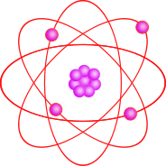

Protons, negatively charged

Nucleus, made up of neutrons and electrons

The radius of the nucleus is 1/100 of the radius of the atom

Most of the mass is concentrated in the nucleus

The radius of the atom is ~ 1 x 10–10m

State three mistakes in the student’s work, and write the corrections below.

1

2

3

*3 marks*

2. What is the mass number of an atom?

**A** □ The number of electrons of the atom

**B** □ The number of protons of the atom

**C** □ The number of neutrons of the atom

**D** □ The number of protons and neutrons of the atom *1 mark*

3. A uranium nucleus is represented as follows:



How many neutrons and how many protons does the uranium nucleus have?

*2 marks*

4. Complete the following sentence.

If an atom has the same number of electrons as protons then the atom…

**A** □ … is positively charged

**B** □ … has no overall charge

**C** □ … is negatively charged

**D** □ … has the same mass and proton number

*1 mark*

5. a) In terms of subatomic particles, identify two similarities between the following nuclei.







*2 marks*

b) How does charge and mass differ between these three nuclei?

*2 marks*

c) What is the name for nuclei that are different in the way shown above?

*1 mark*

6. Explain how the findings of Rutherford’s scattering experiments disproved the plum pudding model and how they led to our current model of the atom.

*6 marks*

7. a) The work of Niels Bohr and other scientists led to the idea that the atom was made of protons, neutrons and electrons.

How was this different to previous ideas of the atom?

*1 mark*

b) Suggest two reasons why discoveries about protons, neutrons and electrons were not made earlier.

1

2

*2 marks*

8. A Physics student from Set A is given a metal sphere and asked to determine the mass of the sphere.

The student completes a rough calculation using the sphere’s density and volume to make a guess at its mass.

A student from Set B is given the same metal sphere and uses a set of calibrated scales to measure the mass of the sphere. Student B obtains a different value to student A.

a) Why would the value obtained by Student B be used rather than the value for Student A?

*2 marks*

Scientific conclusions, experimental data and theories are continuously adapted and remodelled under conditions such as those discussed above.

b) Using your answer to (a) explain why the plum pudding model was replaced by and adapted to the nuclear model.

*1 mark*

9. The diagram below represents the energy levels and electron arrangement of an atom.

**Nucleus**

a) What does the diagram tell you about the arrangement of electrons in an atom?

*1 mark*

b) One of the electrons has moved from its original energy level to an energy level at a greater distance from the nucleus.

How can electromagnetic radiation cause this?

*2 marks*

***Total: 27 marks***

Topic Test 9: Atoms and nuclear radiation

1. a) The following statements were made about the three nuclear radiation particles/rays

|  |  |
| --- | --- |
| • Medium penetrating power  • The highest ionising power of all three  • Has a range of around 15 cm in air  • Has medium ionising power  • Has the longest range of all three | • Has a range of 3–5 cm in air  • The lowest ionising power of all three  • Low penetrating power  • High penetrating power |

Place the statements in the correct box.

|  |  |  |  |
| --- | --- | --- | --- |
|  | Range | Ionising Power | Penetrating Power |
| Alpha |  |  |  |
| Beta |  |  |  |
| Gamma |  |  |  |

*6 marks*

b) Gamma-emitting nuclei are injected into a patient’s bloodstream and detected. This method is used to image the patient’s organs.

What properties of gamma radiation make it suitable for this use?

*2 marks*

2. a) Why would a nucleus emit radiation?

*1 mark*

b) Which of the following statements are true?

**A** □ Activity is the number of stable nuclei recorded each second by a detector

**B** □ Radioactive decay is a systematic process

**C** □ Activity is measured in Grays

**D** □ Activity is the rate at which a source of unstable nuclei decays

*1 mark*

3. What happens to the mass and charge of a nucleus when gamma radiation is emitted from an unstable nucleus?

*2 marks*

4. Two extracts from a document of the office of nuclear regulation are displayed below.

**Extract one:**

*‘A patient is exposed to gamma rays during a PET scan of their head and neck…’*

**Extract two:**

*‘A source of nuclear waste was not contained properly and leaked into the surrounding work areas…’*

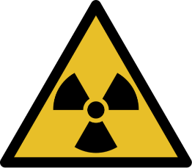

a) Explain which extract is an example of irradiation and which is an example of contamination.

**Irradiation:**

**Contamination:**

*4 marks*

b) Suggest two precautions that can be taken to protect against the hazards of irradiation.

1

2

*2 marks*

c) Explain why it is important for the office of nuclear regulation to publish their findings about the effects of radiation on humans.

*2 marks*

5. Nuclear equations can be used to represent radioactive decay.

Below are two nuclear equations describing two radioactive decays.



**Equation 1:**

**Equation 2:**



a) Name the type of radiation that is emitted in each equation.

**Equation 1:**

**Equation 2**:

*2 marks*

b) For each equation describe how the mass and charge of the nucleus changes.

**Equation 1:**

**Equation 2**:

*4 marks*

c) A third nuclear equation is given below.

Rewrite the equations below with the correct value in the boxes.

*4 marks*

6. A medical physicist is attempting to determine the activity of a radioactive substance.

The radioactive substance can be used as a medical tracer to image a patient’s internal organs.

Therefore, it has to be ensured that the activity of the substance will decrease to a safe level in a relatively short time period.

Below is a graph of number of nuclei in an isotope against time.

a) Explain what is meant by the term ‘half-life’.

*1 mark*

b) What is the half-life of this radioactive isotope?

*1 mark*

**(HT Only)**

The physicist investigates another radioisotope. With this radioisotope the physicist wants to know   
what the net decline of radioactive emission will be after four half-lives.

c) What is the net decline of the radioactive isotope, as a ratio, after four half-lives.

*2 marks*

***Totals***

***FT: 32 marks***

***HT: 34 marks***

Topic Test 10: Nuclear fission and fusion & hazards and uses of radioactive emissions

1. In nuclear fusion, the mass of the products is less than the original mass of the nuclei. Why is there missing mass?

*1 mark*

2. Radiation is emitted constantly in everyday life. The form of radiation is called background radiation.

Add each of the following to the correct column in the table to show whether they are examples of   
man-made sources or natural sources of background radiation.

|  |  |  |  |
| --- | --- | --- | --- |
| Fallout from nuclear weapons testing | Rocks | Soils and plants | Nuclear power |
| Fallout from nuclear accidents | Cosmic rays from space | X-rays | Animals |

|  |  |
| --- | --- |
| **Man-made** | **Natural** |
|  |  |

*8 marks*

3. A GCSE student is concerned after learning about radiation and background radiation in physics.

a) Identify two factors that would affect the level of background radiation the student experiences?

1

2

*2 marks*

The GCSE student attends a school in North London and lives in a residential area in Barnet.

b) Explain why the student does not need to be overly concerned about their exposure to background radiation.

*2 marks*

4. A chain reaction can be controlled and uncontrolled. The chain reaction will have a different impact in each situation.

Provide an example of a *controlled* chain reaction and an *uncontrolled* chain reaction.

*2 marks*

5. How can nuclear radiation be used to treat cancer?

*2 marks*

6. Explain the process of nuclear fission. Include a diagram to support your explanation.

*6 marks*

7. A hospital is choosing between radioisotopes to be used in a PET scan for imaging cancerous tumours.

The radioisotope is placed inside the patient. Once the radioisotope is placed inside the patient it will be another two to three hours before the scan process is complete.

Below are two examples of radioisotopes used in nuclear medicine.

|  |  |
| --- | --- |
| Isotope | Half-life |
| Fluorine-18 | 109.8 minutes |
| Iodine-123 | 13.22 hours |

Which radioisotope do you think would be used in the case of the PET scan? Explain your reasoning.

*3 marks*

***Total: 26 marks***

Non-write-on Topic Tests

Topic Test 1: Energy changes in a system

1. Energy can be stored by systems in different ways

a) State what is meant by a ‘system of objects’ *1 mark*

b) Copy and complete the sentences below to show the energy changes during the following situations.

i) A ball shoots up into the air. ____________________ energy is converted into ____________________ energy. *2 marks*

ii) Water is brought to a boil in an electric kettle. ____________________ energy is converted   
into ____________________ energy. *2 marks*

2. Which of the following energies is stored in a system if a system is compressed? *1 mark*

**A** Kinetic energy

**B** Electrical energy

**C** Thermal energy

**D** Elastic energy

3. A 939 kg car is travelling at 11.1 m/s.



Calculate the kinetic energy of the car. *2 marks*

4. Which of the following is the true definition of specific heat capacity?  *1 mark*

**A** The amount of energy required to raise the temperature of 10 kilograms of the substance by   
one degree Celsius

**B** The amount of power required to raise the temperature of one kilogram of substance by one degree Celsius

**C** The amount of energy required to raise the temperature of one kilogram of substance by one degree Celsius

**D** The amount of power required to raise the temperature of 10 kilograms of the substance by   
one degree Celsius

5. A 45 kg child is jumping on a trampoline that is made of springs with spring constant 5000 N/m.

a) Describe the energy transfer occurring as the child jumps up and down on the trampoline. *3 marks*

b) Use the equation for elastic potential energy, , to calculate the elastic potential   
energy stored in one spring as it is extended by 0.3 m as the child lands on the trampoline. *2 marks*

6. A 55 kg diver is standing at the end of a 2.5 metre diving board.



**2.5 m**

*Use g = 9.8* m/s2

a) Calculate the gravitational potential energy of the diver. *2 marks*

b) Calculate the kinetic energy of the diver when he is 1 m above the water. Assume all   
gravitational potential energy is converted to kinetic energy. *2 marks*

7. A GCSE student is doing an experiment to determine the specific heat capacity of water.

She is going to use an electric heater to heat the water. The energy supplied to this heater is calculated using

a) Describe an experiment, including required apparatus that the student could carry out in order to determine the specific heat capacity of water.

Ensure you include the measurements the student will need to take to complete the experiment. *6 marks*

The student heats up 3.0 kg of water.

b) Using the correct equation from the data sheet, calculate the thermal energy required to bring the water to 100 °C from 20 °C.

*Use the specific heat capacity of water as C = 4180* J/kg°C *2 marks*

c) The specific heat capacity of olive oil is 1790 J/kg°C. Explain whether it takes more or less energy to heat the same mass of oil to 100 °C.

***Note****: the initial temperature of the olive oil is also 20*°C. *1 mark*

8. Two cranes each lift a box the same distance.

Crane 1 lifts a box weighing 80 kg in 30 s. Crane 2 lifts a box weighing 40 kg in 10 s.

Which crane has the greater power? Show your working.

3 marks

***Total: 30 marks***

Topic Test 2: Conservation and dissipation of energy & energy resources

1. a) State the difference between renewable and non-renewable energy. *2 marks*

b) Which of the following table rows is correct? *1 mark*

|  |  |  |
| --- | --- | --- |
|  | Renewable energy resource | Non-renewable energy resource |
| A | Coal | Oil |
| B | Wind | Hydroelectricity |
| C | Gas | Water waves |
| D | Geothermal | Coal |

2. Which of the following statements is true? *1 mark*

**A** The higher the thermal conductivity of a material the **lower** the rate that heat is transferred

**B** The higher the thermal conductivity of a material the **higher** the rate that heat is transferred

**C** The thermal conductivity of a material doesn’t affect the rate that heat is transferred

3. Explain what is meant by the term ‘wasted energy’. *1 mark*

4. A television transfers 1215 J of electrical energy into light energy in a time of 4.5 seconds.

Calculate the power of the television. *2 marks*

5. Which of the following statements are true about energy?

**A** Energy can be transferred usefully and stored. Energy cannot be dissipated.

**B** Energy can be transferred usefully, stored or dissipated. Energy cannot be created or destroyed.

**C** Energy can be transferred usefully. It can also be stored, dissipated, created or destroyed.

**D** Energy can be created. Energy cannot be destroyed. *1 mark*

6. A fossil-fuel power plant has been threatened with closure due to significant protests from members of the scientific community.

a) Give the potential arguments the scientific community would have to support the closure of the   
fossil-fuel plant, and explain why some people would want the plant to stay open. *6 marks*

7. A student is investigating the effectiveness of different materials as thermal insulators using the equipment in Figure 1.

Beaker lid

Insulating material

Beaker with water



Thermometer

**Figure 1**

The student uses boiling water to fill the beaker.

The student covers the beaker with an insulating material and uses a thermometer to measure the decrease in temperature over a given time.

The student repeats the experiment to compare different insulating materials.

a) State two variables that the student should control during the experiment. *2 marks*

The student only takes one set of measurements for each material.

b) Explain a problem this may cause with the student’s results. *1 mark*

The graph of a second student, who takes a range of measurements for each material, is displayed below.

**Temperature/°CC**

**Time/s**

100

500

Material 1

Material 2

Material 3

c) Give your conclusions on the effectiveness of each material as an insulator by comparing all three insulators. *3 marks*

8. An electric motor is used in various mechanical systems, such as hair dryers, to generate movement.

A hair dryer’s electric motor is supplied with 900 kJ of electrical energy but only has an output of 700 kJ of rotational energy.

a) Explain why the input energy is not equal to the output energy of the electric motor. *3 marks*

b) Calculate the efficiency of the motor. Give your answer as a decimal to 1 decimal place. *2 marks*

c) **(HT Only)** Suggest a method for improving the efficiency of the electric motor. *1 mark*

***Totals***

***FT: 25 marks***

***HT: 26 marks***

Topic Test 3: Current, potential difference, resistance and circuits

1. Complete the following table by writing the name of the component or its symbol for each letter.

|  |  |
| --- | --- |
| Circuit symbol name | Circuit symbol |
| Switch (open) |  |
| A |  |
| Cell | B |
| Battery | C |
| Diode |  |
| D |  |
| E |  |
| Light-emitting diode (LED) | F |
| G |  |
| Fuse | H |
| I | **V** |
| Ammeter | J |
| K |  |
| L |  |

*6 marks*

2. a) Match the following quantities to their units and to the unit’s symbol.

|  |  |  |  |  |
| --- | --- | --- | --- | --- |
| Current |  | Seconds |  | Q |
|  |  |  |  |  |
| Charge |  | Amperes |  | I |
|  |  |  |  |  |
| Time |  | Coulombs |  | t |

*3 marks*

b) Write down the equation relating charge, current and time. *1 mark*

3. a) An engineer is creating an electrical circuit to be used in a fridge.

The circuit must include a component that changes resistance as the temperature in the fridge increases and becomes too high.

What component could the engineer use? *1 mark*

b) An electrical circuit is set up by the engineer to investigate the current in a circuit. The circuit is set up as follows:





State the relationship between the two current readings *I*1 and *I*2.

*1 mark*

4. A Physics teacher is demonstrating the potential difference in a series circuit.

The teacher sets up an electrical circuit with a resistor, voltmeter and ammeter.

0.50 A

V

7.0 Ω

a) What reading would you expect on the voltmeter? *2 marks*

b) Explain what would happen to the reading on the voltmeter if the 7 Ω resistor was replaced with a   
10 Ω resistor.

***Note****: the current reading remains the same.* *1 mark*

5. The following statements were made by a group of GCSE students in a Physics lesson on series and parallel circuits.

|  |  |
| --- | --- |
| A: ‘There is the same current through each component’ | B: ‘The total current equals the sum of currents through each component’ |
| C: ‘The total potential difference of the power supply is split between each component in the circuit’ | D: ‘The potential difference drop across each component is equal to the potential difference supplied by the battery’ |

a) For each phrase identify whether the students were talking about a series circuit or a parallel circuit.

*2 marks*

A sound engineer is setting up an electrical circuit to use for a set of speakers.

The sound engineer uses two resistors in series.

b) What equation could the engineer use to calculate the total resistance of the two resistors in series?

*1 mark*

c) If the engineer was to set up the two resistors in parallel instead, what would happen to the total resistance measured? *1 mark*

6. A student is investigating the factors that affect resistance in electrical circuits.

The student wants to determine the total resistance of four 5 Ω resistors in series and compare the value to the total resistance of the four 5 Ω resistors in parallel.

a) Sketch two circuit diagrams, one with four resistors in parallel and one with four resistors in series.

2 *marks*

b) Describe how the student could use each electrical circuit to compare the resistance across each   
resistor in each circuit. 4 *marks*

7. An electrician is testing the electrical output of components to ensure they are working correctly and are safe for use.

The electrician completes a number of tests and produces the following graph for a resistor kept at constant temperature:

**Potential difference/V**

**Current/A**

a) From the graph, is the I-V relationship of a resistor linear or non-linear? *1 mark*

b) Draw similar graphs to the one above for a filament lamp and a diode, and explain their shape. *6 marks*

c) Light-dependent resistors have various practical applications in electrical circuits.

Which of the following statements is true? *1 mark*

**A** An LDR can be used in a circuit to switch on lights when it gets dark

**B** An LDR can be used in a circuit to alert customers as to when the temperature in their fridge   
has become too high

**C** An LDR can be used in a circuit to ring an alarm when noise levels are too high

**D** An LDR can be used in a circuit to indicate when current in the circuit is too low

***Total: 33 marks***

Topic Test 4: Energy transfers and domestic uses

1. An extract of a GCSE student’s classwork in given below:

The unit for power is volts, the unit for resistance is ohms and the unit for voltage is amperes.

a) There are some errors in this extract. Rewrite the extract to correct these errors. *2 marks*

b) Write down the equation which links power, resistance and voltage. *1 mark*

2. Complete the following sentence. *1 mark*

‘Work is done when…’

**A** ‘… there is potential difference across a circuit component’

**B** ‘… charge flows in a circuit’

**C** ‘… there is no current in a circuit’

**D** ‘… there is sufficient amount of charge in a circuit’

3. Match up the following energy transfers and uses.

|  |  |  |
| --- | --- | --- |
| Electrical energy to kinetic energy |  | The energy transfer occurring in the electric motor in a washing machine |
| Electrical energy to heat energy |  | The energy transfer occurring in the bulb of a lamp |
| Electrical energy to light energy |  | The energy transfer occurring in a kettle |
| Electrical energy to sound energy |  | The energy transfer occurring in a loudspeaker |

*3 marks*

4. a) Identify the missing labels on the plug.

**A**



Neutral pin

**B**

**C**

Cable grip

*3 marks*

b) Explain the role of the live, earth and neutral wires seen in an appliance plug. *3 marks*

5. Identify which of the following signals indicates

• an alternating current

**Time/s**

**Current/A**

**Time/s**

**Current/A**

***Graph A***

***Graph B***

• a direct current

*1 mark*

6. A Physics teacher is called upon by the head teacher to determine the power output of their back up electricity generator.

The head teacher gives the Physics teacher the following quantities:

• Current through the generator (I)

• Potential difference supplied to the generator (V)

• The resistance of the electrical system of the generator (R)

Give two equations the teacher could use to determine the power output of the generator, using   
the above quantities. *2 marks*

7. Calculate the potential difference across a component using 390 W of power with 8.0 A flowing through it.

*2 marks*

8. 11.5 C of charge flows through a component which has a potential difference of 170 V across it.

How much energy is transferred to the component? *2 marks*

9. An exchange student from the Bahamas is visiting an English secondary school.

During a Physics class, the students are learning about mains electricity.

The students are asked to calculate the current through a hairdryer with resistance 30 Ω when plugged into the mains supply.

The exchange student from Bahamas uses the value for mains supply for the Bahamas of 150 V.

Explain how the exchange student’s answer will be different. *3 marks*

10. A student is using a kettle in the school common room.

The kettle has a power output of 1800 W and it takes 180 seconds for the kettle to boil

a) How much energy has been transferred in boiling the kettle? *2 marks*

The heating element of the kettle has a resistance of 28 Ω.

b) What is the current through the kettle?

*2 marks*

The student finds another kettle that has a power rating of 2000 W and also takes only 180 seconds to bring water to the boil.

c) Which kettle will transfer energy at a faster rate? Explain your answer.

*2 marks*

11. The electricity that enters our homes is transferred to us using the national grid.



Explain how transformers are used in the national grid and why using step-up transformers in the national grid makes the transfer of energy more efficient.

*6 marks*

***Total: 35 marks***

Topic Test 5: Static electricity

1. Complete the following statement. *1 mark*

An object with a net positive charge will definitely have….

**A** More electrons than protons

**B** More protons than electrons

**C** More protons than neutrons

**D** Equal amounts of protons and electrons

2. Match the following statements. *2 marks*

|  |  |  |
| --- | --- | --- |
| ‘Two objects that carry the same charge…’ |  | ‘… will exert a force on each other’ |
| ‘Two objects that carry different charge…’ |  | ‘… will repel each other’ |
| ‘Two electrically charged objects brought close together…’ |  | ‘… will attract each other’ |

3. a) Draw an electric field pattern for an isolated positively charged sphere. *1 mark*

b) What would happen if an identical charged sphere was brought close to the sphere you have drawn?

*1 mark*

4. The following boxes contain examples of contact and non-contact forces.

|  |  |
| --- | --- |
| Magnetic force | Gravitational force |
| Tension | Lift force from a crane |

Identify which of the forces are contact forces and which are non-contact forces. *4 marks*

5. A Physics teacher uses a balloon to demonstrate the concept of static electricity. She rubs the balloon across her jumper for 30 seconds.

a) Explain how rubbing the balloon on her jumper results in the teacher’s jumper and the balloon   
 both becoming electrically charged. *3 marks*

b) What property of the balloon and the jumper allows them to become electrically charged? *1 mark*

6. Some students are conducting an experiment with a Van de Graaff generator.

The students see sparks jump across the gap in the Van de Graaff generator.

a) Why are the students seeing these sparks? *2 marks*

A student stands on a rubber mat and places her hand on the generator. Her hair stands on end.

b) Explain why the student’s hair stands on end

*2 marks*

Another student touches the first student. He is not standing on a rubber mat. Both students experience a static shock.

c) Why do both students experience a static shock? *1 mark*

7. Two objects are arranged below:

+

+

+

+

+

+

+

+

+

+

+

+

+

+

+

+

–

a) Copy the diagram and draw electric field lines for each of the objects. *4 marks*

b) Will there be a repulsive or attractive force between the two objects? *1 mark*

c) Explain why the objects do not need to be in contact in order to exert a force on one another. *2 marks*

The two objects are brought closer together.

+

+

+

+

+

+

+

+

+

+

+

+

+

+

+

+

–

d) Explain what happens to the force felt between each object. *2 marks*

***Total: 27 marks***

Topic Test 6: The particle model and energy transfers

1. a) State whether each of the following diagrams represents a solid, a liquid or a gas.



**Diagram A**

**Diagram B**

**Diagram C**

*3 marks*

b) If a metal were to change from the state in diagram A to the state in diagram B, explain how its   
 density would change. *2 marks*

2. Match the following physical quantities to their units.

|  |  |  |
| --- | --- | --- |
| Density |  | Kg |
| Mass |  | Kg/m3 |
| Volume |  | m3 |

*3 marks*

3. Which of the following statements is true?

**A** Changes of state are physical changes and not chemical changes

**B** As a substance changes from a liquid to a solid during freezing its mass will increase

**C** When a substance changes state, the substance cannot recover its original properties if the change is reversed

**D** When a substance changes state, its temperature also changes *1 mark*

4. Complete the following sentence.

‘The required energy for a substance to change state is called…’

**A** Thermal energy

**B** Latent heat

**C** Internal energy

**D** Potential energy *1 mark*

5. A group of GCSE students are taking part in an after-school study group. They are discussing the concept of specific heat capacity. The students are in disagreement over the definition of specific heat capacity.

**Student A:** ‘specific capacity of a substance is the amount of energy required to raise the temperature of one kilogram of the substance by one degree Celsius’

**Student B:** ‘specific capacity of a substance is the amount of energy required to raise the temperature of 10 kilograms of the substance by one degree Celsius’

**Student C:** ‘specific capacity of a substance is the amount of power required to raise the temperature of one kilogram of the substance by one degree Celsius’

**Student D:** ‘specific capacity of a substance is the amount of power required to raise the temperature of 10 kilograms of the substance by one degree Celsius’

Which one of the students is correct? *1 mark*

6. a) Two Year 10 students are carrying out an experiment to investigate the energy required to change state.

• **Student 1** boils ethanol to change it from a liquid to a gas

• **Student 2** cools water to change it from a liquid to a solid

State which student will use **specific latent heat of fusion** and which student will use **specific   
latent heat of vaporisation** when determining the energy required to change state. *2 marks*

b) A Physics student is asked to identify the factors that affect latent heat.

The student identifies the following variables:

• Mass

• Temperature

• Volume of the material

• Specific latent heat

Identify which of the factors indicated by the student are correct. *2 marks*

7. A Physics student is given the task of investigating the density of different regular and irregular objects.

The student is asked to determine the density of a solid cube. The 2.3 kg cube has a length of 0.3 m.



**0.3 m**

a) Calculate the value of density the student will obtain for the solid cube. *2 marks*

The student is also given an irregular object. The student cannot determine the dimensions of the object.



b) Explain how the student could determine the density of the irregular-shaped object. 4 *marks*

8. A physicist is investigating how different substances change state.

The physicist uses the experimental data of two substances to sketch graphs relating the temperature of the substance and the heat absorbed of each substance.

a) Identity the following changes of state denoted by each letter: **A**, **B**, **C** and **D**.

**Temperature/°C**

**Heat absorbed/J**

**Graph A**

**A**

**B**

**Temperature/°C**

**Heat absorbed/J**

**Graph B**

**C**

**D**

4 *marks*

b) From the graph, identify what variable remains constant during each of the four changes of state.

*1 mark*

9. On a trek in Iceland a school group are attempting to fill up their water bottles using ice from their surroundings.

Their water bottle can hold 0.5 kg of ice. The specific latent heat of fusion of ice is 334 J/kg.

How much energy is required to melt the ice collected by the students? *2 marks*

10. A chef places a pan of water on the hob to boil.

As the pan of water is brought to the boil some of the water evaporates and becomes steam.

a) Explain what happens to the internal and kinetic energy of the water particles as they are heated.

*2 marks*

b) Identify the different factors which will affect how much the temperature of the water can increase.

*3 marks*

The pan holds 2 kg of water. The specific heat capacity of water is 4181 J/kg°C.

The water in the pan is initially at 21 °C and is brought to the boil at 100 °C.

c) Determine the change in thermal energy that occurs as the pan of water is brought to the boil.

*2 marks*

***Total: 35 marks***

Topic Test 7: Gases and pressure

1. Tick the correct box to complete the statement.

In a gas, molecules have... *1 mark*

**A** linear motion

**B** zero motion

**C** random motion

**D** oscillating motion

2. a) Describe how the motion of the molecules in a gas is affected when the temperature of the   
gas increases. *2 marks*

b) Describe how decreasing the average kinetic energy of molecules in a gas affects the pressure   
of the gas. *2 marks*

3. A pressure cooker is a sealed container in which food is cooked.

The temperature of the air in the pressure cooker increases with no change in volume.

Explain how this affects the pressure of the air in the cooker. *3 marks*

4. a) A closed box with adjustable walls is used by a national laboratory to study the properties of gases.

The box is filled with a gas of fixed mass and temperature. The box’s walls are then adjusted to increase the volume of the box, as seen below.

***Box before***

***Box after***

Compare the pressure exerted on the walls of the box before and after the walls are adjusted. *2 marks*

b) The volume of the box increases from 0.30 m3 to 0.40 m3.

Before the change in volume, the pressure exerted on the walls is 1600 N/m2.

What is the pressure exerted on the walls of the box after the adjustment? *3 marks*

c) Another box has length 0.75 m, width 0.40 m and height 0.60 m.

The box is expanded so that it has length 0.80 m, width 0.55 m and height 0.85 m.

Calculate the change in volume of the box.

*3 marks*

5. Oxygen-filled gas canisters are used frequently in hospitals to supply oxygen to patients with difficulty breathing.

The oxygen is contained in a canister of fixed volume.

The canisters must be stored in places where the temperature can be controlled.

Use the particle model to explain what would happen if the gas in the canister was heated to high temperatures. *3 marks*

6. **(HT Only)** A cyclist obtains a puncture during a race. The cyclist replaces the inner tube and uses a bike pump to inflate the wheel.

Explain why the temperature of the gas inside the inner tube increases as the cyclist uses the pump   
to inflate the wheel. *2 marks*

7. **(HT Only)** A refrigerator contains a coolant gas which is compressed and expands around a series of tubes.

a) Explain how the gas expanding cools the refrigerator.

*3 marks*

b) Why is it important to have a heat sink or extractor fan at the point where the coolant is   
compressed? *2 marks*

***Totals***

***Foundation: 19 marks***

***Higher: 26 marks***

Topic Test 8: Atoms and isotopes

1. An extract from a Year 10 student’s Physics workbook is given below.



Protons, negatively charged

Nucleus, made up of neutrons and electrons

The radius of the nucleus is 1/100 of the radius of the atom

Most of the mass is concentrated in the nucleus

The radius of the atom is ~ 1 x 10–10m

State three mistakes in the student’s work, and write the corrections. *3 marks*

2. What is the mass number of an atom?

**A** The number of electrons of the atom

**B** The number of protons of the atom

**C** The number of neutrons of the atom

**D** The number of protons and neutrons of the atom *1 mark*

3. A uranium nucleus is represented as follows:



How many neutrons and how many protons does the uranium nucleus have? *2 marks*

4. Complete the following sentence.

If an atom has the same number of electrons as protons then the atom…

**A** … is positively charged

**B** … has no overall charge

**C** … is negatively charged

**D** … has the same mass and proton number

*1 mark*

5. a) In terms of subatomic particles, identify two similarities between the following nuclei.







*2 marks*

b) How does charge and mass differ between these three nuclei? *2 marks*

c) What is the name for nuclei that are different in the way shown above? *1 mark*

6. Explain how the findings of Rutherford’s scattering experiments disproved the plum pudding model  
and how they led to our current model of the atom. *6 marks*

7. a) The work of Niels Bohr and other scientists led to the idea that the atom was made of protons, neutrons and electrons.

How was this different to previous ideas of the atom? *1 mark*

b) Suggest two reasons why discoveries about protons, neutrons and electrons were not made earlier.

*2 marks*

8. A Physics student from Set A is given a metal sphere and asked to determine the mass of the sphere.

The student completes a rough calculation using the sphere’s density and volume to make a guess at its mass.

A student from Set B is given the same metal sphere and uses a set of calibrated scales to measure the mass of the sphere. Student B obtains a different value to student A.

a) Why would the value obtained by Student B be used rather than the value for Student A? *2 marks*

Scientific conclusions, experimental data and theories are continuously adapted and remodelled under conditions such as those discussed above.

b) Using your answer to (a) explain why the plum pudding model was replaced by and adapted to the nuclear model.

*1 mark*

9. The diagram below represents the energy levels and electron arrangement of an atom.

**Nucleus**

a) What does the diagram tell you about the arrangement of electrons in an atom? *1 mark*

b) One of the electrons has moved from its original energy level to an energy level at a greater distance from the nucleus.

How can electromagnetic radiation cause this? *2 marks*

***Total: 27 marks***

Topic Test 9: Atoms and nuclear radiation

1. a) The following statements were made about the three nuclear radiation particles/rays

|  |  |
| --- | --- |
| • Medium penetrating power  • The highest ionising power of all three  • Has a range of around 15 cm in air  • Has medium ionising power  • Has the longest range of all three | • Has a range of 3–5 cm in air  • The lowest ionising power of all three  • Low penetrating power  • High penetrating power |

Copy the table below and place the statements in the correct place in the table.

|  |  |  |  |
| --- | --- | --- | --- |
|  | Range | Ionising Power | Penetrating Power |
| Alpha |  |  |  |
| Beta |  |  |  |
| Gamma |  |  |  |

*6 marks*

b) Gamma-emitting nuclei are injected into a patient’s bloodstream and detected. This method is used to image the patient’s organs.

What properties of gamma radiation make it suitable for this use? *2 marks*

2. a) Why would a nucleus emit radiation? *1 mark*

b) Which of the following statements are true? *1 mark*

**A** Activity is the number of stable nuclei recorded each second by a detector

**B** Radioactive decay is a systematic process

**C** Activity is measured in Grays

**D** Activity is the rate at which a source of unstable nuclei decays

3. What happens to the mass and charge of a nucleus when gamma radiation is emitted from an   
unstable nucleus? *2 marks*

4. Two extracts from a document of the office of nuclear regulation are displayed below.

**Extract one:**

*‘A patient is exposed to gamma rays during a PET scan of their head and neck…’*

**Extract two:**

*‘A source of nuclear waste was not contained properly and leaked into the surrounding work areas…’*



a) Explain which extract is an example of irradiation and which is an example of contamination. *4 marks*

b) Suggest two precautions that can be taken to protect against the hazards of irradiation. *2 marks*

c) Explain why it is important for the office of nuclear regulation to publish their findings about   
the effects of radiation on humans. *2 marks*

5. Nuclear equations can be used to represent radioactive decay.

Below are two nuclear equations describing two radioactive decays.



**Equation 1:**

**Equation 2:**



a) Name the type of radiation that is emitted in each equation.

*2 marks*

b) For each equation describe how the mass and charge of the nucleus changes.

*4 marks*

c) A third nuclear equation is given below.

Rewrite with the correct values in the boxes.

*4 marks*

6. A medical physicist is attempting to determine the activity of a radioactive substance.

The radioactive substance can be used as a medical tracer to image a patient’s internal organs.

Therefore, it has to be ensured that the activity of the substance will decrease to a safe level in a relatively short time period.

Below is a graph of number of nuclei in an isotope against time.

a) Explain what is meant by the term ‘half-life’.

*1 mark*

b) What is the half-life of this radioactive isotope?

*1 mark*

**(HT Only)**

The physicist investigates another radioisotope. With this radioisotope the physicist wants to know   
what the net decline of radioactive emission will be after four half-lives.

c) What is the net decline of the radioactive isotope, as a ratio, after four half-lives.

*2 marks*

***Totals***

***Foundation: 32 marks***

***Higher: 34 marks***

Topic Test 10: Nuclear fission and fusion & hazards and uses of radioactive emissions

1. In nuclear fusion, the mass of the products is less than the original mass of the nuclei. Why is there   
missing mass? *1 mark*

2. Radiation is emitted constantly in everyday life. The form of radiation is called background radiation.

Copy the table below and add each of the following to the correct column in the table to show whether they are examples of man-made sources or natural sources of background radiation.

|  |  |  |  |
| --- | --- | --- | --- |
| Fallout from nuclear weapons testing | Rocks | Soils and plants | Nuclear power |
| Fallout from nuclear accidents | Cosmic rays from space | X-rays | Animals |

|  |  |
| --- | --- |
| **Man-made** | **Natural** |
|  |  |

*8 marks*

3. A GCSE student is concerned after learning about radiation and background radiation in physics.

a) Identify two factors that would affect the level of background radiation the student experiences?

*2 marks*

The GCSE student attends a school in North London and lives in a residential area in Barnet.

b) Explain why the student does not need to be overly concerned about their exposure to background radiation. *2 marks*

4. A chain reaction can be controlled and uncontrolled. The chain reaction will have a different impact in each situation.

Provide an example of a *controlled* chain reaction and an *uncontrolled* chain reaction. *2 marks*

5. How can nuclear radiation be used to treat cancer? *2 marks*

6. Explain the process of nuclear fission. Include a diagram to support your explanation. *6 marks*

7. A hospital is choosing between radioisotopes to be used in a PET scan for imaging cancerous tumours.

The radioisotope is placed inside the patient. Once the radioisotope is placed inside the patient it will be another two to three hours before the scan process is complete.

Below are two examples of radioisotopes used in nuclear medicine.

|  |  |
| --- | --- |
| Isotope | Half-life |
| Fluorine-18 | 109.8 minutes |
| Iodine-123 | 13.22 hours |

Which radioisotope do you think would be used in the case of the PET scan? Explain your reasoning.

*3 marks*

***Total: 26 marks***

# Answers

Topic Test 1

1. a) An object or a group of objects (1)

b) • **Kinetic** energy (1) is converted to **gravitational potential** energy (1)

• **Electrical** energy (1) is converted to **heat** energy (1)

2. D (1)

3. (1)

J (1)

4. C (1)

5. a) The elastic potential energy stored in the springs as they are extended (1) is transferred into the kinetic energy of the child as they lift off the trampoline. (1) As they move up/down energy is converted to/from gravitational potential energy. (1)

b) (1)

J (1)

6. a) (1)

J

J (1)

b) (1)

J (1)

7. a)

|  |  |
| --- | --- |
| **Level 3**  Answer written logically, with consideration of scientific method and experimental procedure. All equipment noted. | **5–6** |
| **Level 2**  Answer written with some logical parts, attempts at scientific method and consideration of the experimental procedure. Most equipment noted. | **3–4** |
| **Level 1**  Most parts not logically written. Little scientific method and no consideration of the experimental procedure. Some mention of equipment. | **1–2** |
| **Level 0** – No content that is relevant. | **0** |
| • Fill a beaker with water and use a set of scales to measure the mass of water  • Use a thermometer to measure initial temperature of water  • Place an electric heater in the water  • Heat the beaker to 100 °C  • Determine how much energy was used from the power of the heater using    • Determine specific heat capacity of water using | |

b) (1)

MJ (1)

c) The specific heat capacity is less and, therefore, the energy required to raise the same mass of olive oil to the same temperature is less. (1)

8. (1)

(1)

Crane 1 lifts 2× the mass in 3 the time

So: p so crane 2 has more power (1)

Topic Test 2

1. a) A renewable energy resource is one that can be replenished as it is used (1) whereas a non-renewable energy resource is one that cannot. (1)

b) D (1)

2. B (1)

3. Wasted energy refers to the energy transformed into non-useful forms during an energy transfer / a change of a system (1)

4. (1)

 (1)

5. B (1)

6. a)

|  |  |
| --- | --- |
| **Level 3**  Answer well organised, with consideration of ethical, environmental and economic issues. | **5–6** |
| **Level 2**  Answer mostly well organised, attempts at consideration of ethical, environmental and economic issues. | **3–4** |
| **Level 1**  Answer shows little organisation of ideas. Very little consideration of ethical, environmental and economic issues. | **1–2** |
| **Level 0** – No content that is relevant. | **0** |
| **Support the closure:**  • Fossil fuels are non-renewable and, therefore, the reserve is limited  • Fossil fuels add additional greenhouse gases to the atmosphere and, therefore, increase the effects of global warming  • Air pollution can lead to health problems for humans, and local wildlife and plant life  • Power plants are an eyesore  **Support the plant staying open:**  • Economic reasons, e.g. the fossil-fuel plant generates money for the country and provides jobs / fossil fuels are a cheaper method of providing energy compared to some renewable energy options  • Cheap fuel  • Keep jobs  • Political reasons, e.g. for energy security – a constant supply of energy within your own country at a reasonable cost  • Social reasons, e.g. the local community might feel that renewable energy resources will have a greater impact on their lives | |

7. a) (1) each for any two of:

• The initial temperature of the water for each material

• The time elapsed between the initial temperature and final temperature reading for each material

• Amount of water used

• Amount of insulation used

b) Possible answers:

• The results might not be precise as random error has not been eliminated (1)

• The results might be inaccurate as no anomalies will have been identified (1)

c) • A comparison of how the temperature changes with time (1)

• Material 3 is the most insulating material of the three materials as it has the least reduction in temperature in the given time. (1)

• Material 2 is the least insulating material of the three as it has the greatest reduction in temperature. (1)

8. a) Some energy is converted to rotational energy (1) while some is wasted (1) eg to heat or sound energy (1)

b) 



c) Lubrication of the motor’s axel (1)

Topic Test 3

1. (1) mark per two correct boxes

|  |  |
| --- | --- |
| Circuit symbol name | Circuit symbol |
| Switch (open) |  |
| (A)   Switch (closed) |  |
| Cell | **(B)**  + |
| Battery | **(C)**  + |
| Diode |  |
| (D)   Resistor |  |
| (E)   Variable resistor |  |
| Light-emitting diode (LED) | **(F)** |
| (G)   Lamp |  |
| Fuse | **(H)** |
| (I)   Voltmeter | **V** |
| Ammeter | **(J)**  **A** |
| (K)   Thermistor |  |
| (L)   Light-dependent resistor (LDR) |  |

2. a) (1) mark for each 2 correct match-ups.

|  |  |  |  |  |
| --- | --- | --- | --- | --- |
| Current |  | Seconds |  | Q |
|  |  |  |  |  |
| Charge |  | Amperes |  | I |
|  |  |  |  |  |
| Time |  | Coulombs |  | t |

b) (1)

3. a) Thermistor (1)

b) (1)

4. a) (1)

V (1)

b) If the resistance increases (1) then the potential difference will also increase and, therefore, the reading on the voltmeter will increase. (1)

5. a) (1) mark for each pair the correct way round.

|  |  |
| --- | --- |
| Parallel Circuit | Series Circuit |
| D: ‘The potential difference drop across each component is equal to the potential difference supplied by the battery’  B: ‘The total current equals the sum of currents through each component’ | C: ‘The total potential difference of the power supply is split between each component in the circuit’  A: ‘There is the same current through each component’ |

b) (1)

c) The total resistance would decrease. (1)

6. a) (1) for each correct circuit

b) The student could measure the resistance across the resistors in both circuits by connecting a voltmeter in parallel across each resistor (1)

In the series circuit, an ammeter can be placed in series with the resistors (1)

For the parallel circuit, place an ammeter in series with each resistor (1)

Find resistance across each resistor by R=V/I (1)

7. a) Linear relationship (1)

b) **Filament lamp:** The relationship between potential difference and current is non-linear. (1) As more current flows through the bulb the temperature increases, and so the resistance increases. (1)

(1) Mark for correct graph.

**Potential difference/V**

**Current/A**

**Diode**: The relationship between potential difference and current is non-linear. (1) Current only flows in one direction. (1)

(1) Mark for correct graph.

**Potential difference/V**

**Current/A**

c) A (1)

Topic Test 4

1. a) (1) for each

The unit for power is **watts**, the unit for resistance is ohms and the unit for voltage is **volts**.

b)

2. B (1)

3. (1) for one correct connection, (2) for 2, (3) for 4

|  |  |  |
| --- | --- | --- |
| Electrical energy to kinetic energy |  | The energy transfer occurring in the electric motor in a washing machine |
| Electrical energy to heat energy |  | The energy transfer occurring in the bulb of a lamp |
| Electrical energy to light energy |  | The energy transfer occurring in a kettle |
| Electrical energy to sound energy |  | The energy transfer occurring in a loudspeaker |

4. a) (1) mark for each

**A**: Earth pin

**B:** Live pin

**C:** Fuse

b) **Live wire:** Transfers (alternating) potential difference from the power supply (1)

**Neutral wire**: Completes the circuit (1)

**Earth wire:** Prevents the appliance becoming live (1)

5. (1) for both correct

Graph A: Alternating potential difference

Graph B: Direct potential difference

6. The Physics teacher could use either equation:



7.

(1)

V (1)

8. (1)

J

9. Because the exchange student will use a different value for mains supply (150 V) than the standard for the UK (230 V) (1) and, therefore, using the relationship (1) the exchange student will calculate a lower value for the current (1)

10. a) (1)

J (1)

b) (1)

(1)

A (1) 

c) The second kettle (1), as it has a higher power rating but still brings water to the boil in the same time, and, therefore, since energy transfer is the product of power and time then kettle 2 will transfer more energy in the same time. (1)

11.

|  |  |
| --- | --- |
| **Level 3**  Answer written logically, with consideration of scientific concepts involved and an understanding of transformers and electrical energies. | **5–6** |
| **Level 2**  Answer written with some logical parts, attempts at consideration of scientific concepts involved and attempts at understanding of transformers and electrical energies. | **3–4** |
| **Level 1**  Most parts not logically written. Little scientific method, no consideration of scientific concepts involved and no understanding of transformers and electrical energies. | **1–2** |
| **Level 0** – No content that is relevant. | **0** |
| • Step-up transformers used to increase potential difference  • Step-up from isolated power stations to power cables and transmitted across long distances | |
| • Step-down transformers used to decrease potential difference  • Step-down to suitable value for domestic use before electricity is transferred to homes | |
| • Step-up transformers increase voltage and decrease current | |
| • Higher current causes heating in cables which leads to energy loss | |
| • Transferring at low current means there is little energy loss due to heating | |

Topic Test 5

1. B More protons than electrons (1)

2. (1) for 1 correct answer, (2) for 3 correct answers

|  |  |  |
| --- | --- | --- |
| ‘Two objects that carry the same charge…’ |  | ‘… will exert a force on each other’ |
| ‘Two objects that carry different charge…’ |  | ‘… will repel each other’ |
| ‘Two electrically charged objects brought close together…’ |  | ‘… will attract each other’ |

3. a) (1) mark for correct sketch

+

b) The two spheres would repel each other. (1)

4. Contact forces = Lift force from crane (1), tension (1)

Non-contact forces = Magnetic force (1), gravitational force (1)

5. a) • Negatively charged electrons are rubbed from the balloon to the jumper (1)

• The jumper gains electrons and becomes negatively charged (1)

• The balloon loses electrons and the balloon becomes positively charged (1)

b) Both are insulating materials (1)

6. a) Electrons jumping across the gap (1) when the potential builds to a high enough level (1)

b) Negative charge collects on the student (1) so each strand of hair repels the other strands (1)

c) The electric charge flows from the first student to the second to get to the Earth (1)

7. a) 1 mark per diagram with correct shape of field (2)

1 mark per diagram with correct directions of arrows (2)

+

+

+

+

+

+

+

+

+

+

+

+

+

+

+

+

–

b) Attractive (1)

c) Charged objects are surrounded by electric fields (1), and any other charged object within the electric field will experience a force. (1)

d) The force increases as the distance between the objects is reduced (1) because the electric field is strongest close to the charged object. (1)

Topic Test 6

1. a) Diagram A: Liquid (1)

Diagram B: Solid (1)

Diagram C: Gas (1)

b) (1) each for:

• Density increases

• Particles closer together

2. (1) mark for each correct match

|  |  |  |
| --- | --- | --- |
| Density |  | Kg |
| Mass |  | Kg/m3 |
| Volume |  | m3 |

3. A (1)

4. B (1)

5. Student A (1)

6. a) Student 1: specific latent heat of vaporisation (1)

Student 2: specific latent heat of fusion (1)

b) Mass (1), specific latent heat (1)

7. a) (1)

(1)

b) • The student can fill a basin with water until it’s full and have a second container to catch any water spillage. (1)

• The student should then place the irregular shaped object in the basin. The object will displace water from the basin into the second container. (1)

• The student can then determine the volume of the object from the volume of the water displaced. (1)

• The student can then weigh the object and determine its density via . (1)

8. a) A: Melting (1)

B: Vaporising (1)

C: Condensing (1)

D: Freezing (1)

b) Temperature remains constant during a change of state (1)

9. (1)

(1)

10. a) As the temperature increases the particles move faster and, therefore, gain kinetic energy. (1) Since the internal energy of the particles is the sum of the potential energy and kinetic energy of the particles, the internal energy of the particles also increases. (1)

b) Any three of:

• Mass of water heated (1)

• Conduction properties of pan (1)

• Energy input to the system (1)

• How much heat is lost to the surroundings (1)

c) (1)

(1)

Topic Test 7

1. In a gas, molecules have **random motion** (1)

2. a) The molecules move faster (1) because the increase in temperature causes an increase in average kinetic energy (1)

b) The pressure decreases (1) because the molecules move slower and there are fewer collisions with the walls of the container (1)

3. As the temperature increases, the molecules have greater kinetic energy (1). This means that molecules hit the walls of the container more often and with greater force (1) so the pressure increases (1)

4. a) Pressure decreases (1)

Because particles are more spread out and collide with the walls less frequently (1)

b) (1)

Before:

Nm (1)

After:

N/m2 (1)

c)

m3 (1)

m3 (1)

m3 (1)

5. • As the temperature of the gas increases the gas particles move faster and gain kinetic energy (1)

• The gas particles, therefore, collide more often with the canister’s walls (1)

• The force exerted on the walls increases and, therefore, so does the pressure (1)

6. Work is done on the gas. (1) This energy is transferred into an increase in the internal energy of the gas and, therefore, an increase in temperature. (1)

7. a) As the gas expands it does work (1), which removes energy from the system (1) and causes a decrease in temperature. (1)

b) When the gas is compressed it heats up. (1) This additional heat needs to be removed for the refrigerator to remain cool. (1)

Topic Test 8



~~Protons~~ **Electrons**, negatively charged (1)

Nucleus, made up of neutrons and ~~electrons~~ **protons**. (1)

The radius of the nucleus is ~~1/100~~ **1/10 000** of the radius of the atom (1)

Most of the mass is concentrated in the nucleus

The radius of the atom is ~

1.

2. **D** The number of protons and neutrons of the atom (1)

3. Neutrons: 146

Protons: 92

4. B (1)

5. a) Possible answers:

• They all have the same number of protons (1)

• They all have the same number of electrons (1)

b) Charge stays the same (1), mass increases with number of neutrons (1)

c) Isotopes (1)

6.

|  |  |
| --- | --- |
| **Level 3**  Answer well organised, with consideration of scientific method and experimental procedure. | **5–6** |
| **Level 2**  Answer mostly well organised, attempts at scientific method and consideration of the experimental procedure. | **3–4** |
| **Level 1**  Answer shows little organisation of ideas. Very little scientific method and no consideration of the experimental procedure. | **1–2** |
| **Level 0** – No content that is relevant. | **0** |
| **Plum pudding model**  • solid ball of positive charge  • negative charges throughout  **Current model**  • central positive nucleus  • with negative electrons orbiting  **Rutherford scattering experiment**  • Positively charged alpha particles fired at gold foil  • Particles pass through gold foil – implies mainly empty space  • Large deflections of particles – implies positive charge concentrated in central mass | |

7. a) Previously thought the atom couldn’t be divided (1)

b) (1) each for any two of

• More accurate equipment

• Better/easier communication between scientists

• Electricity (or any other relevant development) not yet discovered

• Needed other discoveries that hadn’t been invented

8. a) Student B (1) as this student has provided new evidence to counteract the previous assumption of Student A (1) OR as this student provided evidence to back their claim whereas Student A’s value is a rough guess / hypothesis (1)

b) Because the scattering experiment was performed which contradicted the accepted plum model and provided new evidence for an adaption of the model (1)

9. a) Possible answers:

• Electrons are different distances from the nucleus (1)

• Electrons are at set energy levels / distances from the nucleus (1)

b) Electromagnetic radiation absorbed (1) Increase energy of electrons (1)

Topic Test 9

1. a) Per row: (1) for 1 correct box, (2) for 3 correct boxes

|  |  |  |  |
| --- | --- | --- | --- |
|  | Range | Ionising Power | Penetrating Power |
| Alpha | Has a range of 3–5 cm in air | The highest ionising power of all three | Low penetrating power |
| Beta | Has a range of 15 cm | Has medium ionising power | Medium penetrating power |
| Gamma | Has the longest range of all three | The lowest ionising power of all three | High penetrating power |

b) High penetrating power so will easily leave the body (1). Low ionising power so will not cause damage to cells (1).

2. a) To become more stable (1)

b) D (1)

3. Mass is conserved (1)

Charge is conserved (1)

4. a) Extract one: irradiation (1); Extract two: contamination (1)

b) Possible answers:

• Shielding (1)

• Protective clothing (1)

• Sealed sources (1)

• If someone has to be exposed to radiation (e.g. for medical reasons), keep the time they are exposed for as short as possible (1)

c) In order for findings to be checked by peer review and, therefore, ensure validity or need to be reassessed (1)

In order to provide the public / medical profession with up-to-date and accurate safety information (1)

5. a) **Equation 1:** Alpha decay (1)

**Equation 2:** Beta decay (1)

b) Equation 1: mass decreases (by 4u) (1), charge decreases (by +2e) (1)

Equation 2: mass stays the same (1)

c) (1) for each missing number

6. a) Half-life refers to the time it takes for a radioactive substance to halve its initial activity / halve its initial number of unstable nuclei. (1)

b) (1) for any answer between 1.5 and 2 hours.

c) (1)

(1)

Topic Test 10

1. Converted into energy (1)

2. Man-made sources: fallout from nuclear accidents (1), fallout from nuclear weapons testing (1), Nuclear power (1),   
x-rays (1)

Natural sources: Animals (1), rocks (1), cosmic rays from space (1), soils and plants (1)

3. a) • Occupation (1)

• Location (1)

• Any other sensible answer (1)

b) • The student is not involved in a role (occupation) that exposes them to radiation sources (1)

• The student lives in North London and in a residential area and, therefore, it can be presumed that the student does not live in an area near any major sources of radioactive substances/radiation. (1)

• No nuclear weapons testing or nuclear accident in North London (1)

4. Controlled: nuclear power generation (1)

Uncontrolled: nuclear bomb ­(1)

5. A source of nuclear radiation can be directed towards the location of cancerous tissue in patients (1) with the intent of destroying the cancerous tissue (1)

Large, unstable nucleus

Smaller nuclei

Emitted neutrons

Neutron

Gamma rays

• A large unstable nucleus (1) absorbs a neutron (1)

• The large nucleus splits into 2 smaller nuclei (1) of equal size (1)

• Neutrons and gamma are emitted (1) and a large amount of energy is released (1)

6.

7. Fluorine-18 (1), as the isotope has the shorter half-life and, therefore, will reduce the amount of time that the isotope is present in the body. (1) This minimises the time during which it could damage healthy tissues (1)