Looking at Plants and Ecosystems (Blue level)

1. What is the function of the guard cells on a leaf? [1 mark]

a) They help to control the amount of light that enters the plant during photosynthesis

b) They prevent bacteria from getting into the leaf

c) They control the size of the stomata

d) They allow water to condense on the leaf

2. Why do leaves often have a large surface area? [1 mark]

a) To increase water loss

b) To allow the gathering of more sunlight to maximise photosynthesis

c) To attract insects

d) To give the plant more strength

3. What might be a negative impact of using insecticides? [1 mark]

a) There will be less food produced

b) There may be disruption of the existing ecosystem or depletion of some insect species

in the area

c) Artificial fertilisers will have to be used

d) Farmers will need to work harder to keep their crops alive

5. The graph below shows that, as the light intensity received by a plant increases, the rate of photosynthesis changes.

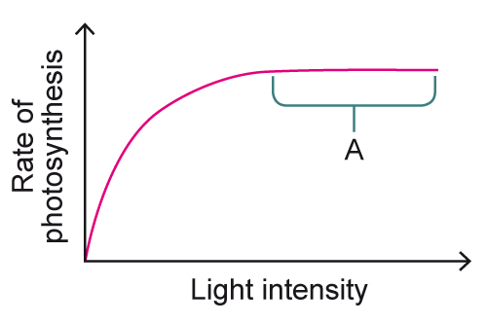

Which statement about region A on the graph is correct? [1 mark]

a) The plant is photosynthesising at its maximum rate

b) The plant cannot photosynthesise any more

c) The plant’s rate of photosynthesis has decreased

d) The plant’s rate of photosynthesis has increased

6. The building of large roads may cut through important habitats and lead to a lot of animals dying every year. One way to reduce the impact of building roads is to build animal crossings, like the one shown here.

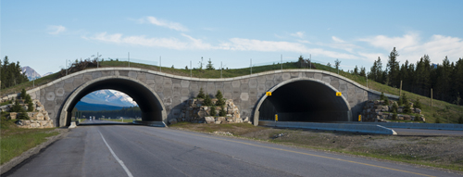

Some studies have shown that, when a crossing is built, the number of animals using it in the first year is very small but, over time, it increases. What is the least likely explanation for this? [1 mark]

a) Adults need to teach their young how to use the crossing which takes time

b) Animals need to get used to or learn how to use the crossing and this takes time

c) As there are not many crossings, animals are very cautious about using them at first

d) Animals prefer crossing using the tarmac of the road

**Matching**

8. Match the shape of the root systems to the function they are adapted to perform. [1 mark]

|  |  |  |
| --- | --- | --- |
| Deep and narrow |  | Support for large plants |
|  |  |  |
| Shallow and spread out |  | Obtaining water from fog and dew |
|  |  |  |
| Above the ground |  | Food and water storage |
|  |  |  |
| Swollen (tuberous) roots |  | Catching surface water |
|  |  |  |
| Thickened roots |  | To gain water from the water table |

10. Why are plants essential for humans? Choose two answers. [1 mark]

a) They can make sugars

b) Without plants we would not have carbon dioxide

c) Plants also take in nitrogen from the atmosphere

d) We can use plants as food, medicine and fuels

12. In recent years, there has been a decline in the numbers of bees and other insect pollinators. What is thought to be the cause of this and what are the consequences to humans if this trend continues? [2 marks]

14. Plants need a variety of minerals to be healthy. This plant's yellow foliage shows that it is at risk of dying due to a mineral deficiency.

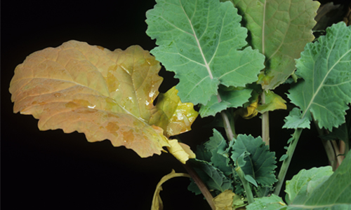

What mineral does it need and why? [2 marks]

15. An experiment was carried out to investigate the relationship between the rate of photosynthesis and the average amount of sucrose arrival in the roots. The results are displayed in the graph.

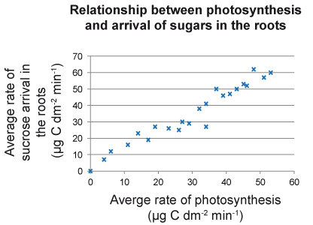

What does the graph show us? [2 marks]