**Additional Transpiration Questions**

**Name: ……………………………. Mark: ……/70 Grade: ……..**

**Q1.**          The diagram shows some cells from the tissues in a root.

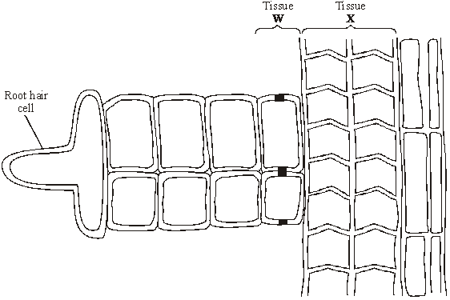

(a)     Name the tissues labelled **W** and **X**.

**W** ...................................................................

**X** .............................................................…....

**(2)**

(b)     Explain why water moves from the apoplast pathway to the symplast pathway when it reaches the tissue labelled **W**.

......................................................................................................................

......................................................................................................................

......................................................................................................................

......................................................................................................................

**(2)**

(c)     ATP is used at a high rate in the phloem tissue of roots. Explain what ATP is used for in phloem tissue.

......................................................................................................................

......................................................................................................................

......................................................................................................................

**(2)**

**(Total 6 marks)**

**Q2.**   The diagram shows part of a leaf. The arrows show one pathway taken by water through the leaf and into the atmosphere.

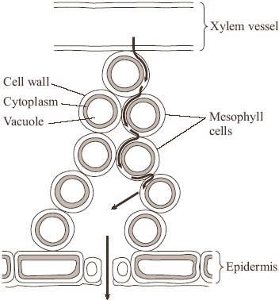

(a)     (i)      Name the pathway shown.

.............................................................................................................

**(1)**

(ii)     Describe and explain how water in the mesophyll cells passes out of the leaf.

.............................................................................................................

.............................................................................................................

.............................................................................................................

.............................................................................................................

.............................................................................................................

**(3)**

(b)     Explain how **two** adaptations of their leaves reduce water loss from xerophytes.

Adaptation....................................................................................................

Explanation...................................................................................................

......................................................................................................................

Adaptation.....................................................................................................

Explanation ..................................................................................................

......................................................................................................................

**(2)**

**(Total 6 marks)**

**Q3.**          (a)     **Figure 1** shows a section through the root of a young plant.

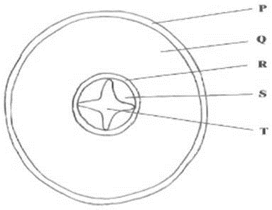

**Figure 1**

(i)      Name the part of the plant labelled **R**.

.............................................................................................................

**(1)**

(ii)     Give the letter which labels a tissue that transports solutes from the leaves.

Answer ......................................

**(1)**

(iii)     Give the letter which labels a tissue that prevents the movement of water through the apoplast pathway.

Answer ......................................

**(1)**

(b)     **Figure 2** shows a single stoma and surrounding cells from the leaf of a xerophytic plant.

**Figure 2**

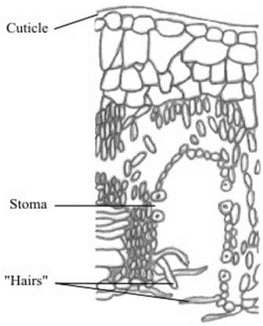

(i)      Explain how the cuticle reduces water loss.

.............................................................................................................

.............................................................................................................

**(1)**

(ii)     Explain how **one** of the other labelled parts reduces water loss.

.............................................................................................................

.............................................................................................................

.............................................................................................................

.............................................................................................................

**(2)**

**(Total 6 marks)**

**Q4.** A student investigated the rate of transpiration from a leafy shoot. She used a potometer to measure the rate of water uptake by the shoot. The diagram shows the potometer used by the student.

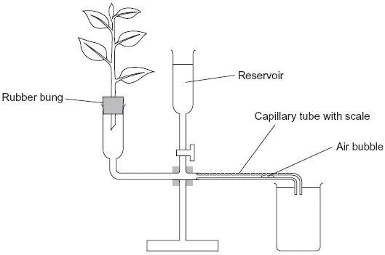

(a)     Give **one** environmental factor that the student should have kept constant during this investigation.

......................................................................................................................

**(1)**

(b)     The student cut the shoot and put it into the potometer under water. Explain why.

......................................................................................................................

......................................................................................................................

**(1)**

(c)     The student wanted to calculate the rate of water uptake by the shoot in cm3 per minute. What measurements did she need to make?

......................................................................................................................

......................................................................................................................

......................................................................................................................

......................................................................................................................

**(2)**

(d)     The student assumed that water uptake was equivalent to the rate of transpiration.

Gve **two** reasons why this might **not** be a valid assumption.

1 ...................................................................................................................

......................................................................................................................

2 ...................................................................................................................

......................................................................................................................

**(2)**

(e)     The student measured the rate of water uptake three times.

(i)      Suggest how the reservoir allows repeat measurements to be made.

.............................................................................................................

.............................................................................................................

**(1)**

(ii)     Suggest why she made repeat measurements.

.............................................................................................................

.............................................................................................................

**(1)**

**(Total 8 marks)**

**Q5.**          A student investigated the rate of transpiration from privet leaves.

•        She obtained two sets of ten privet leaves.

•        She left the ten leaves in set **A** untreated. She covered the upper surfaces of the ten leaves in set **B** with grease.

•        She weighed each set of leaves and then tied all the leaves in each set to a separate length of thread. This is shown in the diagram.

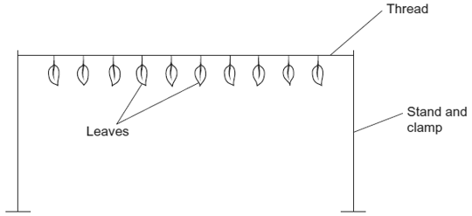

•        She then weighed each set of leaves every 20 minutes over a period of 2 hours and plotted a graph of her results.

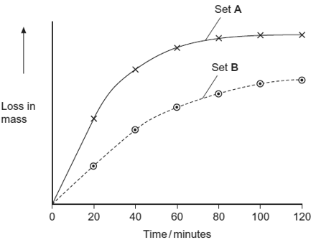

(a)Give **two** environmental conditions that the student should have kept constant during this investigation.

1 ...................................................................................................................

2 ...................................................................................................................

**(2)**

(b)The student measured the water loss in milligrams. Explain the advantage of using ten leaves when taking measurements in milligrams.

......................................................................................................................

......................................................................................................................

**(1)**

(c)Explain the change in mass of untreated leaves in set **A** shown in the graph.

......................................................................................................................

......................................................................................................................

......................................................................................................................

......................................................................................................................

......................................................................................................................

......................................................................................................................

*(Extra space) .*...............................................................................................

......................................................................................................................

......................................................................................................................

**(3)**

(d)The results that the student obtained for the leaves in set **B** were different from those for set **A**. Suggest an explanation for this difference.

......................................................................................................................

......................................................................................................................

......................................................................................................................

......................................................................................................................

......................................................................................................................

**(2)**

**(Total 8 marks)**

**Q6.**          (a)     Explain how water enters a plant root from the soil and travels through to the endodermis.

......................................................................................................................

......................................................................................................................

......................................................................................................................

......................................................................................................................

......................................................................................................................

......................................................................................................................

......................................................................................................................

......................................................................................................................

**(5)**

(b)     From the root, water is transported upwards through the stem. Explain how evaporation from the leaves can cause the water to move upwards.

......................................................................................................................

......................................................................................................................

......................................................................................................................

......................................................................................................................

......................................................................................................................

......................................................................................................................

**(4)**

**S** (c)     In daylight, most of the water evaporates from the leaves but some is used by the plant.

Describe the ways in which this water could be used by the plant.

......................................................................................................................

......................................................................................................................

......................................................................................................................

......................................................................................................................

......................................................................................................................

......................................................................................................................

......................................................................................................................

......................................................................................................................

......................................................................................................................

**(6)**

**(Total 15 marks)**

**Q7.**          (a)     Explain how xylem tissue is adapted for its function.

......................................................................................................................

......................................................................................................................

......................................................................................................................

......................................................................................................................

......................................................................................................................

......................................................................................................................

......................................................................................................................

**(4)**

(b)     The graph shows the flow rate in the xylem in the trunk of a tree.

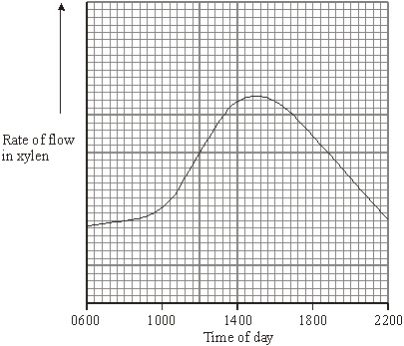

(i)      Explain the increase in the flow rate between 1000 and 1400 hours.

.............................................................................................................

.............................................................................................................

.............................................................................................................

**(2)**

(ii)     The diameter of the trunk decreased during the same period, reaching its minimum when the flow rate was highest. Use your knowledge of the cohesion-tension theory to suggest an explanation for this decrease.

.............................................................................................................

.............................................................................................................

.............................................................................................................

**(2)**

**(Total 8 marks)**

**Q8.**          (a)     The table shows the transpiration rate of a group of plants exposed to different humidities at a temperature of 25°C.

|  |  |
| --- | --- |
| **Humidity / %** | **Transpiration rate / arbitrary units** |
| 20 | 26.0 |
| 40 | 21.0 |
| 50 | 16.5 |
| 60 | 11.0 |
| 70 | 9.5 |

Describe and explain the relationship between humidity and transpiration rate.

......................................................................................................................

......................................................................................................................

......................................................................................................................

......................................................................................................................

......................................................................................................................

......................................................................................................................

**(3)**

**(Total 3 marks)**

**Q9.**          (a)     Students measured the rate of transpiration of a plant growing in a pot under different environmental conditions. Their results are shown in the table.

|  |  |
| --- | --- |
| **Conditions** | **Transpiration rate / g h–1** |
| **A**    Still air 15° | 1.2 |
| **B**    Moving air 15° | 1.7 |
| **C**    Still air 25° | 2.3 |

During transpiration, water diffuses from cells to the air surrounding a leaf.

(i)      Suggest an explanation for the difference in transpiration rate between conditions **A** and **B**.

.............................................................................................................

.............................................................................................................

.............................................................................................................

.............................................................................................................

.............................................................................................................

**(2)**

(ii)     Suggest an explanation for the difference in transpiration rate between conditions **A** and **C**.

.............................................................................................................

.............................................................................................................

.............................................................................................................

.............................................................................................................

.............................................................................................................

**(2)**

(b)     Scientists investigated the rate of water movement through the xylem of a twig from a tree over 24 hours. The graph shows their results. It also shows the light intensity for the same period of time.

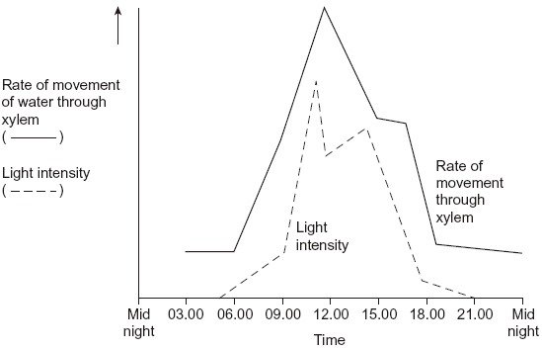

(i)      Describe the relationship between the rate of water movement through the xylem and the light intensity.

.............................................................................................................

.............................................................................................................

**(1)**

(ii)     Explain the change in the rate of water movement through the xylem between 06.00 and 12.00 hours.

.............................................................................................................

.............................................................................................................

.............................................................................................................

.............................................................................................................

**(2)**

(iii)     The scientists also measured the diameter of the trunk of the tree on which the twig had been growing. The diameter was less at 12.00 than it was at 03.00 hours.

Explain why the diameter was less at 12.00 hours.

.............................................................................................................

.............................................................................................................

.............................................................................................................

.............................................................................................................

.............................................................................................................

**(2)**

**(Total 9 marks)**