***AQA Immunity Booklet Answers***

**Pathogens**

A pathogen is a disease causing organism. Examples include bacteria, viruses, fungi and parasites.

**Non Specific Defence**

Our body can defend itself against pathogens in a non specific way. This includes the following methods:

(i)**Hydrochloric Acid**: Denatures the enzymes of most pathogens that enter the stomach.

(ii)**Epithelial Mucus:** Epithelial layers inside the body produce mucus that pathogens stick to.

(ii) **The skin:** Physical barrier that pathogens find it difficult to penetrate.

If a pathogen manages to make it through these defence mechanisms, it is unlikely to escape the *phagocytes,* a type of white blood cell that can undergo the pathogen destroying process known as *phagocytosis.* The following steps happen when a phagocyte comes into contact with a pathogen.



(i)The phagocyte is attracted to the pathogen by

chemoattractants.

(ii)The phagocyte binds to the pathogen.

(iii)The pathogen is engulfed by the phagocyte and is

isolated in a phagosome.

(iv) Lysosomes within the phagocyte migrate

towards the phagosome.

(v) The lysosomes release their lytic enzymes into

the phagosome, where they digest the pathogen.

(vi)The breakdown products of the pathogen are released by exocytosis or are displayed on the surface of the phagocyte

***Exam Question 1***

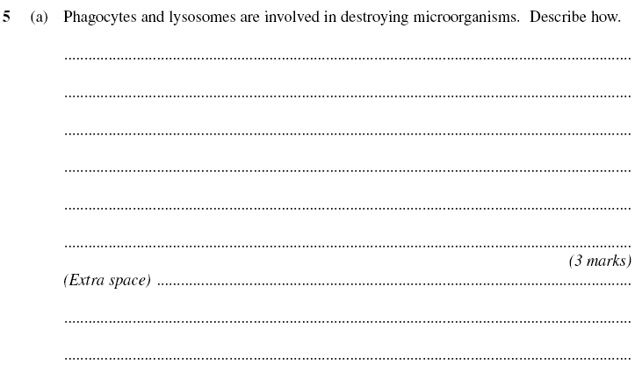

**Specific Defence**

Specific defence involves the *targeted* eradication of pathogens. This can only happen if our body can differentiate between pathogens and our own body cells.

**Antigens**

Antigens are foreign (non self) proteins that are normally displayed on the surface of a pathogen. Each type of pathogen has a different shaped antigen, but every pathogen of the same type has the same antigen. For example, vibrio cholorae (the bacteria responsible for cholera) displays a different shaped antigen to mycobacterium tuberculosis (the bacteria responsible for TB). But every vibrio cholorae pathogen displays the same antigen, as does every mycobacterium tuberculosis pathogen.

This is slightly complicated by the fact that members of the same virus *do not* all always display the exact same antigen. The influenza virus is a classic example. Each influenza virus that displays a different antigen is called a strain. This explains why you can still can get the flu despite having it a few weeks before.

Exam Question 2

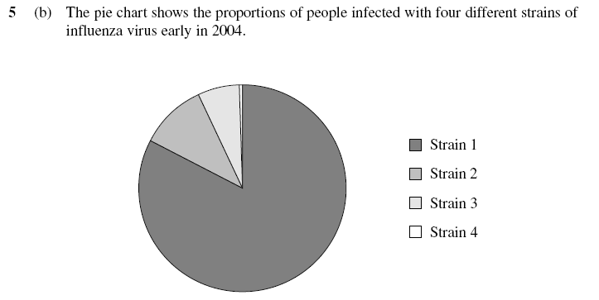

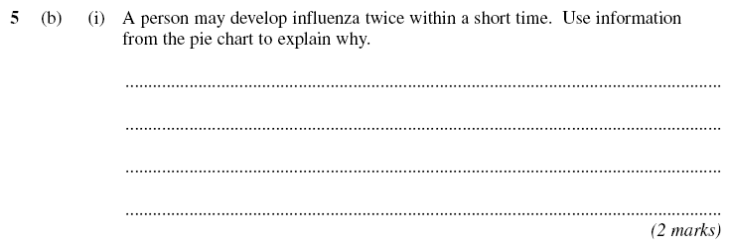

**Immunity**

When an antigen is recognised by a type of white blood cell known as a lymphocyte, the resulting process is known as *immunity,* the ability of our body to protect itself from a disease that we have already experienced. There are two interlinked types of immunity; *Cell mediated immunity* and *humoural immunity.*

**Cell Mediated Immunity**

*T lymphocytes* are important in cell mediated immunity. Known simply as T-cells, they respond to foreign antigens that are attached to pathogens or the body’s own cells. The following diagram explains how a T helper cell becomes activated:

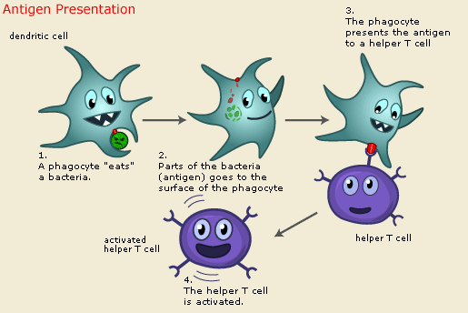

Receptor on the

T helper cell fits perfectly onto the antigen

When activated, the T helper cell divides rapidly by mitosis, forming clones of itself with identical receptors. The cloned T cells then:

1. develop into memory cells that enable a rapid response to future infections of the same pathogen
2. stimulate b lymphocyte production (important in *humoural* immunity)
3. kill infected cells by making a protein that causes lysis of the cell’s surface membrane.

**Humoural Immunity**

Another type of white blood cell, the *B-lymphocyte* or *B cell* for short, is responsible for humoural immunity. When an antigen is encountered by a B cell, the following steps take place, leading to the production of *memory cells* and *antibodies:*

1. The surface antigens of the invading pathogen are taken up by B Cells.
2. These antigens are then presented on the B cell’s surface.
3. T helper cells attach to these processed antigens, activating B cells to divide by mitosis into clones known as *plasma cells*.
4. These plasma cells produce antibodies that are *complimentary* to the antigen.
5. These antibodies attach to antigens on the pathogen and destroy them. This is the *primary* response and as it takes time, the individual will suffer from symptoms of the disease.
6. Some B cells develop into memory cells. These cells divide rapidly and turn into antibody producing plasma cells when our body is infected later by the same pathogen. This is the *secondary* response and the pathogen is destroyed before it can cause any symptoms.

**Antibodies**

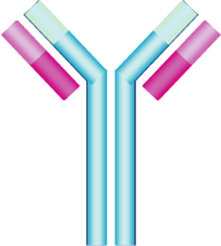

Antibodies are released by B cells in response to a specific

antigen. They are a protein made of four chains. The two

longest chains are called *heavy chains.* The two short

chains are called *light chains.* The *antigen binding site* is

at the top of the Y shape and is also known as the *variable*

*region* because it is different on different antibodies. The

rest of the Y shape is called the constant region because

it is exactly the same for every antibody.

Monoclonal Antibodies are antibodies that are produced from a single clone of B cells.

They can be made in the laboratory using the following method:

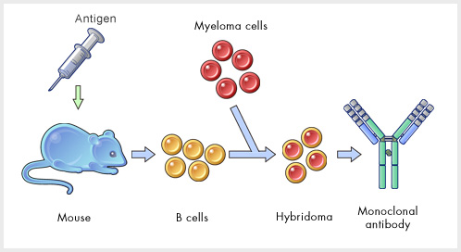

**Vaccination**

Passive immunity is produced by introducing antibodies from an outside source (e.g. monoclonal antibodies). This immunity is short lived. Active immunity is produced by stimulating the body to produce its own antibodies (e.g. vaccination). This is long-lasting.

Vaccination involves the introduction into the body of a vaccine containing a dead or attenuated pathogen or a toxin. The antigens are recognised by the body and an immune response occurs. Memory cells are made during this process which remain dormant in the body, ready to divide rapidly when they come into contact with the same antigen.

If you vaccinate every member of the population against a disease you should be able to eradicate it. Here are a few reasons why vaccination does not eliminate a disease

1. The pathogen may mutate frequently so that its antigens change. This is called antigenic variability. The influenza virus and cholera bacterium is capable of doing this. The body will not have memory cells for the new antigens and so is not immune.
2. There is often many different varieties or strains of a particular pathogen each with their own unique shape of antigen. There is around 100 strains of the common cold virus for example.
3. Certain pathogens hide from the immune system e.g. inside cells or within the intestines.
4. Some people object to vaccination for religious or ethical reasons.

Exam Question 3



**Answers to Exam Questions**

**Question 1**

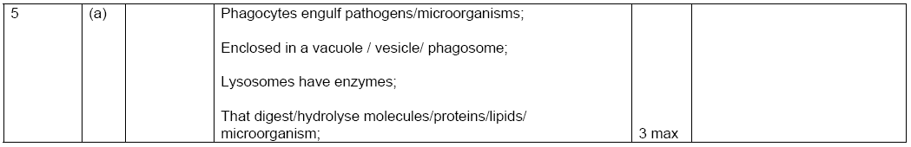

**Question 2**



**Question 3**

