# Section Check In –

# EL: Exponentials and Logarithms

## Questions

1. Solve the equation . [EL6]

2. Evaluate . [EL2,3]

3. Solve the simultaneous equations

,   . [EL2,3,6]

4. Determine the value of *x* in the equation . [EL2,3,6]

5. Express  as a single logarithm. [EL3]

6. Simplify the following:

(i) 

(ii) 

(iii)  [EL3]

7. The graph of  against is a straight line passing through the points

(2, 8) and (0,2).

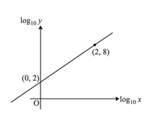

(i) Find the equation relating  against 

(ii) Hence, find the equation relating *y* and *x*. [EL4,5]

8. On the same axes, sketch the curves  and , clearly identifying each curve and any points where the curves cross the axis. [EL1]

9. The average number of visitors per month at a local museum between the year 2000 and 2005 is shown below.

|  |  |  |  |  |  |  |
| --- | --- | --- | --- | --- | --- | --- |
| Year | 2000 | 2001 | 2002 | 2003 | 2004 | 2005 |
| Average number of visitors per month | 350 | 455 | 585 | 761 | 989 | 1285 |

The average number of visitors per month can be modelled by an equation of the form , where is the number of years after 2000.

(i) Using base 10, show that this equation can be written as .

(ii) Fill in the table below and draw a graph to plot  against .

|  |  |  |  |  |  |  |
| --- | --- | --- | --- | --- | --- | --- |
|  | 0 | 1 | 2 | 3 | 4 | 5 |
|  |  |  |  |  |  |  |

(iii) Draw a line of best fit on your graph and use it to estimate the values of  and .

(iv) Use your values of  and  to predict the average number of visitors per month in the year 2010. Comment on the reliability of this estimate. [EL4,5,7]

10. Solve the equation , giving your answer in the form . [EL3,7]

**Extension**

As a rule,  and .

Solve the equation , giving exact values for .

For each of these values of , find the value of  so that .

## Worked solutions

1. 





 (3 s.f.)

2. 





3.  EX (1)

 EX (2) 







 

4. 







5. 

6. (i) 1

(ii) 0

(iii) 1

7. (i)  , 

 , 



(ii) 





8.



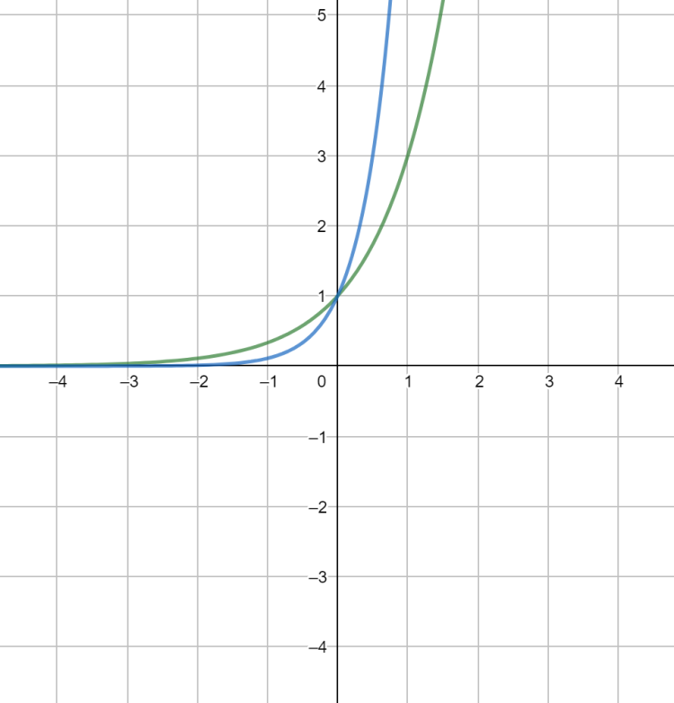





9. (i) 







(ii)

|  |  |  |  |  |  |  |
| --- | --- | --- | --- | --- | --- | --- |
|  | 0 | 1 | 2 | 3 | 4 | 5 |
|  | 2.54 | 2.66 | 2.77 | 2.88 | 3.00 | 3.11 |

(ii) and (iii)

log *n*

*x*

Intercept is  so 

Gradient is  so 

(iv) In 2010,  and .

This is extrapolation. 2010 is 5 years after the data given. The museum may not have the capacity for 4825 visitors per month or it may close or change etc. The figure is not reliable.

10. 











**Extension**





Let 











So 



If 





This is not possible for any value of .

If 

















If 















 This is a negative value so is not a solution of the original equation.

**OCR Resources**: *the small print*OCR’s resources are provided to support the delivery of OCR qualifications, but in no way constitute an endorsed teaching method that is required by the Board, and the decision to use them lies with the individual teacher. Whilst every effort is made to ensure the accuracy of the content, OCR cannot be held responsible for any errors or omissions within these resources.

© OCR 2019 - This resource may be freely copied and distributed, as long as the OCR logo and this message remain intact and OCR is acknowledged as the originator of this work.

OCR acknowledges the use of the following content: n/a

Please get in touch if you want to discuss the accessibility of resources we offer to support delivery of our qualifications: [resources.feedback@ocr.org.uk](mailto:resources.feedback@ocr.org.uk)

We’d like to know your view on the resources we produce. By clicking on [‘Like’](mailto:resources.feedback@ocr.org.uk?subject=I%20liked%20the%20FSMQ%20Check%20In:%20Exponentials%20and%20logarithms) or [‘Dislike’](mailto:resources.feedback@ocr.org.uk?subject=I%20disliked%20the%20FSMQ%20Check%20In:%20Exponentials%20and%20logarithms) you can help us to ensure that our resources work for you. When the email template pops up please add additional comments if you wish and then just click ‘Send’. Thank you.

Whether you already offer OCR qualifications, are new to OCR, or are considering switching from your current provider/awarding organisation, you can request more information by completing the Expression of Interest form which can be found here: [www.ocr.org.uk/expression-of-interest](http://www.ocr.org.uk/expression-of-interest)

Looking for a resource? There is now a quick and easy search tool to help find free resources for your qualification:   
[www.ocr.org.uk/i-want-to/find-resources/](http://www.ocr.org.uk/i-want-to/find-resources/)