A Level Music
AoS2 Popular Song

Some useful articulations in Jazz/Swing instrumental playing.
Info largely taken from: www.timusic.net/debreved/jazz-notation/

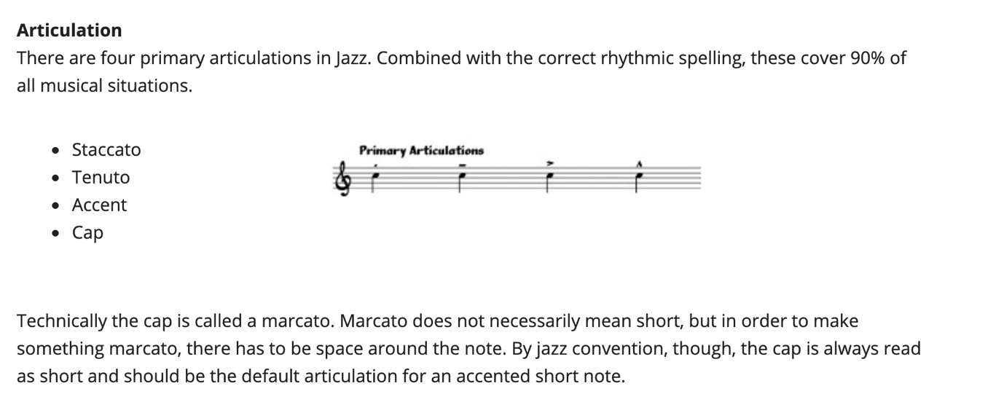

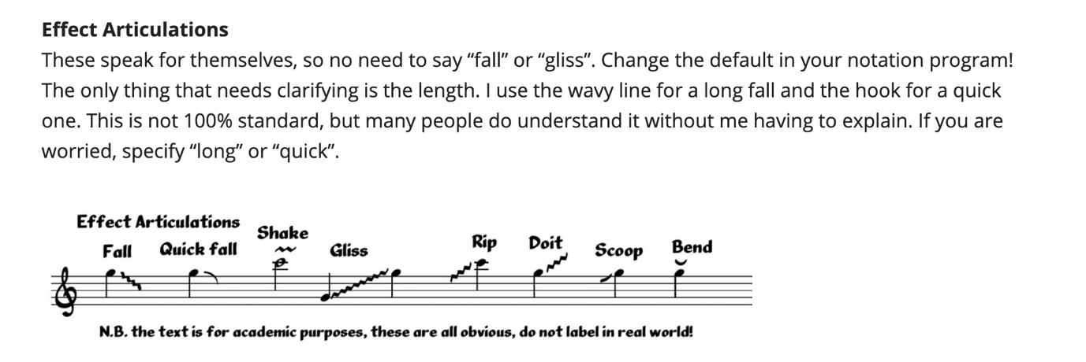

Dynamics
pp, p, mp, mf, f, ff
