**Ways to start a sentence and/or show off your style... Creative Writing**

***Waiting for the Train***

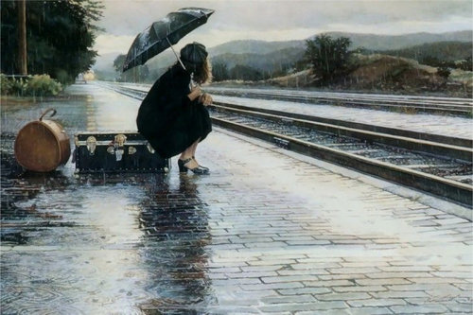

|  |  |
| --- | --- |
| **Technique** | **Example(s)** |
| **1. Opening Connective** | *While she sat waiting on the bursting suitcase, the rain began to drum on top of her umbrella.*  *As she waited, she stared across the top of the mist-shrouded hills and dreamt of home.* |
| **2. Active participle** | *Leaping to her feet, she waved frantically at the confused driver.*  *Kicking the trunk in frustration, she watched the slowly disappearing dot of the train.* |
| **3. Passive participle** | *Stirred from her daydream, she turned to face the mysterious stranger approaching her.* |
| **4. Time Adverbial** | *Minutes later, the horizon remained empty – when would the 10.33 finally arrive?* |
| **5. Place Adverbial** | *Out of the corner of her eye, she suddenly sensed a movement behind her.* |
| **6. Adverb** | *Frantically, she waved her arms at the conductor.* |
| **7. Simile** | *Like a distorted mirror, the wet platform held her shape.* |
| **8. Thoughts /  R Questions** | *Who was he? What did he want?  (see also end of 4)* |
| **9. Dialogue** | *“I’ve been expecting you,” remarked the cloaked figure.* |
| **10. Fragment** | *Silence. Just the slow whisper of the wind.* |