Distillation Using a Liebig Condenser
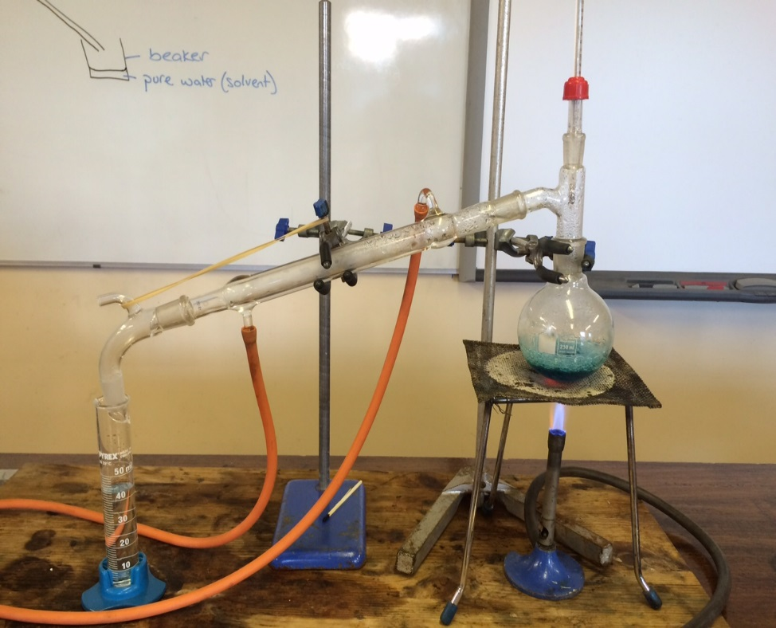
Diagram of Simple Distillation (NB no water jacket around the delivery tube)
