Explaining Chemical Changes (Blue level)

1. Which of the following turns litmus solution red? [1 mark]

a) Table salt

b) Lemon juice

c) Toothpaste

d) Baking powder

2. There are several clues that a chemical reaction has happened. Which two of the following observations are true for the reaction of any acid with any reactive metal? [1 mark]

a) Bubbles of gas are given off

b) A colour change

c) A change in temperature

d) A smelly gas is produced

3. Choose two reasons why putting a fire blanket over a small fire is a good way of dealing with it. [2 marks]

a) The blanket removes the oxygen

b) The blanket insulates people from the heat

c) The blanket is good at mopping up the mess

d) The fire blanket can be reused

4. Look at this picture of a metal reacting with an acid. What evidence is there that a reaction is taking place? [2 marks]

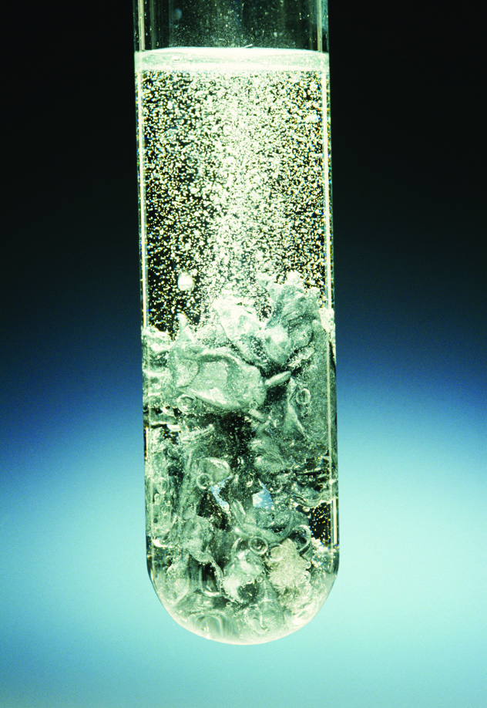

5. Stacey has made an indicator by boiling onion skins in water and filtering the mixture to provide a liquid. Describe how she could then test her indicator to see how well it works. [4 marks]

6. Describe the pH changes when an acid is neutralised by adding alkali to it. [2 marks]

7. Describe what you would see if a piece of magnesium ribbon was put into dilute hydrochloric acid. [2 marks]

10. Tom tests a clear liquid in the lab with universal indicator solution, which turns green. He says that this shows that the liquid is neutral, water and safe to drink. Is he right? [4 marks]

11. Calcium carbonate is added to hydrochloric acid in a flask on a balance. As time passes, the mass is recorded and displayed on a graph. The graph is shown below. Explain what is happening and why. [4 marks]

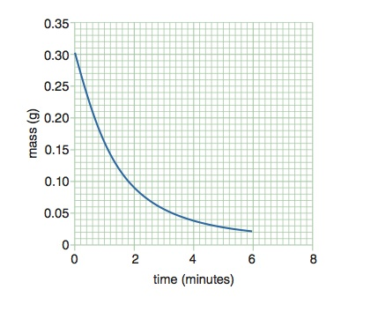

12. Explain why combustion can lead to air pollution. [4 marks]

TOTAL_____/30