**Year 7 Energy Transfers and Sound Practice Questions**(the answers are at the end of the questions)

**Q1.** The drawing below shows a garden water feature. It is solar-powered.

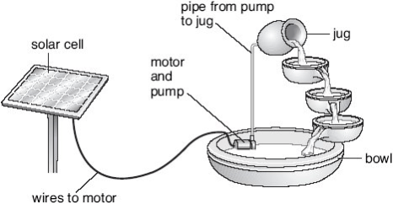

          The solar cell absorbs energy from the Sun.  
The solar cell is connected to a motor in the bowl.  
The motor drives a pump.  
Water is pumped up to the jug and it flows back down to the bowl.

(a)     Use the information above to help you to complete the following sentences.  
Choose words from the list.

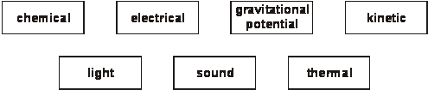

(i)      The useful energy change in the solar cell is from light to ....................................... energy.

1 mark

(ii)     The useful energy change in the motor is from electrical energy to ............................. energy.

1 mark

(iii)     As the water flows from the jug to the bowl ....................................... energy is changed into .................................... energy.

2 marks

(b)     Give **one** advantage and **one** disadvantage of using a solar cell to power the  
water feature.

advantage .................................................................................................... 1 mark

disadvantage ................................................................................................ 1 mark

maximum 6 marks

**Q2.** Luke investigated the heating of water. He predicted that the rise in temperature would depend on the volume of water. The diagram shows the apparatus he used.

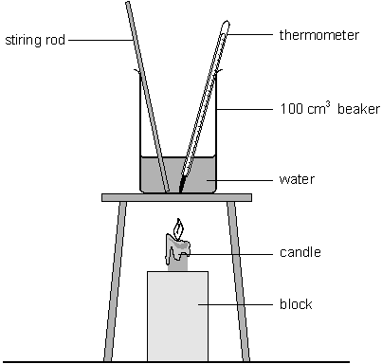

Luke recorded his results in a table as shown below.

|  |  |  |  |
| --- | --- | --- | --- |
| **beaker** | **volume of water, in cm3** | **temperature at start, in °C** | **temperature after 2 minutes, in °C** |
| A | 25 | 18 | 30 |
| B | 50 | 18 | 24 |
| C | 75 | 18 | 22 |

(a)     Why did Luke need to know the temperature of the water at the beginning and at the end of the experiment?

.....................................................................................................................

..................................................................................................................... 1 mark

(b*)*     Did Luke’s results support his prediction? Explain your answer.

.....................................................................................................................

..................................................................................................................... 1 mark

(c)     Luke stirred the water during the experiment. How did this make his results more reliable?

.....................................................................................................................

.....................................................................................................................1 mark

(d)     Which of the following statements about the energy transferred to the beakers is correct?  
Tick the correct box.

|  |  |
| --- | --- |
| Much more energy went into beaker ‘A’ because its temperature increased the most. |  |
| The same amount of energy went into all three beakers. |  |
| Beaker ‘C’ received the most energy because there was more water to heat. |  |

1 mark

(e)     After a time, all three beakers cooled down to room temperature.  
What happened to the thermal energy in the beakers as they cooled down?

.....................................................................................................................

..................................................................................................................... 1 mark

Maximum 5 marks

**Q3.** A bookshelf is 1 metre above the floor. As a book falls from the shelf to the floor it loses 7.5 J of **potential** energy.

(a)     (i)      Tick the box by the correct statement about the **kinetic** energy of the book.

|  |  |
| --- | --- |
| While the book was resting on the shelf it had 7.5 J of kinetic energy. |  |
| While the book was falling, its potential energy was being transformed into kinetic energy. |  |
| While the book was falling, its kinetic energy remained constant. |  |
| While the book was falling, it lost kinetic energy. |  |

1 mark

(ii)     How much **kinetic** energy does the book have just before it hits the floor?

.......................................................................................................... J 1 mark

(b)     When the book hits the floor it stops and loses all its kinetic energy. What happens to this energy?

.....................................................................................................................

..................................................................................................................... 1 mark

Maximum 3 marks

**Q4.** A flywheel is a rotating wheel which is used to store energy.

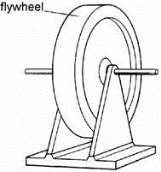

(a)     Energy must be transferred to a flywheel to make it rotate. How is the energy in the rotating flywheel classified? Tick the correct box.

as chemical energy             as potential energy



as kinetic energy                 as thermal energy



1 mark

(b)     A flywheel is rotating at a high speed. No energy is being supplied to it. The flywheel is used to turn a dynamo, and the energy from the dynamo is used to light a bulb.

(i)      The bulb is left connected until the flywheel stops rotating. Not all the energy stored in the flywheel is transferred to the bulb. Some of it is lost. Give **one** place from which it is lost, and explain how it is lost.

Lost from:  ........................................................................................................

..............................................................................................................

By:   ........................................................................................................

..............................................................................................................

2 marks

(ii)     The experiment is repeated using a different bulb which gives out more energy each second. Compared to the first light bulb, describe how the second light bulb will affect the motion of the flywheel, and explain your answer.

.............................................................................................................

.............................................................................................................

.............................................................................................................

.............................................................................................................

2 marks

Maximum 5 marks

**Q5.** The pictures show six different household appliances.

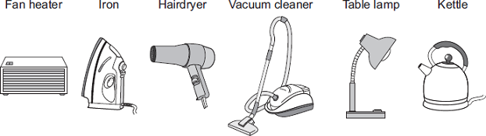

(a)     Four of the appliances, including the fan heater, are designed to transform electrical energy into heat.

Name the other **three** appliances designed to transform electrical energy into heat.

1 ........................................................................................................................

2 ........................................................................................................................

3 ........................................................................................................................ **(3)**

(b)     The bar chart shows the power of three electric kettles, **X**, **Y** and **Z**.

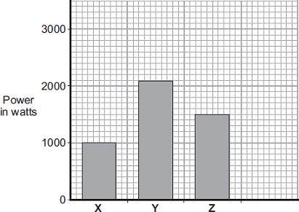

Kettle

(i)      In one week, each kettle is used for a total of 30 minutes. Which kettle costs the most to use? Put a tick ( ) next to your answer.



|  |  |
| --- | --- |
| **X** |  |
| **Y** |  |
| **Y** |  |

**1)**

(ii)     A new ‘express boil’ kettle boils water faster than any other kettle.

Draw a fourth bar on the chart to show the possible power of an ‘express boil’ kettle.

**(1)**

(c)     The graph shows how the time to boil water in an electric kettle depends on the volume of water in the kettle.

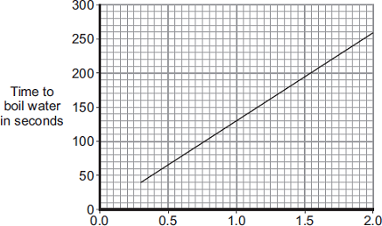

                            Volume of water in litres

A householder always fills the electric kettle to the top, even when only enough boiling water for one small cup of coffee is wanted.

Explain how the householder is wasting money.

........................................................................................................................

........................................................................................................................

........................................................................................................................

........................................................................................................................

........................................................................................................................

........................................................................................................................

**(3)**

**(Total 8 marks)**

**Q6.** The diagram below shows part of the human ear.

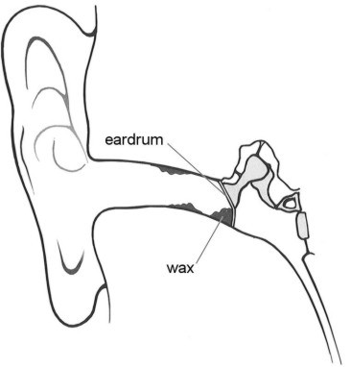

          We can hear somebody speaking because sound waves enter our ears.

(a)     (i)      What do our eardrums do when sound waves reach them?

............................................................................................................. 1 mark

(ii)     Sometimes a lot of wax is produced in the ear.  
The wax rests against the eardrum, as shown above.

         Give **one** reason why we **cannot** hear very well when our ears   
contain a lot of wax.

.............................................................................................................

............................................................................................................. 1 mark

(b)     The table below shows the lowest and highest frequencies that five living things can hear.

|  |  |  |
| --- | --- | --- |
| **living thing** | **lowest frequency (Hz)** | **highest frequency (Hz)** |
| human | 20 | 20 000 |
| sparrow | 300 | 20 000 |
| dog | 20 | 45 000 |
| cat | 20 | 64 000 |
| rabbit | 300 | 42 000 |

(i)      Which **three** living things from the table **cannot** hear a frequency of  
43 000 Hz?

.............................. and .............................. and .............................. 1 mark

(ii)     From the table, choose the living thing that can hear the biggest **range** of frequencies.

............................................................. 1 mark

maximum 4 marks

**Q7.** The dotar is a musical instrument with two strings.

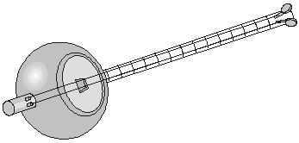

(a)     Aftal plays the dotar very quietly. What must he do to the strings to make a louder sound?

.........................................................................................................................

......................................................................................................................... 1 mark

(b)     Aftal makes the strings tighter so they vibrate more quickly. How does this affect the sound produced by the strings? Tick the correct box.

       The sound has a lower pitch.



       The sound is louder.



       The sound has a higher pitch.



       The sound is quieter.



1 mark

(c)     One of the strings is thicker than the other, so it vibrates more slowly. In what way is the sound made by the thicker string different from the sound made by the thinner string?

......................................................................................................................... 1 mark

(d)     Aftal played the dotar near a microphone connected to an oscilloscope.  
The diagrams below show the patterns made by four sounds.

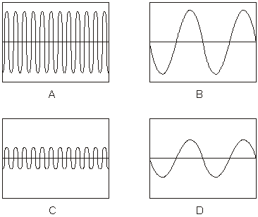

(i)      How does the sound shown in trace A differ from the sound in trace B?

...............................................................................................................

............................................................................................................... 1 mark

(ii)     How does the sound shown in trace A differ from the sound in trace C?

...............................................................................................................

.............................................................................................................1 mark

maximum 5 marks

**Q8.** (a)     The diagrams below show the patterns produced on an oscilloscope by three  
 different sound waves.

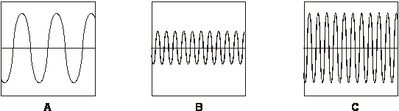

(i)      Which **two** waves have the same loudness? Write the letters.

............ and ............

         How do the diagrams show this?

...............................................................................................................

............................................................................................................... 1 mark

(ii)     Which **two** waves have the same pitch? Write the letters.

............ and ............

         How do the diagrams show this?

...............................................................................................................

............................................................................................................... 1 mark

(iii)     Shuli is listening to a sound that produces the pattern below.

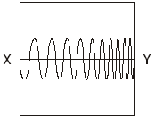

         Describe how the sound that Shuli **hears** changes between X and Y.

............................................................................................................... 1 mark

(b)     The table below shows the maximum time a person can listen to music at  
different sound levels without damage to the ear.

|  |  |
| --- | --- |
| **sound level (decibels)** | **maximum time (hours)** |
| 86 | 8 |
| 88 | 4 |
| 90 | 2 |
| 92 | 1 |
| 94 | 0.5 |

          Estimate the maximum time a person could listen to a sound of 87 decibels.

............ hours

1 mark

(c)     The diagram below shows part of the human ear.

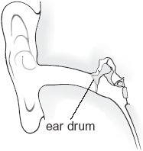

          What happens to the ear drum as a sound gets louder?

........................................................................................................................

........................................................................................................................

1 mark

maximum 5 marks

**End of practice questions**

Mark schemes

**Q1.** (a)     (i)      electrical

**1 (L5)**

(ii)     kinetic *accept ‘movement’*

**1 (L6)**

(iii)     •    gravitational potential *accept ‘gravitational’* ***or*** *‘potential’*

**1 (L6)**

•    kinetic **or** sound **or** thermal *accept ‘heat’ for thermal*

*accept for two marks ‘kinetic into sound’****or****’kinetic into thermal’*

*answers must be in the correct order*

**1**

(b)     *advantage*

•    the energy will always be replaced *accept ‘it will not run out’*

•    it is renewable *accept ‘it does not use fuel* ***or*** *mains electricity’*

•    it is free to run *accept ‘it is cheap’*

•    a battery might leak *accept ‘no pollution with a solar cell’*

**1 (L5)**

*disadvantage*

•    if the Sun goes in the pump will stop

•    it will not work at night **or** in the dark *accept ‘it must be in the Sun to work’*

*accept ‘it is not sunny all the time’ do* ***not*** *accept* *‘can be used again’*

**1 (L5) [6**

**Q2.** (a)     any **one** from

•    to see how much the temperature went up

•    to work out the temperature rise *do* ***not*** *accept ‘to make it a fair test’*

**1 (L5)**

(b)     any **one** from

•    yes because the smaller the volume the greater the rise in temperature

•    yes because the greater the volume the smaller the rise in temperature

**1 (L5)**

(c)     any **one** from

•    it distributed the hot water throughout the beaker

•    it made sure the water was heated evenly

•    to make sure the temperature of the water was the same throughout

*do* ***not*** *accept* *‘the water heats up more quickly’*

**1 (L5)**

(d)     The same amount of energy went into all three beakers.



*if more than one box is ticked, award no mark*

**1 (L6)**

(e)     any **one** from

•    it decreased **or** got less *accept ‘it leaked out’* ***or*** *‘it was lost’  
accept ‘it evaporated some of the water’*

•    it was transferred to the surroundings *accept ‘it heated up the air’*

**1 (L6)**

**[5]**

**Q3.** (a)     (i)      While the book was falling, its potential energy was  
being transformed into kinetic energy.

*ie a √  in the second box down  
if more than one box is ticked award no mark*

**1**

(ii)     7.5 **or** just under 7.5

**1**

(b)     any **one** from

•    transferred to the surroundings **or** spread out into the surroundings

*accept ‘goes into the floor* ***or*** *atmosphere’*

•    turned to thermal energy

*accept ‘sound’ do* ***not*** *accept ‘light’  
do* ***not*** *accept ‘it has changed’*

**1**

**[3]**

**Q4.** (a)     as kinetic energy   *if more than one box is ticked, award no mark*



**1 (L6)**

(b)     (i)      **both the place and the method by which energy is lost are  
required for each mark**

*answers may be in either order*

•    from the axle **or** bearings by heat **or** sound *accept ‘from the bearing by friction’****or*** *‘the bearings get hot* ***or*** *‘from the axle when it squeaks’*

**1 (L7)**

•    from the wires by heat *accept ‘the wires get hot’*

*accept ‘from the dynamo as heat* ***or*** *sound’****or*** *‘from the dynamo when it gets hot* ***or*** *squeaks’  
do* ***not*** *accept ‘goes into the air as heat* ***or*** *sound’* **1 (L7)**

(ii)     it slows down more quickly

*accept ‘it rotates for a shorter time’*

*do* ***not*** *accept ‘it slows down’*

**1 (L7)**

because it transfers energy to the bulb more quickly

*accept ‘because it transfers more energy to the bulb’  
do* ***not*** *accept ‘because it transfers energy to the bulb’*

**1 (L7)**

**[5]**

**Q5.** (a)     iron

**1**

hairdryer

**1**

kettle

**1**

*answers can be in any order*

(b)     (i)       **Y**

**1**

(ii)      bar drawn with any height greater than **Y** *ignore width of bar*

**1**

(c)     (bigger volume) takes more time (to boil)

*accept explanation using data from graph*

**1**

(so) more energy transferred

*do* ***not*** *accept electricity for energy*

**1**

(and) this costs more money

*ignore reference to cost of water*

*wasting more money because heating more water than needed is insufficient*

**1**

**[8]**

**Q6.** (a)     (i)      vibrate *accept ‘move in and out’ ‘move’ is insufficient* **1 (L4)**

(ii)     any **one** from

•    it stops the sound waves **or** vibrations reaching our eardrums

*accept ‘it stops sound reaching our eardrum’*

*accept ‘it absorbs sound’*

*accept ‘it blocks the ear’*

•    it stops the eardrum vibrating *accept ‘it stops the eardrum moving in and out’*

•    the eardrum vibrates less *accept ‘soundwaves are reflected by the wax’*

**1 (L3)**

(b)     (i)      human *and* sparrow *and* rabbit *answers may be in any order*

*accept ‘bird’ for sparrow****all three*** *answers are required for the mark*

**1 (L4)**

(ii)     cat

**1 (L4)**

**[4]**

**Q7.** (a)     pluck them harder

*‘make the strings vibrate more* ***or*** *move more*

*do* ***not*** *accept ‘make the strings vibrate more quickly’*

**1 (L5)**

(b)     The sound has a higher pitch



*if more than one box is ticked, award no mark*

**1 (L5)**

(c)     the sound from the thicker string has a lower pitch **or** a lower frequency

*accept ‘it has a lower pitch* ***or*** *a lower frequency’  
accept ‘the sound from the thicker string is louder****or*** *‘it is louder’*

*answers must include a comparison  
‘it is lower’ is insufficient*

**1 (L5)**

(d)     (i)      the sound in A has a higher pitch **or** a higher frequency

*accept’ it has a higher pitch* ***or*** *higher frequency’*

*answers must show a comparison   
‘the vibrations are quicker’ is insufficient   
‘it is higher’ is insufficient*

**1 (L6)**

(ii)     the sound in A is louder

*accept ‘it is louder’  
accept ‘the sound in C is quieter’  
accept ‘it has a greater amplitude’*

*‘the vibrations are stronger****or*** *of greater amplitude’ is insufficient   
do* ***not*** *accept ‘it is higher’*

**1 (L6)**

**[5]**

**Q8.** (a)     (i)      •    A *and* C *letters may be in either order****both*** *the letter and the correct explanation are required for the mark*

     their amplitudes are the same

*accept ‘the waves are the same height’*

*‘the height of the waves’ is insufficient*

*accept ‘they are equally tall’*

*‘they are big* ***or*** *tall’ is insufficient  
‘taller waves are louder’ is insufficient  
do* ***not*** *accept ‘they are equally long’*

**1 (L6)**

(ii)     •    B *and* C *letters may be in either order****both*** *the letter and the correct explanation  
are required for the mark*

     their frequencies are the same

*accept ‘the waves are the same distance apart’*

*‘the distance apart of the waves’ is insufficient  
‘the less spaced out the waves,  
the higher the pitch’ is insufficient*

*accept ‘the wave lengths are the same’*

*‘they are the same length* ***or*** *thickness* ***or*** *width’ is insufficient*

*accept ‘there are the same number of waves’*

**1 (L6)**

(iii)     •    its pitch becomes higher *accept ‘the frequency gets higher’*

*‘it gets higher’ is insufficient  
‘it becomes high’ is insufficient*

**1 (L6)**

(b)     •    any number between 4.5 and 7.5 *hours* (inclusive)

**1 (L5)**

(c)     any **one** from

•    it vibrates with a greater amplitude

*accept ‘it moves more’*

•    it has larger vibrations *accept ‘burst ear drum’*

*‘it vibrates harder’ and ‘it vibrates more’  
are insufficient responses  
do* ***not*** *accept ‘it vibrates faster’*

**1 (L5)**

**[5]**