Chemicals in the Home

Safety hazard symbols are used everyday to warn us of danger. See what symbols you can find at home or when you go shopping. Record your results in the following table.

Item | Symbols | Hazard | Precaution | Action if spilt
Tippex | 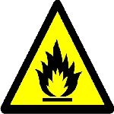 | Highly flammable | Keep away from naked flames | Wash off with water

