|  |  |  |  |
| --- | --- | --- | --- |
| **0** | **1** |  |  |

Phosphates are used in fertilisers to improve plant growth.

|  |  |  |  |
| --- | --- | --- | --- |
| **0** | **1** | **.** | **1** |

Why can mined phosphate rock **not** be used as a fertiliser?

Tick (✓) **one** box.

There is no nitrate in phosphate rock.

Phosphate rock is insoluble in water.

Plants do not need phosphate.

The mining process causes pollution. (*1 mark*)

|  |  |  |  |
| --- | --- | --- | --- |
| **0** | **1** | **.** | **2** |

Link the acids that can change phosphate rock into useful fertiliser salts to the names of the substances they produce.

Draw **two** lines.

|  |  |  |
| --- | --- | --- |
| Acid |  | Substances produced |
|  |  |  |
|  |  | calcium nitrate and phosphoric acid |
| nitric acid |  |  |
|  |  | calcium phosphate only |
| sulfuric acid |  |  |
|  |  | calcium phosphate and calcium sulfate |

(*2 marks*)

|  |  |  |  |
| --- | --- | --- | --- |
| **0** | **1** | **.** | **3** |

Ammonium sulfate is also used in fertilisers. It can be made in the laboratory or in chemical factories (**Table 1**).

**Table 1**

|  |  |
| --- | --- |
| Laboratory process | Factory process |
| * carried out with dilute reactants at room temperature * uses glass apparatus * makes a few grams of product in batches over several days * allows the energy from the reaction to be lost into the surroundings. | * uses concentrated reactants at 60°C * uses stainless steel reaction vessels and pipework * makes many tonnes of product each day in a continuous process * transfers the energy from the reaction to other processes in the factory. |

Which **two** statements explain why the factory process is used for fertiliser production rather than the laboratory process?

Tick (✓) **two** boxes.

The factory process is safer.

The laboratory process is simpler.

The factory process produces more fertiliser each day.

The demand for fertilisers is high.

The laboratory process wastes less energy. (*2 marks*)

|  |  |  |  |
| --- | --- | --- | --- |
| **0** | **2** |  |  |

In 1909 Fritz Haber invented a process to produce ammonia from nitrogen and hydrogen.

|  |  |  |  |
| --- | --- | --- | --- |
| **0** | **2** | **.** | **1** |

Complete the word equation for this process, showing that the reaction is reversible.

nitrogen  hydrogen (*1 mark*)

|  |  |  |  |
| --- | --- | --- | --- |
| **0** | **2** | **.** | **2** |

**Figure 1** shows how the yield of ammonia at 300°C changes with pressure.

**Figure 1**

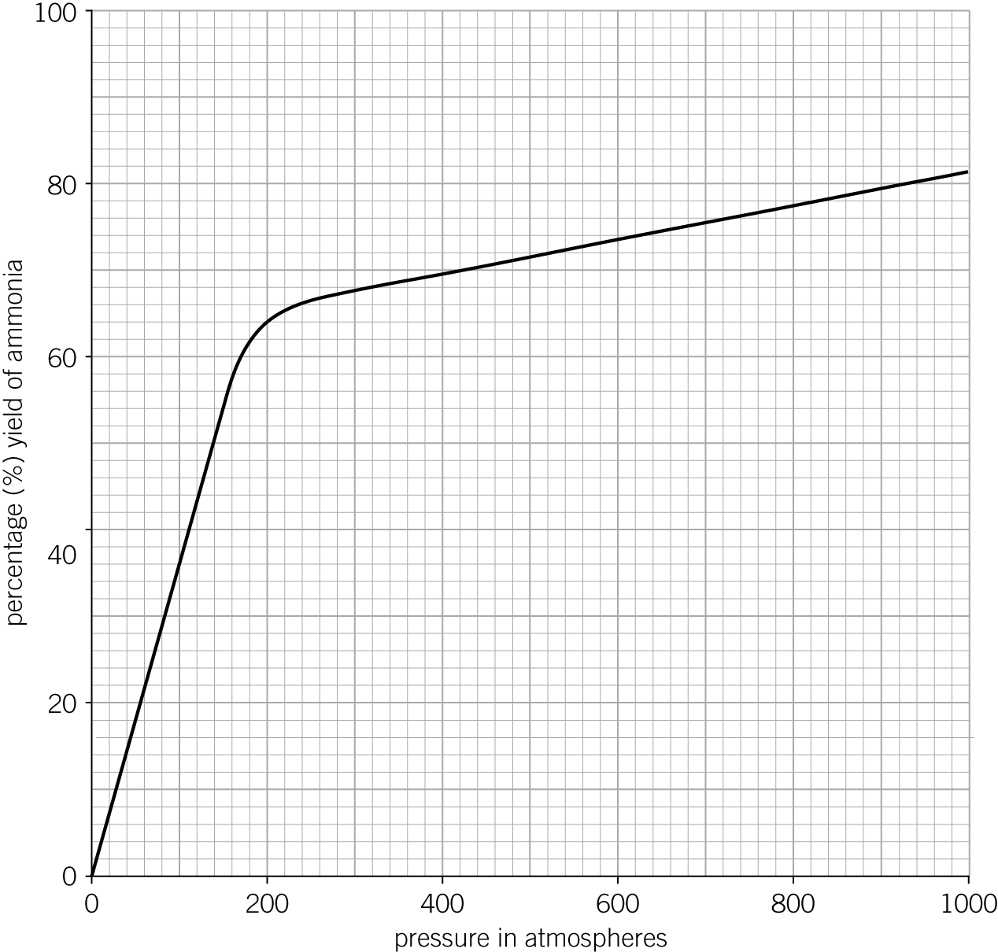

Describe how the yield of ammonia changes as the pressure increases.

(*3 marks*)

|  |  |  |  |
| --- | --- | --- | --- |
| **0** | **2** | **.** | **3** |

**Figure 2** represents the Haber process.

**Figure 2**

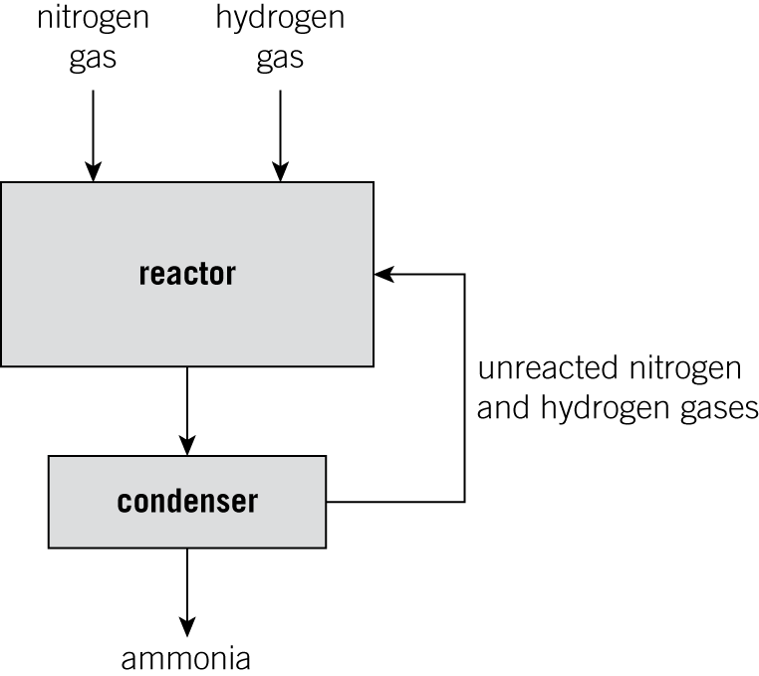

How does the Haber process avoid wasting nitrogen and hydrogen?

(*1 mark*)

|  |  |  |  |
| --- | --- | --- | --- |
| **0** | **2** | **.** | **4** |

Before the Haber process, nitrates were mined in South America. The nitrates were used as fertilisers.

The Haber process allowed ammonia, which is used to make nitrates, to be produced on a large scale anywhere in the world.

Suggest what effect the Haber process had on the miners in South America.

(*1 mark*)

|  |  |  |  |
| --- | --- | --- | --- |
| **0** | **2** | **.** | **5** |

Suggest **one** advantage of producing nitrates on a large scale.

(*1 mark*)

*AQA, 2014*

|  |  |  |  |
| --- | --- | --- | --- |
| **0** | **3** |  |  |

Concrete is a composite material. It is made when water is added to a mixture of cement, sand, and gravel.

Some students investigate the strength of concrete bars.

They use the following method:

**1** Make blocks of concrete with different masses of cement.

**2** Allow the concrete to dry.

**3** Add masses to the supported blocks until they break.

**4** Record the results in a table.

**Figure 3**

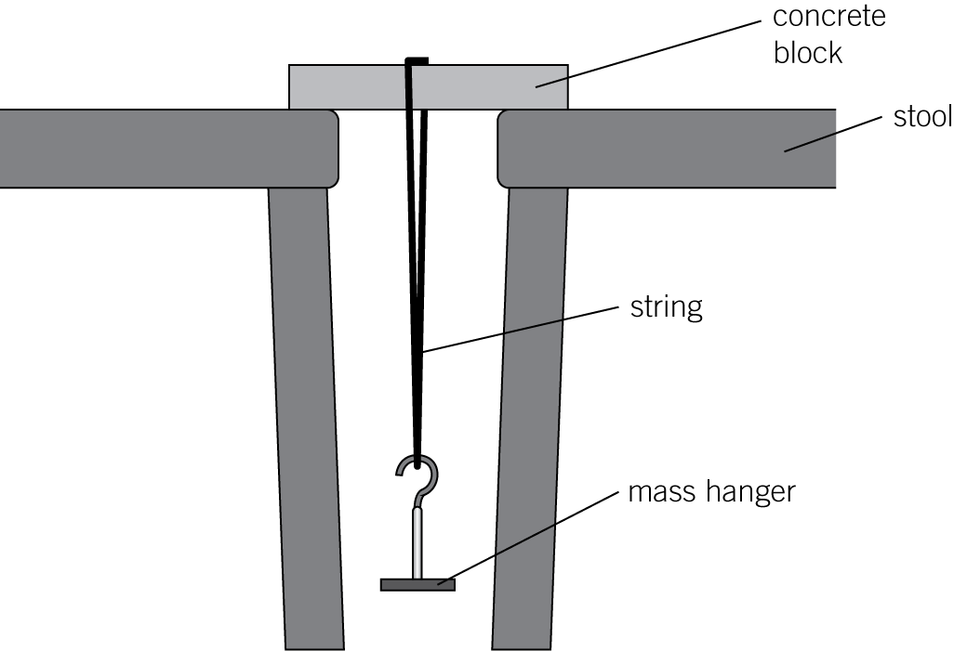

They record their results in **Table 2.**

**Table 2**

|  |  |  |  |  |
| --- | --- | --- | --- | --- |
| Mass of cement in g | Mass added to break the concrete block in g | | | |
| Test 1 | Test 2 | Test 3 | Mean |
| 10 | 1200 | 1100 | 1300 | 1200 |
| 20 | 3400 | 2600 | 2400 |  |
| 30 | 3300 | 3300 | 3300 | 3300 |
| 40 | 3900 | 3700 | 3200 | 3800 |
| 50 | 4200 | 4600 | 4400 | 4400 |

|  |  |  |  |
| --- | --- | --- | --- |
| **0** | **3** | **.** | **1** |

Identify one variable the students should control.

Tick (✓) **one** box.

the distance between the stools

the mass of cement

the order they test the blocks in

the mean force to break the blocks (*1 mark*)

|  |  |  |  |
| --- | --- | --- | --- |
| **0** | **3** | **.** | **2** |

Identify the two anomalous results in **Table 2**.

Tick (✓) **one** box.

1100 g and 3200 g

1100 g and 4200 g

3200 g and 3400 g

3400 g and 4200 g (*1 mark*)

|  |  |  |  |
| --- | --- | --- | --- |
| **0** | **3** | **.** | **3** |

Calculate the mean mass needed to break a block containing 20 g of cement.

mean mass  g (*1 mark*)

|  |  |  |  |
| --- | --- | --- | --- |
| **0** | **3** | **.** | **4** |

The students want to show the relationship between the mass of cement used and the mean mass needed to break the block.

On the grid below add a suitable number scale to each axis and plot the students graph.

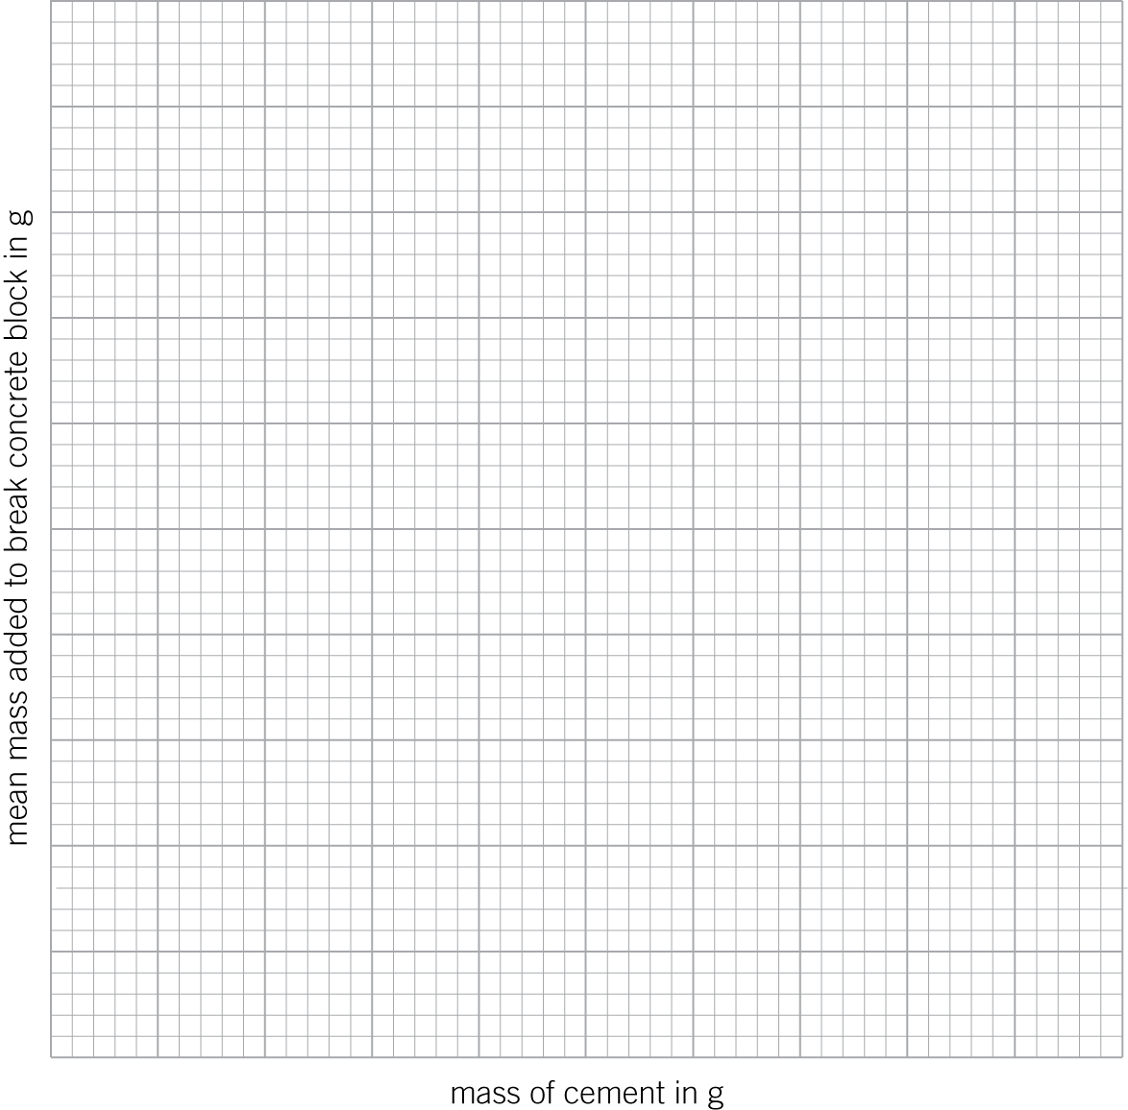 (*3 marks*)

|  |  |  |  |
| --- | --- | --- | --- |
| **0** | **4** |  |  |

Some students set up an experiment using nails to investigate the conditions needed for iron to rust **(Figure 4)**.

**Figure 4**

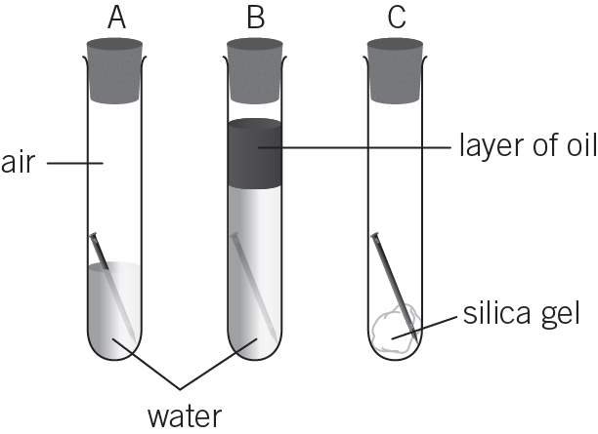

All the tubes contain air.

Tube **A** contains tap water.

Tube **B** contains boiled water.

|  |  |  |  |
| --- | --- | --- | --- |
| **0** | **4** | **.** | **1** |

Iron rusts when it is exposed to which **two** substances?

Tick (✓) **two** boxes.

ions dissolved in water

oil

oxygen

silica

water (*1 mark*)

|  |  |  |  |
| --- | --- | --- | --- |
| **0** | **4** | **.** | **2** |

Which iron nails will rust?

(*1 mark*)

|  |  |  |  |
| --- | --- | --- | --- |
| **0** | **4** | **.** | **3** |

What is the purpose of the silica gel?

(*1 mark*)

|  |  |  |  |
| --- | --- | --- | --- |
| **0** | **4** | **.** | **4** |

Name **two** elements which could be wrapped around nails to protect them from rust.

(*2 marks*)

|  |  |  |  |
| --- | --- | --- | --- |
| **0** | **5** |  |  |

Glue guns use rods of polymer as the glue, which melt when they are heated in the gun. The melted polymer gets squeezed out of the gun’s nozzle. When the polymer cools, it solidifies and sticks objects together.

The bodies of some kettles are also made from polymers.

Using your knowledge of polymer structures, compare the two types of polymer needed to do these jobs.

(*6 marks*)