Cleaning your House can be Hazardous to Health!

Safety hazard symbols are used everyday to warn us of danger. You have been asked to help clean your house. To make sure you are as safe as possible, write down the types of hazard you would expect to use and the precautions you might take and actions if you spill the chemical. Fill in the table below. Once you have used the chemicals on your bench, swap the chemicals with others in the room.
TAKE CARE! These are genuine cleaning products – take note of hazard symbols and do not open them.

Item | What it cleans | Symbols | Hazard | Precaution | Action if spilt
EZ Stain Remover  (Ethanol) | Grass stains on clothes | 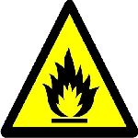 | Highly flammable | Keep away from naked flames | Wash off with water

