**Chemistry Chapter 12 Question Booklet**

**Monday 27th March & Tuesday 28th March Booklet Part 1: Questions 1 - 4**

12.1 Finite & Renewable Resources, 12.6 Reduce Reuse Recycle, 12.5 Life Cycle Assessments.

Name: ………………………….. Mark: ………/42 Grade: ………

**Q1.** Large hydrocarbon molecules can be cracked to produce smaller, more useful molecules.

Alkanes and alkenes are produced when hydrocarbons are cracked.

(a)  Give **two** conditions used for cracking.

1  _________________________________________________________________

2  _________________________________________________________________

**(2)**

(b)  Butane (C4H10) is an alkane.

The figure below shows part of the displayed structural formula of butane.

Complete the displayed structural formula of butane in the figure.

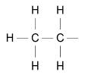

**(1)**

(c)  Butane burns in oxygen.

Complete the word equation for the complete combustion of butane.

butane + oxygen ⟶ ________________________ + ________________________

**(2)**

(d)  Ethene is an alkene. Give a test for alkenes.

Give the result of the test if an alkene is present.

Test _______________________________________________________________

Result  _____________________________________________________________

___________________________________________________________________

**(2)**

(e)  Each year many tonnes of crude oil are extracted from the Earth.

It took millions of years for the crude oil to be formed.

What do we call development that meets the needs of current generations without compromising the resources for future generations?

Tick (**✓**) **one** box.

|  |  |
| --- | --- |
| Finite development |  |
| Global development |  |
| Natural development |  |
| Sustainable development |  |

1. **(Total 8 marks)**

**Q2.** (a)     The hydrocarbon C16H34 can be cracked.

Balance the equation for cracking C16H34

C16H34     →  ________________  C2H4  +  C8H18

**(1)**

(b)     Describe the differences between cracking and distillation.

___________________________________________________________________

___________________________________________________________________

___________________________________________________________________

___________________________________________________________________

**(2)**

(c)     What type of reaction is cracking? Tick **one** box.

|  |  |
| --- | --- |
| Combustion |  |
| Decomposition |  |
| Neutralisation |  |
| Precipitation |  |

**(1)**

(d)     Ethene is used to make poly(ethene).

Poly(ethene) is used to make plastic bags.

the table below shows data from a Life Cycle Assessment (LCA) for a plastic bag and a paper bag.

|  |  |  |
| --- | --- | --- |
|  | **Plastic bag** | **Paper bag** |
| Raw materials | Crude oil or natural gas | Wood |
| Energy used in MJ | 1.5 | 1.7 |
| Mass of solid waste in g | 14 | 50 |
| Mass of CO2 produced in kg | 0.23 | 0.53 |
| Volume of fresh water used in dm3 | 255 | 4 520 |

A company stated: ‘A Life Cycle Assessment shows that using plastic bags has less environmental impact than using paper bags’.

Evaluate this statement. Use your knowledge and the information from above the table above.

___________________________________________________________________

___________________________________________________________________

___________________________________________________________________

___________________________________________________________________

___________________________________________________________________

___________________________________________________________________

___________________________________________________________________

___________________________________________________________________

___________________________________________________________________

___________________________________________________________________

**(6)**

**(Total 10 marks)**

**Q3.** Crude oil is a mixture of hydrocarbons.

(a)  The hydrocarbons in crude oil are separated into fractions by fractional distillation.

**Figure 1** shows a fractional distillation column.

**Figure 1**

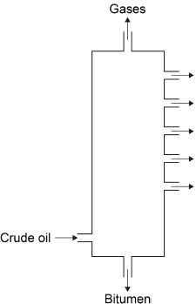

Crude oil vapour passes up the column.

Complete the sentence. Choose the answer from the box.

|  |  |  |  |
| --- | --- | --- | --- |
| **condenses** | **dissolves** | **freezes** | **melts** |

Each fraction _____________________ at a different level.

**(1)**

(b)  Why do the fractions separate? Tick **one** box.

|  |  |
| --- | --- |
| The fractions have different boiling points. |  |
| The fractions have different flammability. |  |
| The fractions have different melting points. |  |
| The fractions have different viscosity. |  |

**(1)**

Most of the hydrocarbons in crude oil are alkanes.

(c)  **Figure 2** represents an alkane molecule.

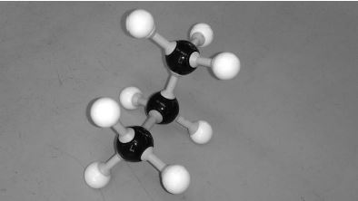

Name the alkane.

___________________________________________________________________

**(1)**

(d)  Methane (CH4) is an alkane. What is the general formula for alkanes? Tick **one** box.

|  |  |
| --- | --- |
| CnHn |  |
| CnH2n |  |
| CnH2n−2 |  |
| CnH2n+2 |  |

**(1)**

(e)  Alkanes burn in oxygen. Balance the equation for methane burning.

________CH4 + ________O2 ⟶ ________CO2 + ________H2O

**(1)**

(f)  Ethene is an alkene. Which reagent is used to test for alkenes? Tick **one** box.

|  |  |
| --- | --- |
| Anhydrous copper sulfate |  |
| Bromine water |  |
| Damp litmus paper |  |
| Limewater |  |

**(1)**

The table below shows data from a life cycle assessment (LCA) for the disposal of 10 000 biodegradable plastic bags.

|  |  |  |
| --- | --- | --- |
|  | **Burning and using the energy to generate electricity** | **Landfill** |
| **Mass of carbon dioxide produced in kg** | 25 | 15 |
| **Mass of solid residue in kg** | 0.050 | 0.070 |
| **Mass of sulfur dioxide produced in kg** | 0.20 | 0.30 |

(g)  Why are life cycle assessments (LCA) done?

___________________________________________________________________

___________________________________________________________________

**(1)**

(h)  Compare the **two** methods for the disposal of biodegradable plastic bags.

Use information from the table above.

___________________________________________________________________

___________________________________________________________________

___________________________________________________________________

___________________________________________________________________

___________________________________________________________________

___________________________________________________________________

___________________________________________________________________

___________________________________________________________________

___________________________________________________________________

___________________________________________________________________

**(4)**

**(Total 11 marks)**

**Q4.**

Atmospheric pollution is emitted by cars.

Some car emissions contain nitrogen dioxide.

(a)  Describe how nitrogen dioxide (NO2) is produced in the engine of a car that burns fossil fuels.

___________________________________________________________________

___________________________________________________________________

___________________________________________________________________

___________________________________________________________________

___________________________________________________________________

___________________________________________________________________

**(3)**

The table below shows the concentration of nitrogen dioxide in the air in three different areas for 1 week.

|  |  |  |  |
| --- | --- | --- | --- |
|  | **Concentration of nitrogen dioxide in the air in micrograms per m3** | | |
| **Day** | **City centre** | **Countryside** | **Motorway** |
| Monday | 35 | 8 | 22 |
| Tuesday | 37 | 8 | 23 |
| Wednesday | 37 | 8 | 23 |
| Thursday | 34 | 8 | 23 |
| Friday | 37 | 8 | 23 |
| Saturday | 29 | 7 | 20 |
| Sunday | **X** | 6 | 17 |

(b)  The mean value for nitrogen dioxide in the air for the whole week in the city centre is 33 micrograms per m3.

Calculate the value (**X**) for the concentration of nitrogen dioxide in the air in the city centre on Sunday.

___________________________________________________________________

___________________________________________________________________

___________________________________________________________________

___________________________________________________________________

**X** = __________ micrograms per m3

**(2)**

(c)  Each value in the table above has an uncertainty of ± 2 micrograms per m3.

Explain why this uncertainty is **most** significant for countryside data.

___________________________________________________________________

___________________________________________________________________

___________________________________________________________________

___________________________________________________________________

**(2)**

Nitrogen dioxide is removed from car emissions by catalytic converters.

(d)  In a catalytic converter nitrogen dioxide (NO2) reacts to produce nitrogen and oxygen.

Complete the equation for the reaction.

You should balance the equation.

_____ NO2 → _______________ + _______________

**(2)**

(e)  The catalyst in a catalytic converter contains platinum.

Platinum is a finite resource.

What is meant by a ‘finite resource’?

___________________________________________________________________

___________________________________________________________________

**(1)**

(f)  Emissions from cars contain carbon dioxide.

Explain why carbon dioxide emissions during use and operation are **not** the total carbon footprint for a car.

Refer to the stages of the life cycle assessment of a car in your answer.

___________________________________________________________________

___________________________________________________________________

___________________________________________________________________

___________________________________________________________________

___________________________________________________________________

___________________________________________________________________

**(3)**

**(Total 13 marks)**

**Monday 3rd April Booklet Part 2: Questions 5 - 9**

12.2 Potable Water & 12.3 Waste Water

Name: ………………………….. Mark: ………/54 Grade: ………

**Q5.**

This question is about drinking water.

(a)     Name **two** methods of treating water from rivers, lakes or the sea to produce drinking water. Tick **two** boxes.

|  |  |
| --- | --- |
| Anaerobic digestion |  |
| Cracking |  |
| Desalination |  |
| Electrolysis |  |
| Sterilising |  |

**(2)**

(b)     The table below shows the amounts of dissolved ions in a sample of drinking water.

|  |  |
| --- | --- |
| **Dissolved ion** | **Mass in mg per dm3** |
| Cl– | 250 |
| Na+ | 200 |
| NO3+ | 40 |

What is the name of the ion with the symbol Cl–? Tick **one** box.

|  |  |
| --- | --- |
| Calcium ion |  |
| Carbonate ion |  |
| Chloride ion |  |
| Chlorine ion |  |

**(1)**

(c)     Use the information in the table above to complete the bar chart in **Figure 1**.

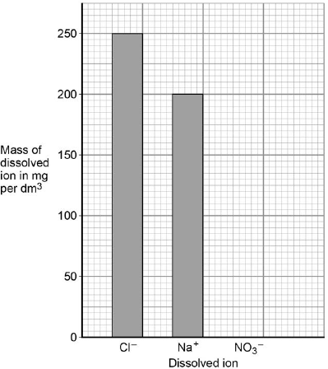

**(1)**

(d)     Look at the questions labelled **A, B, C, D**.

**A**   How many substances are there in drinking water?

**B**   How much fluoride is in drinking water?

**C**   Is fluoride soluble in drinking water?

**D**   Should fluoride be added to drinking water?

Which **one** of the questions cannot be answered by science alone? Tick **one** box.

|  |  |  |  |  |  |  |  |  |  |  |  |
| --- | --- | --- | --- | --- | --- | --- | --- | --- | --- | --- | --- |
| **A** |  |  | **B** |  |  | **C** |  |  | **D** |  |  |

**(1)**

(e)     Give **two** reasons why the answer you have chosen cannot be answered by science alone.

1. _________________________________________________________________

___________________________________________________________________

2. _________________________________________________________________

___________________________________________________________________

**(2)**

(f)      A sample of drinking water contains 1.5 mg of fluoride per dm3 of water.  
A person drinks 1 dm3 of this water.

The recommended daily amount of fluoride is 4.0 mg.

Which calculation gives the percentage of the recommended daily amount of fluoride in 1 dm3 of this water?

Tick **one** box.

|  |  |
| --- | --- |
|  |  |
|  |  |
|  |  |
|  |  |

**(1)**

(g)     **Figure 2** shows the effect of fluoride in drinking water on tooth decay in different age groups.

**Figure 2**

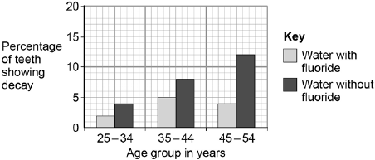

Describe the pattern of tooth decay in **Figure 2** for water without fluoride.

Use data to justify your answer.

___________________________________________________________________

___________________________________________________________________

___________________________________________________________________

___________________________________________________________________

**(2)**

(h)     Describe the effect of adding fluoride to drinking water for the age groups in **Figure 2**.

___________________________________________________________________

___________________________________________________________________

___________________________________________________________________

___________________________________________________________________

**(2)**

**(Total 12 marks)**

**Q6.** A student investigated the mass of dissolved solids in water samples.

The diagram below shows the apparatus used.

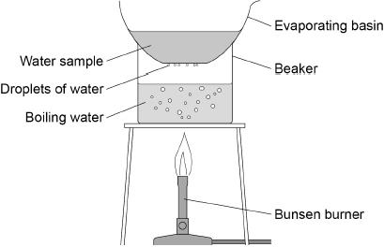

This is the method used.

1.   Record the mass of a dry evaporating basin.

2.   Pour 25 cm3 of the water sample into the evaporating basin.

3.   Place the evaporating basin on the beaker for 10 minutes.

4.   Record the mass of the evaporating basin and contents.

(a)     What is used to find the mass of the evaporating basin? Tick (**✓**) **one** box.

|  |  |
| --- | --- |
| Balance |  |
| Beaker |  |
| Measuring cylinder |  |
| Thermometer |  |

**(1)**

One error is that droplets of water collect on the bottom of the evaporating basin.

(b)     Suggest how this error affects the mass of the evaporating basin and contents.

___________________________________________________________________

___________________________________________________________________

**(1)**

(c)     How can this error be corrected?

___________________________________________________________________

___________________________________________________________________

**(1)**

(d)     Another error in the method is that not all the water was removed from the water sample.

How can this error be corrected?

Tick (**✓**) **one** box.

|  |  |
| --- | --- |
| Add more boiling water to the beaker. |  |
| Heat until the mass of the evaporating basin and contents is constant. |  |
| Stir the water sample in the evaporating basin with a glass rod. |  |

**(1)**

(e)     The water in the water sample turns into steam.

What is the name of this process?

___________________________________________________________________

**(1)**

Another student did the experiment correctly with three water samples **A**, **B** and **C**.

The table below shows the results.

|  |  |  |  |  |
| --- | --- | --- | --- | --- |
| **Water sample** | **Mass of dissolved solids in g** | | | |
| **Test 1** | **Test 2** | **Test 3** | **Mean** |
| **A** | 0.23 | 0.23 | 0.20 | **X** |
| **B** | 0.03 | 0.07 | 0.02 | 0.04 |
| **C** | 1.45 | 1.60 | 1.45 | 1.50 |

(f)      The range is the difference between the largest value and the smallest value.

Which water sample has the greatest range of results? Tick (**✓**) **one** box.

|  |  |
| --- | --- |
| **A** |  |
| **B** |  |
| **C** |  |

**(1)**

(g)     Calculate the mean mass **X** for water sample **A**. Use table above.

___________________________________________________________________

___________________________________________________________________

___________________________________________________________________

___________________________________________________________________

**X** = _______________ g **(2)**

(h)     What is the dependent variable in this experiment? Tick (**✓**) **one** box.

|  |  |
| --- | --- |
| Mass of dissolved solids |  |
| Time taken for water to heat |  |
| Type of water sample |  |
| Volume of boiling water |  |

**(1)**

(i)      A different water sample contains 3.6 g of dissolved solids in 150 cm3

Calculate the mass of dissolved solids in 25 cm3 of this sample.

___________________________________________________________________

___________________________________________________________________

___________________________________________________________________

___________________________________________________________________

Mass = _______________ g

1. **(Total 11 marks)**

**Q7.**

A student investigated the mass of dissolved solids in 5 cm3 samples of water.

The diagram below shows the apparatus.

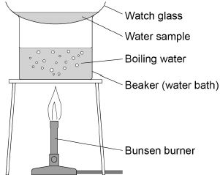

The table below shows the student’s results.

|  |  |  |  |  |
| --- | --- | --- | --- | --- |
| **Type of water** | **Mass in g** | | | |
| **Watch glass** | **Watch glass and dissolved solids** | **Dissolved solids in 5 cm3 of water** | **Dissolved solids in 1000 cm3 of water** |
| Sea water | 9.34 | 9.48 | 0.14 | 28.00 |
| River water | 9.15 | 9.23 | 0.08 | **X** |
| Rainwater | 8.93 | 8.93 | 0.00 | 0.00 |

(a)  Calculate mass **X** in the table above.

___________________________________________________________________

___________________________________________________________________

Mass **X** = ___________________ g

**(1)**

(b)  5 cm3 is a small volume of water for each experiment.

Give **one** advantage and **one** disadvantage of using a larger volume.

Advantage __________________________________________________________

___________________________________________________________________

Disadvantage _______________________________________________________

___________________________________________________________________

**(2)**

(c)  Potable water is **not** pure water.

Describe the difference between potable water and pure water.

___________________________________________________________________

___________________________________________________________________

___________________________________________________________________ **(1)**

(d)  Potable water is obtained from both groundwater **and** from sea water.

Describe how groundwater and sea water are treated to produce potable water.

___________________________________________________________________

___________________________________________________________________

___________________________________________________________________

___________________________________________________________________

___________________________________________________________________ **(3)**

(e)  The percentage by mass of dissolved solids in a 6.50 g sample is 2.2%

Calculate the mass of the dissolved solids.

___________________________________________________________________

___________________________________________________________________

___________________________________________________________________

___________________________________________________________________

Mass of dissolved solids = _______________________ g

**(2) (Total 9 marks)**

**Q8.** Water that is safe to drink contains dissolved substances.

(a)  What do we call water that is safe to drink? Tick (**✓**) **one** box.

|  |  |
| --- | --- |
| Desalinated |  |
| Filtered |  |
| Fresh |  |
| Potable |  |

**(1)**

(b)  Describe a test for pure water.

Give the result of the test if the water is pure.

Test _______________________________________________________________

Result  _____________________________________________________________

___________________________________________________________________

___________________________________________________________________

**(2)**

(c)  Describe a method to determine the mass of dissolved solids in a 100 cm3 sample of river water.

___________________________________________________________________

___________________________________________________________________

___________________________________________________________________

___________________________________________________________________

___________________________________________________________________

___________________________________________________________________

___________________________________________________________________

___________________________________________________________________

___________________________________________________________________

___________________________________________________________________

**(4)**

(d)  A sample of river water contains 125 mg per dm3 of dissolved solids.

Calculate the mass of dissolved solids in grams in 250 cm3 of this sample of river water.

Give your answer to 2 significant figures.

___________________________________________________________________

___________________________________________________________________

___________________________________________________________________

___________________________________________________________________

___________________________________________________________________

___________________________________________________________________

Mass of dissolved solids = ___________________________ g

**(4)**

(e)  A water company allows a maximum of 500 mg per dm3 of sulfate ions in drinking water.

A sample of drinking water contains 44 mg per dm3 of sulfate ions.

Calculate the percentage (%) of the maximum allowed mass of sulfate ions in the sample of drinking water.

___________________________________________________________________

___________________________________________________________________

___________________________________________________________________

___________________________________________________________________

Percentage (%) of the maximum allowed mass = ________________ %

**(2) (Total 13 marks)**

**Q9.** This question is about pollutants.

(a)     Waste water has harmful substances removed before being released into the environment.

Complete the sentences.

Agricultural waste water requires the removal of harmful ____________________.

Industrial waste water may require the removal of harmful ____________________.

**(2)**

(b)     How is sewage sludge treated before being released into the environment? Tick (**✓**) **one** box.

|  |  |
| --- | --- |
| Aerobic biological treatment |  |
| Anaerobic digestion |  |
| Grit removal |  |
| Screening |  |

**(1)**

(c)     Hydrocarbons are used to make polymers. Polymers are used to make plastic bags.

In one year 8.0 billion plastic bags were used.

The next year there was a charge for plastic bags and only 1.3 billion plastic bags were used.

Calculate the percentage decrease in the number of plastic bags used.

___________________________________________________________________

___________________________________________________________________

___________________________________________________________________

___________________________________________________________________

___________________________________________________________________

___________________________________________________________________

Percentage decrease = _______________ %

**(3)**

Oxides of nitrogen are pollutants formed in car engines.

(d)     Give **one** problem oxides of nitrogen cause.

___________________________________________________________________

**(1)**

(e)     The graph below shows the mass of oxides of nitrogen produced from car engines from 1986 to 2016.

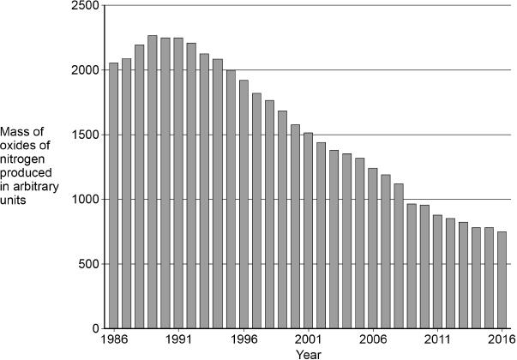

Suggest why the mass of oxides of nitrogen produced from car engines increased and then decreased.

Increased __________________________________________________________

___________________________________________________________________

Decreased _________________________________________________________

___________________________________________________________________

**(2) (Total 9 marks)**

**Tuesday 4th April Booklet Part 3: Questions 10 - 13**

12.4 Extracting Metals from Ores (Copper)

Name: ………………………….. Mark: ………/47 Grade: ………

**Q10.** Industries use the Earth’s resources to produce useful products.

Copper is produced from copper ore and from recycling waste copper.

(a)  The energy needed to produce 1 kg of copper from copper ore is 70 MJ.

The energy needed to produce 1 kg of recycled copper is 27 MJ.

Calculate the energy saved if 100 kg of copper is produced from recycled copper and **not** from copper ore.

___________________________________________________________________

___________________________________________________________________

___________________________________________________________________

___________________________________________________________________

Energy saved = _______________ MJ

**(3)**

(b)  Producing copper from recycling waste copper reduces emissions of sulfur dioxide.

Why is reducing emissions of sulfur dioxide important?

___________________________________________________________________

___________________________________________________________________

**(1)**

(c)  Copper is used to make coins.

A coin of mass 8 g contains 75% copper.

Calculate the mass of copper in the coin.

___________________________________________________________________

___________________________________________________________________

___________________________________________________________________

Mass of copper = ________ g

**(2)**

(d)  Iron and glass are both produced from the Earth’s resources.

Some processes can reduce the use of limited resources.

Draw **one** line from the description of the process to the name of the process.

|  |  |  |
| --- | --- | --- |
| **Description of process** |  | **Name of process** |
|  | | |
|  |  | Extraction |
|  | | |
| Scrap steel is added to iron from a blast furnace |  | Quarrying |
|  | | |
|  |  | Reacting |
|  | | |
| A glass bottle is refilled |  | Recycling |
|  | | |
|  |  | Reusing |

**(2)**

(e)  Life cycle assessments are used to assess the environmental impact of producing iron nails and glass bottles.

There are four stages, **A**, **B**, **C** and **D**, in a life cycle assessment.

The stages are **not** in the correct order.

|  |  |
| --- | --- |
| Stage **A** | Disposal |
| Stage **B** | Extracting and processing raw materials |
| Stage **C** | Manufacturing and packaging |
| Stage **D** | Use and operation |

What is the correct order of stages **A**, **B**, **C**, and **D**? Tick (**✓**) **one** box.

|  |  |
| --- | --- |
| **C**, **D**, **B**, **A** |  |
| **D**, **B**, **C**, **A** |  |
| **B**, **C**, **D**, **A** |  |

**(1)**

**(Total 9 marks)**

**Q11.** Copper can be produced from copper(II) sulfate solution by two different methods.

**Method 1 – Electrolysis**

(a)     To produce copper by electrolysis a student has inert electrodes, a d.c. power supply, a switch and electrical wires for the external circuit.

Draw and label the apparatus set up to produce copper from copper(II) sulfate solution by electrolysis.

**(2)**

(b)     Suggest why the colour of the copper(II) sulfate solution fades during the electrolysis.

___________________________________________________________________

___________________________________________________________________

___________________________________________________________________

___________________________________________________________________

**(3)**

(c)     Explain how copper is produced from copper(II) sulfate solution by electrolysis.

___________________________________________________________________

___________________________________________________________________

___________________________________________________________________

___________________________________________________________________

___________________________________________________________________

___________________________________________________________________

___________________________________________________________________

___________________________________________________________________

___________________________________________________________________

**(4)**

**Method 2 – Displacement**

(d)     The chemical equation for the displacement of copper using iron is:

             CuSO4   +   Fe      Cu   +   FeSO4



Calculate the minimum mass of iron needed to displace all of the copper from 50 cm3 of copper(II) sulfate solution.

The concentration of the copper(II) sulfate solution is 80 g CuSO4 per dm3.

Relative atomic masses (*A*r): O = 16; S = 32; Fe = 56; Cu = 63.5

Give your answer to 2 significant figures.

___________________________________________________________________

___________________________________________________________________

___________________________________________________________________

___________________________________________________________________

___________________________________________________________________

Mass of iron = __________________ g

**(4)**

**(Total 13 marks)**

**Q12.**

This question is about copper and its compounds.

(a)     The table shows information about bioleaching and phytomining.

Bioleaching and phytomining are used to extract copper from low grade ores.

|  |  |  |
| --- | --- | --- |
|  | **Bioleaching** | **Phytomining** |
| **Metal extracted from** | Waste from quarrying | Contaminated ground |
| **Speed of process** | Very slow | Slow, made more efficient using quick-growing plants |
| **Pollution** | Produces a solution of toxic chemicals which may run off into rivers  Takes a long time to stop the process if river pollution occurs | Involves combustion of plants but decontaminates polluted ground |

Compare phytomining and bioleaching. Use the information in the table.

___________________________________________________________________

___________________________________________________________________

___________________________________________________________________

___________________________________________________________________

___________________________________________________________________

___________________________________________________________________

___________________________________________________________________

___________________________________________________________________

**(4)**

(b)     Describe how copper sulfate solution is obtained from the plants used in phytomining.

___________________________________________________________________

___________________________________________________________________

___________________________________________________________________

___________________________________________________________________

**(2)**

(c)     Copper is displaced from a solution of copper sulfate using iron.

Write a balanced symbol equation for this reaction.

___________________________________________________________________

**(2)**

(d)     How does this displacement reaction take place?

Tick **one** box.

|  |  |
| --- | --- |
| Electron sharing |  |
| Electron transfer |  |
| Proton transfer |  |

**(1)**

(e)     Describe how copper conducts electricity.

___________________________________________________________________

___________________________________________________________________

___________________________________________________________________

___________________________________________________________________

**(2)**

(f)      Suggest how anhydrous copper sulfate is used to test for water.

___________________________________________________________________

___________________________________________________________________

___________________________________________________________________

___________________________________________________________________

**(2)**

**(Total 13 marks)**

**Q13.**

Industries use the Earth’s natural copper resources to produce useful products.

The figure below shows the world production of copper from 1900 to 2020.

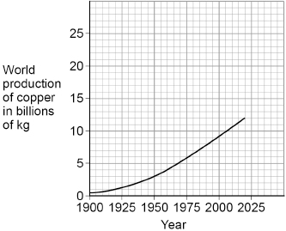

(a)  Describe the trend shown by the graph in the figure above.

___________________________________________________________________

___________________________________________________________________

___________________________________________________________________

___________________________________________________________________

**(2)**

(b)  Suggest **one** reason for the trend in the figure above.

___________________________________________________________________

___________________________________________________________________

**(1)**

(c)  Suggest **one** reason why the trend cannot be used to accurately predict the future world production of copper.

___________________________________________________________________

___________________________________________________________________

**(1)**

(d)  High-grade copper resources are now difficult to find.

Phytomining is used to extract copper from low-grade ores.

There are five stages, **A**, **B**, **C**, **D** and **E**, in phytomining.

The stages are **not** in the correct order.

|  |  |
| --- | --- |
| Stage **A** | Copper compounds from ash are dissolved in acid. |
| Stage **B** | Plants absorb metal compounds. |
| Stage **C** | Plants are burned. |
| Stage **D** | Plants are harvested. |
| Stage **E** | Solution of copper compound is electrolysed. |

What is the correct order of stages **A**, **B**, **C**, **D**, and **E**?

Tick (**✓**) **one** box.

|  |  |
| --- | --- |
| **B**, **C**, **D**, **E**, **A** |  |
| **B**, **D**, **C**, **A**, **E** |  |
| **D**, **B**, **C**, **E**, **A** |  |
| **D**, **C**, **B**, **A**, **E** |  |

**(1)**

(e)  Give **two** disadvantages of phytomining compared with traditional mining methods.

Do **not** refer to cost in your answer.

1  _________________________________________________________________

___________________________________________________________________

2  _________________________________________________________________

___________________________________________________________________

**(2)**

(f)  In one year, 8.89 × 109 kg of copper was produced.

41.0% of this copper was produced from recycled copper.

The energy needed to produce 1 kg of copper from copper ore is 70.4 MJ.

The energy needed to produce 1 kg of recycled copper is 27.2 MJ.

Calculate the difference in energy used if all the copper was produced from recycling.

Give your answer to 3 significant figures.

___________________________________________________________________

___________________________________________________________________

___________________________________________________________________

___________________________________________________________________

___________________________________________________________________

___________________________________________________________________

___________________________________________________________________

___________________________________________________________________

Difference in energy used (3 significant figures) = _______________ MJ

**(5)**

**(Total 12 marks)**