**Additional Circulation Questions**

**Name: ………………………. Mark: …………/72 Grade: ………….**

**Q1.**          The diagram shows a cross-section of a blood vessel.

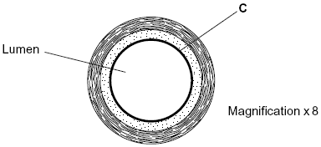

(a)     Name layer **C**.

......................................................................................................................

**(1)**

(b)     Calculate the actual diameter of the lumen of this blood vessel in millimetres. Show your working.

Answer ............................................. mm

**(2)**

(c)     The aorta has many elastic fibres in its wall. An arteriole has many muscle fibres in its wall.

(i)      Explain the importance of elastic fibres in the wall of the aorta.

.............................................................................................................

.............................................................................................................

.............................................................................................................

.............................................................................................................

**(2)**

(ii)     Explain the importance of muscle fibres in the wall of an arteriole.

.............................................................................................................

.............................................................................................................

.............................................................................................................

.............................................................................................................

**(2)**

(d)     The graph shows the rate of blood flow in different blood vessels. It also shows the total cross-sectional area of these blood vessels.

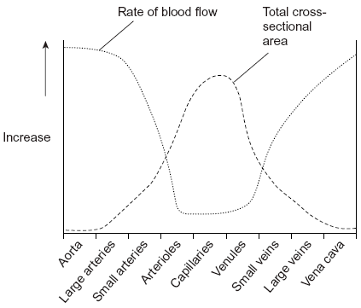

(i)      The rate of blood flow decreases from the aorta to the capillaries. Use information from the graph to explain why.

.............................................................................................................

.............................................................................................................

.............................................................................................................

**(1)**

(ii)     Efficient exchange of substances in the capillaries is linked to the rate of blood flow. Explain how.

.............................................................................................................

.............................................................................................................

.............................................................................................................

**(1)**

**(Total 9 marks)**

**Q2.**          (a)     The pulmonary artery and aorta are described as organs. Explain why.

......................................................................................................................

......................................................................................................................

**(1)**

(b)     Give **one** way in which blood in the pulmonary artery is different from blood in the aorta.

......................................................................................................................

......................................................................................................................

**(1)**

(c)     Give **two** ways in which the structure of a artery is different from the structure of a vein.

1 ...................................................................................................................

......................................................................................................................

2 ...................................................................................................................

......................................................................................................................

**(2)**

(d)     The maximum blood pressure in the aorta changes as the distance from the heart increases.

(i)      Describe how the blood pressure changes.

.............................................................................................................

.............................................................................................................

**(1)**

(ii)     What causes this change in maximum blood pressure?

.............................................................................................................

.............................................................................................................

**(1)**

**(Total 6 marks)**

**Q3.**          The diagram shows some of the large blood vessels in a mammal.

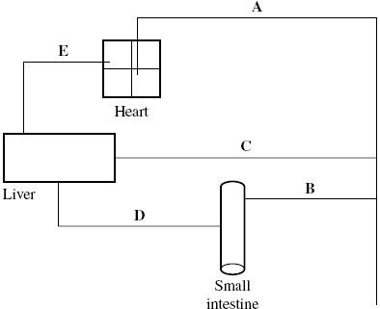

(a)     Add arrows to the diagram to show the direction of blood flow in each of the blood vessels **A** to **E**.

**(1)**

(b)     (i)      Which of blood vessels **A** to **E** is the hepatic portal vein?



**(1)**

(ii)     Which of blood vessels **A** to **E** contains blood at the lowest pressure?



**(1)**

(c)     Complete the table to show **two** differences between the structure of vessel **C** and the structure of vessel **E**.

|  |  |  |
| --- | --- | --- |
| **Structural feature** | **Vessel C** | **Vessel E** |
|  |  |  |
|  |  |  |

**(2)**

(d)     Blood vessel **B** contains smooth muscle in its walls. Explain how this muscle may reduce the blood flow to the small intestine.

......................................................................................................................

......................................................................................................................

......................................................................................................................

......................................................................................................................

**(2)**

(e)     Elastic tissue in the walls of blood vessel **A** helps to even out the pressure of blood through this vessel. Explain how.

......................................................................................................................

......................................................................................................................

......................................................................................................................

......................................................................................................................

**(2)**

**(Total 9 marks)**

**Q4.**          The diagram shows tissue fluid and cells surrounding a capillary.

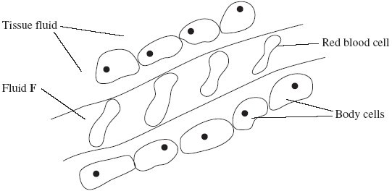

(a)     Name fluid **F**.

......................................................................................................................

**(1)**

(b)     Give **one** way in which fluid **F** is different from tissue fluid.

......................................................................................................................

**(1)**

(c)     (i)      The blood pressure is high at the start of the capillary. Explain how the left ventricle causes the blood to be at high pressure.

.............................................................................................................

.............................................................................................................

**(1)**

(ii)     The blood pressure decreases along the length of the capillary. What causes this decrease in pressure?

.............................................................................................................

.............................................................................................................

**(1)**

(d)     In children, some diets may result in a low concentration of protein in fluid **F**. This can cause the accumulation of tissue fluid. Explain the link between a low concentration of protein in fluid **F** and the accumulation of tissue fluid.

......................................................................................................................

......................................................................................................................

......................................................................................................................

......................................................................................................................

......................................................................................................................

......................................................................................................................

**(3)**

**(Total 7 marks)**

**Q5.**          (a)     Haemoglobin is a protein. Its molecules have a quaternary structure. Explain what is meant by a quaternary structure.

......................................................................................................................

......................................................................................................................

**(1)**

The diagram shows oxygen dissociation curves for human haemoglobin.

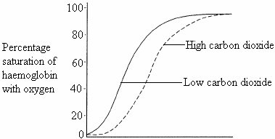

(b)     Haemoglobin is 96 % saturated with oxygen when it leaves the lungs. Use the graph to explain why.

......................................................................................................................

......................................................................................................................

......................................................................................................................

**(2)**

(c)     (i)      There is a high concentration of carbon dioxide in rapidly respiring tissue.  
Explain why.

.............................................................................................................

.............................................................................................................

**(1)**

(ii)     Carbon dioxide helps haemoglobin to release oxygen to rapidly respiring tissues.  
Use the graph to explain how.

.............................................................................................................

.............................................................................................................

.............................................................................................................

.............................................................................................................

**(2)**

(d)     Ground squirrels are mammals that spend much of their lives in burrows underground.  
The table shows the partial pressure of oxygen in a ground-squirrel burrow and in the air above ground.

|  |  |
| --- | --- |
| **Source of air sample** | **Partial pressure of oxygen / kPa** |
| Ground-squirrel burrow | 15.8 |
| Above ground | 21.1 |

Suggest the advantage to a ground squirrel of having haemoglobin that has an oxygen dissociation curve to the left of the curve for human haemoglobin.

......................................................................................................................

......................................................................................................................

......................................................................................................................

......................................................................................................................

**(2)**

**(Total 8 marks)**

**Q6.**          Lugworms live in mud where the partial pressure of oxygen is low. The graph shows oxygen dissociation curves for a lugworm and for a human.

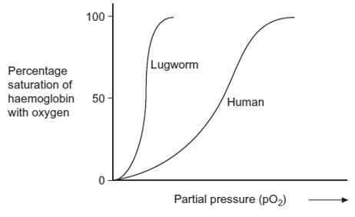

(a)Explain the advantage to the lugworm of having haemoglobin with a dissociation curve in the position shown.

......................................................................................................................

......................................................................................................................

......................................................................................................................

......................................................................................................................

**(2)**

(b)In humans, substances move out of the capillaries to form tissue fluid. Describe how this tissue fluid is returned to the circulatory system.

......................................................................................................................

......................................................................................................................

......................................................................................................................

......................................................................................................................

......................................................................................................................

......................................................................................................................

*(Extra space)* ...............................................................................................

......................................................................................................................

......................................................................................................................

**(3)**

**(Total 5 marks)**

**Q7.**          (a)     **Figure 1** shows the oxygen dissociation curve for human haemoglobin.

**Figure 1**

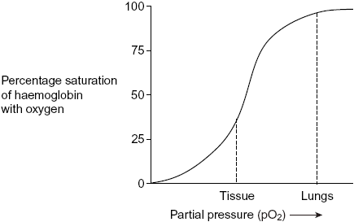

Use **Figure 1** to describe how haemoglobin loads and unloads oxygen in the body.

......................................................................................................................

......................................................................................................................

......................................................................................................................

......................................................................................................................

......................................................................................................................

**(3)**

(b)     **Figure 2** shows oxygen dissociation curves from mammals of different size.

**Figure 2**

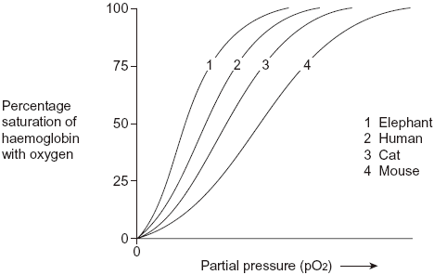

(i)      Describe the relationship between the size of mammals and the oxygen dissociation curves of their haemoglobins.

.............................................................................................................

.............................................................................................................

**(1)**

(ii)     Heat from respiration helps mammals to maintain a constant body temperature.

Use this information to explain the relationship between the surface area to volume ratio of mammals and the oxygen dissociation curves of their haemoglobins.

.............................................................................................................

.............................................................................................................

.............................................................................................................

.............................................................................................................

.............................................................................................................

.............................................................................................................

.............................................................................................................

**(4)**

**(Total 8 marks)**

**Q8.**          (a)     Haemoglobin contains iron. One type of anaemia is caused by a lack of iron. This type of anaemia can be treated by taking tablets containing iron. A number of patients were given a daily dose of 120 mg of iron. **Figure 1** shows the effect of this treatment on the increase in the concentration of haemoglobin in their red blood cells.

**Figure 1**

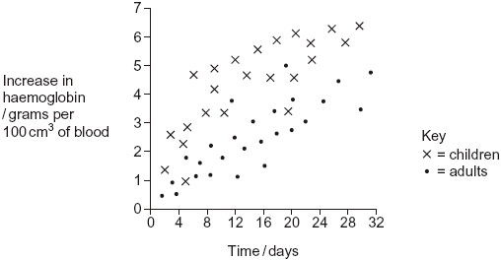

(i)      Give **one** difference in the response of adults and children to this treatment.

.............................................................................................................

.............................................................................................................

**(1)**

(ii)     You could use the graph to predict the effect of this treatment on the increase in haemoglobin content of an adult after 40 days. Explain how.

.............................................................................................................

.............................................................................................................

.............................................................................................................

.............................................................................................................

**(2)**

(iii)     Haemoglobin has a quaternary structure. Explain what is meant by a quaternary structure.

.............................................................................................................

.............................................................................................................

**(1)**

(b)     (i)      Pernicious anaemia is another type of anaemia. One method of identifying pernicious anaemia is to measure the diameter of the red blood cells in a sample of blood that has been diluted with an isotonic salt solution. Explain why an isotonic salt solution is used to dilute the blood sample.

.............................................................................................................

.............................................................................................................

.............................................................................................................

.............................................................................................................

.............................................................................................................

.............................................................................................................

**(3)**

(ii)     A technician compared the red blood cells in two blood samples of equal volume. One sample was from a patient with pernicious anaemia, the other was from a patient who did not have pernicious anaemia. **Figure 2** shows some of the results she obtained.

**Figure 2**

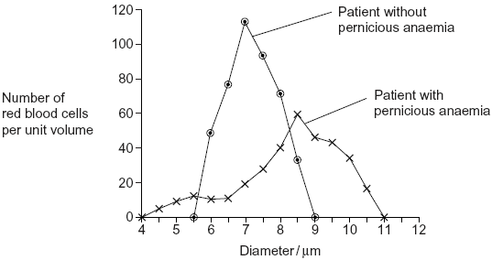

Describe **two** differences between the blood samples.

1 ..........................................................................................................

.............................................................................................................

2 ..........................................................................................................

.............................................................................................................

**(2)**

**(Total 9 marks)**

**Q9.**          (a)     An increase in respiration in the tissues of a mammal affects the oxygen dissociation curve of haemoglobin. Describe and explain how.

......................................................................................................................

......................................................................................................................

......................................................................................................................

......................................................................................................................

**(2)**

(b)     There is less oxygen at high altitudes than at sea level.

(i)      People living at high altitudes have more red blood cells than people living at sea level. Explain the advantage of this to people living at high altitude.

.............................................................................................................

.............................................................................................................

.............................................................................................................

.............................................................................................................

**(2)**

(ii)     The graph shows oxygen dissociation curves for people living at high altitude and for people living at sea level.

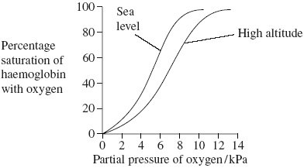

Explain the advantage to people living at high altitude of having the oxygen dissociation curve shown in the graph.

.............................................................................................................

.............................................................................................................

.............................................................................................................

.............................................................................................................

**(2)**

**(Total 6 marks)**

**Q10.**          The graph shows the oxyhaemoglobin dissociation curve at two different partial pressures of carbon dioxide (pCO2).

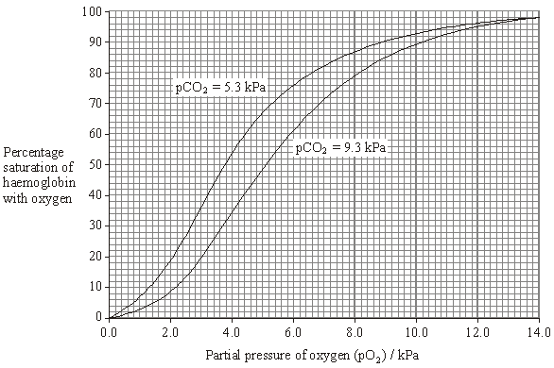

(a)     During vigorous exercise, the blood entering a leg muscle had a pO2 of 4 kPa and a pCO2 of 5.3 kPa. The blood leaving the muscle had a pO2 of 2.8 kPa and a pCO2 of 9.3 kPa. Each dm3 of blood leaving the lungs contained 200 cm3 oxygen and was 98% saturated with oxygen.

Use this information and information from the graph to calculate the volume of oxygen released to the muscle from 1 dm3 of blood. Show your working.

Answer ...................................... cm3 oxygen

**(2)**

**S**       (b)     The blood leaving a muscle has a lower pH than the blood entering it. During vigorous exercise, the fall in pH is even greater. Explain what causes this greater fall in pH.

......................................................................................................................

......................................................................................................................

......................................................................................................................

......................................................................................................................

......................................................................................................................

**(3)**

**(Total 5 marks)**