|  |  |  |  |
| --- | --- | --- | --- |
| **0** | **1** |  |  |

Alcohols can be burnt as fuels.

A group of students investigated the temperature rise when 1 g of different alcohols was burnt. They heated 50 cm3 of water in a beaker each time.

**Figure 1**

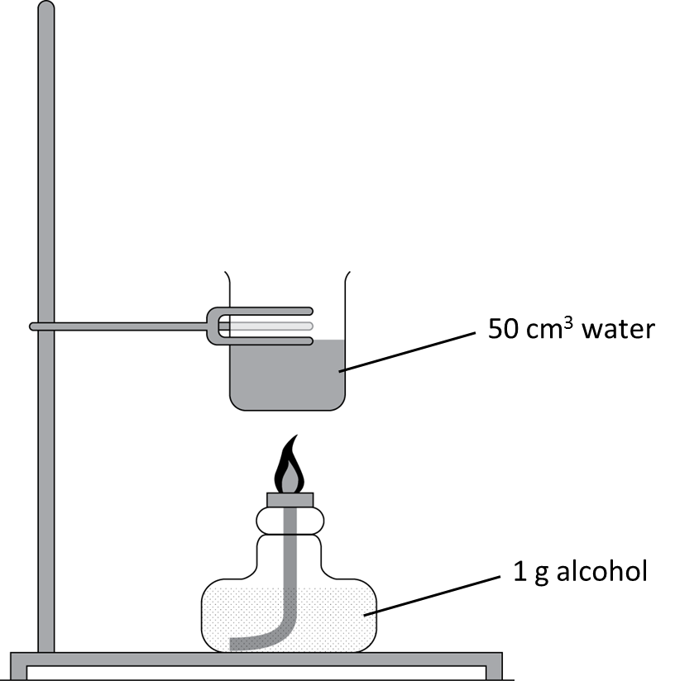

**Table 1** shows their results.

**Table 1**

|  |  |  |  |  |  |
| --- | --- | --- | --- | --- | --- |
| Name of alcohol | Number of carbon atoms in one molecule of alcohol | Temperature rise when 1 g was burnt in °C | | | |
| First trial | Second trial | Third trial | Mean |
| propanol | 3 | 15.9 | 17.6 | 16.2 |  |
| butanol | 4 | 16.8 | 17.0 | 16.6 | 16.8 |
| pentanol | 5 | 17.1 | 17.3 | 17.2 | 17.2 |
| hexanol | 6 | 17.4 | 17.4 | 17.4 | 17.4 |

|  |  |  |  |
| --- | --- | --- | --- |
| **0** | **1** | **.** | **1** |

One of the group’s measurements was taken when more than 1 g of propanol had been burnt. Calculate the mean temperature rise when 1 g of propanol was burnt, taking this error into account.

Give your answer to 3 significant figures.

(*2 marks*)

Mean temperature rise   °C

|  |  |  |  |
| --- | --- | --- | --- |
| **0** | **1** | **.** | **2** |

Estimate the mean temperature rise expected for 1 g of heptanol, C7H15OH.

Mean temperature rise   °C (1 mark)

|  |  |  |  |
| --- | --- | --- | --- |
| **0** | **1** | **.** | **3** |

Describe **one** change the students could make to the apparatus so that all of the alcohols produced a larger temperature rise.

(*1 mark*)

|  |  |  |  |
| --- | --- | --- | --- |
| **0** | **1** | **.** | **4** |

The students noticed that as the number of carbon atoms in one molecule of the alcohol increased, more soot was left on the bottom of the beaker.

Suggest why.

(*1 mark*)

|  |  |  |  |
| --- | --- | --- | --- |
| **0** | **2** |  |  |

Ethanol is useful as a solvent and a fuel. It can be made from renewable or non-renewable resources.

Compare **two** ways of producing ethanol. You should name the starting materials and the products and state the reaction conditions for each process.

(*6 marks*)

|  |  |  |  |
| --- | --- | --- | --- |
| **0** | **3** | **.** | **1** |

Butanoic acid is a carboxylic acid. Carboxylic acids dissolve in water to form acidic solutions.

Complete the symbol equation to show the reaction that takes place between butanoic acid and water.

CH3CH2CH2COOH(aq) ⇌ (aq) + (aq) (*2 marks*)

|  |  |  |  |
| --- | --- | --- | --- |
| **0** | **3** | **.** | **2** |

A student tests a solution of propanoic acid by reacting it with sodium carbonate.

Complete the word equation for this reaction. (*1 mark*)

propanoic + sodium → + water + carbon

acid carbonate dioxide

|  |  |  |  |
| --- | --- | --- | --- |
| **0** | **3** | **.** | **3** |

Complete the symbol equation for the reaction in **03.2**. (*1 mark*)

2CH3CH2COOH(aq) + Na2CO3(aq) → 2(aq) + H2O(l) + CO2(g)

|  |  |  |  |
| --- | --- | --- | --- |
| **0** | **3** | **.** | **4** |

Describe what the student would observe to show that a chemical reaction is taking place.

(*1 mark*)

|  |  |  |  |
| --- | --- | --- | --- |
| **0** | **3** | **.** | **5** |

Carboxylic acids react with alcohols to product organic compounds called esters. Esters have a fruity smell.

Propanoic acid reacts with ethanol to produce the ester ethyl propanoate.

**Figure 2** shows the displayed formula for ethyl propanoate.

**Figure 2**

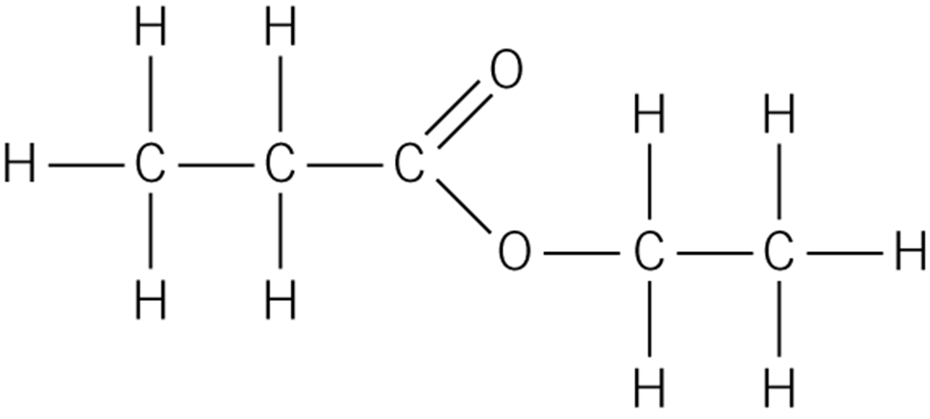

Another ester is shown in **Figure 3**.

**Figure 3**

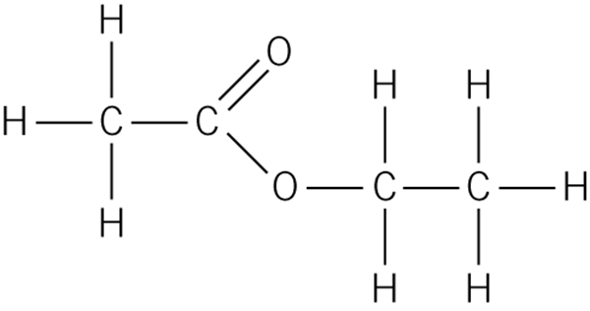

Name the carboxylic acid and the alcohol used to make this ester.

Carboxylic acid:

Alcohol: (*2 marks*)

|  |  |  |  |
| --- | --- | --- | --- |
| **0** | **4** |  |  |

Propene is a hydrocarbon obtained by cracking long alkane molecules. Its displayed formula is displayed in **Figure 4**.

**Figure 4**

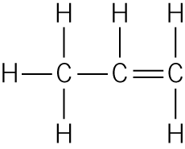

|  |  |  |  |
| --- | --- | --- | --- |
| **0** | **4** | **.** | **1** |

Propene is described as unsaturated.

Describe what the term unsaturated means.

(*1 mark*)

|  |  |  |  |
| --- | --- | --- | --- |
| **0** | **4** | **.** | **2** |

Propene reacts with chlorine and hydrogen.

Complete the displayed formula below to show the product of the reaction between propene and chlorine.

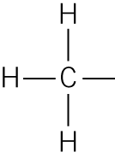 (1 mark)

|  |  |  |  |
| --- | --- | --- | --- |
| **0** | **4** | **.** | **3** |

Give the molecular formula of the product of the reaction between propene and hydrogen.

(*1 mark*)

|  |  |  |  |
| --- | --- | --- | --- |
| **0** | **4** | **.** | **4** |

Describe the different reaction conditions needed for propene to react with chlorine and hydrogen.

(*3 marks*)

|  |  |  |  |
| --- | --- | --- | --- |
| **0** | **5** | **.** | **1** |

The structural formula of butanoic acid is shown below.

Draw a ring around the functional group. (1 mark)

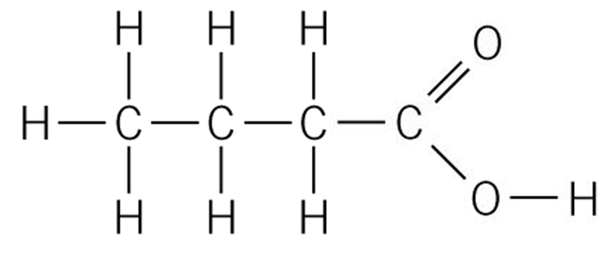

|  |  |  |  |
| --- | --- | --- | --- |
| **0** | **5** | **.** | **2** |

Solutions of butanoic acid and sulfuric acid of concentration 1 mol/dm3 have different pH values.

Explain why a solution of sulfuric acid has a lower pH than a solution of butanoic acid with the same concentration.

(*2 marks*)

|  |  |  |  |
| --- | --- | --- | --- |
| **0** | **5** | **.** | **3** |

A student added an equal mass of sodium carbonate to two test tubes, one containing butanoic acid and one with sulfuric acid, both of the same concentration.

Name the gas produced in each test tube.

(*1 mark*)

|  |  |  |  |
| --- | --- | --- | --- |
| **0** | **5** | **.** | **4** |

Describe **and** explain **one** difference the student saw in the reactions.

(*2 marks*)