Magnetism and Electricity (Blue level)

1. Which method would be the most effective to test the strength of a magnet? [1 mark]

a) See if the magnet will pick up a 100 g mass

b) Count the number of paper clips the magnet will hold

c) Sprinkle iron filings around the magnet and count the number of magnetic field lines

d) See if it will repel a bigger magnet

2. Complete this sentence: The Earth has its own magnetic field with a magnetic \_\_ [1 mark]

a) N pole at its centre

b) S pole at its centre

c) N pole at its geographic North pole

d) S pole at its geographic North pole

3. Which statement about lights in your house is true? [1 mark]

a) Lights are wired in series so they can be switched on or off individually

b) Lights are wired in parallel so they can be switched on or off individually

c) Lights are wired in series so they each get the same voltage

d) Lights are wired in parallel so they each get the same current

4. Which arrangement would produce the strongest electromagnet? [1 mark]

a) Low current, high number of coils, iron core

b) High current, low number of coils, iron core

c) High current, high number of coils, iron core

d) High current, high number of coils, copper core

5. Six different objects were tested to see if electricity would flow through them using a simple circuit and a light bulb. The results are shown in the table.

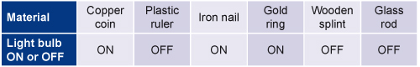

Which statement is the best general conclusion you can draw from the results? [1 mark]

a) Copper conducts but plastic doesn’t

b) Metals are good conductors

c) Some objects conduct and some don’t

d) Metals are good conductors and non metals are good insulators

6. Six metals are listed in order of their reactivity, from the most reactive to the least reactivate.

MAGNESIUM, ZINC, IRON, TIN, LEAD, COPPER

Which combination will produce the highest voltage when used in a battery? [1 mark]

a) Magnesium and zinc

b) Magnesium and copper

c) Zinc and lead

d) Zinc and copper

7. Which one of these would not make a D.C. motor in a battery powered car run faster? [1 mark]

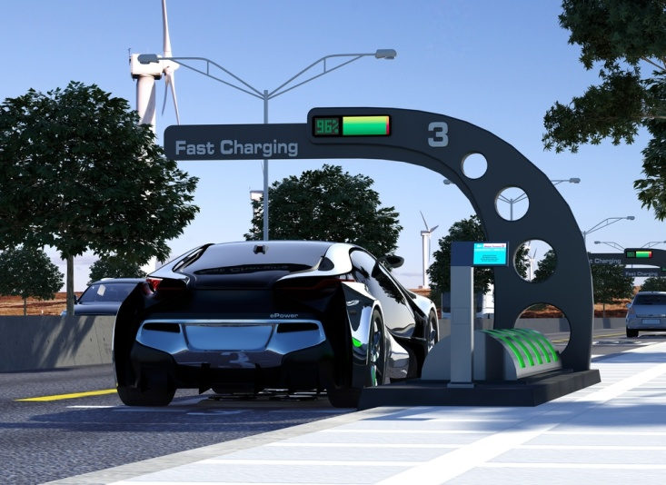

a) Increasing the number of coils

b) Increasing the strength of the magnets

c) Increasing the voltage supplied

d) Increasing the size of the car’s road wheels

6. Which two statements about magnetism are true? [1 mark]

a) Magnetism is an example of a contact force

b) Alloys of cobalt and iron are usually magnetic

c) Magnets have four poles: north, south, east and west

d) Two magnets can attract or repel each other depending on their orientation

8. Match the circuit diagrams to the correct descriptions. [1 mark]

|  |  |  |
| --- | --- | --- |
| 540211_sci_ass_ch6_13_A.jpg |  | Two cells with two bulbs in parallel |
|  |  |  |
| 540211_sci_ass_ch6_13_B.jpg |  | Two cells with three bulbs in parallel |
|  |  |  |
| 540211_sci_ass_ch6_13_C.jpg |  | Two cells with two bulbs in series |
|  |  |  |
| 540211_sci_ass_ch6_13_D.jpg |  | One cell with two bulbs in series |

9. What two parts would you find in an electric bell? [1 mark]

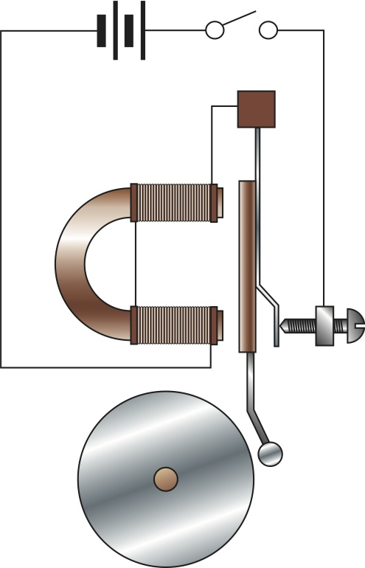

a) A coiled spring

b) A plastic core

c) An iron armature

d) A hammer and bell

10. Choose two actions that would make the current bigger in a series circuit. [1 mark]

a) Add more cells

b) Add more light bulbs

c) Use fewer cells

d) Use fewer light bulbs

11. In a simple D.C. motor, how can the movement be stopped and how can it be reversed? [2 marks]

12. Explain the difference between a permanent and temporary magnet. Give an example of each. [2 marks]

13. Explain why touching a 1.5 V battery won’t kill you but touching 240 V mains might. [2 marks]

14. Compare the differences between two bulbs connected in series to a single cell, with two bulbs connected in parallel to a single cell. [2 marks]

15. Describe how an electric bell works. [4 marks]



16. Simon set up this circuit to investigate how a bulb behaved if the voltage supplied to it changed. Explain how he used the circuit to get the readings and what the readings show. [4 marks]

|  |  |
| --- | --- |
| Voltage | Current |
| 0 | 0 |
| 1 | 0.20 |
| 2 | 0.38 |
| 3 | 0.55 |
| 4 | 0.70 |

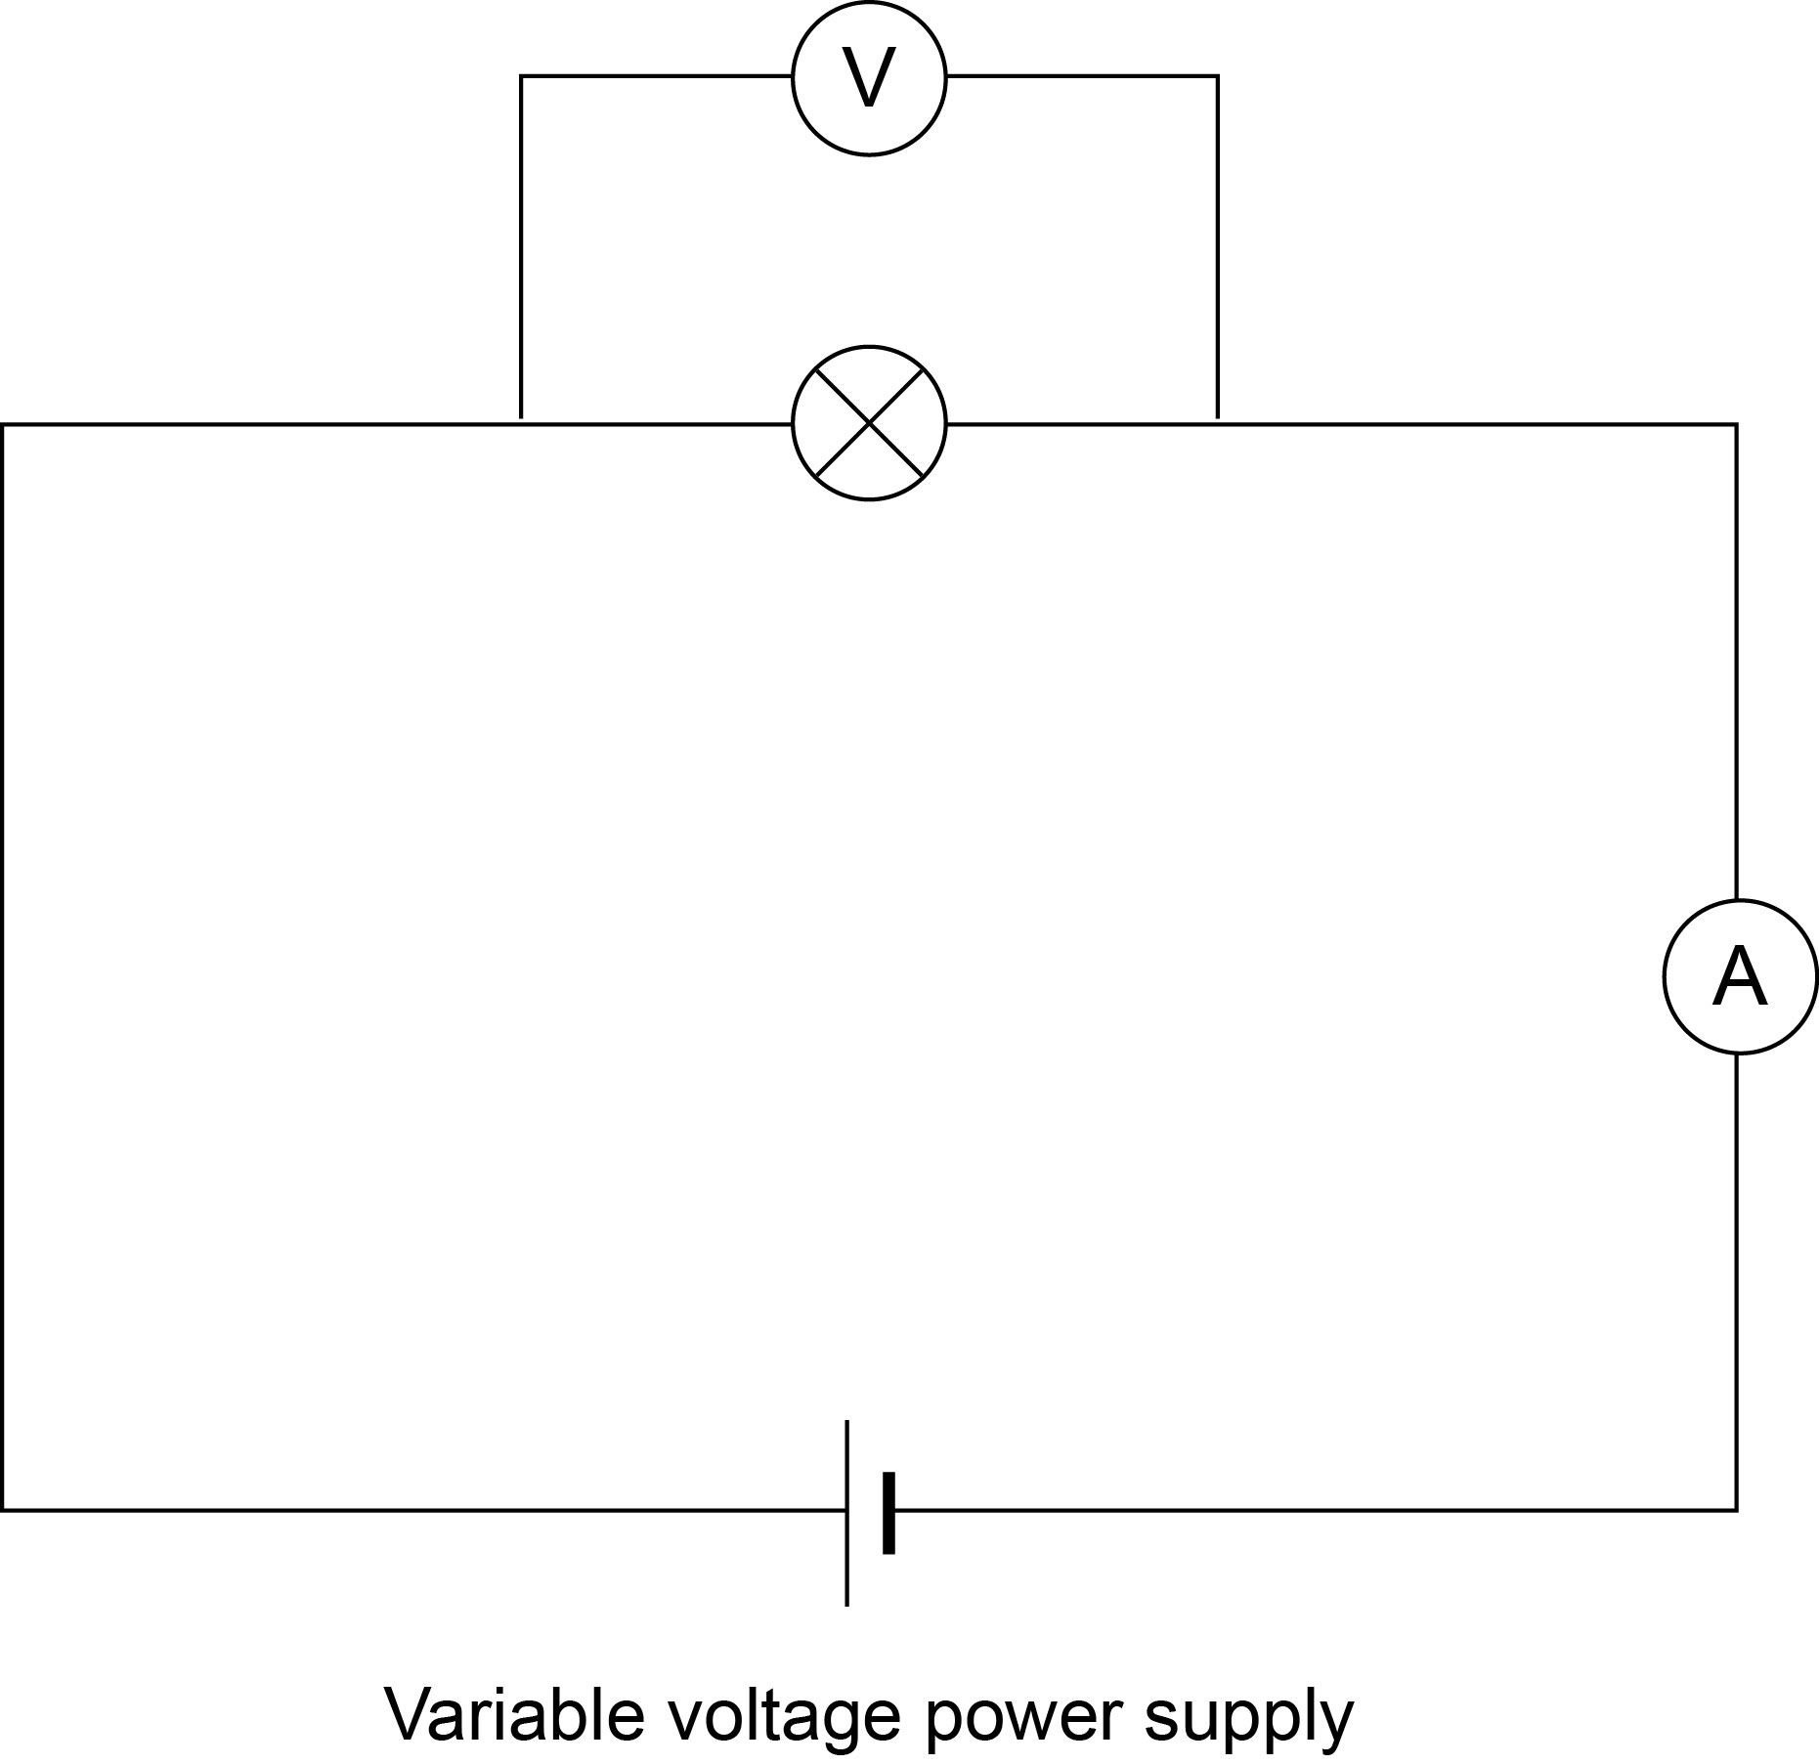

17. Adam is designing a circuit to control the lights in a toy house. The house has a staircase and the circuit has to control the lights on the staircase so they can be turned on or off both at the top of the stairs and at the bottom.

This is his design. Look at this and explain how it works. [4 marks]

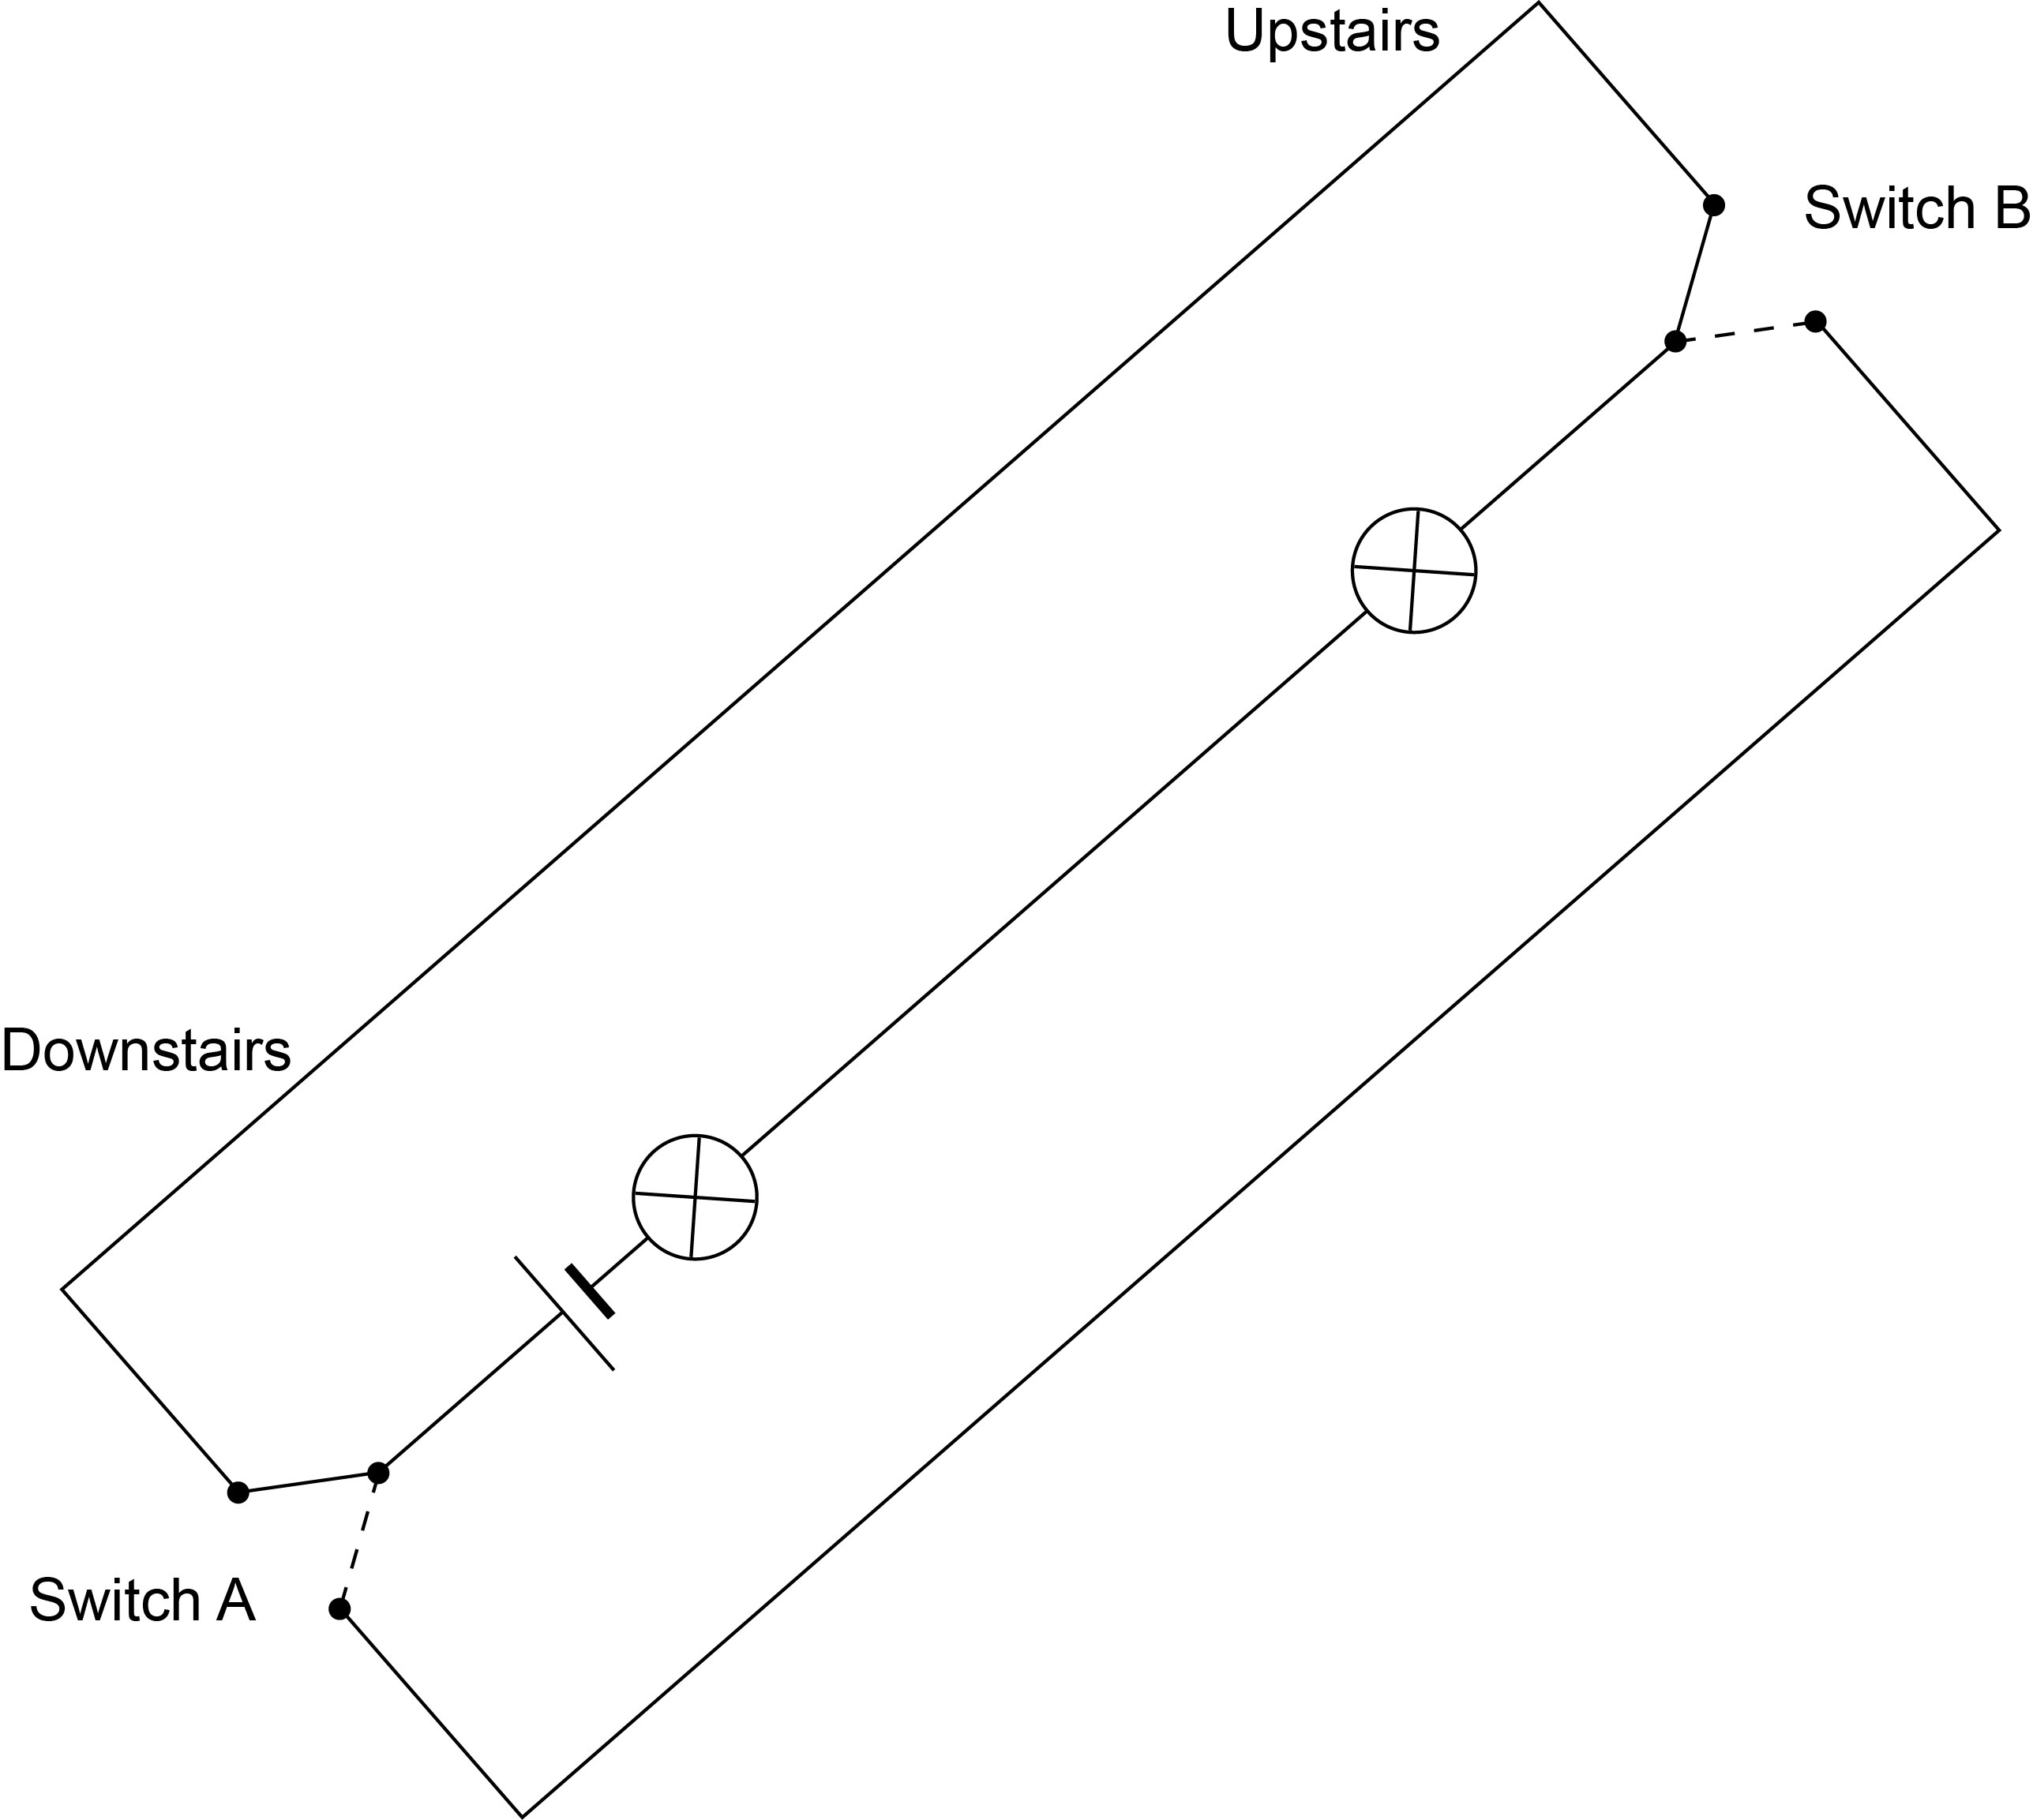

8. Describe how you could show the shape and direction of a field around a magnet. [2 marks]

15. Jo has three objects hidden inside separate wrappers. She knows that one is a magnet. Another is magnetic and the third is non-magnetic. She has to work out which is which, using nothing but the three objects. How could she tell which was which? [2 marks]