Question | Answers | Extra information | Marks | AO /  Spec ref.
01 | many  monomers  double |  | 1  1  1 | AO1  C7.3.1
02 | ethene — poly(ethene)  monosaccharide — cellulose  amino acid — protein |  | 1  1  1 | AO1  C7.3.1  C7.3.4
03 | 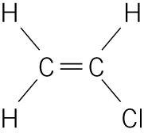 — 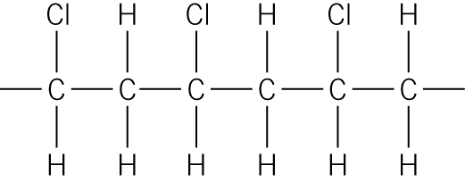  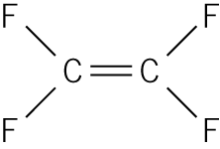 — 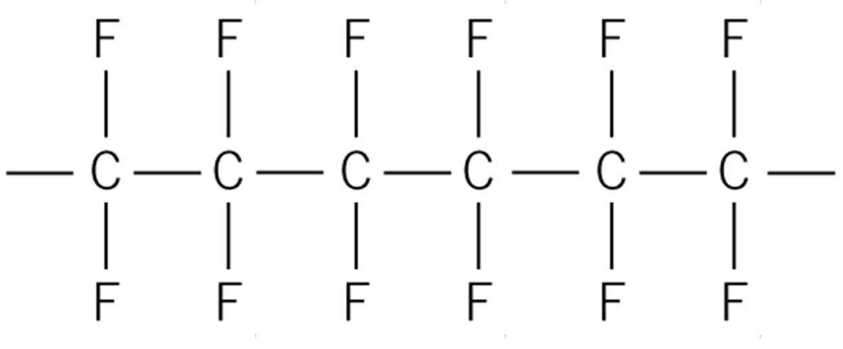  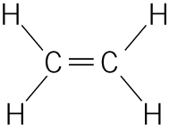 — 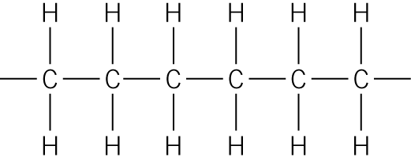 | 1 mark for each correct link;  more than one line from monomer box gets no mark. | 3 | AO2  C7.3.1
04.1 | (very) strong/flexible/hardwearing | Accept does not rot/not biodegradable. | 1 | AO2  C7.3.1
04.2 | propene | No mark if more than one box ticked. | 1 | AO2  C7.3.1
04.3 | addition | No mark if more than one box ticked. | 1 | AO1  C7.3.1
04.4 | 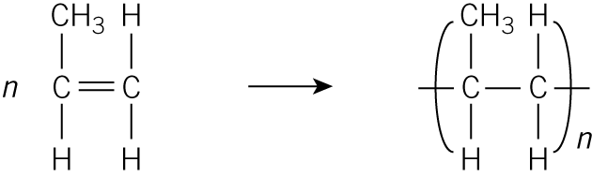 | No mark if more than one box ticked. | 1 | AO2  C7.3.1
04.5 | poly(tetrafluoroethene) | Brackets required. | 1 | AO2  C7.3.1
05.1 | starch  cellulose |  | 1  1 | AO2  C7.3.4
05.2 | DNA or deoxyribonucleic acid |  | 1 | AO2  C7.3.4
06.1 | chloroethene | Accept vinyl chloride. | 1 | AO2  C7.3.1
06.2 | Smooth line of best fit touching all points. | Do not accept ‘dot to dot’ lines. | 1 | AO3  C7.3.1
06.3 | constant thickness or width of strips | Accept length. | 1 | AO3  C7.3.1
06.4 | Subtracted initial length (or 10cm) from stretched length. |  | 1 | AO3  C7.3.1
06.5 | The strip snapped/broke. | Accept any sensible reason. | 1 | AO3  C7.3.1
06.6 | poly(ethene)  the graph/line/curve is steeper/rises more quickly | Accept ‘the extensions increase sooner/more quickly/with less force’. | 1  1 | AO3  C7.3.1
07 | Level 3 (5–6 marks): There is a reasonably detailed description of the structure and explanation of the importance. |  | 6 | AO1×4  AO2×2  C7.3.4
 | Level 2 (3–4 marks): There is a basic description of the structure and explanation of the importance.
 | Level 1 (1–2 marks): There is a basic description of the structure or explanation of the importance.
 | Level 0 (0 marks): No relevant content.
Indicative content:
Structure:
- large molecule
- polymer
- helix/spiral
- double/two chains
- four different monomers
- nucleotides
- intermolecular forces
Importance:
- essential for living things
- genetic instructions/genes
- controls development/function
- viruses.
This indicative content is not exhaustive, other creditworthy responses should be awarded marks as appropriate.

