|  |  |  |  |
| --- | --- | --- | --- |
| **0** | **1** |  |  |

The properties of molecules in crude oil depend on their size.

Match the properties of molecules in crude oil with their sizes. Draw **four** lines.

|  |  |  |
| --- | --- | --- |
| **Property** |  | **Size of molecules** |
|  |  |  |
| gases at room temperature |  |  |
|  |  | small molecules |
| high boiling point |  |  |
|  |  |  |
| low viscosity |  |  |
|  |  | large molecules |
| very flammable |  |  |

(3 marks)

|  |  |  |  |
| --- | --- | --- | --- |
| **0** | **2** |  |  |

Crude oil is a mixture of many different chemical compounds.

|  |  |  |  |
| --- | --- | --- | --- |
| **0** | **2** | **.** | **1** |

Fuels, such as petrol (gasoline), can be produced from crude oil.

Fuels react with oxygen to transfer energy to the surroundings.

Name the type of reaction that releases energy from a fuel.

(*1 mark*)

|  |  |  |  |
| --- | --- | --- | --- |
| **0** | **2** | **.** | **2** |

Fuels react with oxygen to produce carbon dioxide. The reaction of a fuel with oxygen can also produce a different oxide of carbon.

Name this different oxide of carbon and explain why it is produced.

(*2 marks*)

|  |  |  |  |
| --- | --- | --- | --- |
| **0** | **2** | **.** | **3** |

Most of the compounds in crude oil are hydrocarbons. Hydrocarbons with the smallest molecules are very volatile.

**Figure 1**

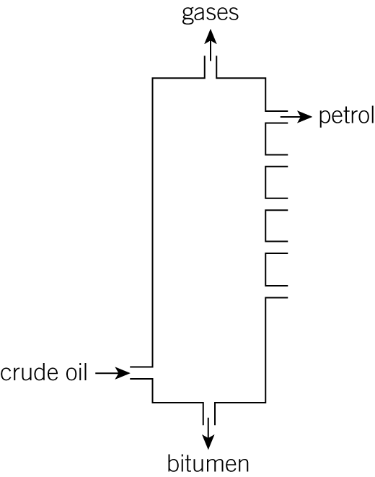

Describe and explain how **petrol** is separated from the mixture of hydrocarbons in crude oil.

Use **Figure 1** and your knowledge to answer this question.

(*6 marks*)

*AQA, 2013*

|  |  |  |  |
| --- | --- | --- | --- |
| **0** | **3** |  |  |

**Table 1** shows the boiling points of some alkanes.

**Table 1**

|  |  |  |
| --- | --- | --- |
| Name | Formula | Boiling point in°C |
|  | C4H10 | 0 |
| pentane | C5H12 | 36 |
| hexane | C6H14 | 69 |
| heptane | C7H16 |  |
| octane | C8H18 | 126 |
| nonane | C9H20 | 151 |
| decane | C10H22 | 174 |

|  |  |  |  |
| --- | --- | --- | --- |
| **0** | **3** | **.** | **1** |

The alkanes belong to a homologous series.

Give the general formula of the alkane series.

(*1 mark*)

|  |  |  |  |
| --- | --- | --- | --- |
| **0** | **3** | **.** | **1** |

Give the formula of the alkane whose molecules contain 28 hydrogen atoms.

(*1 mark*)

|  |  |  |  |
| --- | --- | --- | --- |
| **0** | **3** | **.** | **3** |

Draw the **displayed** formula for pentane, C5H12. (1 mark)

|  |  |  |  |
| --- | --- | --- | --- |
| **0** | **3** | **.** | **4** |

On the grid in **Figure 2** plot a graph of the number of carbon atoms in each alkane molecule against its boiling point in °C.

Draw a line of best fit. (3 marks)

**Figure 2**

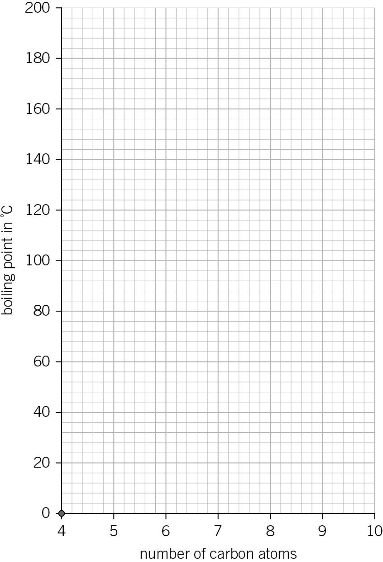

|  |  |  |  |
| --- | --- | --- | --- |
| **0** | **3** | **.** | **5** |

Use the **Figure 2** to estimate the boiling point of heptane, C7H16.

 °C (*1 mark*)

|  |  |  |  |
| --- | --- | --- | --- |
| **0** | **3** | **.** | **6** |

Use the **Table 1** to give an approximate estimate of the boiling point of propane, C3H8.

 °C (*1 mark*)

|  |  |  |  |
| --- | --- | --- | --- |
| **0** | **4** |  |  |

This question is about changing large hydrocarbon molecules into smaller ones.

The apparatus in **Figure 3** shows how this can be done in the laboratory.

**Figure 3**

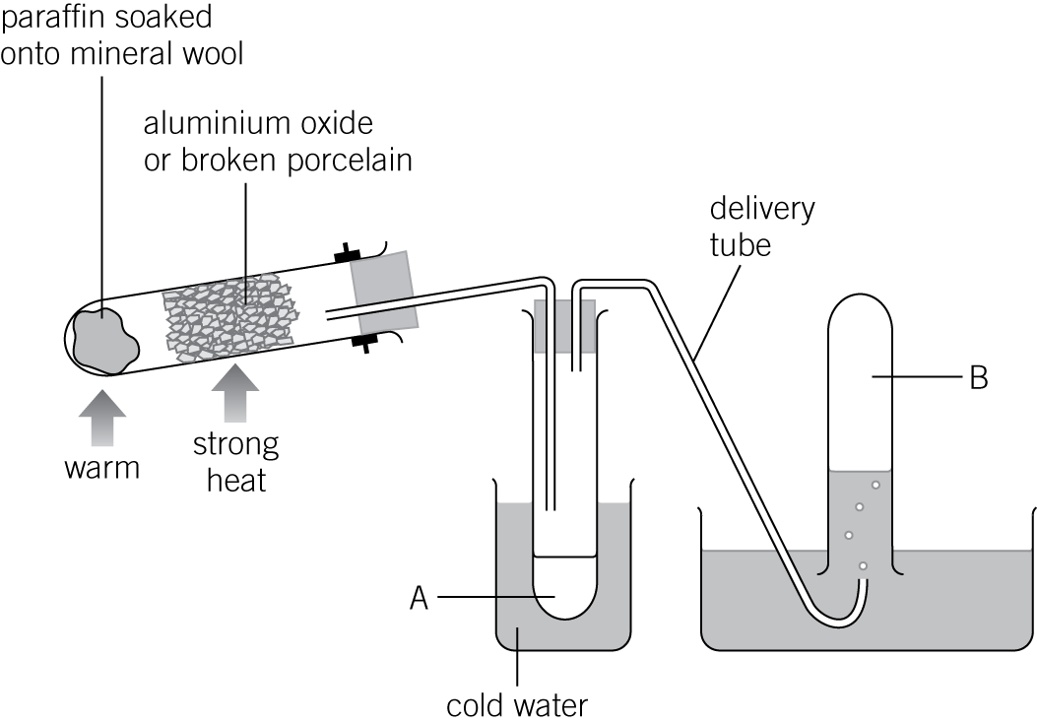

|  |  |  |  |
| --- | --- | --- | --- |
| **0** | **4** | **.** | **1** |

Name this process.

(*1 mark*)

|  |  |  |  |
| --- | --- | --- | --- |
| **0** | **4** | **.** | **2** |

The paraffin used is a mixture of alkanes.

Describe what happens if paraffin is shaken with bromine water.

(*1 mark*)

|  |  |  |  |
| --- | --- | --- | --- |
| **0** | **4** | **.** | **3** |

Describe **and** explain what happens if **B** is shaken with bromine water.

(*2 marks*)

|  |  |  |  |
| --- | --- | --- | --- |
| **0** | **4** | **.** | **4** |

Which product, **A** or **B**, contains smaller molecules?

Explain your answer.

(*2 marks*)

|  |  |  |  |
| --- | --- | --- | --- |
| **0** | **4** | **.** | **5** |

Paraffin contains dodecane, C12H26.

Balance the equation for one possible reaction of dodecane:

C12H26 → C6H14  C2H4 (1 mark)

|  |  |  |  |
| --- | --- | --- | --- |
| **0** | **4** | **.** | **6** |

Suggest why changing dodecane into smaller molecules is useful.

(*3 marks*)