|  |  |  |  |
| --- | --- | --- | --- |
| **0** | **1** |  |  |

Draw **one** line connecting each small molecule below to its corresponding polymer. (*3 marks*)

|  |  |  |  |  |  |  |
| --- | --- | --- | --- | --- | --- | --- |
| Small molecule | | |  | Polymer | | |
|  | | |  |  | | |
|  | | |  | | protein |
| ethene |  | | |  |
|  |  | | | poly(ethane) |
|  |  | | |  |
| monosaccharide |  | | | DNA |
|  |  | | |  |
|  |  | | | cellulose |
| amino acid |  | | |  |
|  | | |  | | poly(ethene) |

|  |  |  |  |
| --- | --- | --- | --- |
| **0** | **2** |  |  |

Carrier bags can be made from poly(ethene), poly(propene), or poly(chloroethene). Different polymers stretch differently when forces are applied to them.

|  |  |  |  |
| --- | --- | --- | --- |
| **0** | **2** | **.** | **1** |

Give the name of the small molecule poly(chloroethene) is made from.

(*1 mark*)

|  |  |  |  |
| --- | --- | --- | --- |
| **0** | **2** | **.** | **2** |

Some students wanted to compare how much each type of bag stretched when a force was added (**Figure 1**).

**Figure 1**

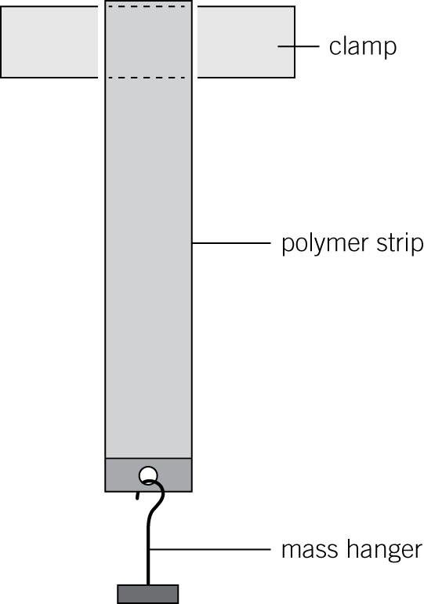

They used the following method:

**1** Cut a 10 cm strip from a bag.

**2** Clamp the strip to a stand.

**3** Add masses to the mass hanger.

**4** Measure the new length of the strip each time.

**5** Repeat the experiment with strips from the other bags.

They recorded their results (**Table 1**), and plotted a graph (**Figure 2**).

**Table 1**

|  |  |  |  |
| --- | --- | --- | --- |
| Force in N | Extension in cm | | |
| poly(ethene) | poly(propene) | poly(chloroethene) |
| 0 | 0.00 | 0.00 | 0.00 |
| 2 | 0.15 | 0.10 | 0.05 |
| 4 | 0.35 | 0.25 | 0.15 |
| 6 | 0.70 | 0.55 | 0.40 |
| 8 | 1.40 | 1.05 | 0.80 |
| 10 | 3.00 | 1.75 | 1.35 |
| 12 | 5.90 | 2.70 | 2.00 |
| 14 |  | 3.90 | 2.70 |
| 16 |  | 5.50 | 3.50 |
| 18 |  |  | 4.40 |
| 20 |  |  | 5.30 |

**Figure 2**

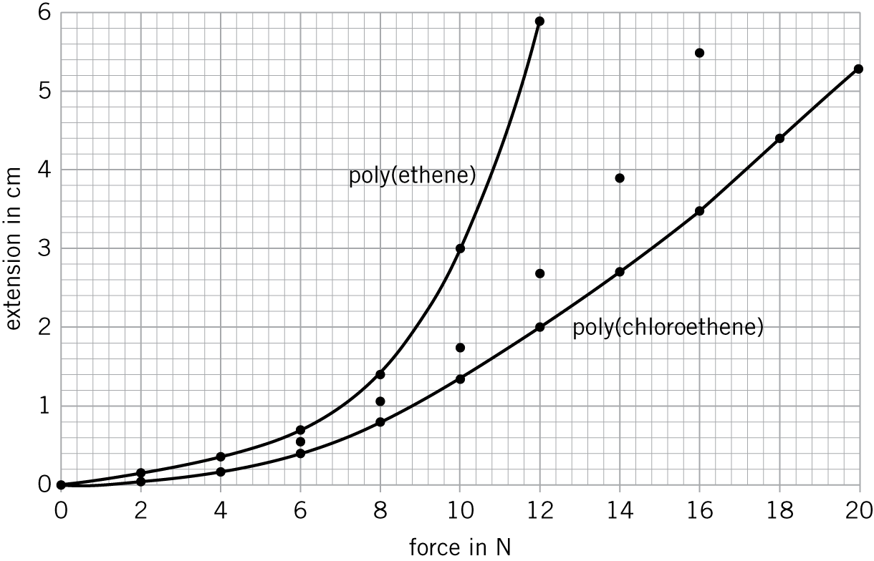

On **Figure 2**, draw the line of best fit for poly(propene). (*1 mark*)

|  |  |  |  |
| --- | --- | --- | --- |
| **0** | **2** | **.** | **3** |

Give **one** variable the students needed to control to ensure valid results.

(*1 mark*)

|  |  |  |  |
| --- | --- | --- | --- |
| **0** | **2** | **.** | **4** |

Suggest how the students calculated the extension for each force.

(*1 mark*)

|  |  |  |  |
| --- | --- | --- | --- |
| **0** | **2** | **.** | **5** |

Suggest why the students could not complete **Table 1** for poly(ethene) and poly(propene).

(*1 mark*)

|  |  |  |  |
| --- | --- | --- | --- |
| **0** | **2** | **.** | **6** |

Identify which polymer stretches most easily. Use **Figure 2** to explain your answer.

(*2 marks*)

|  |  |  |  |
| --- | --- | --- | --- |
| **0** | **3** |  |  |

**Figure 3** shows a simplified model of a DNA molecule.

**Figure 3**

**

Use **Figure 3** and your knowledge and understanding to describe the structure of DNA, and explain its importance to living organisms.

(*6 marks*)

|  |  |  |  |
| --- | --- | --- | --- |
| **0** | **4** |  |  |

PTFE is a polymer that is used as a non-stick coating on frying pans.

PTFE is made from many molecules of tetrafluoroethene.

|  |  |  |  |
| --- | --- | --- | --- |
| **0** | **4** | **.** | **1** |

Give the full chemical name of PTFE.

(*1 mark*)

|  |  |  |  |
| --- | --- | --- | --- |
| **0** | **4** | **.** | **2** |

Describe how PTFE is formed from its monomer.

(*2 marks*)

|  |  |  |  |
| --- | --- | --- | --- |
| **0** | **4** | **.** | **3** |

Complete the equation that represents how PTFE is formed from its monomer. (*3 marks*)

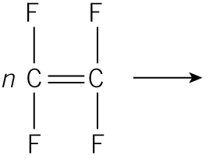 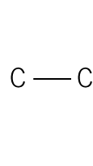

|  |  |  |  |
| --- | --- | --- | --- |
| **0** | **5** |  |  |

Soft drinks bottles are made from a polymer called PET.

PET is a condensation polymer.

The equation for the formation of PET is:

**

|  |  |  |  |
| --- | --- | --- | --- |
| **0** | **5** | **.** | **1** |

How does the equation show that PET is a condensation polymer?

(*1 mark*)

|  |  |  |  |
| --- | --- | --- | --- |
| **0** | **5** | **.** | **2** |

**Monomer A** and **monomer B** have different functional groups.

Name the functional group in:

**Monomer A:** (*1 mark*)

**Monomer B:** (*1 mark*)

|  |  |  |  |
| --- | --- | --- | --- |
| **0** | **5** | **.** | **3** |

Name the type of condensation polymer that PET is by completing the word below.

PET is a poly. (*1 mark*)

|  |  |  |  |
| --- | --- | --- | --- |
| **0** | **5** | **.** | **4** |

Polypeptides are also condensation polymers.

One monomer that can form a polypeptide is glycine (**Figure 4**).

**Figure 4**

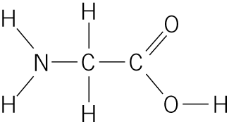

Name the group of compounds glycine belongs to.

(*1 mark*)

|  |  |  |  |
| --- | --- | --- | --- |
| **0** | **5** | **.** | **5** |

Complete the diagram below to show how two glycine molecules link together.

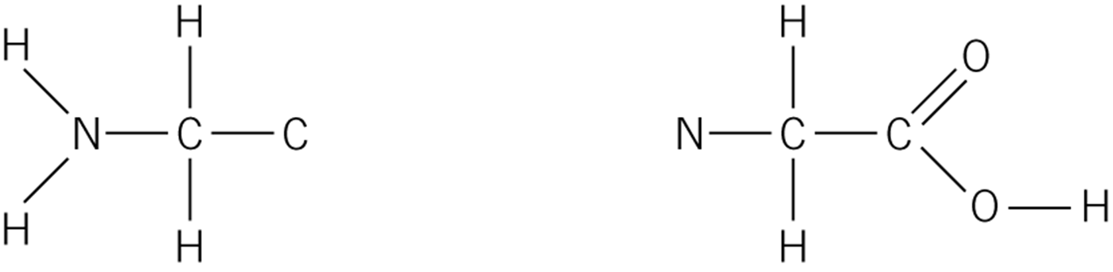  (*2 marks*)

|  |  |  |  |
| --- | --- | --- | --- |
| **0** | **5** | **.** | **6** |

Name the small molecule that is also formed when glycine polymerises.

(*1 mark*)