V:\Ed-Departments\Editorial\Ed Secondary\Sec Sci Maths\Sci\GCSE Sci 2016\Kerboodle AQA GW\Design elements\Higher Tab below.jpg Extracting copper from malachite

Specification reference

* C10.1.4 Alternative methods of extracting metals 

Aims

In this activity you will find out how to extract copper from a sample of copper ore.

Learning outcomes

After completing this activity, you should be able to:

* describe the processes of phytomining and bioleaching
* write balanced symbol equations to explain metal extraction techniques
* explain the need for new ways of extracting metals (in particular copper)
* explain in detail how phytomining and bioleaching extract metals
* write word, symbol, and ionic equations to explain metal extraction techniques and identify the species being oxidised or reduced
* realise low quality ores can be extracted economically by certain methods.

Safety

* Copper oxide, copper carbonate, and copper sulfate solution are harmful and corrosive chemicals.
* Sulfuric acid is a corrosive chemical.
* Chemical splash proof eye protection MUST be worn throughout.
* Wash hands after completing the practical.

Equipment

|  |  |
| --- | --- |
| * Bunsen burner * flameproof mat * spatula * dropping pipette * boiling tube * boiling tube holder * boiling tube rack * filter funnel * filter paper * 100 cm3 conical flask * mineral wool | * 100 cm3 beaker * three wires * two crocodile clips * low voltage power supply * two carbon electrodes * copper carbonate powder * 2 mol/dm3 (dilute) sulfuric acid * iron nail |

Setting the scene

Malachite is a copper ore containing copper carbonate (CuCO3). In the school laboratory there are two methods we can use to extract copper from malachite ore:

1 Thermally decompose the malachite to make copper oxide, and then dissolve the copper oxide in sulfuric acid to produce copper sulfate solution. We then displace the copper from this solution with a more reactive metal.

2 We produce copper sulfate solution from the malachite by adding sulfuric acid and filtering. We then electrolyse the solution to extract the copper.

Method 1

1 Place three spatulas of copper carbonate in the boiling tube.

2 Using the boiling tube holder heat strongly at a 45° angle in blue Bunsen flame (see Diagram 1). Adding a plug of mineral wool will help to keep the copper carbonate powder in the test tube and reduce the fumes.

3 When all the powder has changed from green to black, remove the heat and allow to cool in the boiling tube rack.

4 Using a dropping pipette, half fill the boiling tube with dilute sulfuric acid (see Diagram 2).

5 Mix well and leave for a minute for the reaction to complete.

6 Filter the contents of the boiling tube into a conical flask and keep the filtrate (see Diagram 3).

7 Place an iron nail into this filtrate and record what you see.

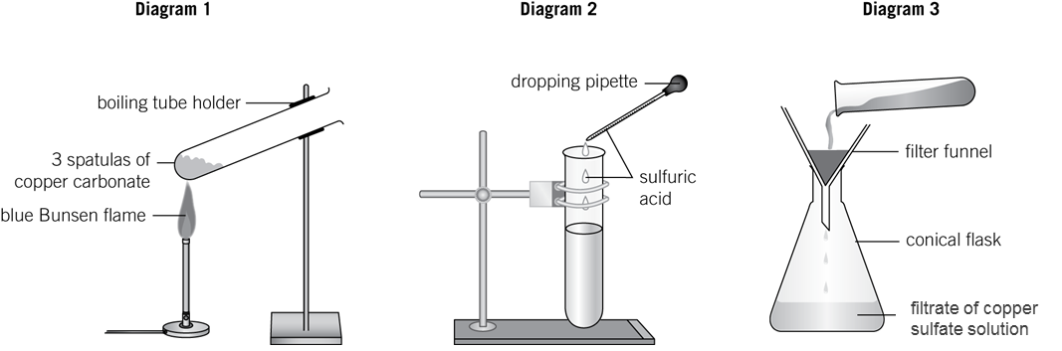

Method 2

1 Slowly add sulfuric acid to three spatulas of copper carbonate in a beaker.

2 When the bubbling stops filter the solution to obtain a blue solution of copper sulfate.

3 Pour the copper sulfate liquid into a small beaker.

4 Set up the electrolysis circuit as shown in the diagram below.

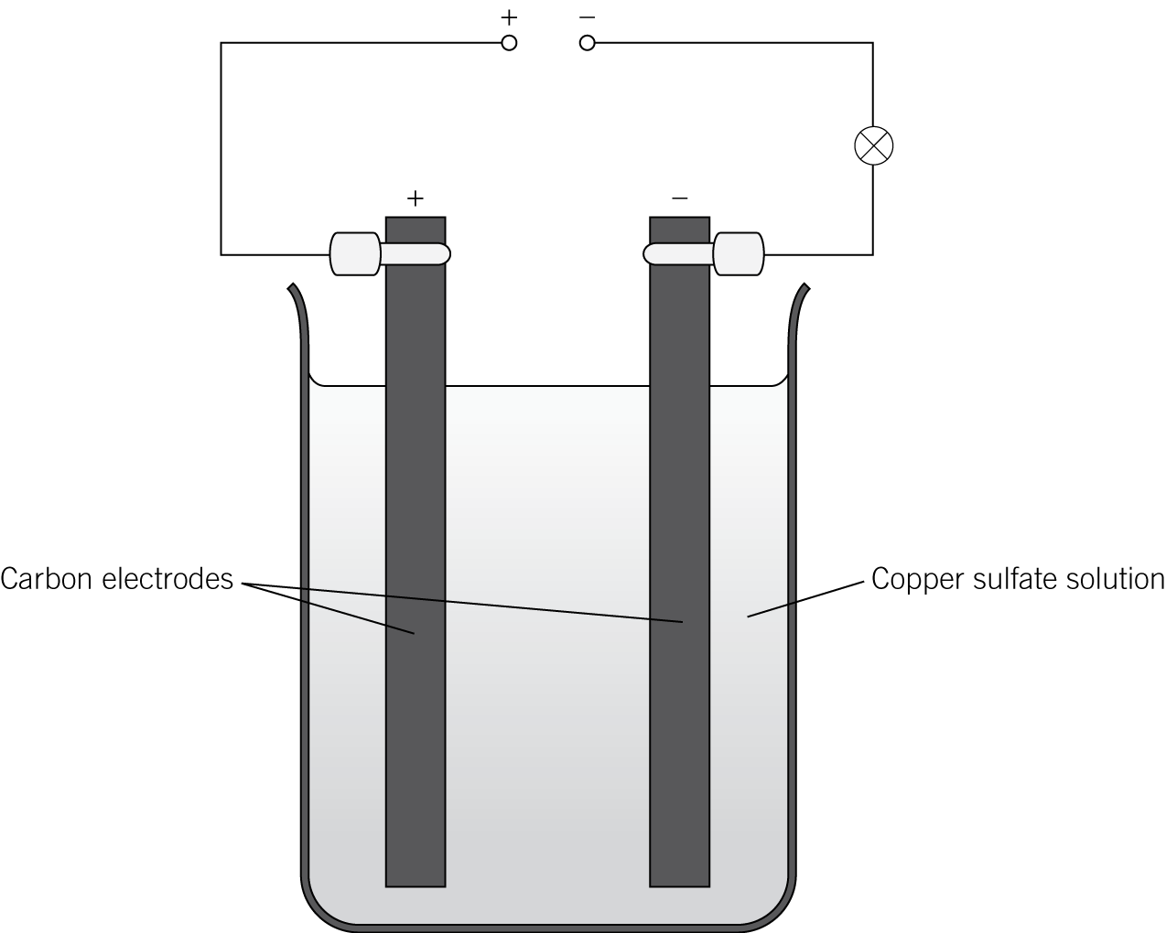

5 Turn on the power and record what you see.

Questions

1 a Complete the word equation for the thermal decomposition of copper carbonate (malachite):

copper carbonate →  (*2 marks*)

b Complete the balanced symbol equation, including state symbols, for the thermal decomposition of copper carbonate (malachite):

CuCO3(s) →  (*2 marks*)

2 a Complete the word equation for the displacement of copper by iron metal (the iron metal forms an iron(II) salt):

copper sulfate  iron →  (*2 marks*)

b Complete the balanced symbol equation, including state symbols, for the displacement of copper by iron metal:

CuSO4(aq)  → FeSO4(aq)  (*2 marks*)

c Complete the ionic equation, including state symbols, for the displacement of copper by iron metal:

Cu2+(aq)  Fe(s) →  (*2 marks*)

3 a Complete the word equation for the reaction of copper carbonate (malachite) with sulfuric acid:

copper carbonate  →   water (*3 marks*)

b Complete the balanced symbol equation, including state symbols, for the reaction of copper carbonate (malachite) with sulfuric acid:

CuCO3(s)  →  CO2(g)  (*3 marks*)

4 Complete the equation for the deposition of copper at the electrode (cathode):

Cu2+(aq)  → (*2 marks*)

Student follow-up

1 There is a finite amount of the copper ore malachite and it is in danger of running out. New techniques like **phytomining** and **bioleaching** have been developed to remove copper from low-grade ores.

Complete this statement about these processes by inserting the correct word from the list. Each word can only be used once.

|  |
| --- |
| copper burnt ash electrolysis bioleaching phytomining ions |

In plants are used to absorb copper from soil containing low-grade copper ore. The plants are then and the copper is extracted from the copper compounds in the In bacteria feed on low-grade copper ores. By various processes, a solution of ions, called the leachate is formed, which then undergoes to obtain the copper. (*6 marks*)

2 A student started with 24.70 g of malachite ore (CuCO3). After carrying out the extraction experiment, the weight of copper formed was 7.62 g. Use these figures to estimate the percentage copper content of the ore.

(Ar values: Cu  63.5, C  12, O  16).

(*5 marks*)