Forensic Science – Fingerprints

Look at the booklet – Structure of the Skin

1. Give any three of the functions of the skin. [3]

_______________________________________________________________________________________________

_______________________________________________________________________________________________

_______________________________________________________________________________________________

1. Why is the skin on the fingers not smooth? [1]

_______________________________________________________________________________________________

1. Name the three layers of the skin [3]

_______________________________________________________________________________________________

_______________________________________________________________________________________________

Look at the booklet – What are Fingerprints?

1. When are a person’s fingerprints formed? [1]

_______________________________________________________________________________________________

1. How would the fingerprints on a baby’s finger compare to their fingerprints when they have grown to their full adult size? [2]

_______________________________________________________________________________________________

_______________________________________________________________________________________________

1. How have fingerprints been used in history? [1]

_______________________________________________________________________________________________

_______________________________________________________________________________________________

1. What are the two main types of prints? Describe how each of these prints is taken/collected. [3]

_______________________________________________________________________________________________

_______________________________________________________________________________________________

_______________________________________________________________________________________________

1. What are the (calculated) chances of two fingerprints being identical? [1]

_______________________________________________________________________________________________

1. Do identical twins have (a) the same DNA and (b) the same fingerprints? [2]

_______________________________________________________________________________________________

1. List three important uses of fingerprints [3]

_______________________________________________________________________________________________

_______________________________________________________________________________________________

_______________________________________________________________________________________________

1. Use the booklet to help you fill in the words on this flow chart for identifying the features of a fingerprint. [20]

First Level Detail

Basic Pattern

More detailed pattern

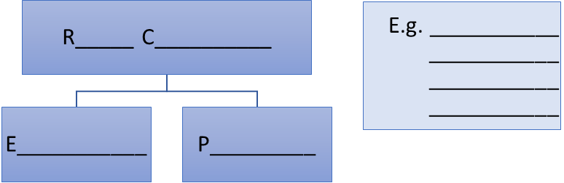

Second Level Detail

Third Level Detail

[Worksheet /40]