|  |  |  |  |
| --- | --- | --- | --- |
| **0** | **1** |  |  |

Use words from the box to complete the sentences below about polymers.

**proteins** **two**  **alkanes** **single** **monomers**

**double** **alcohols**  **many** **four**

When polymers form, small molecules called join together to make a very large molecule. For example, alkene molecules contain bonds which open up to let them join together. (*3 marks*)

|  |  |  |  |
| --- | --- | --- | --- |
| **0** | **2** |  |  |

Draw **one** line connecting each small molecule below to its corresponding polymer. (*3 marks*)

|  |  |  |  |  |  |  |
| --- | --- | --- | --- | --- | --- | --- |
| Small molecule | | |  | Polymer | | |
|  | | |  |  | | |
|  | | |  | | protein |
| ethene |  | | |  |
|  |  | | | poly(ethane) |
|  |  | | |  |
| monosaccharide |  | | | DNA |
|  |  | | |  |
|  |  | | | cellulose |
| amino acid |  | | |  |
|  | | |  | | poly(ethene) |

|  |  |  |  |
| --- | --- | --- | --- |
| **0** | **3** |  |  |

Small molecules can join together.

Link the displayed formulae of the monomers below with the polymers they can produce.

Draw **three** lines. (*3 marks*)

|  |  |  |
| --- | --- | --- |
| Monomer |  | Polymer |
|  |  |  |
|  |  | *Layout Disk 1:01_Q2A Media:OUP:GCSE Kerboodle Worksheets:Design HO 03/17:z_Source:Priority 1 – 31st March:PNGs:AQA Chemistry C11-C15 ESQs:oxo_aqa16_c11ss_xq01_awfg01d.png* |
|  |  |  |
| *Layout Disk 1:01_Q2A Media:OUP:GCSE Kerboodle Worksheets:Design HO 03/17:z_Source:Priority 1 – 31st March:PNGs:AQA Chemistry C11-C15 ESQs:oxo_aqa16_c11ss_xq01_awfg01a.png* |  | *Layout Disk 1:01_Q2A Media:OUP:GCSE Kerboodle Worksheets:Design HO 03/17:z_Source:Priority 1 – 31st March:PNGs:AQA Chemistry C11-C15 ESQs:oxo_aqa16_c11ss_xq01_awfg01e.png* |
|  |  |  |
| *add2 OS:Users:add2:Downloads:Small design handover:oxo_AQA16_C11_pt01_awfg08.png* |  |  |
|  |  |  |
| Layout Disk 1:01_Q2A Media:OUP:GCSE Kerboodle Worksheets:Design HO 03/17:z_Source:Priority 1 – 31st March:PNGs:AQA Chemistry C11-C15 ESQs:oxo_aqa16_c11ss_xq01_awfg01c.png |  | *Layout Disk 1:01_Q2A Media:OUP:GCSE Kerboodle Worksheets:Design HO 03/17:z_Source:Priority 1 – 31st March:PNGs:AQA Chemistry C11-C15 ESQs:oxo_aqa16_c11ss_xq01_awfg01g.png* |
|  |  |  |
|  |  | *Layout Disk 1:01_Q2A Media:OUP:GCSE Kerboodle Worksheets:Design HO 03/17:z_Source:Priority 1 – 31st March:PNGs:AQA Chemistry C11-C15 ESQs:oxo_aqa16_c11ss_xq01_awfg01h.png* |

|  |  |  |  |
| --- | --- | --- | --- |
| **0** | **4** |  |  |

Poly(propene) is a polymer that is used to make ropes.

|  |  |  |  |
| --- | --- | --- | --- |
| **0** | **4** | **.** | **1** |

Suggest why poly(propene) is suitable for making ropes.

(*1 mark*)

|  |  |  |  |
| --- | --- | --- | --- |
| **0** | **4** | **.** | **2** |

From which small molecules is poly(propene) made?

Tick (✓) **one** box.

ethene

propene

butene

propane (*1 mark*)

|  |  |  |  |
| --- | --- | --- | --- |
| **0** | **4** | **.** | **3** |

When poly(propene) is made, no other molecules are formed.

What type of polymerisation reaction makes poly(propene)?

Tick (✓) **one** box.

oxidation

addition

neutralisation

thermal decomposition (*1 mark*)

|  |  |  |  |
| --- | --- | --- | --- |
| **0** | **4** | **.** | **4** |

Which equation shows how poly(propene) is formed?

Tick (✓) **one** box.

*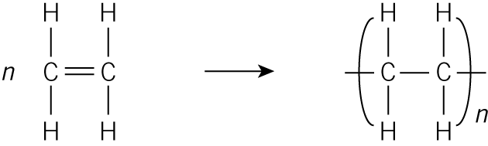*

*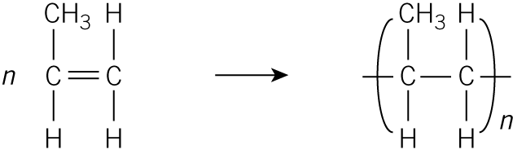*

*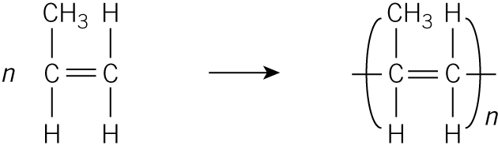*

*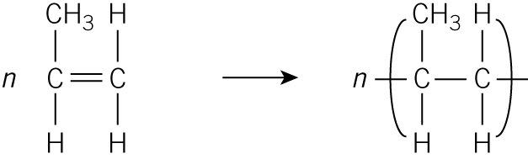* (*1 mark*)

|  |  |  |  |
| --- | --- | --- | --- |
| **0** | **4** | **.** | **5** |

PTFE is a polymer that is used as a non-stick coating on frying pans.

PTFE is made from many molecules of tetrafluoroethene.

Give the full chemical name of PTFE.

(*1 mark*)

|  |  |  |  |
| --- | --- | --- | --- |
| **0** | **5** | **.** | **1** |

Potato cells contain two natural polymers made from a single small molecule.

Name these polymers.

(*2 marks*)

|  |  |  |  |
| --- | --- | --- | --- |
| **0** | **5** | **.** | **2** |

The nucleus of potato cells contains a polymer that controls the size, shape, and colour of the potato.

Name this polymer.

(*1 mark*)

|  |  |  |  |
| --- | --- | --- | --- |
| **0** | **6** |  |  |

Carrier bags can be made from poly(ethene), poly(propene), or poly(chloroethene). Different polymers stretch differently when forces are applied to them.

|  |  |  |  |
| --- | --- | --- | --- |
| **0** | **6** | **.** | **1** |

Give the name of the small molecule poly(chloroethene) is made from.

(*1 mark*)

|  |  |  |  |
| --- | --- | --- | --- |
| **0** | **6** | **.** | **2** |

Some students wanted to compare how much each type of bag stretched when a force was added (**Figure 1**).

**Figure 1**

*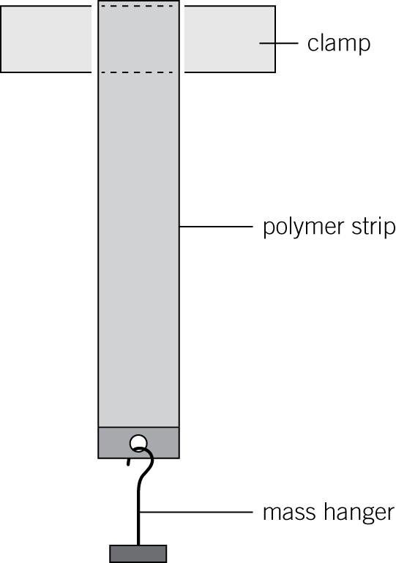*

They used the following method:

**1** Cut a 10 cm strip from a bag.

**2** Clamp the strip to a stand.

**3** Add masses to the mass hanger.

**4** Measure the new length of the strip each time.

**5** Repeat the experiment with strips from the other bags.

They recorded their results (**Table 1**), and plotted a graph (**Figure 2**).

**Table 1**

|  |  |  |  |
| --- | --- | --- | --- |
| Force in N | Extension in cm | | |
| poly(ethene) | poly(propene) | poly(chloroethene) |
| 0 | 0.00 | 0.00 | 0.00 |
| 2 | 0.15 | 0.10 | 0.05 |
| 4 | 0.35 | 0.25 | 0.15 |
| 6 | 0.70 | 0.55 | 0.40 |
| 8 | 1.40 | 1.05 | 0.80 |
| 10 | 3.00 | 1.75 | 1.35 |
| 12 | 5.90 | 2.70 | 2.00 |
| 14 |  | 3.90 | 2.70 |
| 16 |  | 5.50 | 3.50 |
| 18 |  |  | 4.40 |
| 20 |  |  | 5.30 |

**Figure 2**

*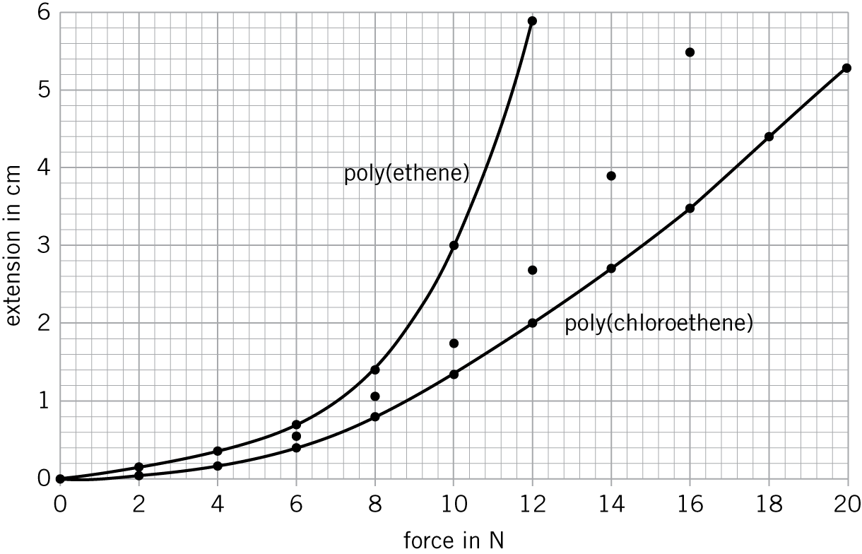*

On **Figure 2**, draw the line of best fit for poly(propene). (*1 mark*)

|  |  |  |  |
| --- | --- | --- | --- |
| **0** | **6** | **.** | **3** |

Give **one** variable the students needed to control to make sure that their results were valid.

(*1 mark*)

|  |  |  |  |
| --- | --- | --- | --- |
| **0** | **6** | **.** | **4** |

Suggest how the students calculated the extension for each force.

(*1 mark*)

|  |  |  |  |
| --- | --- | --- | --- |
| **0** | **6** | **.** | **5** |

Suggest why the students could not complete **Table 1** for poly(ethene) and poly(propene).

(*1 mark*)

|  |  |  |  |
| --- | --- | --- | --- |
| **0** | **6** | **.** | **6** |

Identify which polymer stretches most easily. Use **Figure 2** to explain your answer.

(*2 marks*)

|  |  |  |  |
| --- | --- | --- | --- |
| **0** | **7** |  |  |

**Figure 3** shows a simplified model of a DNA molecule.

**Figure 3**

*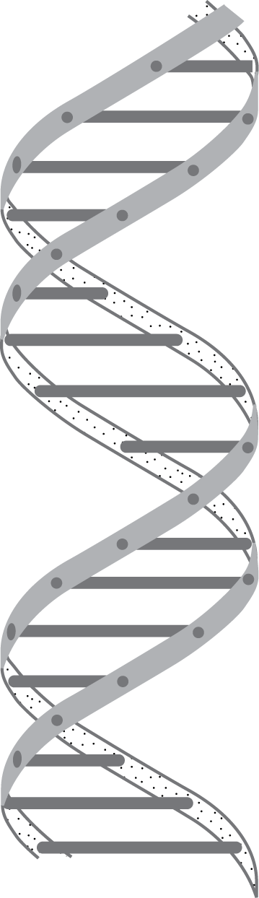*

Use **Figure 3** and your knowledge and understanding to describe the structure of DNA.

Explain its importance to living organisms.

(*6 marks*)