CLASSICS PAPER 1 Myth and Religion.

As well as this revision guide you will need to look at the set reading sources.
You can find them in the Firefly revision section
http://elizabethcollege.fireflycloud.net/classics/year-11/classics-civilisation/revision/the-set-sources-copy

Table of Contents

Greek Gods

Roman Gods

Heracles (Greek based mythology)

Hercules (Roman based mythology)

Temples and Priests (Greece)
- Priests
- Prescribed Temples

Temples and Priests (Rome)
- Priests
- Prescribed Temples

Foundation Myths (Greece)

Foundation Myths (Rome)

Festivals (Greece)
- The Great Panathenaia
- The City Dionysia

Festivals (Rome)
- The Lupercalia
- The Saturnalia

Myths and Symbols of Power (Greece)
- The Centauromachy
- The Amazonomachy

Death and Burial (Greece)
- Preparation of the Body
- Funerary Procession
- Burial of the Body
- Festivals for the Dead and the Ancestors

Death and Burial (Rome)
- Preparation of the Body
- Funerary Procession
- Burial of the Body
- Festivals for the Dead and the Ancestors

Journeying to the Underworld (Greece)

Journeying to the Underworld (Rome)

Extra Textbook Info

Greek Gods

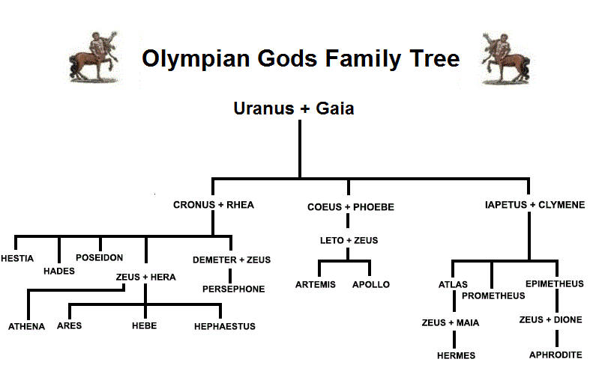
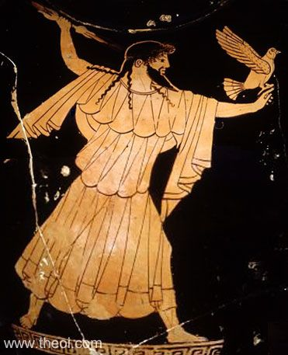
Zeus: Head of the Olympian Gods. Killed his Father Cronos is the war between the Olympians and the Titans. Rescued his siblings from Cronos' stomach. Split the Earth between himself (the sky) and his brothers, Poseidon (the sea) and Hades (the Underworld). Typically represented as a bearded man wielding a lightning bolt or sceptre, being seated on a throne or having an eagle

….......................................................................................................................
Poseidon: Brother of Zeus and God of the seas. Important for sailors and those taking sea journeys. Sides with the Greeks in the Trojan War as the Trojans never repaid him for helping to repair the city. Later in Homer's Odyssey, Poseidon relentlessly pursues Odysseus after he blinds the cyclops Polyphemus. Poseidon is represented as a bearded man holding a trident.

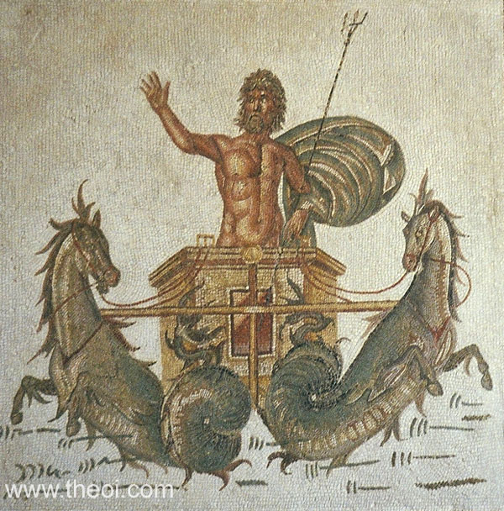
….......................................................................................................................
Hades: A chthonic deity and ruler of the underworld. Is not thoroughly mentioned in Greek literature except in the Homeric Hymn to Demeter. Typically depicted with a cornucopia showing his links ton Persephone and Demeter
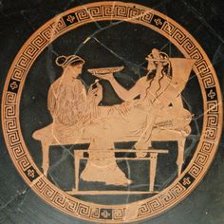
….......................................................................................................................
Hera: Wife of Zeus. Queen of the Gods and responsible for marriage, women, childbirth and family. Opposes Trojans as Paris didn't pick her in the Story of the Golden Apple. Spent much time taking revenge on women who bore children with Zeus. Normally depicted with a diadem and on a throne
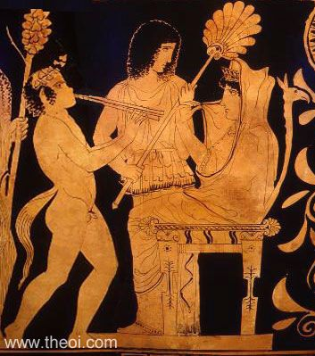
….......................................................................................................................
Athena: Goddess of war and wisdom. Born when Zeus impregnated Metis who gave Zeus the prophecy that the next god born would become the next ruler of the Gods. To prevent this, Zeus turned Metis into a fly and then swallowed it. Zeus then got a bad headache. He asked Hephaestus to sort it out and so he was to strike Zeus on the head. Athena then sprang out of Zeus' head as an adult woman. She is depicted with a helmet, spear and aegis (breastplate with a Gorgon on the centre). She also had Nike (winged Goddess of victory). Athena won a contest with Poseidon for ownership of Athens.
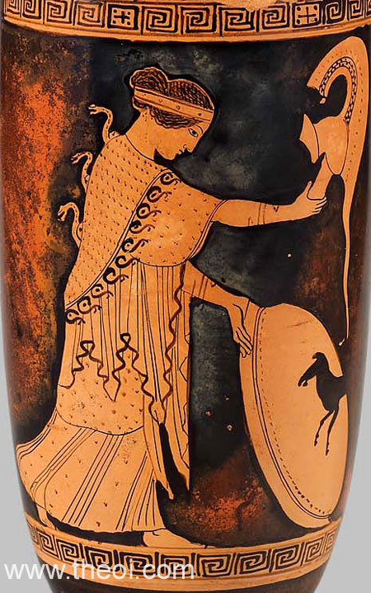
….......................................................................................................................
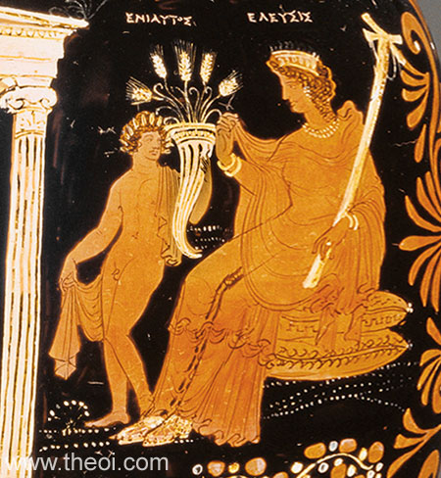
Demeter: Goddess of agriculture and the harvest making her very important to Greek culture and society as they depended on the harvest for survival. The Eleusinian Mysteries (a cult) was established in her name and promised an afterlife beyond the underworld. Depicted wearing a diadem and holding a bundle of wheat, grain or flowers as well as a cornucopia or torch

….......................................................................................................................
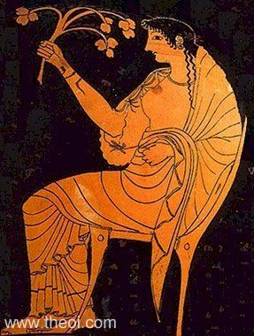
Hestia: Goddess of the home and the hearth (the fire kept in households). This meant that Hestia was central for families' wellbeing. Every sacrifice in the house started with her. The symbolism of the fire would also extend to the security of the city. Hestia is usually veiled and is rarely seen in art

….......................................................................................................................
Hephaistos: God of metalworking, fire and craftsmen. Son of Zeus and Hera per the Iliad but Hesiod states that Hephaistos was born just from Hera as revenge for Zeus' philandering. Hephaistos also walks with a limp. The 1st story says that he was born with it while the 2nd story says that he got it when Zeus tried to throw him off Olympus. After falling for a whole day, he landed on the island of Lemnos where the locals looked after him. He is usually depicted with a hammer
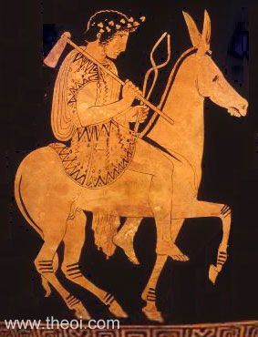
….......................................................................................................................
Aphrodite: Goddess of love and beauty. Born when Cronos cut off Uranus' genitalia and threw it into the sea. She then rose from the sea. She is irresistible to any man or god except Athena, Hestia and Artemis. As the winner of the Story of the Golden Apple, Aphrodite gave Paris Helen of Sparta which began the Trojan war. Aphrodite was caught with Ares by her husband Hephaestus. Hephaistos then ensnared them in an unbreakable net and all the other gods laughed at them. She is usually depicted rising out of the sea on a sea shell or on a dove. In statues, she is usually depicted naked
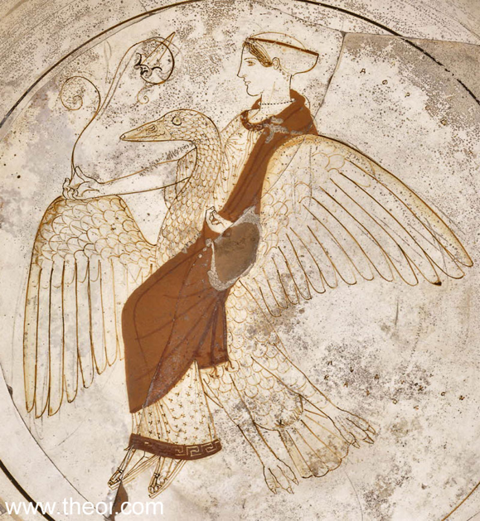
….......................................................................................................................
Artemis: Goddess of hunting, wildlife and childbirth. Twin sister of Apollo. Associated with the moon. Also referred to as Phoebe in Phoebe and Apollo. Usually depicted with a bow and arrow.
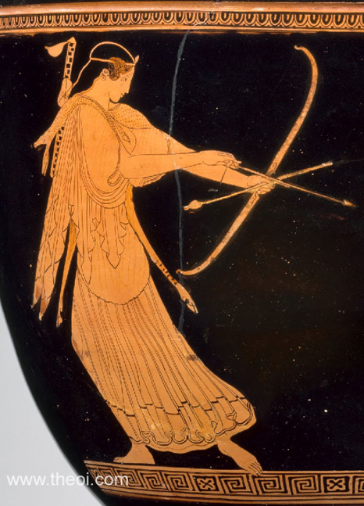

….......................................................................................................................
Apollo: God of music and the arts, education, archery and prophecies. Associated with the sun. Given the epithet Phoebus meaning 'shining'. Had cult centres in Delos where he was born and Delphi. Usually depicted with a bow and arrow and a lyre. Also has eternal youth so is always depicted as young, almost childlike.
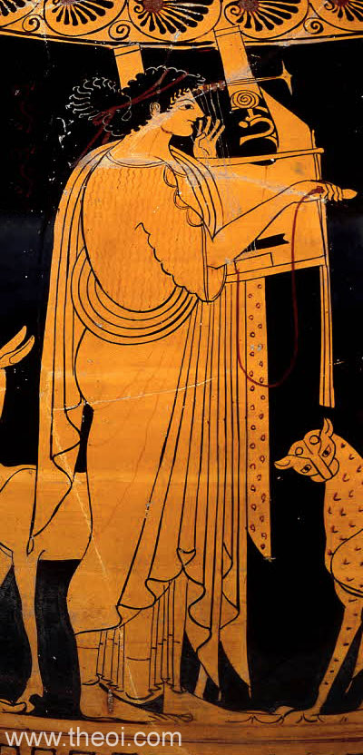
….......................................................................................................................
Hermes: God of travel and trade and messenger of the gods. Only god other than Dionysus to be able to travel to the underworld. Depicted with winged boots, traveler's cap and a caduceus (staff)
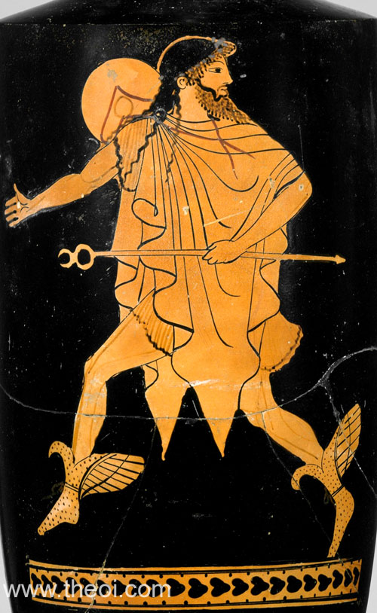
….......................................................................................................................
Ares: God of war. Either described as a god who gave courage to those in battle in the Homeric Hymns but in the Iliad, he is described a merciless killer when Zeus says "always your delight in strife and war and fighting". Ares is considered the opposite of Athena because while Athena represents the strategic and tactical side of war, Ares represents the full violence of it. Ares is usually seen with his armour on
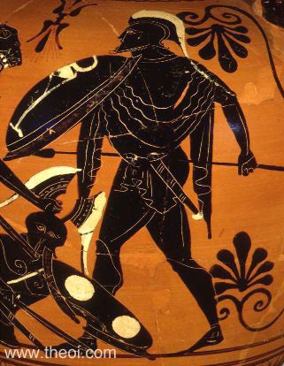
….......................................................................................................................
Dionysus: God of wine and theatre. Son of Zeus and the Theban mortal Semele. Because of this, he had to face Hera's wrath and so Zeus hid from her. Dionysus is not a full God and so is not considered an Olympian God. He enjoyed his own festival, the Dionysia. He is depicted with a thyrsus (staff with a pine cone on top), vines and an animal skin. Also depicted with his companions, the maenads and the satyrs.
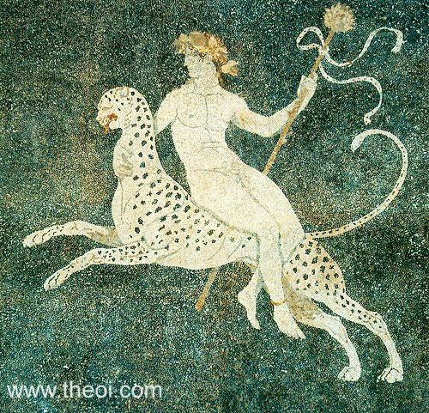
…....................................................................................................................
Roman Gods
Before Rome was founded, Italy consisted of lots of different tribes. The most influential tribe was the Etruscans. Once Rome was founded in 753BC and the city began expanding into Etruscan territory, they absorbed some of their culture and adapted it into their own (especially their temple design and divination). Another key influence was the Greeks as they expanded out to different parts of the Mediterranean such as South Italy and Sicily. This made it be known as Magna Graecia (Great Greece). Like the Etruscans, the Romans had a lot of contact with the Greeks and absorbed religious and ideas and adapted it for thwor own culture.
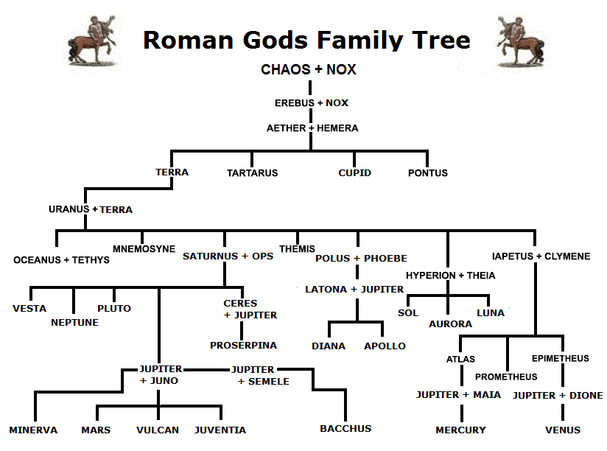
Jupiter: Equivalent of Zeus King of the Gods and controller of the skies. Comes from the Etruscan Iov pater or Father Jove. His temple was the Temple of Jupiter Optimus Maximus on the Capitoline Hill. Like Zeus, he's shown as a bearded man wielding a lightning bolt, sitting on a throne with an eagle and a sceptre.

…....................................................................................................................
Neptune: Equivalent of Poseidon. God of the seas, earthquakes and storms. Also linked with horses. Became an increasingly important figure to sailors and merchants as Rome expanded overseas. Represented as a bearded man holding a trident

…....................................................................................................................
Pluto: Equivalent of Hades. Makes an appearance in the story of Orpheus and Eurydice. Not usually depicted much in Roman art but the myth of him abducting Prosperina (Persephone) became popular on sarcophagi

…....................................................................................................................
Juno: Equivalent of Hera. Responsible for childbirth, marriage and women. In the beginning of Virgil's Aeneid, she takes revenge on Aeneas by killing many of his men. Typically represented wearing a diadem, holding a sceptre and accompanied by a peacock

…....................................................................................................................
Ceres: Equivalent of Demeter. Very important to the Roman plebs. Had a temple on the Aventine Hill. Had a festival dedicated to her from the 12th - 19th April every year. Depicted wearing a diadem and holding a bundle of wheat, grain or flowers

…....................................................................................................................
Vesta: Equivalent of Hestia. Goddess of the hearth and fire. Became very important for the family and the state as fire was responsible for helping families cook and warming them For the state, she was the goddess of the eternal flame brought to Rome by Aeneas. It was believed that if this flame ever went out, Rome would be destroyed. Vesta is shown with a veiled head, if at all

…....................................................................................................................
Vulcan: Equivalent to Hephaestus. God of fire, metalworking and craftsmen. Vital for the Romans as there was a great deal of industry and warfare in Rome. The Vulcanalia was held on 23rd August every year for him. In the Aeneid he crafts the shield that Aeneas uses in battle. Depicted with a hammer

…....................................................................................................................
Venus: Equivalent to Aphrodite. Goddess of love and beauty and the mother of Aeneas. Augustus linked his family, the Julii, to Venus and used her symbols in his art. Usually depicted naked and accompanied by her son Cupid

…....................................................................................................................
Minerva: Equivalent to Athena. Goddess of wisdom and warfare, although the Romans more closely associate war with Mars. As goddess of wisdom she's usually depicted with an owl. But if she's the goddess of war, she's depicted with a helmet, spear and aegis

…....................................................................................................................
Diana: Equivalent to Artemis. Goddess of hunting, childbirth and the moon. Could be referred to as Phoebe. Temple and shrine on Aventine Hill. Dedicated by Rome's sixth king, Servius Tullius, who was allegedly born a slave. This meant that the temple of cult of Diana had a huge following. Depicted with a bow or arrow

…....................................................................................................................
Apollo: God of music, arts, education, archery and prophecies. Apollo had no Etruscan equivalent so his name was directly take from the Greek pantheon. Important to sculptors, artists and the Roman leaders, especially Augustus after the Battle of Actium. Depicted with a lyre and with eternal youth

…....................................................................................................................
Mercury: Equivalent to Hermes. God of travel and trade. Messenger to the Gods. Important to travellers with an empire so large. Important god kept in the home's lararium (shrine found in homes dedicated to the household gods). Depicted with winged sandals, traveller's cap and caduceus

…....................................................................................................................
Mars: Equivalent to Ares. God of war but also god of agriculture in early Roman culture. Mars was very important to the Romans as they expanded their empire through military conquest. The area outside of Rome was known as Campus Martius or Field of Mars and was where the army would assemble and train before going to war. Depicted wearing his armour

…....................................................................................................................
Bacchus: Equivalent to Dionysus. God of wine and theatre. Around 200BC the Bacchanalia was founded in Rome from Greece. As a mystery cult, not much is known about it. The cult was banned by the Roman state in 186 BC as they met in private and they could have been plotting to overthrow the republic. Depicted with thyrsus, vines and animal skin as well as his companions the maenads and the satyrs.

Hercules/Heracles
One day, Creon, King of Thebes, went on a campaign with Amphitryon. His wife, Alcmene, was visited by Zeus who impregnated her. As explained in The Homeric Hymn to Hercules The Lion Hearted, Zeus took the form of Amphitryon to trick Alcmene. Amphytrion then slept with Alcmene. A seer (person who could see the future) told Amphytrion than Alcmene slept with another man. When he realised it was a God, he was relieved. Alcmene was pregenant with two children (one being Zeus' and one bein Amphytrion's. Zeus began boasting that he would have a son who could rule on earth while he ruled the skies. Hera, angry, made him promise that the first son of the House of Perseus born that night would become king. Hera then asked Eileithyia, her daughter, to prolong Alcmene's birth until Sthenelus' son Eurystheus would be born. Hera hoped that the prolonged labour would kill both Alcmene and the unborn Hercules. The plan failed and Hercules was born. Eurystheus became king of Mycaene. Hera then sent two poisonous snakes to kill Hercules but this plan failed again as Hercules killed the snakes. Alcmene abandoned Hercules in the woods where he was found by Athena. She took Heracles to Mount Olympus hoping he'd be accepted there. Hera, however, rejected him and ordered that he be returned to Alcmene to raise him. Athena was now Heracles' protector

When Heracles grew up, he married Creon's daughter, Megara but it didn't last long. Hera sent the goddess Madness to drive Heracles insane and to kill his family. In his depression, Heracles left Thebes and journeyed to Delphi and consulted with an oracle who, unbeknownst to him, was working for Hera. The oracle told him to serve King Eurystheus for 10 years

As punishment, Eurystheus sent Heracles on 10 seemingly impossible quests. However, he had help on The Lernaean Hydra and was offered money on the Augean Stables

1) The Nemean Hind: Hercules is depicted as being quite youthful in his first labour. Heracles first trued to attack the lion with bows and arrows and other weapons but soon found out that the lion's skin is impenetrable. He then strangled it to death. However, Heracles needed to present proof of his victory to Eurystheus but there was no way to cut the lions skin to take proof. Athena then told Heracles to skin the lion with one of its own claws. From this point on, Heracles is depicted wearing a lion skin as a cloak and a lion's head as a helmet.

2) The Lernaean Hydra: Heracles was tasked with finding and killing the Lernaean Hydra, a beast with many heads and venom for blood. However, when one head was removed from a hydra, two more grew in its place. Heracles got help from his cousin Iolaus. When Heracles cut off one of the heads, Iolaus would seal the neck with a flaming torch. Hera then sent a giant crab after Heracles but Heracles crushed it with his foot once it bit him. Once all the heads were removed, Heracles buried the immortal head under a pile of rocks. Heracles then used the Hydra's venom as poison for his arrows

3) The Golden Hind: Also known as the Ceryneian Hind as it was from Mt. Ceryneia in Arcadia. It was said to be larger than a bull and golden from head to hoof. The hind wasn’t as dangerous as the previous two labours but the hind was incredibly fast. Heracles spent a year tracking the hind before snaring it. On the way back to Mycenae, Heracles ran into Apollo and Artemis, the hind being sacred for the latter, who demanded that Heracles let the hind go. Their anger subsided, however, Heracles told them that it was only termporary and it was for Eurystheus.

4) The Erymanthian Boar: Heracles had to bring the Boar bath alive. The boar, like the hind, was much larger than any other other boar. The animal was terrorising Arcadia and Heracles chased it down in the winter snow, caught it, bound it by its legs and carried it back to Mycenae. On Heracles' arrival, Eurystheus was so scared that he hid it in a pithos jar.

5) The Augean Stables: Heracles had to clean the stables for the king of Elis, Augeas, in one day. Augeas' cattle were famed for the amount of egestion they did and Eurystheus thought it impossible to be cleared out in one day. Heracles diverted the rivers Alpheius and Peneius through the stables, clearing them instantly. Augeas did not give Heracles his promised payment so Heracles raised an army and defeated Augeas. To commemorate the victory, Heracles founded the Olympic Games in honour of his father

6) The Stymphalian Birds: Defeat the Stymphalian birds. The birds had ravaged the farm lands of Stymphalos, sometimes even eating the people. Heracles went deep in the marshes but wasn’t sure how to rouse the birds. Athena gave him a rattle designed by Hephaistos. The birds flew out once it was shaken and Heracles shot them down with his arrows or a sling shot

7) The Cretan Bull: Bring the bull to Mycenae. The bull was destroying Cretan homes and farmland. King Minos was therefore happy to let Heracles deal with them. Heracles crept behind the bull and strangled it but let go before it passed out. Heracles rode the bull across Greece to Mycenae where Eurystheus was once again terrified of it and locked it in a pithos. Heracles let it go and it wandered to Marathon where it was defeated by Theseus

8) The Mares of Diomedes: Heracles killed the stablemen of mad horses belonging Diomedes, the king of Bistones in Thrace. Heracles stole the horses and when Diomedes found out, he set his men to find Heracles. Heracles left the horses with Abderos while he fought Diomedes. The horses overpowered Abderos and ate him. In retaliation, the defeated Diomedes was fed to the horses. Now that the horses appetites were sated, Heracles rode them to Mycenae where they were either free to roam Argos. Apollodorus, however, says that they were killed by wild animals in Olympus

9) The Belt of Hippolyte: Hippolyte was the Queen of the Amazons, a race of women warriors living in Asia Minor near the Black Sea. Ares, Hippolyte's father, gave her the belt but Eurystheus' daughter wanted the belt. Heracles was sent to got it. Hippolyte admired Heracles' deeds and so on his arrival gave him the belt. Hera took the form of an Amazons and spread rumours that Heracles actually wanted to steal Hippolyte. The Amazons rode out to kill Heracles. A bloody battle ensued where Heracles killed Hippolyte and took the belt

10) The Cattle of Geryon: Took place at the 'edge of the world'. Heracles had to steal Geryon's cattle who were famed for their red hinds. Heracles killed the stableman Eurityon and his dog Orthrus. Geryon, warned of Heracles' actions, rushed over there with three heads and three sets of arms and legs. Heracles beat him with his bow and club. In the ride back from Erytheia, Heracles rode through southern Italy where it was believed his links to Rome were formed.

11) The Apples of the Hesperides: The Garden of the Hesperides was where golden apples grew as Zeus and Hera's wedding gift from Gaia. The apples were guarded by the Hesperides, daughters of Atlas, and were associated with the light of the world. Heracles did not know where the garden was so he searched from North Africa to the Near East and then to Illyria. Here he fought his arch-rival Achelous. His final stop was on Mt. Caucasus where Prometheus was chained up. As punishment from Zeus, an eagle would come and peck out Prometheus' liver and then it would grow back and the cycle repeats. Heracles kills the eagle and as a reward, Prometheus showed Heracles how to acquire the apples. Heracles travels to Atlas who had been tasked by Zeus with holding up the world. Heracles offered to hold up the world if Atlas went to go get the apples. When Atlas got back, he offered to deliver the apples himself so that he wouldn't have to hold up the skies. Heracles tricked Atlas into holding up the world while he went and 'got some pillows for his shoulders'. He actually took the apples and run off. Once Heracles presented the apples to Eurystheus, Athena took them back to the Hesperidian garden

12) Cerberus: Heracles had to retrieve Cerberus from the underworld. In Homer's Odyssey, Hercules' ghost states that he brought back Cerberus with Hermes and Athena's help. Heracles was accepted into the Eleusian Mysteries and upon arriving in the underworld, he was greeted by Persephone and Hades and they said that if he could subdue Cerberus without any weapons then they would let him take the dog. Heracles strangled Cerberus and took the dog to Eurystheus. Cerberus was then returned to the underworld

Hercules and Olympia

The Olympics was founded in 776 BC in Olympia, Elis (west of the Peloponnese). There are multiple origin stories for this:

Pelops and Hippodamia: Shown on the Eastern pediment of the Temple of Zeus near Olympia. Hippodamia was the daughter of Oinomaos, king of a town called Pisa near Olympia. An oracle foretold that once Hippodamia gets married, Oinomaos would die. To prevent this, Oinomaos challenged any potential suitor to a chariot race. If they won, they could have Hippodamia, if not they would die. After many suitors died, Pelops arrived. He made sure that he won by bribing the charioteer to change the bronze linchpins (fastener to stop a wheel coming off an axis) for wax ones. As they raced, the linchpins melted away and Oinomaos was thrown from the chariot, killing him. The Olympic Games were set up as funerary games to honour him

Heracles and the Augean Stables: When Heracles completed his 5th labour (The Augean Stables), he was not paid by Augeas, king of Elis who had promised payment on completion of the labour. Heracles rose up an army against him and beat him. The Olympic games were set up in honour of Zeus

The story of Pelops and Hippodamia is on the eastern pediment of the Temple of Zeus near Olympia. The 12 labours of Heracles were also depicted on the temple (6 on the entrance and 6 on the back). The Temple of Zeus is in the sanctuary of Altis

The Cretan Bull
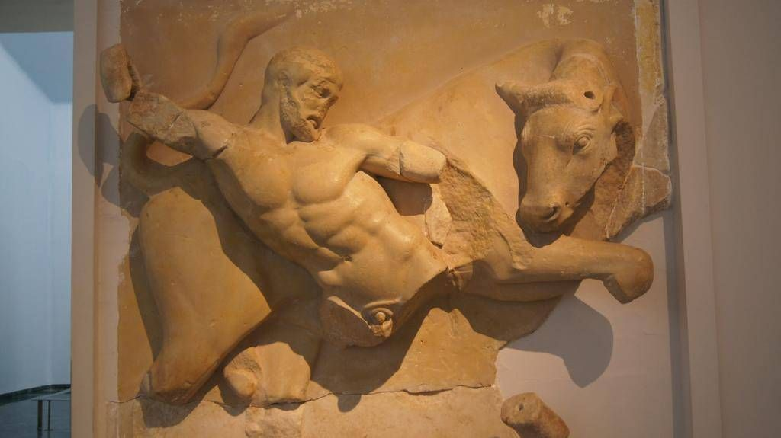
Create a scene that can be easily recognisable: The context behind the metope and where its placed makes it easily recognisable as the part of the temple where the metope was was full of Hercules' labours. The metope even shows Heracles with his club although he didn't have it with him in the Cretan Bull

Create realism in the scene: Heracles' body is well sculpted; his abdominals follow the correct lines. His right pectoral correctly reacts to the actions of his right arm. The bull's head and legs suggest movement away from Heracles. Both figures are in the correct proportion

Fill the space so as to not leave any blank spaces: The sculptor has formed a cross between the two characters using diagonals to fill the space. The space left by the bull's front legs is taken up by Heracles' legs. The club also fills up space in the top left hand space

Rome

The Romans had the same stories of Hercules as the Greeks. They wrote some of Hercules' lesser adventures such as Hercules and Cacus, Hercules and Achelous and Hercules and Nessus as well as Hercules' death

Hercules and Cacus: Took place during Hercules' 10th labour, the cattle of Geryon. Hercules transported the cattle through Southern Italy 500 years before Romulus founded Rome, meaning that the area around the river Tiber was only full of tribes. While Hercules was sleeping, Cacus stole 8 of Hercules' cattle. To fool Hercules, Cacus lead the cattle out backwards so their hoof marks would look like they were coming in. Cacus' plans would have succeeded but a single cow mooed as Hercules walked past. Cacus blocked the cave with a boulder behind him which Hercules couldn't move. Hercules, not willing to give up, takes off the mountain top where Cacus was hiding. Hercules bombarded Cacus with whatever he could find and Caucus in return expelled plumes of black smoke at Hercules. Enraged, Hercules launched headlong into the smoke and strangled Cacus, killing him

The Cult of Hercules in Rome

King Evander, who was king of the land Cacus tormented, founded the cult of Hercules as thanks for what he did. The main ritual was an animal sacrifice and the burning of incense, which only men were allowed to partake in. The sacrifice took place at the Great Altar of Hercules, between the River Tiber and the Forum Boarium on the Palantine Hill. The cult was run by the Pontitii and the Pinarii families who were instructed by Hercules on how to worship him. In 312 BC, this responsibility was transferred to a group of slaves. Gladiators also worshipped Hercules. If they were freed, a wooden sword was presented to them which would the Temple of Hercules the Victor, built in the same area as the Great Altar in the second century BC

Hercules and Achelous: The story was told to Theseus by the river god while he waited for the river waters to recede after a flood. After telling Theseus and his men many stories, they asked why he only had one horn.

The story describes a contest between Hercules and Achelous for the hand of Deianira of Aitolia. They decided this with a fight. They both put their cases forward for why they should be Deianira's suitor. Hercules referenced his divine parentage and his labours while Achelous stated his status as a god trumped Hercules' as a mortal. Achelous also suggested that Hercules' labours were his own fault and the story of his birth was fake. Hercules challenged Achelous to a fight. The first battle was a show of intense strength and power. Hercules won this. Achelous changed his form to a snake which Hercules belittled, reminding him how he killed the Lernaean Hydra. Hercules won easily. Achelous again changed forms to a single horned bull. This would remind readers of Hercules' fights with the Cretan Bull and the Erymanthian Boar. Hercules broke the horn and it then filled with fruit and became a horn of plenty.

Hercules and Nessus: Having wed Deianira, Hercules wanted to return home to Tiryns. They arrived at the river Evenus, which was too deep to walk across. While Hercules could walk across, Deianira could not. The centaur Nessus offered to assist but he ran off with Deianira. Hercules quickly shot Nessus with a poison arrow. As a final act, Nessus gives Deianira his poison soaked tunic.

The death of Hercules: Several years after the episode with Nessus, Rumour spread lies to Deianira on behalf of Juno. These made her think that Hercules was in love with Iole, a princess from Oechalia in Thessaly. Deianira gives Hercules the poison-soaked tunic in order to make him fall in love with her again. Her slave gave it to Hercules. While giving sacrifice to the Gods, the heat from the pyre makes the poison stick to his skin, killing him. Upon dying, Hercules makes a funeral pyre and dies on it. On seeing this, Jupiter and all the other Gods agree to let Hercules into Mount Olympus, including Juno.

Temples and priests
The Sanctuary
The sanctuary was a holy area containing temples and altars to one or more gods usually separated from the surrounding area or city by a wall. The sanctuary has a fresh water source at the entrance to purify themselves so the area was not polluted (impure). People could be polluted if they have come in contact with a dead person or baby or committed murder

The Greek Temple

A temple is dedicated to a god and was used to house the cult statue of that god. It can be more easily compared to a house where gods can reside in away from Mt. Olympus. Only priests could enter the temple. Altars were usually outside the temple so people could watch sacrifices as it was a communal part of a God's worship

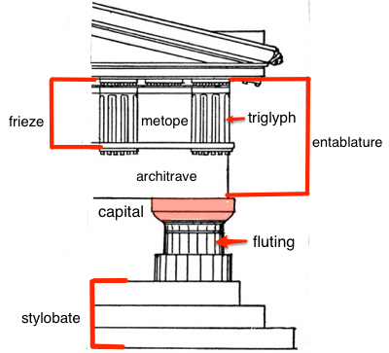

Hexastyle, octastyle, decastyle, dodecastyle: 6, 8, 10, 12 columns at each façade
Dipteral: 2 lots of colums at one side
Engaged columns: Cloumns built into the wall
Peristyle: a continuous porch around the temple
Distyle in antis: two columns in front of naos and two behind opisthodomos
Stylobate: Steps around a temple

Doric frieze: a frieze around a temple put into metopes and separated by triglyphs
Ionic frieze: a continuous frieze around the outside of a temple. Useful for telling continuous stories
Pediment: The triangular space at either end of the temple, this would either be blank or with a statue in it

Colonnade: stood on stylobate and ran around and supported the temple
Naos/cella: The room where the cult statue was stored
Opisthodomos: Where the temple's treasures were held
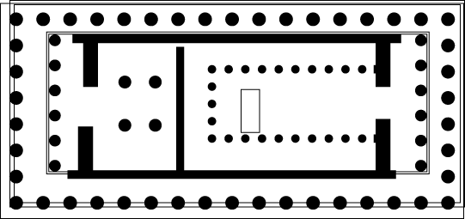

Priests
Priests were called a hiereus and a preistess was called a hiereia. The priests attended to the gods and while the priestesses attended to the goddesses. Their main role was to sacrifice to them. A priesthood was a temporary role which required no specialist training. Some were priests just for a festival while others lasted for a whole year or their whole life. A citizen would hope to be a priest at least once in their lives. Priests also didn't have to hold regular sermons, preach about their god or perform any pastoral care for the community. They simply had to perform the correct ritual at the right time. The priest would also be important for the festival of their god e.g. priests for Dionysus would be important for the Great Dionysia and get front row seats. The Olympia, the priestess of Demeter was the only one who could watch the Olympic Games.

Priests used manteis to predict future events (loosely comparable to modern day fortune tellers. Most claimed to be able to tell the future but those that were reliable were more closely followed. Haruspices read the entrails of dead animals to tell if anything bad was going to happen while augurs tried to tell the flight of birds to tell the future. The mantis was so important that one would accompany armies on battles

Sacrifice

The Greeks would present many gifts to the gods to honour them. The gift of food was a popular gift and this was usually done with a blood sacrifice. This involved a carefully planned ritual. First, the correct animal would be chosen for the sacrifice. This would usually be a domestic animal of the hiereus. The correct animal also had to be chosen for the god. Individual households would restrict their sacrificial animals to chickens and pigs. Cities, however, would spare no expense. The most expensive sacrifice would be the hecatomb, the sacrifice of 100 bulls. These would happen at great festivals such as the Great Panathenaia and the Olympic Games. This would cost 8000 drachmae (34kg of silver). This was divided into 3 parts

The Preparation

The participants would ensure they weren't polluted while wearing their best clothes. The animal's horns would be gilded (covered in a thin layer of gold). Attendants would lead the animal to the altar. A maiden with a basket of barley grains or cakes would also carry a sacrificial knife in the basket for the kill. The number of the attendants could vary as if it was a large festival such as the Great Panathenaia then the whole city could take part but there would be much fewer if it was a smaller sacrifice, but there would be water bearers and musicians at minimum. The musicians would calm the animal as the entire process would have to be repeated if the animal became scared as a scared animal was a negative sign. The participants would cleanse themselves with water again after the animal arrived at the altar. The fire is lit by this point. The participants would then pour water on the animal's head to cause it to nod. This was important as the animal had to seem to agree to the sacrifice. The priest would then utter a prayer to the god

The Kill

The chief sacrificer would take the knife from the basket and remove some of the hairs, throwing them into the fire. The animal's throat was then cut. The animals blood would then be poured over the altar as at funeral's women would let out a high-pitched scream to symbolise the animal's passing from life to death

The Sharing of the Sacrifice

The feasting would now begin and none went to waste. The god received the meat first and prepared by removing the animal's thigh bone and wrapping it in fat. This bone was then burned on the altar while white wine was poured on the fire. The entrails of the animal would then be read by a haruspex. The remaining meat was then cooked and shared with the community

The Parthenon

When the Persians sacked Athens in 480 BC, they also burnt down the temples and other religious buildings on the Acropolis. The Athenians then fought off the Persians and became the head of the Delian League and so by the 450s the Delian League essentially became an Athenian Empire. Pericles, the leading politician at the time, moved the treasury of the League to Athens. The city used the money to pay for many buildings in the city to be rebuilt including many buildings on the Acropolis, which was a sanctuary dedicated to Athena. Buildings were built to honour Athena and others. The treasury then was put into the opisthodomos of the Parthenon. The temple was mainly built by Phidias, the main architect, who was in charge of the general design and the cult statues. He also worked with Iktinos and Kallikrates

On entering the sanctuary, visitors would see the statue Athena Promachos (meaning to go before battle). In the Southeast was the small Athena Nike (victory); to the north was the Erechtheion and the Parthenon was towards the south east side, which was dedicated to Athena Parthenos (the virgin). The entire sanctuary was dedicated to Athena Polias. The altar to Athena Polias was between the Erechtheion and the Parthenon

The Parthenon was 69.5m long and 30.9m wide. It:

- Oriented east to west
- Stood on a three-step base
- Surrounded by a colonnade
- Had a naos and opisthodomos

There was a unique feature to the Parthenon. Running around the temple naos was the ionic frieze. This was 540ft in length and went around the entire temple. This increases the grandeur of the temple.

Athena and the Parthenon

The main temple were Athena's worship was the Erechtheion, housing a small wooden statue of Athena. Outside the temple was the statue of Athena Polias where most of the sacrifices took place. The Parthenon was merely an offshoot of the cult of Athena and so did not house its own priesthood of altar but was instead used as the treasury of the Delian League; as a monument to Athens' greatness and as a monument to Athena herself.

On the eastern pediment above the entrance Athena's birth is depicted and the western pediment depicted the contest for the naming of Athens. In the naos of the Parthenon is the cult statue of Athena. It stood 13-metres tall, was made of chryselephantine and was sculpted by Phidias

The Temple of Zeus at Olympia

The temple was situated in the sanctuary of Olympus called the Altis. It's building did not begin until around 472 BC although the Olympic Games were believed to be founded in around 776 BC and the Altar of Zeus was already there before the 5th Century. Pausanias says that it was unknown who originally built the temple (saying it could have been Heracles or two generations after Heracles) but it is concluded to be one of the oldest structures in Olympia. The ash from the hecatombs (sacrifice of 100 oxen) would build up under the altar and, in Pausanias’ day, the pile was almost 7 metres tall. Also, the fact that the altar was around about 200 years before the temple shows the importance of sacrifice in Greek culture.

The temple was 64.1 metres long and 27.7 metres wide. It was in a very similar style to traditional Greek temples such as:

- Oriented from east to west,
- Stylobate
- Surrounded by a colonnade
- It had a naos and an opisthodomos

On the eastern pediment is the myth of Oenomaus and Pelops with Zeus, God of justice, in the centre while Oenomaus stands on one side and Pelops stands on the other. To the side of the men are Hippodamia and Sterope, Oenomaus’ wife. The horses in the scene are slightly smaller than expected to fit the triangular shape of a pediment. He finishes with two figures in either corner, anthropomorphic personifications of the two great rivers of Olympus, the Kaldeos and the Alpheios.

The 12 labours of Heracles are sculpted onto the metopes, six on the western metopes and six on the eastern metopes.

The Cult Statue of Zeus

It was around 13 metres tall and depicted Zeus sitting on his throne, all made of chryselephantine, with a Nike in his right hand and a sceptre in his left with an eagle sitting on his shoulder and sandals on his feet. In front of Zeus is a pool of olive oil to help maintain the ivory as well as to maintain a shimmering effect on the statue

It is also a testament to the skill of Phidias as he can design both the cult statue of Zeus in Olympia and the cult statue of Athena in the Parthenon at the same time while both places are miles apart. The temple was finished in 456 BC although the cult statue was later added in 448 BC

Rome

The Sanctuary

The sanctuary was a holy area in a city or town that contained a temple and an altar. This was usually separated from the city by a wall. A sanctuary could have altars and temples to more than one God and had a fresh water source at its entrance for worshippers to wash their hands and feet as if they were dirty or ‘polluted’ this could anger the Gods

The Altar

The altar was the most important part of the sanctuary but it could exist in its own right (e.g. Ara Pacis). This was where sacrifices and offerings to the Gods took place, which was a communal aspect of worship and could involve the whole city

The Temple Building

Roman temples were based on a mix of Etruscan and Greek styling (although there are notable anomalies such as the Pantheon). The temple would usually be oriented from east to west; be placed on a podium so people can only enter from the front where stairs would lead to the entrance; the colonnade would stand on the podium and run around the temple (the side and rear columns would be semi-engaged – embedded in a wall); the main room would be the cella and contain a statue of the god
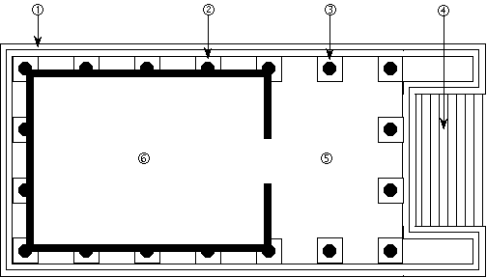

Priests

In Rome, priesthood was concerned with politics and Roman society in general as well as religion. The main (and debatably only) role of a Roman priest was to uphold the Pax Deorum (Peace of the Gods). This was done by uttering the correct prayer, completing the appropriate sacrifice and fulfilling their priestly duties at festivals. The relationship between god and man in Rome can be described by the Latin phrase do ut des meaning I give so that you give as the Romans offered sacrifices to the Gods in return for favours

Unlike the Greeks, the Roman priests weren’t assigned to any specific temple or god and would keep their heads veiled at all times when engaging in religious duties. Unlike priests today, their actions didn’t matter when it came to being a priest if they upheld the pax deorum. Also, it was only a part-time job. Being a priest could also progress a Roman’s political life as shown by the fact that the Roman Emperors would be the Pontifex Maximus as well as Emperor. Accordingly, many budding politicians became priests

Rome has many different priestly colleges which has different roles and responsibilities in upholding the pax deorum. The main colleges were: The Pontifices, the Augurs and the Vestals

The Pontifices

The Pontifices were the most important college in Rome. The college numbered a maximum of 15 and was headed by the Pontifex Maximus, a life-long post. The word means ‘bridge builder’ and may infer the role as a mediator between man and god. Their main roles were to protect the temples, regulate the burial and inheritance laws and supervise the religious calendar, giving them immense power over what happens in Rome. The post was elected from the pontifices until the election of Augustus in 13BC when the emperor held the post

The Augurs

An augur would determine the will of the gods by ‘taking the auspices’ involving reading the flight of birds, the behaviour of animals and the direction of thunder. The taking of the auspices was common both in state business and personal life. There were multiple rumours that the augurs, along with the other colleges, were corrupt and would take bribed. Although there is no evidence, it cannot be ruled out

The Vestal Virgins

A college of 6 priestesses (the only ones in Rome). They were goddesses of Vesta, the Goddess of the home and the hearth and their importance was shown by the fact that live in the Roman Forum, the hub of political and social life in Rome.

The Vestals would be chosen by the Pontifex Maximus from a fit and healthy girl from the ages of 6-10 as they were expected to be in the post for 30 years as well as take a vow of chastity
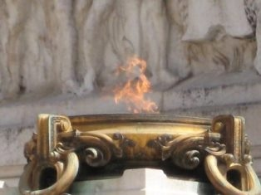
The most important duty for a vestal virgin was to protect the sacred flame, brought from Troy by Aeneas, housed in the Temple of Vesta. It was believed that if the flame went out, Rome would fall. Vestal Virgins also made the mola salsa (a mix of salt and flour sprinkled on the head of sacrificial victims)

In addition to their accommodation, they were allowed front row seats at certain events, they could own their own property, write their will and vote. However, if the eternal flame ever went out, the virgins would be whipped. If they broke their vow of chastity, they would be buried alive and the male would be whipped to death

Haruspices

Unlike the augurs, the haruspices were of Etruscan origin and would specialise in the reading the entrails of sacrificed animals and would be consulted at festivals and battles. To start, the haruspex would watch to see how the animal falls once it is killed; then examine the smoke and the fire at the altar and finally read the animal’s entrails, specifically the liver.

Sacrifices

The Preparation

In a large state sacrifice, a pontifex would lead it but a private citizen would do it in smaller ceremonies. The participants would make sure that they weren’t polluted for the ceremony and would dress in their best clothes. The animal would be prepared by gilding the horns if necessary. The animal would then be led to the altar, it would be a good omen if it did it willingly, while flute players would drown out any noise which may disturb the animal.

The Kill

The priest would sprinkle mola salsa on its head and then wine to make the animal nod in agreement to being sacrificed. The priest would utter a prayer, giving the sacrifice to the god. The popa (Roman official) would then strike the animal on the head to dtun it and then the cultrarius (another Roman official) would slit its throat

The Sharing of the Sacrifice

The feast would now begin and none of the animal went to waste. The priest would utter a prayer, state the reason for the sacrifice and then the haruspex would read the entrails and would be cooked and offered to the gods. The remaining meat was cooked, cut up and served to the local community. In a state sacrifice, the priests would eat first then the senate and other elite citizens and so on. The sharing of the meat was meant to show the communal aspect of the sacrifice and worship in general

The Temple of Portunus (Fortuna Virilis)

This temple was wrongly attributed to Fortuna Virilis (manly fortune) once but is now correctly associated with Portunus, god of harbours. It was constructed sometime between 120BC and 80BC and is one of the most well-preserved Roman temples

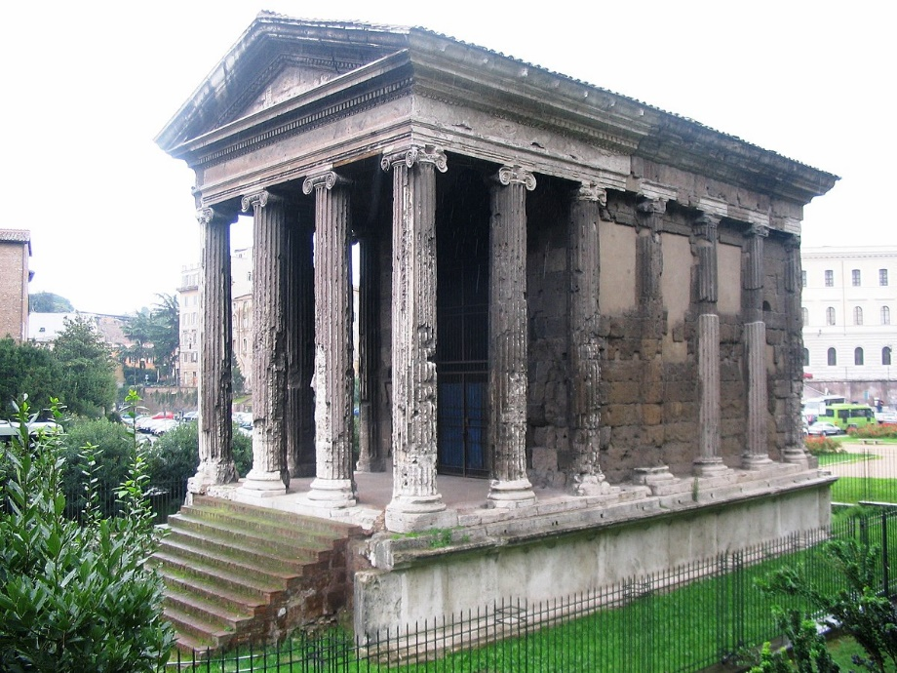

The temple is in the forum Boarium next to the river Tiber and between the Palatine and Aventine hills. It also stands next to the circular temple of Hercules the Victor and the GreaAltar of Hercules. The altar no longer exists but it stood at the foot of the temple steps. The temple was inspired by both Etruscan and Greek styles. The Etruscan influence is seen by the podium and the steps that the temple stands on. The Greek influence comes from the porch and the free-standing columns at the front of the temple as well as the semi-engaged columns in the cella

The Pantheon

The original temple was commissioned by Emperor Augustus and built by Marcus Agrippa between 27BC and 25BC but this was burnt in 80AD. The Pantheon was then rebuilt by Hadrian in around 125AD. The word Pantheon means all gods and so it is believed to be dedicated to all the gods but this has been debated since the 2nd century AD
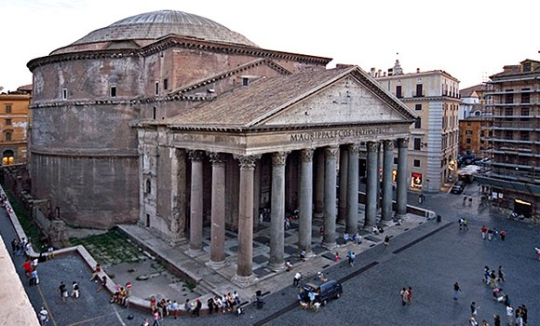

The temple is in the ancient Roman Campus Martius of Fields of Mars where the army met before campaigns, elections took place and Romans did exercise. The plan of the temple seems not to conform to the general Roman structure. Although the front is quite conventional by its standing on a podium with free standing columns around the porch and semi-engaged columns towards the rear of the porch. However, the temple features a rotunda at the rear of the temple with an oculus at the top to let in natural light

Hadrian rebuilt the Pantheon with his familial links to Augustus in mind. He restored the original transcription which read

M.AGRIPPA.L.F.COS.TERTIVM. FECIT

Marcus Agrippa, son of Lucius, built this when consul for the third time

The original interior would have allowed many cult statues to be placed in the temple.
Foundation myths

The Naming of Athens

The main story for Athens’ naming comes from a description by Pausanius of the western pediment of the Parthenon. The legendary king Cecrops held a competition between Poseidon and Athena as to who would become patron god of Athens. They each had to offer a gift which would be of use to the Athenians. Poseidon sprung a salt water spring with his trident while Athena gave an olive tree. The salt water spring would have been mostly useless for Athenians while the olive tree would have been useful for numerous reasons such as using olive oil. Athena was then made the winner and the patron saint of Athens

Theseus and Athens
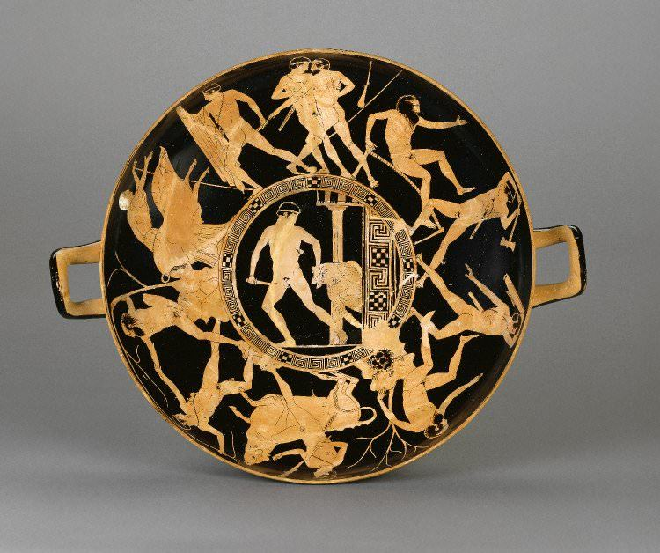
Theseus, although not the founder of Athens, did unite the different tribes of Athens under one banner

He was born of Aegeus, king of Athens and Aethra, daughter of Pittheus, the king of Troezen
as it was prophesised by an oracle that the next time Aegeus would have sex, he would conceive a boy. Aethra received a message from Athena saying that she should go to Sphairia near the Troezen coast. When she arrived, Poseidon rose from the sea and had sex with Aethra so that the child would have godly qualities. When Theseus was born, Aegeus fled to Athens, worrying that Theseus’ cousins would get jealous and kill him. Beforehand, he left sandals and a sword under a rock that only a man with godly qualities could lift for Theseus to use and come to Athens, where he would be king. When he came of age, Theseus easily lifted the rock; there were now two ways to get to Athens: by boat, the route considered to be far easier and the route that Aethra and Pittheus begged him to use, or by land, which was full of trials and monsters. He decided to go by land, wanting to follow in his cousin Hercules’ steps.

His second labour (lifting the rock was considered his first) was to face the robber Sinis – the pine bender. Sinis would tie his victims to bent pine trees and then release them, tearing them in two. There are multiple versions of the myth. One says that Theseus asked him to help him bend a pine tree. When done, Theseus would let go with Sinis on it, flinging him to his death. Another says that Theseus tied him to two bent trees and tore him in two. After he killed Sinis, Theseus married his daughter Perigune and bore a son called Melanippus.

The next labour, the Crommyonian sow was unlike his previous labours as he sought it out as opposed to coming upon it. The ‘sow’ was a nickname of a thief, called so because of her beastly behaviour, who Theseus killed

After this was an old man called Sciron, an old man who would push passers-by into the sea while they were washing his feet where they would be consumed by a giant turtle. Theseus took the old man by the feet and threw him off the cliff

Theseus then arrived at the city of Eleusis, ruled by King Cercyon. Cercyon challenged Theseus to a wrestling match and, if he won, he would become the King of Eleusis. Theseus won the match and became King of Eleusis but went onto Athens anyway

The last of Theseus’ 6 labours was a man called Procrustes who would invite visitors to stay a night on his ‘magical’ bed which could fit everyone. If they were too small, he would use a mallet to stretch them out and if they were too tall he would chop off their legs and head. Theseus made Procrustes go on the bed first and Theseus beheaded him

When Theseus finally arrived in Athens, he found out that the city was under the control of the witch Medea. Theseus had originally planned to infiltrate the city and defeat Medea in secret but she already knew who he was. She arranged for Theseus to prove his heroism by defeating the Bull of Marathon. Theseus easily defeated the bull and marched it through Athens before sacrificing it.

Medea then arranged for Theseus to be poisoned during the sacrifice but he unsheathed his father’s sword to cut the meat. When Augeas saw this, he was so excited that he knocked over the poison and proclaimed his son the heir of Athens. The spilling of the poison exposed Medea for who she really was and she flew Athens

As Minos’, the king of Crete, son was killed, Athens was forced to pay the consequences by giving 7 boys and 7 girls over to Crete as a sacrifice to the minotaur. The sacrifice coincided with Theseus’ return so he bravely volunteered to fight the minotaur. Theseus met, and fell in love with, Ariadne in Crete. She gave Theseus a ball of wool so he wouldn’t get lost in the labyrinth and a sword to fight the minotaur. Theseus was successful and killed the minotaur.

Leaving the island of Naxos, Theseus left Ariadne behind. This may have been for a few reasons: Ariadne may have been pregnant with Theseus’ child and one night while he was checking on his boat he was blown away by the wind and was unable to return. Ariadne then went to live her life on Naxos. Another possibility is that Theseus met another woman who he fell in love with and Theseus left Ariadne for her. A final possibility is that, in a dream, Athena came to Theseus and told him that Dionysus has chosen Ariadne as his bride and so he left Ariadne on Naxos to wait for her to become a God

When Theseus sailed back from Athens, he forgot to replace his black sail, signalling that he’d died, with his white sail, meaning that he’d survived. Upon seeing this, Augeas flung himself into the sea in despair. Theseus was distraught that his mistake made this happen

As king, Theseus quickly began to realise that Athens lacked unity because it was made up of 10 warring factions. He travelled to each of these towns and negotiated their allegiance to Athens. He promised that they would not be ruled by a king but instead by a democracy, giving them an opportunity to vote for their leaders. Theseus wouldn’t solely rule apart from in times of war. Theseus destroyed all the small town halls and council chambers and instead built a central town hall and council chamber in Athens to symbolise the new alliance. Theseus also founded the Panathenaic Games to unite all religions and cultures in Athens

Rome

Livy

Titus Livius was born in northern Italy either in 59BC and 64BC. Despite being of high stature, he did not involve himself in politics but rather devoted himself to literary works such as his History of Rome, although the exact date he wrote that is not known. It is thought that Livy lived through a time of great turbulence; Livy was born during the civil war between Caesar and Pompey Magnus in 59BC, he was 21 or 26 when Caesar was assassinated and a year later Octavian and Marc Antony defeated Brutus and Cassius in the Battle of Philippi. What followed was a civil war between the 2nd triumvirate ending in the Battle of Actium in 37BC. Octavian was then renamed Augustus by the senate and he ushered in an age of peace.

However, Livy is not very trustworthy as an historical source for many reasons. Many records of Rome were lost when the Gauls sacked Rome in 386BC, many legends and myths of Rome were oral leading to change and variation over time. Also, Livy also rarely separated fact from myth

Aeneas
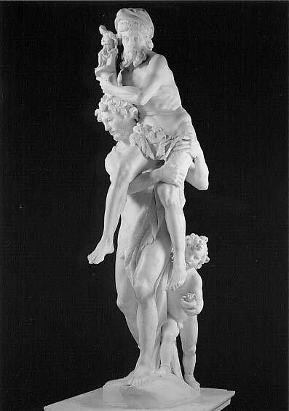
The birth of Aeneas was noted in the Homeric Hymn to Aphrodite. Venus boasted to the other
Gods that she had made them sleep with mortal women and as punishment Jupiter sent Venus to Earth with the desire for a mortal man. Venus met Anchises and she, disguised as a mortal woman, had sex with him. This made Aeneas the product of god and man, like Hercules and Theseus before him.

Aeneas was raised as a fierce fighter in Troy and fought against the Greeks in the Trojan war. He was mentioned many timers as a brave fighter in the Iliad. When Odysseus’ Trojan horse ploy worked and Troy fell, Aeneas escaped with his father, Anchises, his mother, his son Ascanius and the public Penates (the sacred objects of the city). He lost his wife and later discovered she was killed by the Greeks. Aeneas travelled past the Aegean Sea, past Macedon, through Carthage and then to the west coast of Italy. Aeneas also discovered his pietas (piety) on this journey, a Roman virtue meaning respect for Rome, your city and the gods. When Aeneas arrived in Italy, he fought with the local tribe and won while making peace with King Latinus of Latium and founded a new city. He married Latinus’ daughter Lavina and they had a child called Ascanius, it is unknown if this is the same Ascanius who escaped Troy with Aeneas and there’s been a confusion of the source material or if this is just another child of Aeneas.

Aeneas did not found Rome himself but he founded the bloodline which founded Rome. His son Ascanius founded the city of Alba Longa and this then led to a line of kings eventually culminating in Romulus and Remus.

Amulius was a king of Alba Longa who was corrupt and ordered the killing of his two grandnephews Romulus and Remus. However, a she-wolf rescued them and suckled them in the cave of Lupercus. When they came of age, the brothers killed Amulius and gave the city to their uncle Numitor. Due to the overcrowded nature of Alba Longa, the boys decided to found a new city. They found a place which seemed suitable for a city, with 7 hills. The two brothers looked for signs that they should be king by reading the flight of birds. Remus’ birds appeared first but Romulus had more birds. This led to a bitter argument over who the gods want to be king and eventually the brothers fought over the crown for the new city. Romulus killed his brother Remus and named the city after him, Rome

Plutarch

Plutarch was born in Boeotia, Greece around AD 50 and died around AD 120. He was a popular writer and worked as a writer and became a priest of Apollo in Delphi in around 90 AD. He lived in a relatively peaceful time compared to Livy where the Empire was in place and the emperor’s power was unquestioned. Plutarch was a biographer best known for his Lives series which examined the lives of famous Greeks and Romans. He also wrote Parallel Lives where he compared the lives of two famous figures: a Greek and a Roman such as Theseus and Romulus

As a biographer, Plutarch was more concerned with the character of the individual than his history. When writing Lives, he would often use one main source and supplement it with others. When writing about the events in his subjects’ lives, it is likely that Plutarch used Livy as a source as he was the main source for Roman history. Plutarch did not make clear his personal favourite between Romulus and Theseus but did compare the two is different areas such as the greatness of their deeds, their leadership, the reasons for their misfortune, their achievements, their relationship to their children and their relationship to women and the Gods

Festivals

Greece

The Great Panathenaia

The Panathenaia was open to all Athenians and resident foreigners and was considered the most important Greek festival as it fell on the same day as Athena’s birthday. From 566 BC, the Great Panathenaia was run every four years and was open for anyone who wished to come. The festival included more athletic and literary competitions than the normal Panathenaia.

The exact programme is not known but it is thought that it ran something like:

Day 1: Rhapsodic and musical contests
Day 2: Boy’s and youth’s athletics
Day 3: Men’s athletics
Day 4: Equestrian events
Day 5: Tribal contests
Day 6: All night celebration, procession and sacrifice
Day 7: Apobates and boat race
Day 8: Prize-giving

The rhapsodic contests would consist of reciting verses from Homer’s Iliad and Odyssey as part of oral tradition, requiring excellent memory to take part and win. In the musical contests, there were 4 main competition revolving around the aulos (flute) and kithara (a type of lyre). The contests were singers accompanied by the aulos, soloists on the aulos, singers accompanied by kithara and soloists on the kithara.

Sports was an important part of the Great Panathenaia as 3 of the 8 days was taken up by it. These competitions were usually Athenian exclusive but there were some competitions for non-Athenians while women were strictly forbidden from taking part. The winners would receive an amount of Panathenaic amphorae (jars containing olive oil). The amphorae would have an image of Athena on one side and the event they won it for on the other side, reinforcing the association between Athens and Athena.

Events included the stadion where competitors would run the length of the stadium; wrestling founded from Theseus defeating King Cercyon of Eleusis. The contest asked competitors to attempt to get their opponent on their back or shoulders a ‘fall’. After 3 falls, the game was won. The competitors also had to cover themselves in oil to make it harder; boxing where, unlike the modern sport, competitors would not wear protective headwear and would wear leather strips around their knuckles instead of gloves. The objective was to knock out the opponent so many blows were to the head and not the body, making it very dangerous; pankration, meaning all strength, using a mix of boxing and wrestling as well as kicking moves. The only rules were no biting and no eye gouging; pentathlon consisting of discus, javelin, long jump, stadion and wrestling and equestrian events including a four-horse chariot race, a mounted javelin contest where competitors would have to hit their targets while on a horse and apobates (dismounter) where fully armoured charioteers would dismount from their horse, run alongside them for some time and then getting back on. In apobates, the award went to the owner of the horses and not the rider.

There were 4 events made of tribal contests in the Great Panathenaia open to any citizen of Athens in their tribe. There were a series of strength trials, a boat race that took place in the nearby town of Piraeus and another was a war dance competition accompanied by the aulos.

On the evening before the procession. There would be an all-night celebration before the procession including a two-mile run from Dipylon Gate to the altar on the Acropolis. Each competitor would have a lit torch and the first to reach the altar and light the sacrificial flame to Athena would win followed by singing and dancing in honour of Athena.

On the sixth day, Athenians would present Athens with her peplos. In the mid-fifth century two peploi were made. The smaller one was presented to the state of Athena in the Erechtheion and the larger one was presented to Athena Parthenos. The procession began at Dipylon Gate, going to the foot of the Acropolis before the larger of the two peploi was used as a sail on the ceremonial boat before being removed and taken to the altar of Athena Polias. The procession was depicted on the Parthenon. The sacrifice began after the procession at the altar of Athena Polias, where only Athenians were allowed. 100 oxen were sacrificed along with other animals.

The City Dionysia

The date for the City Dionysia seemed to coincide with the alliance between Eleutherae and Athens. Eleutherae offered Athens a wooden statue of Dionysus but that was rejected by the city. Soon after, Athenian men’s genitals were affected by disease and this was seen as a sign to honour Dionysus. Appropriately, Dionysus was honoured by a festival of theatre over 5 days in mid-March. The festival was mainly based in the sanctuary of Dionysus.

The sanctuary was built to the south side of the Acropolis and was conventional of Greek temples but was relatively small.

The eponymous archon was one of the most important administrative positions in Athens (and the year was also named after them). The archon would select 3 tragic playwrights and 5 comic playwrights who would have to write 17 plays in total. He would also have to choose a choregos to finance the play

The festival wasn’t exclusive or elitist when it came to participation. The dithyramb competition required 100 members of each tribe to perform a choral dance in honour of Dionysus. The chorus was also made up of amateur members. A procession took place before the festival began with a wooden statue of Dionysus brought in to resemble the events of mid-sixth century BC.

Day 1: Pompe, dithyrambic contests and komos
Day 2: Opening ceremony, 5 comedies
Day 3: 3 tragedies, 1 satyr-play
Day 4: 3 tragedies, 1 satyr-play
Day 5: 3 tragedies, 1 satyr-play; judging and prize-giving

The pompe was the grand procession accompanied by the wooden statue of Dionysus from the city gates to Dionysus’ sanctuary. People would bring phalluses to honour Dionysus’ association with fertility and recreation. The dithyramb, written in honour of Dionysus, came next. The komos was held in the evening of the first day and a symbol of the celebration was a phallus and so leather phalluses would be brought to represent Dionysus

The opening ceremony began on the 2nd day and the priest of Dionysus would sacrifice a piglet followed by the 10 generals of Athens pouring libations on the floor to the 12 Olympians. The plays cost 2 obals (a day’s wages for some workers) but Athenians set up the Theoric Fund in the late 5th century to pay for poor workers to watch plays

Comedies were developed much later than tragedies and could have reflected the growing political freedom in Athens at the time. Many comedies reversed roles such as slaves controlling masters, women controlling men and mocking politicians. The only comedy playwright is Aristophanes who only has 11 surviving plays.

Tragedies were made up of a trilogy and a satyr-play so a day was invested into each of the 3 tragedy playwrights. The genre of tragedy plays often focused on human suffering and fundamental questions to do with human nature. Notable tragedy playwrights include Sophocles and Euripides.

Satyr-plays were the last plays of days 3, 4 and 5. They would bring light relief to the viewer after they watched 3 tragedies. The theme would usually be mythological and didn’t relate to the main tragedy.

After the satyr-play on the last day, the judges would write the plays in order of preference and placed the list in an urn. The archon would pick out 5 of the 10 lists and the playwright with the most votes would win and receive a garland of ivy

Rome

The Lupercalia

The festival was believed to be based off a festival of purification and fertility in honour of the God Lupercus. The word ‘lupus’ meant wolf in Latin and so it also links to the foundation story of Rome. The festival was once associated with sheep and farming but, as that became less important to Rome, it became more about honouring Romulus. The festival itself took place annually on 15th February. The priests at the festival were called Luperci and were chosen from the noble male population

The festival began by the Luperci gathering in the Lupercal (the cave where it was believed that the she-wolf suckled Romulus and Remus. The cave contained an altar to Lupercus. Once the sacrifice took place, 2 teams took place in a foot race around the Palatine Hill. The route took them around the Roman forum. As the runners went, they struck spectators with leather straps to grant great fertility.

The sacrifice consisted of dogs and goats. The animals had mola salsa sprinkled on their head and, once they were killed, the sacrificial knife was dipped in their blood which then dripped onto the foreheads of those present. The blood would then be wiped off by wool with milk. A haruspex would inspect the entrails and, if they were positive, the participants would eat the sacrificial meat. Afterwards, the Luperci would cut the sacrifice’s skin into strips. Some were used during the race while some were used for covering part of the body

The Saturnalia

This festival was held in honour of the god Saturn and celebrated: the end of the winter sowing, the coming of new light, rebirth and the promise of a bright future and a hope to return to the Golden Age (a time when humans and gods lived together as equals). The length of the festival varied. At its longest it lasted for 6 days from the 17th to the 23rd December but Augustus shortened it to 3 days before Claudius lengthened it back to 5 days. The festival remained popular throughout history up to when Constantine the Great made the dates of the Saturnalia coincide with the date for the birth of Christ.

In 497 BC, the Temple of Saturn was dedicated during the Saturnalia and the priests of the temple lead the sacrifice themselves. The priests were elected annually so the prospect of being a priest of Saturn was very interesting to many leading Romans.

Unconventially, the priest conducted the sacrifice with his head uncovered like the Greeks alluding to the relationship between Saturn and Cronos. After the sacrifice, the state paid for a feast that took place in Rome’s streets. All levels of society took part and so it was very expensive. The feast also included a statue of Saturn to indicate he was watching over them.

The festival also promoted equality and so the slaves and their masters were equals for a short while. Romans did this by taking off their togas and men put on a pilius, a cap which symbolised freedom

Myths and Symbols of Power

The Centauromachy

Lapiths were a mythical tribe of men that lived in Thessaly and were ruled by Ixion. Ixion was attracted to Hera, Zeus’ wife. To get back at Ixion, Zeus made an image of Hera in the clouds. Ixion flew into the cloud and the next rainfall brought the birth of the centaurs, half-man, half-horse hybrids who were related to the Lapiths but were much less civilised than the Lapiths.

The centauromachy (battle between the centaurs and the Lapiths) took place at a wedding of King Perithos, Ixion’s son. Theseus and the centaurs were invited to the wedding as well but the centaurs became disorderly with the women and a fight broke out between the two tribes. Theseus and the Lapiths either chased off or killed the centaurs. The story highlights the differences between the sophisticated and civilised Lapiths and the uncivilised, savage centaurs.

Many believe that the Lapiths represent the Greeks and the centaurs represent the Persians and the Lapiths winning over the centaurs represents the Greek win over the centaurs in the Battle of Plataea in 479 BC. The Persians were then seen as uncivilised savages from then on and so the centauromachy was used to represent the victory over the centaurs

In 480 BC, the Persians sacked Athens and destroyed a temple to Athena on the Acropolis. When Pericles rebuilt the Parthenon, the Centauromachy was added to symbolise the message that Athens will never give up. Also, the inclusion of Theseus in the myth would make it even more important to the Athenians.

34 of the 92 metopes which ran around the Parthenon depicted the centauromachy. The metopes were sculpted by more than one sculptor and so there is a wide variation in the quality and finish of the sculptors.

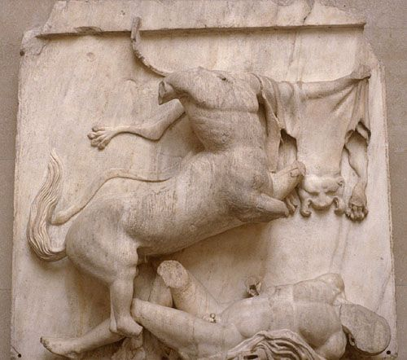

Create a scene that is easily recognisable

The centaur dominates a large amount of the scene and it was likely carrying a weapon. The sense of a battle is clear as the centaur is seen standing over the Lapith. The metopes would have been viewed from 10 metres above, increasing the sense of drama when viewed from below

Create realism in the scene

The left arm of the centaur is carved in low relief while the body is carved in high relief to help it be more visible from below. Meanwhile, the Lapith is seen to be defeated due to the twisted shape of the Lapith, especially landing on his arms

Fill the space so as not to leave blank spaces

The centaur fills a large amount of the upper space due to its wide stature and forms a ‘z’ shape in the metope. The skin draped over the right arm of the centaur fills up a lot of the right side of the metope. The twisted body of the Lapith fills up a lot of the bottom part of the metope

Amazonomachy

The Amazons were a tribe of women who lived in Asia Minor (Western Turkey). They only interacted with men when they needed to repopulate and any sons born were killed. The Amazonomachy describes the ninth labour of Heracles, the Belt of Hippolyta, was to steal the belt of the Amazonian queen Hippolyta. This led to the first war between the Greeks and the Amazons and then the second war where Hercules brought back an Amazonian wife for Theseus. The Amazons declared war on Athens in response. The Amazonomachy depicted both wars and once again shows the power of the Greeks over foreigners

The temple where the Amazonomachy was put was in a small town in the Peloponnese, over 35 miles southwest of Olympia. The temple was built by Iktinos in 450 BC, the same architect who helped build the Parthenon. The Amazonomachy was twinned with the Centauromachy. The Amazonomachy ran around the inside of the temple’s naos and allowed
the viewer to see it in its whole in one place

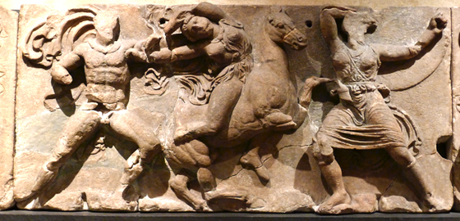

Create a scene that is easily recognisable

The sculptor has created a scene where a man fights two women with a bare breast, to denote Amazons

Create realism in the scene

The drapery on the woman on the right depicts movement towards the left. The shallow relief on the Amazon and the Greek shows them in mid-flight where the horseback Amazon tries to flee from the Greek. The horse is rather small compared to the Amazonian
Fill the space so as not to leave big blank areas

The left and right hand characters mirror each other. The bent knees fit well with the theme of action in the metope. The sculptor has depicted the Greek pulling the Amazonian from her horse

Rome

The architecture of Augustan Rome

Augustus wished to recreate the architecture of fifth century Greece as he considered it the high point of structural and architectural achievement

The Pax Romana (peace of Rome) was key to Rome under Augustus. After the civil war, he sought to be the bringer of peace.

The Pax Deorum was very important to Romans. If they appeased the gods, Rome would flourish and it would suffer if they were angered

The promotion of Augustus and his family was very important to him. To do this, he would emphasise his family’s links to the gods and promoted his future heirs

The Augustus of Prima Porta
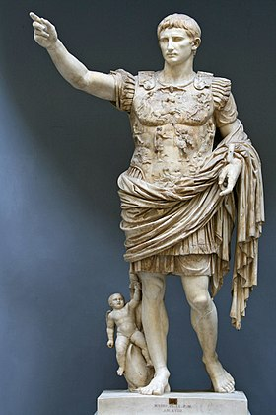

The current Augustus of Prima Porta is a copy made around 20 BC to 14 AD for Livia, Augustus’ 2nd wife. It was displayed in the town of Prima Porta, the first town north of Rome. The statue was based off Doryphorus (the spear-bearer), sculpted by Polykeitos around 440 BC. The statue was not a direct copy but was changed in a few ways to Romanise it

The right arm is raised to make Augustus seem like an orator who’s commanding an army

The breastplate seems like that of a soldier. The breastplate has been combined with a senatorial toga, unusually mixing together Augustus’ roles as commander-in-chief and as Pontifex Maximus. The breastplate used images of Apollo, Augustus’ patron god, Artemis, Apollo’s sister; Tellus, mother Earth, holding a cornucopia and other deities

The central figures represent the return of the Roman standards. The standard was first lost by Marcus Crassus, a Roman general who once commanded Julius Caesar, in 53 BC. Another was lost by Marc Antony in the 40s BC. Tiberius negotiated the returns of the standards with the Parthians.

At the feet of Augustus, there is a statue of Cupid. Cupid was the son of Venus and is therefore seen to be related to Augustus

Ara Pacis
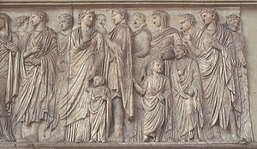
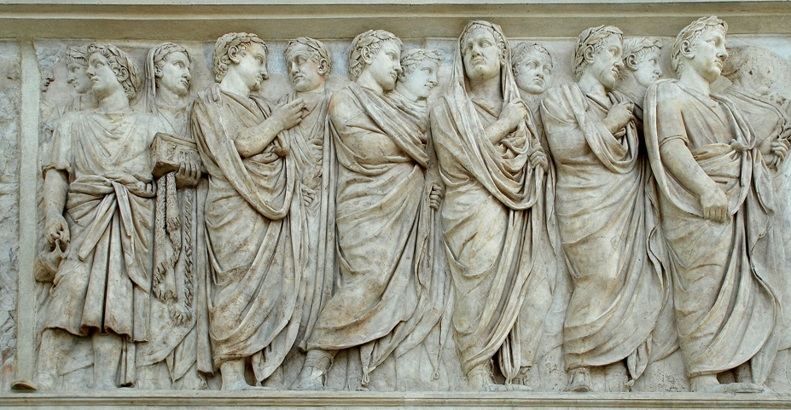

The ‘Altar of Peace’ was commissioned by the senate in 13 BC after Augustus’ victories in Hispania and Gaul.

The altar was surrounded by an enclosure wall sculpted inside and out. Doorways were included in the western and eastern walls of the structure. These walls depicted scenes linked to the Roman imperial family and how they were linked to Gods and their foundation stories. The northern and southern walls depicted the procession that took place to the Ara Pacis before the annual sacrifice. They are stylistically similar to the Panathenaic procession depicted on the Parthenon.

The northern wall depicts senators and priests. One carries an incense box and others carried laurel leaves. Many of the priests had their heads veiled and the bottom of the frieze of contains floral patterns

The southern wall depicts the imperial family including Augustus’ wife Livia, Marcus Agrippa and nephews Lucius and Gaius Caesar and Tiberius, Livia’s son

Death and burial

Preparation of the Body

It was an important to the Greeks that the dead were properly respected and taken care of, no matter their social status or wealth. The corpse’s eyes and mouth were closed, the body was washed, perfumed and wrapped in a white cloth. A coin was then placed in the corpse’s mouth so that they can pay Charon, the boatman who transports the dead over the River Styx. What followed was the prosthesis or ‘laying out’. The process lasted for two days and gave friends and family the chance to pay their respects to the body. The women would then perform a lament. They would cut their hair, dress in shabby black clothing and wail beside the dead, beating their chests and flailing their arms

Funerary Procession

Before the third day, the ekphora took place. The body was processed from their house to the burial ground. The body was either carried by a wagon or by pallbearers. The procession included men, women, children and an aulos player.

Burial of the Body

The body was always buried outside the body to remove any chance of religious pollution as well as to reduce the chance of disease. In Athens, the main burial found was in Karameikos, just northwest of the city walls. The body would then be buried or cremated. For cremation, a pyre would be built and the body would lie on top. When the body was burned, the ash was given to the family. The ashes would then be placed in a shrine or a grave. To aid their journey to the underworld, the body would add gifts on the grave. It could be an item important to the person in life or a piece of food. If the family was rich, a stele may be used for the deceased. It was believed that if the family neglected the stele, it would dishonour the family memory. It would be a monument to the god. A sacrifice would be done after the burial or cremation, usually an offering of the blood of the dead to Hades and Persephone. A period of mourning began for 30 days. On the 3rd, 9th and 13th day of each month, the family visited the grave of deceased loved ones.

Festivals for the dead and the ancestors

There were other festivals dedicated to respecting the dead. The Anthestria took place in late January and lasted three days. It was celebrated in honour of Dionysus. On the 1st day, the dead were believed to have rose from the Underworld. Wine from the previous year was opened and offered as libations to Dionysus. On the 2nd day, groups would hold drinking contests and would pour libations of wine on the deceased’s grave. The last day was dedicated to the dead. Families would make offerings to Hermes, who could travel between Earth and the Underworld. The living were not allowed to eat any food. The ceremony marked the period between the dead leaving Athens and the return to the Underworld

The second celebration was the Genesia, which took place in late September. Athenians would decorate their loved one’s graves with ribbons and offer libations and food in honour of their dead ancestors
Rome

Like the Greeks, it was important that the dead were treated with respect, no matter their social status, responsibility and wealth. It was important that the deceased weren’t buried in the city due to religious pollution and the risk of disease. The wealthy were buried in tombs along the roads leading into towns and cities, allowing passers-by to pay their respects

Wealth and Status in Rome

Much of our evidence of Roman funerals comes from wealthy funerals as so much money was invested in them. For working-class funerals, however, not much money can be invested into their funerals and so they found other ways to hold funerals. The main option is funeral clubs. Members would pay a monthly fee to pay for it. The club would meet for meals and gathering to let members make social connections. Funeral clubs would organise themselves into guilds such as the baker’s guild and the blacksmith’s guild. When one of its members dies, the funeral club would pay for the funeral and may pay for tombs and lavish ceremonies

Preparation of the Body

Roman burial practice was very similar to that of the Greeks. The last breath of the deceased would be attempted to be sealed by a kiss and then the person present would call the deceased’s name out. The ceremony would be dome afterwards if the corpse died unaccompanied. The body was washed, perfumed and put in their best clothes. A coin would be placed in their mouth to pay Charon. Wealthy families would have the body put in their atrium for 8 days, giving friends and families a chance to pay their respects. Women would lament while beating their chests.

Funerary Procession

The funeral took place 8 days after a death and involved a large variety of roles including flute and horn players. The family would wear funerary masks of ancestors to symbolise the acceptance of the deceased into the afterlife. A small but wealthy family would pay for professional mourners to process and lament the dead. They would also pay actors to mimic the deceased.

Burial of the Body

The body was cremated or buried once outside the city. Like the Greeks, the family’s wealth determined the tombs size. A wealthy person would have either a large family tomb or an individual tomb. Rich would also place their dead into sarcophagi which contained reliefs of mythological battles and heroes.

The dead would not be forgotten once they were buried. A marble bust would be placed in the house and were believed to have turned into Manes. The family would leave food and offerings at their tomb.

Festivals for the Dead and the Ancestors

The Parentalia

The Parentalia took place over 9 days from 13 – 21 February. People were not allowed to marry, temples were closed and no official business can take place, apart from a domestic sacrifice by a vestal virgin on the first day. The festival centred around the family rather than the State. Offerings took place during the first 8 days of the festival and on the 9th day the family would meet and share a meal at the home to give them an opportunity to undo the wrongs that took place

The Lemuria

The Lemuria took place on the 9th, 11th and 13th of May. Like the Parentalia, citizens were not allowed to conduct any official business. Unlike the Parentalia, the Lemuria was to ward off evil spirits contrasted with honouring the family’s deceased ancestors

Journeying to the Underworld

The Homeric Hymns were 33 poems dedicated to the Gods written in a style of the Iliad and the Odyssey. This suggests that it was written by Homer, although the actual poet is unknown. One of the most notable poems was the Homeric Hymn of Demeter. The poems were passed down through oral tradition.

The main themes in the hymn to Demeter are the relationships between the Gods and the relationship between man and the Gods. The poem establishes that Gods have the same feelings as men, showing their anthropomorphism

In lines 1-18, the daughter of Demeter, Persephone, was entrapped by Hades, who enlisted Gaia to create a flower which would be irresistible to the young, childlike Persephone, with the support of his brother Zeus so that Hades can marry Persephone. This highlights the fact that the head of a Greek household was a male and males had complete control over females in the family even to force them to marry someone, which was acceptable in Greek culture.

In lines 19-39, Hades emerged from the ground and took Persephone to be her Queen. Before she was sucked into the Underworld, Persephone let out screams which were only heard by Helios, Hecate and Demeter.

In lines 40-89, Zeus’ animosity towards Demeter is made clear so she sprang into action to search for Persephone. After 9 days, Hecate tells Demeter that she heard Persephone’s screams but doesn’t know anything else. They approach Helios as it was rumoured that he saw what happened. They went to Helios who told them that it was Zeus who offered Persephone to Hades

In lines 90-104, Demeter gets angry and leaves Mount Olympus. She disguises herself as an old woman, takes refuge under a tree and mourns for her daughter

Lines 105-300 are relatively inconsequential to the storyline but tell of what Demeter did when she lived among men. A family took her in and allowed her to look after their son. She fed the baby ambrosia to grant him immortality. Demeter tried to throw the child in the fire to shed his human form and make him a god but the mother came in and took her child before Demeter could throw him into the fire. Enraged, Demeter demanded that the people of Eleusis build her a temple so she can teach them how to worship her correctly.

In lines 301-334, the Eleusians completed their temple, showing that the gods need humans as well as humans needing gods. Zeus realised the problems kidnapping Persephone would have for the gods’ relationships so he ordered Iris to beg Demeter to return home but Demeter refused to return. Zeus then sent all the gods to give Demeter gifts. Demeter stated that only Persephone’s return will convince her to return.

In lines 335-385, Zeus sends Hermes to the Underworld to appeal to Hades to release Persephone. Hermes only care about human was the fact that they would be wiped out without Demeter’s interference, meaning the gods would be deprived of sacrifices. Hades relented and gave Persephone to Hermes. Before she left, Hades gave Demeter a pomegranate seed to eat, not knowing that this would then mean that she would have to stay in the Underworld for a set period. Persephone then left the Underworld

In lines 386-474, Persephone reunites with her mother but Demeter soon realises that Persephone ate something in the Underworld. She then explains that Persephone must spend half the year with Hades in the Underworld and the other half can be spent on Earth. This is the Greek and Roman explanation for the seasons. Autumn and Winter is when Persephone is with Hades and so Demeter punishes the humans. In Spring and Summer, Persephone is with Demeter and so she is happy and gives the people good conditions to grow crops

Rome

Orpheus

Orpheus’ father was the Thracian king Oeagrus or Apollo and his mother was the muse Calliope. Apollo taught him how to the lyre and Calliope taught him how to sing. Orpheus’ song was able to enchant anyone who heard it. He was even able to enchant the sirens on the journey of the Golden Fleece with Jason. After he finished his journey with Jason, he visited a maiden called Eurydice.

In lines 1-10, there are multiple bad omens happening to Eurydice such as a torch smoking and Orpheus not speaking the correct words at his wedding. Eurydice is bitten by a venomous snake and dies

In lines 11-39, Orpheus finds out that Eurydice has died and is overcome with grief so he decided to go to the Underworld and retrieve Eurydice. He descends into the Underworld and plays his lyre to impress Pluto and Prosperina. Orpheus argued that, although everyone will die and go to the Underworld, he argued that Eurydice had her years cut short. He also told them that he would not come back until he died

In lines 40-64, Orpheus continues his song and Pluto and Prosperina are so moved that they bring forward Eurydice. The only conditions the gods had was that Eurydice must walk behind Orpheus until they exit the Taenaran Gate. As they got close to the exit, Orpheus got so worried that Eurydice got left behind that he looked back. Eurydice was then pulled back into the Underworld forever

Extra Textbook Information

Hiera: Means 'holy affairs in Greek
Religio: Means 'correct worship of the state Gods' in Latin

These terms show just how the Greeks and Romans worshipped Gods. They worshipped through actions such as sacrifices and libations rather than belief in monotheistic religions today

Polytheism: Combination of poly meaning many and theos meaning Gods. Used to describe religions with many different Gods

Anthropomorphism: The Gods were humanoid in both shape and actions. This made them more relatable to humans as they wove the Gods through their foundation myths which helped them explain the nature around them. This also explained why the Gods could either be happy or sad and vengeful, like humans

Epithets: A word or a phrase used to describe a quality or a skill possessed by a God e.g. 'Demeter with the lovely hair'

Titans: Gods who came before the Olympians. Cronus castrated his father, Uranus, to become the head of the gods. To stop his children rising up against him, Cronos ate his first 5 children but his wife, Rhea, hid the youngest child, Zeus and raised him in a cave. When Zeus grew up, he freed his sibling and lead them in war against the titans. They imprisoned many of the Titans in Tartarus in the underworld. Atlas and Prometheus escaped this punishment by cooperating with the Olympians

Homer's Iliad and Odyssey: Two oldest epics dedicated to the bard Homer. The Iliad starts in media res in the tenth year of the Trojan war and centres around the wrath of the Greek hero Achilles. The story ends with an epic battle between Achilles and the Trojan king Hector. The Odyssey is named after Odysseus, its hero the king of Ithaca. The story starts as Odysseus goes home after the Trojan war but is blown off course by Poseidon. This left Odysseus with a 10-year journey back to Ithaca on which he faced Gods, witches and giants.

Hesiod: A Greek believed to have been alive in 7th century BC. He wrote poetry about the Gods, from their birth to Hesiod's time. This was called the Theogony

Eleusinian mysteries: a cult to Demeter. Called mysteries as their rituals are not known. Linked to the Homeric Hymn to Demeter. Promised salvation after death (not the underworld)

The Aeneid: An epic Roman poem composed by Virgil in 19 BC. Heavily influenced by Homer's works but from a Roman perspective. Starts at the end of the Trojan War after the walls were breached and the Greeks had captured Troy. Aeneas escapes and heads for Italy. Juno and Venus make heavy appearances (Juno trying to stop Aeneas and Venus trying to help him). Aeneas lands on the West coast of Italy and fights with the native tribe. Aeneas eventually marries Lavinia, daughter of Latinus and became king of Latium. Aeneas' son Ascanius founded Alba Longa and from this line, Romulus and Remus were born

Servius Tullius: 6th king of Rome born a slave. When he was crowned, he made a treaty with the surrounding Latins saying that Rome was the head of Latium. He honoured the treaty by building a temple to Diana, who was very popular around Latium

Actium: A battle between Octavian and Mark Antony and Cleopatra in Actium as a final civil war battle which cemented Octavian's power

Mars: Very important God for Augustus. When he went to fight against Brutus and Cassius at the Battle of Phillipi, Octavian said that if he won, he would build a temple to Mars. When they won, Octavian built a temple (Mars Ultor or Avenger) in 27 BC in the centre of the Forum. This is where the senate met for discussing war and where generals would conduct a ceremony before going to war. They would also dedicate a portion of the spoils of war to Mars as well.

Didorius Sicilus: A Greek historian who lived in the first century BC. Wrote the Bibliotheca Historia (Library of History) which covered the mythic beginnings of Greek and non-Greek civilisations around the Mediterranean to 60 BC

Pseudo-Apollodorus: The Bibliotheca was believed to have been written by Apollodorus of Athens in the 2nd century BC. However, a reference in the book made reference to a man who lived around 100 years later in one of the chapters which would make it impossible for Apollodorus to have written it. Therefore, Pseudo is added as a prefix

Apollo and Cassandra: The Trojan princess Cassandra was a priestess on Apollo. One day, Apollo offered Cassandra the gift of prophesy in return for sex. She initially accepted and Apollo gave her the gift of prophesy but then she refused to sleep with him. As punishment, Apollo made sure that no one would believe her prophecies.

Prometheus: A Titan who was a great supporter of humans. He once took a sacrificial animal and divided it into two parts: the bones wrapped around with glistening fat and the entrails wrapped around with the best cuts of meat. He offered Zeus either part. Zeus chose the visually appealing bone. This is why the Greeks offered the gods the thigh bone wrapped in fat and ate the other parts of the sacrificial animal

Chryselephantine: A mixture of gold and ivory which statues were normally made of. The ivory represented the skin while the gold represents its clothes. They were melted down in times of recession, hence why the cult states of Athena Nike and Zeus at the temple of Zeus at Olympia no longer exist

The Temple of Vesta: This was where many important politicians such as Julius Caesar and Marc Antony would leave their wills. In 34 BC, Marc Antony left for Egypt to be with Cleopatra. Octavian got his will from the temple and read it to the senate where they learnt that, upon Marc Antony’s death, the eastern provinces would go to Cleopatra and her children

Suovetaurilia: One of the most common sacrifices in Rome consisting of a pig, sheep and ox. It would be used to purify thing such as new buildings and land. Before being sacrificed, the animals would be processed around whatever needed to be purified

Erechtheion: Built in 421 BC as part of Pericles’ building program, the Erechtheion was built for Athena, Poseidon and the legendary king Erechthus. The temple contained a well which was meant to be the spot where Poseidon made the salt water spring appear. It also contained the tombs of legendary kings Erechthus and Cecrops.

Doryphorus of Polykeitos: The original statue was originally made of bronze but the new statue was made of marble, a less structurally strong substance. Therefore, the Romans had to add support struts to stop the marble from cracking and breaking off. The supports can be disguised as the right arm and left leg

Pliny the Younger: He was born around AD 61 and died around AD 113. He was a lawyer, magistrate and writer. None of his works survive but many of his letters do. They give us much information about the time in which she lived such as the eruption of Vesuvius in AD 79 in Pompeii, at which Pliny was an eye witness and Pliny the Elder, his uncle, trying to save the population

