# Section Check In – CA: Calculus

## Questions

1. Given that , find the value of . [CA1]

2. Find . [CA8]

3. Evaluate . [CA11]

4. A particle has acceleration ms-2. At , the particle starts from point P with , calculate;

(i) the velocity at s.

(ii) the distance travelled from P in 10 s. [CA14]

5. Determine the equation of the normal to the curve  at the point . [CA4]

6. Given that  find the equation of the curve which passes through the point (2, 11). [CA9]

7. The equation of a curve is . Determine the area of the region enclosed by the curve and the axis. [CA12]

8. The equation of a curve is . Determine the nature and the coordinates of each of the stationary points. [CA5,6]

9. The curve , where , has a stationary point at 

Find the value of  . [CA5]

10. Find the area of the region enclosed by the curves  and . [CA13]

**Extension**

A rectangular sheet of card, 400 cm by 300 cm is to be used to make an open box. Squares, *x* by *x* are cut from each corner and then the sides folded to make the box.

Find the value of *x* that gives the maximum volume of the box.

## Worked solutions

1. .

Substituting  gives 

2. Expanding the integrand,  giving 

3. 

4. (i) 





 ms-1

(ii) 





 m (2 km)

5. When , 



When ,  , therefore gradient of normal -1

 , at (2, -30) equation of normal oe

6. 

Passing through (2, 11),  , 



7. When ,







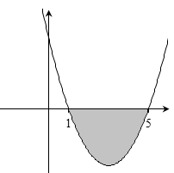

*x*

*y*





Therefore area enclosed by curve and *x*-axis (below the *x*-axis) is 32 units squared.

8. 

For stationary point,  giving  and therefore  and 

Sketch of positive cubic curve shows  is a maximum and  is a minimum.

When  ,  : (-2, 53)

When  ,  : (2, -43)

9. 

 when 

 , 

10.

*y*

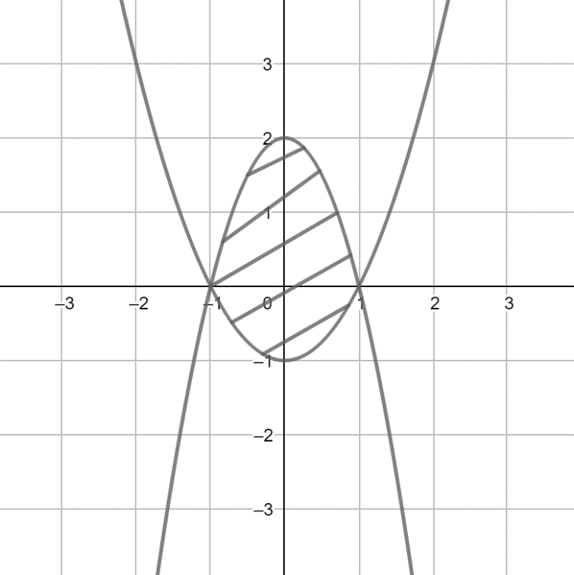

**

**

*x*

Curves intersect   , 

Area = 





 square units

**Extension**

  for turning point.

But  which is greater than 300 width of card, therefore cm.

Checking graphically:

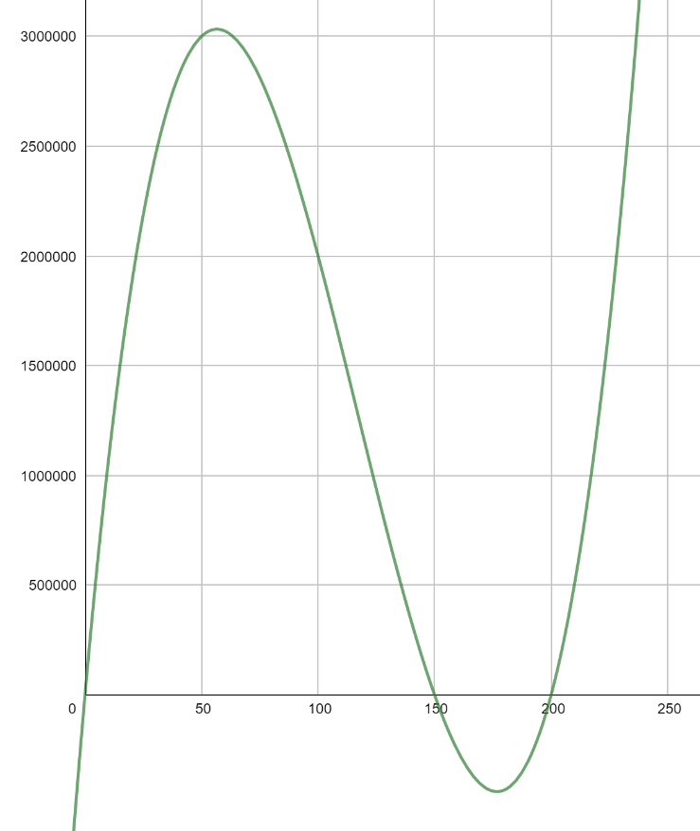

**OCR Resources**: *the small print*OCR’s resources are provided to support the delivery of OCR qualifications, but in no way constitute an endorsed teaching method that is required by the Board, and the decision to use them lies with the individual teacher. Whilst every effort is made to ensure the accuracy of the content, OCR cannot be held responsible for any errors or omissions within these resources.

© OCR 2019 - This resource may be freely copied and distributed, as long as the OCR logo and this message remain intact and OCR is acknowledged as the originator of this work.

OCR acknowledges the use of the following content: n/a

Please get in touch if you want to discuss the accessibility of resources we offer to support delivery of our qualifications: [resources.feedback@ocr.org.uk](mailto:resources.feedback@ocr.org.uk)

We’d like to know your view on the resources we produce. By clicking on [‘Like’](mailto:resources.feedback@ocr.org.uk?subject=I%20liked%20the%20FSMQ%20Check%20In:%20Calculus) or [‘Dislike](mailto:resources.feedback@ocr.org.uk?subject=I%20disliked%20the%20FSMQ%20Check%20In:%20Calculus)’ you can help us to ensure that our resources work for you. When the email template pops up please add additional comments if you wish and then just click ‘Send’. Thank you.

Whether you already offer OCR qualifications, are new to OCR, or are considering switching from your current provider/awarding organisation, you can request more information by completing the Expression of Interest form which can be found here: [www.ocr.org.uk/expression-of-interest](http://www.ocr.org.uk/expression-of-interest)

Looking for a resource? There is now a quick and easy search tool to help find free resources for your qualification:   
[www.ocr.org.uk/i-want-to/find-resources/](http://www.ocr.org.uk/i-want-to/find-resources/)