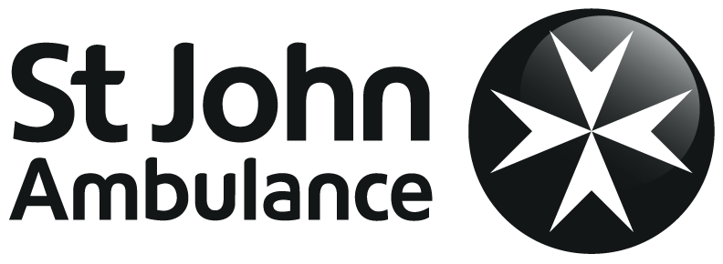 **Basic Training & One Star Assessment**

**You will be tested on:**

* 1. When and how to get help
  2. Your ability to deal with a casualty who is not breathing (CPR)
  3. Your ability to deal with an unconscious casualty with a bleeding wound
  4. Your ability to deal with an unconscious casualty

**COPING IN AN EMERGENCY**

**Key points:**

* + Assess the situation
  + Make the area safe
  + Give emergency aid
  + Get help

**Communication and casualty care**

**Key points:**

* + Always communicate with the casualty if possible
  + Listen carefully to what your casualty tells you
  + Always make sure you have the correct information before dialling 999 or 112.

**Primary Survey**

**DRABC**

* **D**anger
* **R**esponse
* **A**irway
* **B**reathing
* **C**heck for severe bleeding.

**Before attempting first aid you should always:**

* check that you are safe
* check for a response
* open the casualty’s airway if necessary
* check to see if the casualty is breathing
* if breathing, check to see if the casualty is bleeding.

**RESUSCITATION**

**CPR is used when a casualty has stopped breathing or has irregular breathing (agonal breathing).**

* + The DR ABC sequence must be performed before carrying out CPR
  + If the casualty is not breathing dial 999 or 112 for an ambulance
  + Give 30 chest compressions
  + Give two rescue breaths
  + This should be continued until the ambulance arrives.

**RECOVERY POSITION**

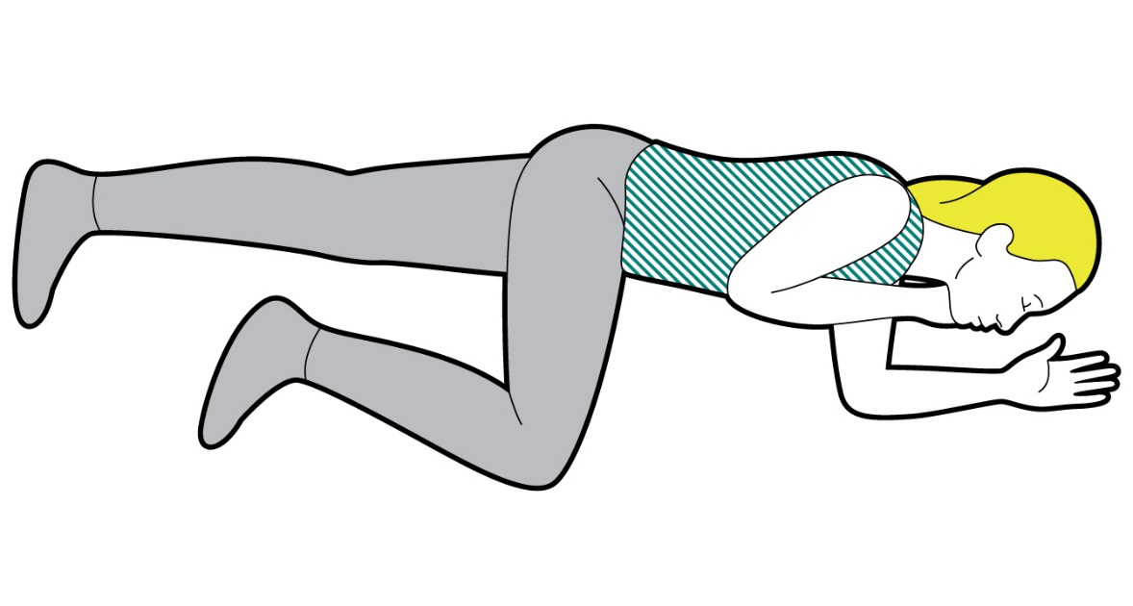

**The position is used for unresponsive, breathing casualties.**

**It maintains an open airway so the casualty can breathe.**

1. Place the arm nearest to you at right angles to the casualty’s body.

2. Bring the other arm across the casualty’s chest and hold the back of their hand against the cheek closest to you. Keep holding their hand there.

3. Lift the leg furthest away from you until the foot is flat on the floor. Keep your hand on top of their knee.

4. Pull on their knee and roll the casualty towards you into the recovery position.

5. Position the upper leg to stop the casualty from rolling on their front. Reopen the airway.

**CHOKING**

**What you may see:**

* + Difficulty with speaking or breathing (mild obstruction)
  + Unable to speak or breathe (complete obstruction)
  + Red or purple colour around the neck and face, casualty may turn blue
  + Pointing to or grasping the mouth or throat.

**What you should do:**

* + Ask: “Are you choking?”
  + Give up to five back blows
  + Give up to five abdominal thrusts
  + Call 999/112 and repeat until obstruction removed or help arrives
  + If abdominal thrusts have been used seek medical advice.

**MINOR BLEEDING & NOSE BLEED:**

**What you will see:**

* + Blood oozing from the wound or dripping from the nose
  + Signs of shock.

**What you should do:**

* + **Put on disposable gloves, if available**
  + **Clean by rinsing it under running water and pat dry the wound**
  + **Raise and support the injured part**
  + **Clean and dry the area around the wound**
  + **Cover with an adhesive dressing.**

**NOSE BLEED: What you should do:**

* + **Sit the casualty down, leaning forward**
  + **Get them to pinch the soft part of their nose for 10 minutes and check to see if the bleeding has stopped**
  + **Try this 3 times for a maximum 30 minutes**
  + **Once the bleeding has stopped clean the area**
  + **If the bleeding is severe seek medical help.**

**SHOCK**

**What you will see:**

**Initially:**

* + Pale, cold, clammy skin
  + Sweating

**As shock develops:**

* + Grey-blue skin

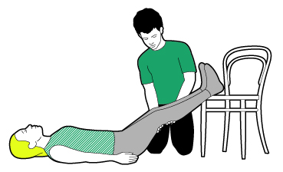

* + Weakness and dizziness
  + Nausea and possibly vomiting.
  + Thirst

**What you should do:**

* + Treat any injuries that may have caused shock
  + Help the casualty to lie down
  + Raise and support the casualty’s legs, if possible
  + Call 999 or 112
  + Loosen any tight clothing
  + Keep the casualty warm.

**BLEEDING AND SHOCK**

**Severe bleeding: what you will see:**

* + Bleeding from a wound
  + An object may sometimes be embedded in a wound
  + Signs of shock.

**What you should do:**

* + Ask the casualty to apply pressure to the wound. If an object is embedded in the wound, apply pressure on either side of the object
  + Ask a helper to call 999/112
  + Put on disposable gloves and apply a sterile dressing
  + Treat for shock
  + Support the injured area.

**Amputation: what you will see:**

* + A severed limb or part of a limb
  + Signs of shock.

**What you should do:**

* + Put on disposable gloves, if available
  + Apply pressure and raise the injured part
  + Apply a sterile dressing
  + Treat for shock.
  + Ask a helper to call 999/112.
  + Put on disposable gloves, if available
  + Wrap the severed part in cling film or a plastic bag
  + Wrap the package in soft fabric and place in a container of crushed ice
  + Label and hand to the emergency services

**Internal bleeding: what you will see:**

* + Bleeding from body openings
  + Pattern bruising
  + Signs of shock.

**What you should do:**

* + Treat as for shock
  + Dial 999 or 112 for an ambulance.

**BONES MUSCLES AND JOINTS**

**Definitions:**

* + Fracture – a crack or break in the bone
  + Dislocation – a bone in a joint that has moved out of place
  + Sprains and strains – damage to soft tissues.

**What you will see:**

* + Swelling
  + Bruising
  + Difficulty moving the injured limb
  + Pain.

**What you should do:**

* + Tell the casualty not to move
  + Support the injured part if possible
  + Arrange for the casualty to   
    be taken to hospital.

**What you should do:**

* + Rest the injury
  + Ice - apply a cold compress or icepack
  + Comfortable support
  + Elevate the injured limb.

**BITES AND STINGS**

**What you will see:**

* + There may be pain, redness or swelling around the site of the bite or sting
  + The severity will depend on what has bitten or stung the casualty
  + A severe allergic reaction is a possible complication.

**What you should do:**

* + Reassure the casualty and scrape off the sting if necessary
  + Raise the bitten or stung part, if possible
  + Apply an icepack
  + If the pain or swelling continues tell the casualty to seek medical help.

**FOREIGN OBJECTS**

**Foreign objects in the eye**

**What you should do:**

* + Tell the casualty not to rub their eye
  + Carefully pour clean water on to the eye
  + If the foreign object is still on the eye, try to lift it off with a moist swab or tissue
  + If this does not work, seek medical help.

**Foreign objects in the ear**

**What you should do:**

* + If an insect is in the ear, tilt the head and flood the ear with tepid water
  + Otherwise take the casualty to hospital.

**Foreign objects in the nose**

**What you should do:**

* + Tell the casualty to breathe through their mouth
  + Send the casualty to hospital or a walk-in center
  + Do not try to remove the object.