Music Department
Assessment Criteria for Written Work

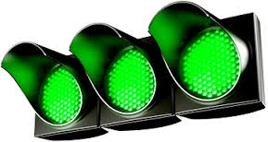
EXCELLENT file shows secure understanding of musical matters. Notation is neat, clear and shows accumulated knowledge. Vocabulary is well defined and linked with current class work. You could communicate musical ideas with other musicians.
Good administration: care taken with spelling, grammar & presentation.
SECURE Good grasp of musical matters. Notation shows secure knowledge, with new theory being applied. Vocabulary is clearly understood and could be applied to current work. Any misunderstandings are being addressed.
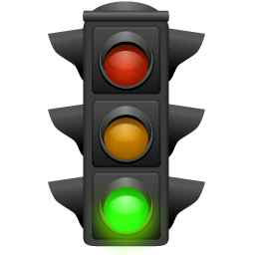
A few corrections or practice required (terminology/notation/spelling/grammar). Administration is generally good, but could be brushed up a little.
ADEQUATE showing developing understanding and a general grasp of the work covered in class. Worksheets show increasing knowledge. Notation is developing; an awareness of the presentation of musical ideas is evident and musical ideas are understandable.
Practice is required (finesse in presenting notated work, clarify your understanding. Do corrections and check in with your teacher.

Administrative matters need attention (dates/order of sheets).
SOME CONCERNS Inconsistent grasp of work covered.

Persistent errors emerging. Notation lacks precision or shows recurring lack of understanding. Written work lacks detail or is incorrect. Another musician would have difficulty understanding what you have written.
Errors are repeated without correction. More careful attention to detail needed (read the question!).
Work missing/incomplete/unexplained gaps. Corrections not done.
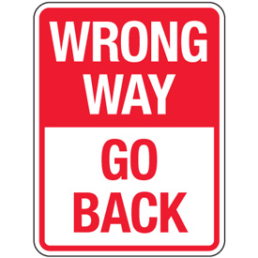
POOR Stop and get back on the right track!
Ask for help. Sort out terminology.
Work is still missing. Corrections repeatedly not done.
You must attend a subject removal to catch up.

How to write a good definition

Think about the word you are being asked to define. Listen out for the word in class and think about how it is being used.

Do some research; check through your file sheets, check in a dictionary and talk to someone to check your understanding of the word. Try to use the word in class discussions.

Aim for 3 sentences:

- Start with a short sentence that clearly states what the word means.

The way in which sounds are organised and grouped together (against the pulse?)

- Think about how you demonstrate this musical idea in class.

The rhythm matches the lyric syllables of a song.

- Are there any specific examples you could include based on current classwork?

Rhythms we are studying include ta (crotchet) and ti-ti (quavers).

Want to really expand and extend?

Is this musical term linked to any other musical idea? Would this help to clearly define the word?

A steady pulse helps to accurately perform rhythms.

