**Immunity Questions**

Name: ……………………… Mark: ………/36 Grade: …….   
**Q1.**          Antibodies are proteins. The diagram shows an antibody.

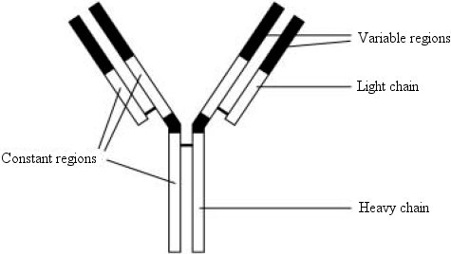

(a)     Name

(i)      the monomers that form the heavy and light chains

.............................................................................................................

(ii)     the chemical bonds that join these monomers.

.............................................................................................................

**(2)**

(b)     The specificity of an antibody depends on its variable regions. Explain how.

......................................................................................................................

......................................................................................................................

......................................................................................................................

......................................................................................................................

**(2)**

(c)     In a pregnant woman, some antibodies cross the placenta from the mother to the fetus. These antibodies only provide short-term immunity for newborn babies. Explain why these antibodies only provide short-term immunity.

......................................................................................................................

......................................................................................................................

......................................................................................................................

**(2)**

**(Total 6 marks)**

**Q2.**          The box jellyfish produces a poison (venom) which enters the blood when a person is stung. A person who has been stung can be treated with an injection of antivenom. This antivenom is produced by injecting small amounts of venom from box jellyfish into sheep, then extracting antibodies from the sheeps’ blood. These antibodies are then injected into the person who has been stung.

(a)     If a sheep is injected with the box jellyfish venom on more than one occasion a higher yield of antivenom is obtained. Explain why.

......................................................................................................................

......................................................................................................................

......................................................................................................................

......................................................................................................................

**(2)**

(b)     Injecting antivenom does not give a person lasting protection against the venom of box jellyfish. Explain why.

......................................................................................................................

......................................................................................................................

......................................................................................................................

......................................................................................................................

**(2)**

(c)     Suggest **one** possible problem in injecting people with antivenom made in this way.

......................................................................................................................

......................................................................................................................

**(1)**

**(Total 5 marks)**

**Q3.**          A test has been developed to determine if a person is infected with variant CJD (vCJD), the human form of BSE (mad cow disease). The test detects the protein which causes vCJD in a urine sample.

The test kit contains the following components.

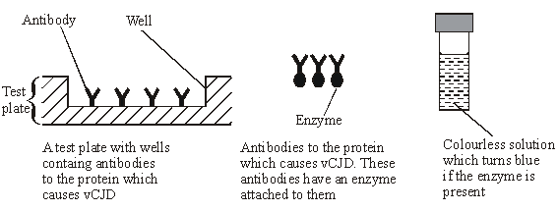

(a)     Complete the flow chart to describe how this test would be used.

|  |
| --- |
| Urine sample is added to well in test plate |

**↓**

|  |
| --- |
| Plate is washed to remove unbound vCJD protein |

**↓**

|  |
| --- |
|  |

**↓**

|  |
| --- |
|  |

**↓**

|  |
| --- |
|  |

**(3)**

(b)     Explain why this test would detect vCJD, but not other antigens in the urine.

......................................................................................................................

......................................................................................................................

......................................................................................................................

......................................................................................................................

**(2)**

**(Total 5 marks)**

**Q4.** Read the following passage.

The life cycle of the malarial parasite consists of a number of stages. Some of these stages  
occur in humans and some occur in mosquitoes. At each stage, the parasite has different  
antigens on the surface of its cells. Attempts have been made to extract some of these antigens  
and use them to make vaccines to combat the disease. A trial has recently been carried out

5      with one of these vaccines. An injection of the vaccine was given to a group of people chosen  
at random at the start of the trial. Another injection was given 30 days later.

Blood samples were taken at regular intervals throughout the trial. After the first injection,  
the concentration of antibody in the blood rose slowly then fell quickly. After the second  
injection, the concentration rose quickly. It reached a maximum concentration of

10    approximately twice the concentration it reached after the first injection.

Use information from the passage and your own knowledge to answer the following questions.

(a)     What is meant by *antigens* (line 3)?

......................................................................................................................

......................................................................................................................

......................................................................................................................

......................................................................................................................

**(2)**

(b)     (i)      Use information from the passage to sketch a graph to show the effects of the two injections on the concentration of antibody in the blood.

**(3)**

(ii)     Suggest **one** reason why it was necessary to give two injections of the vaccine   
(line 6).

.............................................................................................................

.............................................................................................................

**(1)**

(iii)     Although this vaccine is made from antigens from malarial parasites, it does not cause malaria. Explain why this vaccine does not cause malaria.

.............................................................................................................

.............................................................................................................

.............................................................................................................

.............................................................................................................

**(2)**

(c)     The blood from those taking part in the trial was also examined under the microscope at the beginning of the trial. Explain how this would enable those who had malaria to be identified.

......................................................................................................................

......................................................................................................................

**(1)**

**(Total 9 marks)**

**Q5.**          Read the following passage.

Herpes viruses cause cold sores and, in some cases, genital warts. Scientists are well  
on the way to producing an antibody which will counteract herpes infection. This antibody works  
by sticking to the virus and blocking its entry into cells. It has proved very effective in animal  
tests.

5       One drawback with this approach, however, is that antibodies are at present produced using  
hamster ovary cells. This method is expensive and only produces limited amounts. A new  
technique is being developed to produce antibodies from plants. It involves introducing the  
DNA which codes for the required antibody into crop plants such as maize.

          Use information from the passage and your own knowledge to answer the questions.

(a)     (i)      What is an antibody?

.............................................................................................................

.............................................................................................................

.............................................................................................................

**(2)**

(ii)     Describe how antibodies are produced in the body following a viral infection.

.............................................................................................................

.............................................................................................................

.............................................................................................................

.............................................................................................................

.............................................................................................................

.............................................................................................................

.............................................................................................................

**(6)**

(b)     Taking a course of these antibodies from plants to treat a herpes infection would not produce long-term protection against disease. Explain why.

......................................................................................................................

......................................................................................................................

......................................................................................................................

......................................................................................................................

**(2)**

(c)     Explain **one** advantage of using antibodies from plants to treat a disease, rather than antibodies produced in an experimental animal (lines 5-6).

......................................................................................................................

......................................................................................................................

**(1)**

**(Total 11 marks)**