**Gas Exchange in Humans**

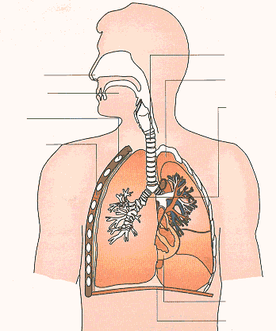

* The thorax is an airtight chamber consisting of:

**-  
-  
-**

* Air passes through nostrils
* As air passes through air passages it is __________________________________, odour detected
* Air passes through pharynx and into the ______________
* The wall of the trachea is strengthened and held open by _________________ arranged ___ shaped bands of ______________________
* ______________________ of trachea during inspiration
* Lower end of trachea splits into 2 _______________
* Each ___________________is subdivided into many ____________________
* Form finer and finer tubes-end in alveolar ducts which lead into _________________________
* Each alveolus consists of ________________________________________________________:
* Epithelium consists of 2 types of cells:
* _________________________ – large, ___________________ cells which make up alveolar wall
* Type II pneumocytes – secrete _____________________ a lipid/protein which _____________________________ and prevents the lungs collapsing
  + Connective tissue – composed of collagen and elastin
  + Capillaries – form a dense network around each alveolus
* Walls of the respiratory tract lined with _______________________________ cells and goblet cells which ____________________________
* Mucus __________________________________________________
* Beating of the ______________ carries mucus and trapped particles to the back of the buccal cavity where it is ________________
* Mucus also moistens the incoming air

**Mechanism of Ventilation**

* Air is passed in and out of the lungs by movements of the _____________ and _____________ muscles
* Which alter the _____________ of the thoracic cavity
* It is an _____________ process

**Inspiration (breathing in)**

* _____________ intercostal muscles contract
* _____________ intercostals relax
* Rib cage pulled _________ and ________
* Diaphragm _____________
* Diaphragm _____________
* _____________ volume of thorax
* Pressure in _____________ and therefore _____________ (intrapulmonary pressure) is reduced to _____________ than atmospheric pressure
* Air enters lungs, inflating alveoli, until air pressure in lungs (intrapulmonary pressure) is _____________ to atmospheric pressure

**Expiration (breathing out)**

* ________________ process brought about by ___________ __________ of lung tissue, respiratory muscles and ___________ of rib cage
* External intercostals ___________ , internal intercostals ___________
* Ribcage ___________ mainly under own ___________
* Diaphragm ___________ ; dropping rib cage forces it into a ___________ shape.
* It pushes _______ into thoracic cavity
* Reduces ___________ of thorax, ___________ intrapulmonary pressure ___________ that of atmosphere
* Air is forced ___________ by the ___________ internal pressure

