# Section Check In – CG: Coordinate Geometry

## Questions

1. Find the equation of the straight line through the point  which has a gradient of 6. Give your answer in the form .

[CG5]

2. Find the centre and radius of the circle with equation .

[CG3]

3. What is the equation of the circle with diameter AB, where A has coordinates (-3, 7) and B has coordinates (7, -1).

[CG3]

4. Sketch the graph  for  where . Show clearly any intersections with the axis.

[CG4]

5. Illustrate on a single graph the following four inequalities.

(i) (a) 

(b) 

(c) 

(d) 

(ii) Find the maximum value of to the nearest integer.

[CG7]

6. The coordinates of three points are  and .

(i) Show that  is perpendicular to .

(ii) Explain why the mid-point of  is the centre of the circle through ,  and .

(iii) Find the equation of the circle through ,  and .

[CG2,3,5]

7. The point  has coordinates  and the point  has coordinates . The gradient   
of  is  and the distance  is . Determine the possible values of  and .

[CG1,5]

8. A furniture manufacturer produces tables and chairs.

In each week the following constraints apply.

* There are 24 workers, each working 40 hours (i.e. there are 960 worker-hours available).
* There is a maximum of £1800 available for the purchase of materials.
* Each table requires £30 worth of materials and 12 worker-hours.
* Each chair requires £10 worth of materials and 6 worker-hours.
* It is necessary to make at least 3 times as many chairs as tables.

Let *x* be the number of tables produced each week and *y* be the number of chairs produced each week.

(i) Explain why  and .

(ii) Show that the cost of materials constraint reduces to the inequality .

(iii) Show that the worker-hour constraint reduces to the inequality.

(iv) Find the inequality relating to the number of tables and chairs made each week.

(v) Plot these five inequalities on a graph. Indicate the region for which these inequalities hold. (you may find it easier to shade out the regions which are not required).

When finished, each table is sold for a profit of £20 and each chair is sold for a profit of £5.

(vi) The manufacturer wishes to maximise the profit. Explain why the objective function is given by .

(vii) Find the number of tables and chairs that should be made in order to maximise the profit.

[CG6,7,8]

9. A circle with centre at the origin has radius . A tangent to the circle has equation . Find the possible values of .

[CG3,5]

10. Sketch the curves  and  on the same axes, and show that the shortest distance between the two curves is .

[CG1]

**Extension**

What assumptions have been made in the mathematical model used in question 8?

## Worked solutions

1. Equation of line is 



Equation of line is  oe

2. Equation is 

Completing the square twice, 

Simplifying, equation is 

Hence centre is (-1, 3) and radius is 5.

3. Centre of circle: midpoint of AB, 

Radius of circle:

Equation of circle: 

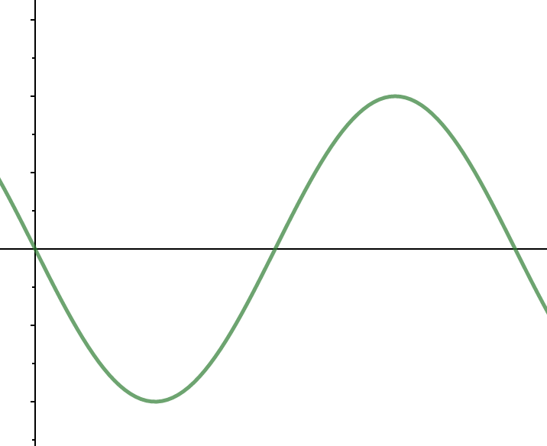

*a*

*-a*

180

360

4.

5. (i)

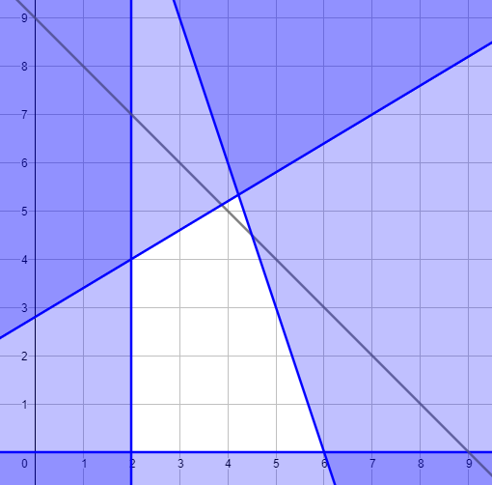

(ii) 

6. (i) Gradient of AB is  ; gradient of BC is . oe

Product of gradients  so lines are perpendicular

(ii) Since angle , the angle in a semicircle property means that triangle ABC is a right angled triangle with AC the diameter of circle. Mid-point of the diameter is the centre of the circle

(iii) Centre of circle: midpoint of AC, 

Radius of circle:

Equation of circle: 

7. Gradient of PQ 

Distance PQ 







 or 

Coordinates of P: (14,10) or (2,4)

8. (i) The number of tables and chairs produced each week cannot be negative.

(ii) 

(iii) 

(iv) 

(v)

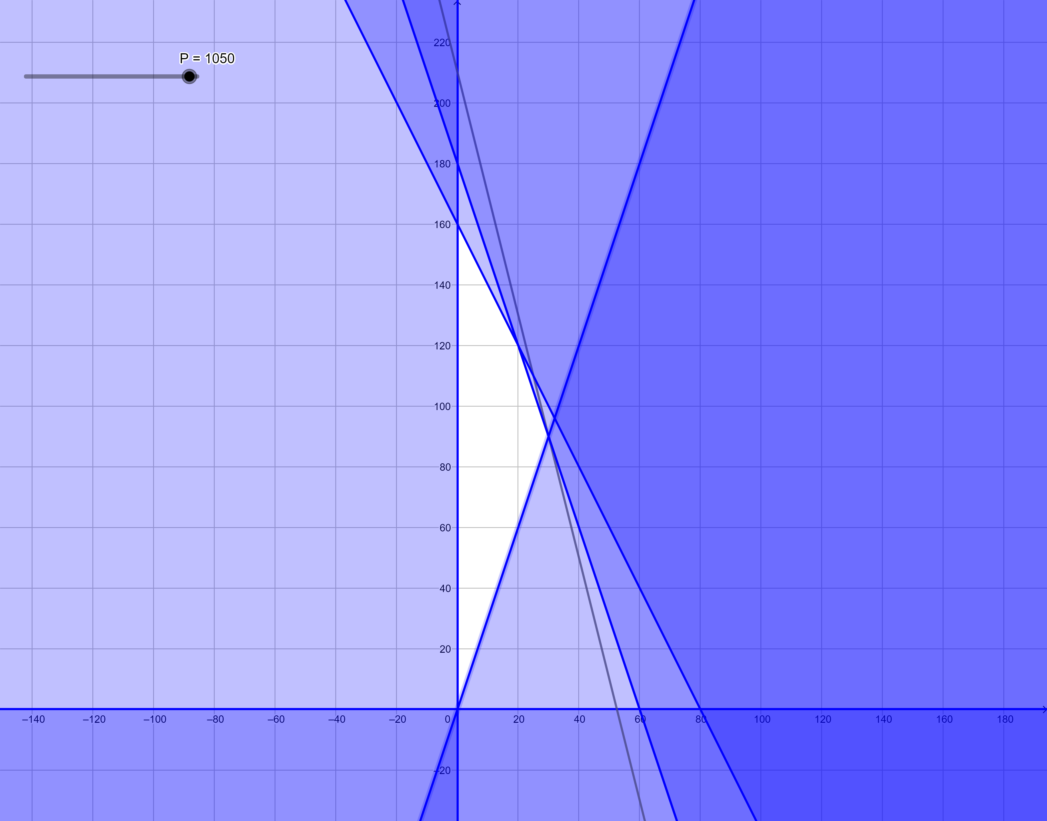

(vi) The profit P is equal to 20 times the number of tables manufactured plus 5 times the number of chairs manufactured.

(vii)

|  |  |  |
| --- | --- | --- |
| *x* | *y* | *P* |
| 0 | 0 | 0 |
| 0 | 160 | 800 |
| 20 | 120 | 1000 |
| 30 | 90 | 1050 |

30 tables and 90 chairs.

9. Equation of circle is 

Line meets circle where 

Expanding and simplifying, 

For two distinct roots, discriminant 

Simplifying

10.

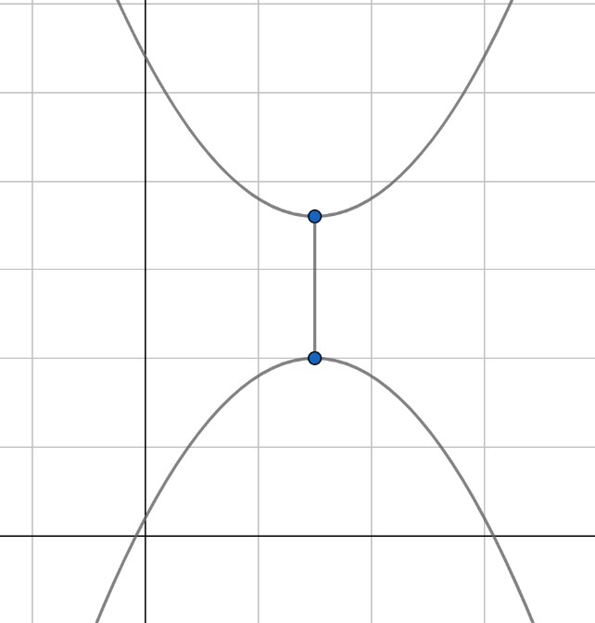





At  both curves at minimum, therefore closest point. (3,18) and (3,10): Distance between minimums is  .

**Extension**

Students may consider a number of different assumptions that have been made, including, but not limited to:

* The Profit assumes that all the tables and chairs manufactured are sold each week.
* All workers can do any part of the manufacturing process.
* No wasted material or rejected tables/chairs.
* Cost of materials is constant.
* All required materials are available when needed.
* etc.

**OCR Resources**: *the small print*OCR’s resources are provided to support the delivery of OCR qualifications, but in no way constitute an endorsed teaching method that is required by the Board, and the decision to use them lies with the individual teacher. Whilst every effort is made to ensure the accuracy of the content, OCR cannot be held responsible for any errors or omissions within these resources.

© OCR 2019 - This resource may be freely copied and distributed, as long as the OCR logo and this message remain intact and OCR is acknowledged as the originator of this work.

OCR acknowledges the use of the following content: n/a

Please get in touch if you want to discuss the accessibility of resources we offer to support delivery of our qualifications: [resources.feedback@ocr.org.uk](mailto:resources.feedback@ocr.org.uk)

We’d like to know your view on the resources we produce. By clicking on [‘Like’](mailto:resources.feedback@ocr.org.uk?subject=I%20liked%20the%20FSMQ%20Check%20In:%20Coordiate%20geometry) or ‘[Dislike’](mailto:resources.feedback@ocr.org.uk?subject=I%20disliked%20the%20FSMQ%20Check%20In:%20Coordinate%20Geometry) you can help us to ensure that our resources work for you. When the email template pops up please add additional comments if you wish and then just click ‘Send’. Thank you.

Whether you already offer OCR qualifications, are new to OCR, or are considering switching from your current provider/awarding organisation, you can request more information by completing the Expression of Interest form which can be found here: [www.ocr.org.uk/expression-of-interest](http://www.ocr.org.uk/expression-of-interest)

Looking for a resource? There is now a quick and easy search tool to help find free resources for your qualification:   
[www.ocr.org.uk/i-want-to/find-resources/](http://www.ocr.org.uk/i-want-to/find-resources/)