**Transpiration**

**Name: …………………………………………. Mark: ………./ 32 Grade: …………..**

**Q1.** A student investigated the distribution of stomata on leaves from two species of plant. She removed small pieces from the lower surface of the leaves of each plant species. She mounted these pieces on separate microscope slides. She then counted the number of stomata in several parts of the epidermis on each piece of leaf tissue using an optical microscope.

(a)     Suggest appropriate units the student should use to compare the distribution of stomata on leaves.

___________________________________________________________________

**(1)**

(b)     The pieces of leaf tissue examined were very thin.

Explain why this was important.

___________________________________________________________________

___________________________________________________________________

___________________________________________________________________

___________________________________________________________________

___________________________________________________________________

**(2)**

(c)     Give **two** reasons why it was important that the student counted the number of stomata in several parts of each piece of leaf tissue.

1. _________________________________________________________________

___________________________________________________________________

2. _________________________________________________________________

___________________________________________________________________

**(2)**

(d)     One of the two plant species used by the student in this investigation was a xerophyte.

Other than the distribution of stomata, suggest and explain **two** xerophytic features the leaves of this plant might have.

1. _________________________________________________________________

___________________________________________________________________

2. _________________________________________________________________

___________________________________________________________________

**(2)**  
Question 1 continues over the page…..

(e)     The student then compared the rate of transpiration (evaporation of water) from the two species of plant. She did this by measuring the rate of water uptake by each plant species.

Suggest **two** reasons why the rate of water uptake by a plant might not be the same as the rate of transpiration.

1. _________________________________________________________________

___________________________________________________________________

2. _________________________________________________________________

___________________________________________________________________

**(2)**

**(Total 9 marks)**

**Q2.** Environmental factors can affect the density of stomata in the lower epidermis of leaves of plants of the same species.

Scientists investigated how growing plants at different temperatures affected the density of stomata in the lower epidermis of leaves. They grew plants of the same species from seeds.

Their method is outlined below.

•        They took 8 trays containing soil and planted 50 seeds in each tray.

•        They put each tray in a controlled environment at a different temperature.

•        When the plants had grown from the seeds, they selected 20 fully grown leaves from the plants in each tray.

•        They determined the mean number of stomata per mm2 in the lower epidermis for each group of leaves.

Their results are shown in the graph.

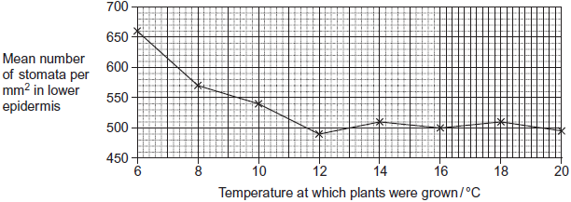

(a)     Give **three** environmental variables, other than temperature, that the scientists would have controlled when growing the plants.

1. _________________________________________________________________

2. _________________________________________________________________

3. _________________________________________________________________

**(3)**

(b)     The scientists used a range of temperatures from 6 to 20 °C.  
Using their data, explain why they did not use temperatures above 20 °C.

___________________________________________________________________

___________________________________________________________________

___________________________________________________________________

**(1)**

(c)     The scientists only selected fully grown leaves from the plants.

Suggest why.

___________________________________________________________________

___________________________________________________________________

___________________________________________________________________

**(1)**

(d)     The plants grown at higher temperatures had a lower number of stomata per mm2.  
This would be an advantage to the plant because the transpiration rate increases as the temperature increases.

Explain why the transpiration rate increases when the temperature increases.

___________________________________________________________________

___________________________________________________________________

___________________________________________________________________

___________________________________________________________________

___________________________________________________________________

**(2)**

**(Total 7 marks)**

**Q3.** A biologist investigated the rate of water movement during the day in different parts of a tree. The results are shown in the graph.

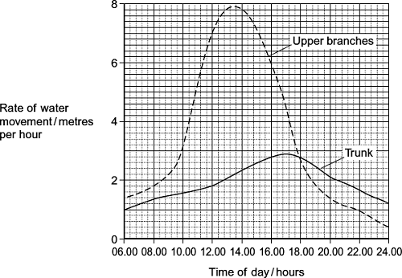

(i)      Describe how the rate of water movement in the upper branches changed over the period shown in the graph.

___________________________________________________________________

___________________________________________________________________

___________________________________________________________________

___________________________________________________________________ **(2)**

(ii)     The rate of water movement in the upper branches was different from the rate of water movement in the trunk. Describe how.

___________________________________________________________________

___________________________________________________________________

___________________________________________________________________

___________________________________________________________________**(2)**

(iii)    The results of this investigation support the cohesion tension theory. Explain how.

___________________________________________________________________

___________________________________________________________________

___________________________________________________________________

___________________________________________________________________

**(2)**

**(Total 6 marks)**

**Q4.** (a)     Scientists measured the rate of water flow and the pressure in the xylem in a small branch. Their results are shown in the graph.

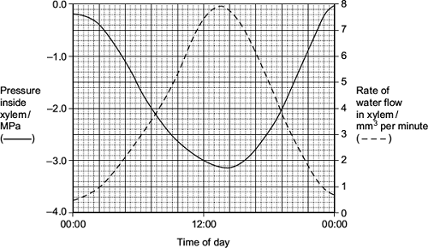

(i)     Use your knowledge of transpiration to explain the changes in the rate of flow in the xylem shown in the graph.

______________________________________________________________

______________________________________________________________

______________________________________________________________

______________________________________________________________

______________________________________________________________

______________________________________________________________

**(3)**

(ii)     Explain why the values for the pressure in the xylem are negative.

______________________________________________________________

______________________________________________________________

______________________________________________________________

**(1)**

**(Total 4 marks)**

Questions continue over the page…..

**Q5.** (a)     Explain how xylem tissue is adapted for its function.

___________________________________________________________________

___________________________________________________________________

___________________________________________________________________

___________________________________________________________________

___________________________________________________________________

___________________________________________________________________

___________________________________________________________________

___________________________________________________________________

**(4)**

(b)     The graph shows the flow rate in the xylem in the trunk of a tree.

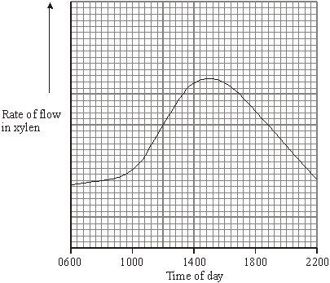

The diameter of the trunk decreased during the same period, reaching its minimum when the flow rate was highest. Use your knowledge of the cohesion-tension theory to suggest an explanation for this decrease.

______________________________________________________________

______________________________________________________________

______________________________________________________________

______________________________________________________________

**(2)**

**(Total 6 marks)**

**End of questions**