**A2 Greek Relations with Persia 479-460 BC**

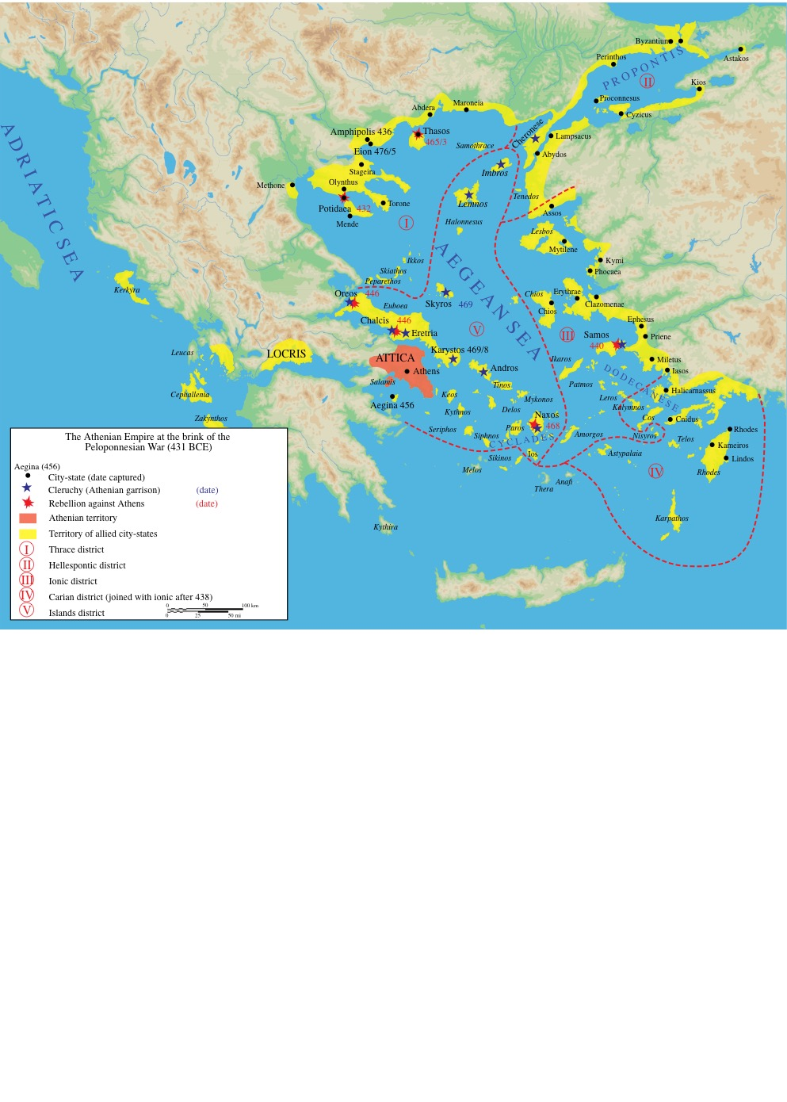

The Rise of Athens and the decline of Spartan Influence in the Aegean.

The sources:

Thucydides:

………………………………………………………………………………………………………………………………………………………………………………………………………………………………………………………………………………………………………………………………………………………………………………………………………………………………………………………………………………………………………………………………………………………………………………………………………………………………………………………………………………………………………………………………………………………………………………………………………………………………………………………………………………………………………………………………………………………………………………………………………………………………………………………………………………………………………………………………………………………………………………………………

Plutarch:

Life of Aristeides

Life of Cimon

………………………………………………………………………………………………………………………………………………………………………………………………………………………………………………………………………………………………………………………………………………………………………………………………………………………………………………………………………………………………………………………………………………………………………………………………………………………………………………………………………………………………………………………………………………………………………………………………………………………………………………………………………………………………………………………………………………………………………………………………………………………………………………………………………………………………………………………………………………………………………………………………

Diodorus

………………………………………………………………………………………………………………………………………………………………………………………………………………………………………………………………………………………………………………………………………………………………………………………………………………………………………………………………………………………………………………………………………………………………………………………………………………………………………………………………………………………………………………………………………………………………………………………………………………………………………………………………………………………………………………………………………………………………………………………………………………………………………………………………………………………………………………………………………………………………………………………………

The actions of the Hellenic League and the Spartans in Sestos.

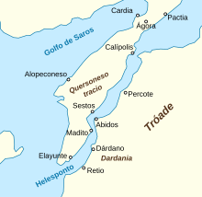

1.89-93

The following is an account of how Athens came to be in the position to gain such strength. After the Persians had retreated from Europe, defeated by the Hellenes on sea and land, and after those of them who had fled by sea to Mycale had been destroyed, the Spartan king Leotychides, who had commanded the Hellenes at Mycale, returned home, taking with him the allies from the Peloponnese. The Athenians, however, with the allies from Ionia and the Hellespont who had already revolted from the king of Persia, stayed behind and besieged the city of Sestos, which was occupied by the Persians. They spent the winter there and finally took the place after the Persians had evacuated it. They then sailed out of the Hellespont and dispersed to their own cities. Meanwhile the Athenian people, as soon as their land was free from foreign occupation, began to bring back their children and wives and what property they had left from the places where they had hidden them away. They also started on the rebuilding of their city and their fortifications; for only small portions of their surrounding wall were still standing, and most of their houses were in ruins, the few remaining ones being those in which important Persian officers had had their quarters. 90    When the Spartans heard of what was going on they sent an embassy to Athens. This was partly because they themselves did not like the idea of Athens or any other city being fortified, but chiefly because they were urged on by their allies, who were alarmed both by the sudden growth of Athenian sea-power and by the daring which the Athenians had shown in the war against the Persians. The Spartans proposed that not only should Athens refrain from building her own fortifications, but that she should join them in pulling down all the fortifications which still existed in cities outside the Peloponnese. In making this suggestion to the Athenians they concealed their real meaning and their real fears; the idea was, they said, that if there was another Persian invasion, the Persians would have no strong base from which to operate, such as they had in Thebes; and that the Peloponnese was capable of serving the needs of everyone, both as a place of refuge and as a place from which to attack. After this speech from the Spartans, the Athenians, on the advice of Themistocles, immediately sent them away with the reply that they would send an embassy to discuss the points that had been raised. Themistocles then proposed that they should send him to Sparta at once, but should not for the time being send the other delegates elected to go with him; instead they should wait until they had built their fortifications high enough to be able to be defended. Meanwhile the whole population of the city was to work at building the walls; no private house or public building which might be of any use to the work was to be spared, but must in every case be demolished. So Themistocles set off, leaving these instructions behind him and indicating that he himself would arrange everything else that needed arranging in Sparta. When he arrived there he did not approach the Spartan government, but kept on putting things off on various excuses. If anyone in authority asked him why he did not come before the Assembly, he replied that he was waiting for his colleagues, that they had not been able to leave Athens because of urgent business, but that he expected them to come soon and 91   was surprised that they had not arrived already. The Spartans believed what Themistocles said because of the respect in which they held him; but as other people kept on arriving, all positively asserting that the fortifications were being built and had already reached a certain height, they did not see how they could reject such information. Themistocles, realizing this, told them that instead of being led astray by rumours they ought to send some reliable people of their own who could go and see for themselves and come back with a correct report. This the Spartans did, and Themistocles sent secretly to Athens, telling the Athenians to keep the Spartan envoys there, to avoid, if possible, putting them under open constraint, but not to let them go until he and his colleagues had got back. For his fellow delegates – Abronichus, the son of Lysicles, and Aristides, the son of Lysimachus – had now arrived, and had told him that the fortifications were now sufficiently far advanced. Themistocles therefore was afraid that the Spartans might now refuse to let them go, once they received accurate information about what had happened. The Athenians followed his instructions and detained the Spartan delegates. Themistocles approached the Spartan authorities and at last spoke to them openly. He said that Athens was now fortified, and fortified sufficiently well to be able to protect her people: that if the Spartans or their allies wanted to send embassies to Athens on any subject, they should in future go there prepared to recognize that the Athenians were capable of making up their own minds both about their own interests and about the interests of the rest of Hellas. He pointed out that when the Athenians decided to abandon their city and take to their ships, it was not in consultation with Sparta that they adopted that daring resolution, and that whenever they had joined in counsel with the Spartans it was clear that no one else had offered better advice. And now they thought it better that their city should be fortified; it was better for their own citizens and also would be an advantage to the whole alliance; for it was only on the basis of equal strength that equal and fair discussions on the common interest could be held. This meant either that no city in the alliance should be fortified or else that what the Athenians had done should be approved.

………………………………………………………………………………………………………………………………………………………………………………………………………………………………………………………………………………………………………………………………………………………………………………………………………………………………………………………………………………………………………………………………………………………………………………………………………………………………………………………………………………………………………………………………………………………………………………………………………………………………………………………………………………………………………………………………………………………………………………………………………………………………………………………………………………………………………………………………………………………………………………………………

92    After listening to this, the Spartans showed no open signs of displeasure towards Athens. The fact was that their original embassy to the Athenian people had not stated any intention to prevent the action but had only appeared to offer advice. Also this was a time when Sparta was particularly friendly to Athens, because of the courage displayed by Athens against the Persians. All the same the Spartans had not got their own way and secretly they felt aggrieved because of it. The delegates from both states returned home without making any complaints. 93    In this way the Athenians fortified their city in a very short time. Even today one can see that the building was done in a hurry. The foundations are made of different sorts of stone, sometimes not shaped so as to fit, but laid down just as each was brought up at the time; there are many pillars taken from tombs and fragments of sculpture mixed in with the rest. For the city boundaries were extended on all sides, and so in their haste they used everything that came to hand, sparing nothing.        Themistocles also persuaded them to complete the walls of Piraeus, which had been begun previously during his year of office as archon. He liked the position of the place, with its three natural harbours, and he considered that if the Athenians became a seafaring people they would have every advantage in adding to their power.15 Indeed it was he who first ventured to tell the Athenians that their future was on the sea. Thus he at once began to join in laying the foundations of their empire. In breadth the wall was built according to his specifications, just as one can see it today around Piraeus. There was room for two wagons to pass each other with their stones for the building, and the space in between the outer surfaces was not filled in with rubble or clay; instead large blocks of stone were cut and fitted together, with clamps of iron and lead on the outside. The height of the finished wall was about half what he planned. With these great and thick walls he intended to repulse all enemy attacks, and he considered that they could be perfectly well defended by a few troops of inferior quality, so that the rest would be able to serve in the navy. It was particularly on the navy that his thoughts were concentrated. He realized, I imagine, that it was easier for a Persian force to approach Athens by sea than by land, and in his view Piraeus was a more valuable place than the main city of Athens. Indeed, the advice that he constantly gave to the Athenians was that if ever they should be hard pressed on land they should go down to Piraeus, take to their ships, and defy all comers. It was in this way, directly after the Persian withdrawal, that the Athenians fortified their city and generally strengthened their position.

………………………………………………………………………………………………………………………………………………………………………………………………………………………………………………………………………………………………

………………………………………………………………………………………………………………………………………………………………………………………………………………………………………………………………………………………………………………………………………………………………………………………………………………………………………………………………………………………………………………………………………………………………………………………………………………………………………………………………………………………………………………………………………………………………………………………………………………………………………………………………………………………………………………………………………………………………………………………………………………………………………………………………………………………………………………………………………………………………………………………………………………………………………………………………………………………………………………………………………………………………………………………………………………………………………………………………………………………………

1.107

Athens builds the long walls:

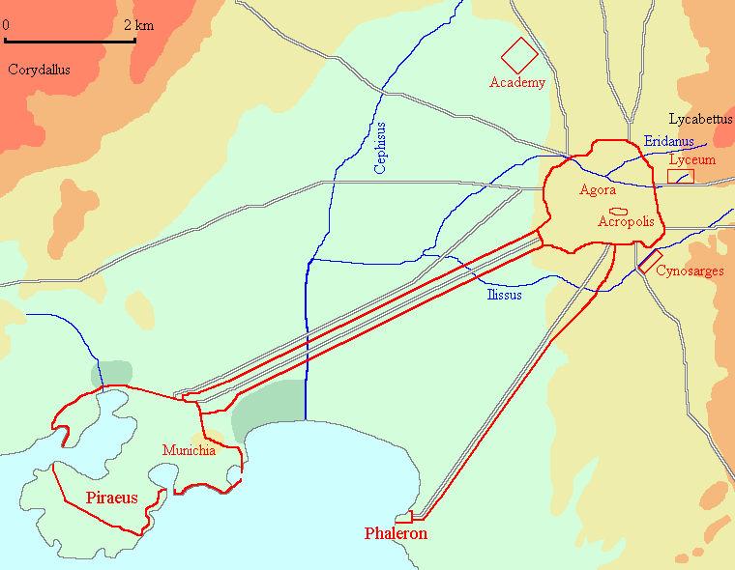

107    At about this time the Athenians began to build their two long walls down to the sea, one to Phalerum and one to Piraeus. And at the same time the Phocians started a campaign against Doris, the original homeland of the Spartans, containing the towns of Boeum, Cytinium, and Erineum. When they had captured one of these places the Spartans came to the assistance of the Dorians with a force of 1,500 hoplites of their own and 10,000 of their allies. This force was commanded by Nicomedes, the son of Cleombrotus, acting as deputy for the Spartan King Pleistoanax, who was still under age. The Spartans compelled the Phocians to come to terms and to give back the town which they had taken. They then began to think of their return journey. If they went by sea, across the Gulf of Crisa, the Athenians would be able to sail up with their fleet and stop them; nor did the route across Geraneia appear to be a safe one, since the Athenians held Megara and Pegae. The passes over Geraneia are difficult ones and were always guarded by the Athenians; moreover, on this occasion the Spartans had information that the Athenians had every intention of preventing them from taking this route. It seemed best, therefore, to stay in Boeotia and wait and see what the safest line of march would be. In this course they were also influenced by the fact that there was a party in Athens who were secretly negotiating with them in the hope of putting an end to democratic government and preventing the building of the Long Walls.

………………………………………………………………………………………………………………………………………………………………………………………………………………………………………………………………………………………………………………………………………………………………………………………………………………………………………………………………………………………………………………………………………………………………………………………………………………………………………………………………………………………………………………………………………………………………………………………………………………………………………………………………………………………………………………………………………………………………………………………………………………………………………………………………………………………………………………………………………………………………………………………………………………………………………………………………………………………………………………………………………………………………………………………………………………………………………………………………………………………………

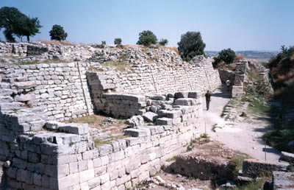

The Delian League:

94    Soon afterwards Pausanias, the son of Cleombrotus, was sent out from Sparta in command of the Hellenic forces. He had with him twenty ships from the Peloponnese; the Athenians joined his force with thirty ships and there were a number more from the other allies. They went first to Cyprus and won over most of the island; later they went against Byzantium, which was in Persian occupation, and, still under the command of Pausanias, forced the place 95   to surrender. But Pausanias had already begun to reveal the arrogance of his nature, and was becoming unpopular with the Hellenes, particularly so with the Ionians and those who had just recently been liberated from Persian domination. These states approached the Athenians, asking them, since they were their own kinsmen, to take them under their protection and, if Pausanias acted in a dictatorial manner, not to allow it. These approaches were welcomed by the Athenians, who made up their minds to put a check on Pausanias and to arrange matters generally in a way that would best suit their own interests. Meanwhile the Spartans recalled Pausanias to face a court of inquiry in connection with various reports that they had received. Serious charges had been made against him by Hellenes arriving at Sparta: instead of acting as commander-in-chief, he appeared to be trying to set himself up as a dictator. It happened that he was recalled just at the time when, because of his unpopularity, the allies, apart from the soldiers from the Peloponnese, had gone over to the side of the Athenians. At Sparta Pausanias was condemned for various acts of injustice against individuals, but he was acquitted on all the main counts: one of the most serious charges was that he was collaborating with the Persians, and there seemed to be very good evidence for this. Instead of sending him out again as commander-in-chief, they sent Dorcis and other officers with quite a small force. But by this time the allies were no longer willing to accept them as supreme commanders. Realizing this, the Spartans went back, and afterwards Sparta sent out no other commanders. They feared that when their officers went overseas they would become corrupted, as they had seen happen in the case of Pausanias, and at the same time they no longer wanted to be burdened with the war against Persia. They regarded the Athenians as being perfectly capable of exercising the command and as being also at that time friendly to themselves.

94    Soon afterwards Pausanias, the son of Cleombrotus, was sent out from Sparta in command of the Hellenic forces. He had with him twenty ships from the Peloponnese; the Athenians joined his force with thirty ships and there were a number more from the other allies. They went first to Cyprus and won over most of the island; later they went against Byzantium, which was in Persian occupation, and, still under the command of Pausanias, forced the place 95   to surrender. But Pausanias had already begun to reveal the arrogance of his nature, and was becoming unpopular with the Hellenes, particularly so with the Ionians and those who had just recently been liberated from Persian domination. These states approached the Athenians, asking them, since they were their own kinsmen, to take them under their protection and, if Pausanias acted in a dictatorial manner, not to allow it. These approaches were welcomed by the Athenians, who made up their minds to put a check on Pausanias and to arrange matters generally in a way that would best suit their own interests. Meanwhile the Spartans recalled Pausanias to face a court of inquiry in connection with various reports that they had received. Serious charges had been made against him by Hellenes arriving at Sparta: instead of acting as commander-in-chief, he appeared to be trying to set himself up as a dictator. It happened that he was recalled just at the time when, because of his unpopularity, the allies, apart from the soldiers from the Peloponnese, had gone over to the side of the Athenians. At Sparta Pausanias was condemned for various acts of injustice against individuals, but he was acquitted on all the main counts: one of the most serious charges was that he was collaborating with the Persians, and there seemed to be very good evidence for this. Instead of sending him out again as commander-in-chief, they sent Dorcis and other officers with quite a small force. But by this time the allies were no longer willing to accept them as supreme commanders. Realizing this, the Spartans went back, and afterwards Sparta sent out no other commanders. They feared that when their officers went overseas they would become corrupted, as they had seen happen in the case of Pausanias, and at the same time they no longer wanted to be burdened with the war against Persia. They regarded the Athenians as being perfectly capable of exercising the command and as being also at that time friendly to themselves. 96    So Athens took over the leadership, and the allies, because of their dislike of Pausanias, were glad to see her do so. Next the Athenians assessed the various contributions to be made for the war against Persia, and decided which states should furnish money and which states should send ships – the object being to compensate themselves for their losses by ravaging the territory of the King of Persia. At this time the officials known as ‘Hellenic Treasurers’ were first appointed by the Athenians. These officials received the tribute, which was the name given to the contributions in money. The original sum fixed for the tribute was 460 talents.16 The treasury of the League was at Delos, and representative meetings were held in the temple there.

Thucydides. History of the Peloponnesian War (Kindle Locations 1549-1573). Penguin Books Ltd. Kindle Edition.

………………………………………………………………………………………………………………………………………………………………………………………………………………………………………………………………………………………………………………………………………………………………………………………………………………………………………………………………………………………………………………………………………………………………………………………………………………………………………………………………………………………………………………………………………………………………………………………………………………………………………………………………………………………………………………………………………………………………………………………………………………………………………………………………………………………………………………………………………………………………………………………………………………………………………………………………………………………………………………………………………………………………………………………………………………………………………………………………………………………………………………………………………………………………………………………………………………………………………………………………………………………………………………………………………………………………………………………………………………………………………………………………………………………………………………………………………………………………………………………………………………………………………………………………………………………………………………………………………………………………………………………………………………………………………………………………………………………………………………………………………………………………………………………………………………………………………………………………………………………………………………………………………………………………………………………………………………………………………………………………………………………………………………………………………………………………………………………………………………………………………………………………………………………………………………………………………………………………………………………………

Thucydides. History of the Peloponnesian War (Kindle Locations 1549-1567). Penguin Books Ltd. Kindle Edition.

Herodotus 8.3

From [3] the first, even before Sicily was asked to join the alliance, there had been talk of the advisability of giving Athens command of the fleet; but the proposal had not been well received by the allied states, and the Athenians waived their claim in the interest of national survival, knowing that a quarrel about the command would certainly mean the destruction of Greece.1 They were, indeed, perfectly right; for the evil of internal strife is worse than united war in the same proportion as war itself is worse than peace. It was their realization of the danger attendant upon lack of unity which made them waive their claim, and they continued to do so as long as Greece desperately needed their help. This was made plain enough by their subsequent action; for when the Persians had been driven from Greece and the war had been carried to Persian territory, the Athenians made the insufferable behaviour of Pausanias their excuse for depriving the Lacedaemonians of the command.2

Herodotus. The Histories (Penguin Classics) (Kindle Locations 8855-8863). Penguin Books Ltd. Kindle Edition.

Plutarch : Aristeides.

23

Pausanias and the other Spartan commanders behaved to the allies. He himself treated them with courtesy and consideration and saw to it that Cimon made himself accommodating to them and took part in their operations. In this way, before the Spartans knew it, he had eased them out of the leadership, and he did this not with the help of troops or ships or cavalry, but through tact and diplomacy. The Athenians were already well liked, thanks to the justice of Aristides and the affability shown by Cimon, but the grasping and overbearing conduct of Pausanias served to endear them to the Greeks even more. The allied commanders were constantly treated with arrogance and ill-temper by Pausanias, and their men were punished with floggings or by being forced to stand all day with an iron anchor on their shoulders. No one was allowed to get straw for bedding, or fodder for his horse, or to draw water until the Spartans had helped themselves, and their servants, who were armed with whips, would drive away anyone who approached. Aristides once intended to tax Pausanias with this and expostulate with him, but he put on a frown, told Aristides that he was occupied and refused to listen to him. After this the generals and admirals of the Greek expedition, especially those of Chios, Samos, and Lesbos, approached Aristides and pressed him to accept the supreme command and rally around him the allies who had long wished to be quit of Sparta and to transfer their support to Athens. Aristides told them that he regardedPausanias and the other Spartan commanders behaved to the allies. He himself treated them with courtesy and consideration and saw to it that Cimon made himself accommodating to them and took part in their operations. In this way, before the Spartans knew it, he had eased them out of the leadership, and he did this not with the help of troops or ships or cavalry, but through tact and diplomacy. The Athenians were already well liked, thanks to the justice of Aristides and the affability shown by Cimon, but the grasping and overbearing conduct of Pausanias served to endear them to the Greeks even more. The allied commanders were constantly treated with arrogance and ill-temper by Pausanias, and their men were punished with floggings or by being forced to stand all day with an iron anchor on their shoulders. No one was allowed to get straw for bedding, or fodder for his horse, or to draw water until the Spartans had helped themselves, and their servants, who were armed with whips, would drive away anyone who approached. Aristides once intended to tax Pausanias with this and expostulate with him, but he put on a frown, told Aristides that he was occupied and refused to listen to him. After this the generals and admirals of the Greek expedition, especially those of Chios, Samos, and Lesbos, approached Aristides and pressed him to accept the supreme command and rally around him the allies who had long wished to be quit of Sparta and to transfer their support to Athens. Aristides told them that he regarded

Plutarch. The Rise and Fall of Athens: Nine Greek Lives (Classics) (pp. 134-135). Penguin Books Ltd. Kindle Edition.

………………………………………………………………………………………………………………………………………………………………………………………………………………………………………………………………………………………………………………………………………………………………………………………………………………………………………………………………………………………………………………………………………………………………………………………………………………………………………………………………………………………………………………………………………………………………………………………………………………………………………………………………………………………………………………………………………………………………………………………………………………………………………………………………………………………………………………………………………………………………………………………………………………………………………………………………………………………………………………………………………………………………………………………………………………………………………………………………………………………………

Aristeides’s role:

Plutarch Aristeides 24. 1-5

Pausanias and the other Spartan commanders behaved to the allies. He himself treated them with courtesy and consideration and saw to it that Cimon made himself accommodating to them and took part in their operations. In this way, before the Spartans knew it, he had eased them out of the leadership, and he did this not with the help of troops or ships or cavalry, but through tact and diplomacy. The Athenians were already well liked, thanks to the justice of Aristides and the affability shown by Cimon, but the grasping and overbearing conduct of Pausanias served to endear them to the Greeks even more. The allied commanders were constantly treated with arrogance and ill-temper by Pausanias, and their men were punished with floggings or by being forced to stand all day with an iron anchor on their shoulders. No one was allowed to get straw for bedding, or fodder for his horse, or to draw water until the Spartans had helped themselves, and their servants, who were armed with whips, would drive away anyone who approached. Aristides once intended to tax Pausanias with this and expostulate with him, but he put on a frown, told Aristides that he was occupied and refused to listen to him. After this the generals and admirals of the Greek expedition, especially those of Chios, Samos, and Lesbos, approached Aristides and pressed him to accept the supreme command and rally around him the allies who had long wished to be quit of Sparta and to transfer their support to Athens. Aristides told them that he regarded

Plutarch. The Rise and Fall of Athens: Nine Greek Lives (Classics) (pp. 134-135). Penguin Books Ltd. Kindle Edition.

………………………………………………………………………………………………………………………………………………………………………………………………………………………………………………………………………………………………………………………………………………………………………………………………………………………………………………………………………………………………………………………………………………………………………………………………………………………………………………………………………………………………………………………………………………………………………………………………………………………………………………………………………………………………………………………………………………………………………………………………………………………………………………………………………………………………………………………………………………………………………………………………………………………………………………………………………………………………………………………………………………………………………………………………………………………………………………………………………………………………

Pausanias allegiance to Persian king is mentioned later in Thucydides

After the Spartan Pausanias had been recalled by his government for the first time from his command in the Hellespont and had been tried and acquitted, he was not sent out again in an official capacity. However, on his own initiative and without Spartan authority he took a trireme from the town of Hermione and sailed to the Hellespont. He pretended that his intention was to join in the national struggle against Persia, but in fact he went in order to intrigue with the King of Persia, as he had already begun to do before, with the aim of becoming ruler of Hellas.

130    Even before this Pausanias had had a great reputation among the Hellenes because of his generalship at the battle of Plataea, and now, when he received this letter, he thought even more of himself and could no longer bear to live in the ordinary way. Instead he used to go out of Byzantium dressed in the Persian style of clothing; he was escorted on his journeys through Thrace by a bodyguard of Persians and Egyptians; he held banquets in the Persian manner, and was so far incapable of concealing his purpose that in small matters he made it quite clear what he intended to do later and on a grander scale. He shut himself off from normal contacts and behaved towards everyone alike in such a high-handed way that no one was able to come near him. This was one of the chief reasons why the allied forces turned towards the Athenians. 131    It was because they had heard that he was behaving like this that the Spartans had recalled him once already. Now he had gone out again, without their authority, in a ship from Hermione, and appeared to be acting in just the same way as before. Then, too, when, after a siege, he was driven out of Byzantium by the Athenians, he did not return to Sparta; instead he was reported to have established himself at Colonae in the Troad, to be carrying on intrigues with Persia, and to be prolonging his stay abroad for no good reason. A point was now reached where the ephors could wait no longer. They sent out to him a herald with a scytale,23 instructing him to return with the herald on pain of being declared a public enemy by the Spartans. Pausanias particularly wished to avoid becoming suspected, and at the same time felt confident of being able to clear himself by means of bribery. So for the second time he returned to Sparta. On his arrival he was thrown into prison by the ephors (who have the power to imprison the King), but later he managed to have himself released, and offered to answer any complaints that might be made of him at an inquiry.

………………………………………………………………………………………………………………………………………………………………………………………………………………………………………………………………………………………………………………………………………………………………………………………………………………………………………………………………………………………………………………………………………………………………………………………………………………………………………………………………………………………………………………………………………………………………………………………………………………………………………………………………………………………………………………………………………………………………………………………………………………………………………………………………………………………………………………………………………………………………………………………………………………………………………………………………………………………………………………………………………………………………………………………………………………………………………………………………………………………………

Diodorus 11.46-47

46 1 As for us, since throughout our entire history we have made it our practice in the case of good men to enhance their glory by means of the words of praise we pronounce over them, and in the case of bad men, when they die, to utter the appropriate obloquies, we shall not leave the turpitude and treachery of Pausanias to go uncondemned. 2 For p247who would not be amazed at the folly of this man who, though he had been a benefactor of Greece, had won the battle of Plataea, and had performed many other deeds which won applause, not only failed to safeguard the esteem he enjoyed but by his love of the wealth and luxury of the Persians brought dishonour upon the good name he already possessed? 3 Indeed, elated by his successes he came to abhor the Laconian manner of life and to imitate the licentiousness and luxury of the Persians, he who least of all had reason to emulate the customs of the barbarians; for he had not learned of them from others, but in person by actual contact he had made trial of them and was aware how greatly superior with respect to virtue his ancestors' way of life was to the luxury of the Persians.

And in truth because of his own baseness Pausanias not only himself received the punishment he deserved, but he also brought it about that his countrymen lost the supremacy at sea. In comparison, for instance, take the fine tact of Aristeides in dealing with the allies: when they took note of it, both because of his affability toward his subordinates and his uprightness in general, it caused them all as with one impulse to incline toward the Athenian cause. 5 Consequently the allies no longer paid any heed to the commanders who were sent from Sparta, but in their admiration of Aristeides they eagerly submitted to him in every matter and thus brought it about that he received the supreme command by sea

without having to fight for it. 47 1 At once, then, Aristeides advised all the allies as they were holding a general assembly to designate p249the island of Delos5 as their common treasury and to deposit there all the money they collected, and towards the war

Siculus, Diodorus. Bibliotheca Historica: (Historical Library) (Kindle Locations 20694-20705). Kindle Edition.

………………………………………………………………………………………………………………………………………………………………………………………………………………………………………………………………………………………………………………………………………………………………………………………………………………………………………………………………………………………………………………………………………………………………………………………………………………………………………………………………………………………………………………………………………………………………………………………………………………………………………………………………………………………………………………………………………………………………………………………………………………………………………………………………………………………………………………………………………………………………………………………………………………………………………………………………………………………………………………………………………………………………………………………………………………………………………………………………………………………………

Sparta’s Reaction to Athens’s new status:

Diodorus 11.50

When Dromocleides was archon in Athens, the p255Romans elected as consuls Marcus Fabius and Gnaeus Manlius. In this year the Lacedaemonians, now that for no good reason they had lost the command of the sea, were resentful; consequently they were incensed at the Greeks who had fallen away from them and continued to threaten them with the appropriate punishment. 2 And when a meeting of the Gerousia12 was convened, they considered making war upon the Athenians for the sake of regaining the command of the sea. 3 Likewise, when the general Assembly was convened, the younger men and the majority of the others were eager to recover the leadership, believing that, if they could secure it, they would enjoy great wealth, Sparta in general would be made greater and more powerful, and the estates of its private citizens would receive a great increase of prosperity. 4 They kept calling to mind also the ancient oracle in which the god commanded them to beware lest their leadership should be a "lame" one, and the oracle, they insisted, meant nothing other than the present; for "lame" indeed their rule would be if, having two leaderships, 13 they should lose one of them. 5 Since practically all the citizens had been eager for this course of action and the Gerousia was in session to consider these matters, no one entertained the hope that any man would have the temerity to suggest any other course. 6 But a member of the Gerousia, Hetoemaridas by name, who was a direct descendant of Heracles and enjoyed favour among the citizens by reason of his character, undertook to advise that they leave the Athenians with their leadership, since it was not to Sparta's interest, he declared, to lay claim to the p257sea. He was able to bring pertinent arguments in support of his surprising proposal, so that, against the expectation of all, he won over both the Gerousia and the people. 7 And in the end the Lacedaemonians decided that the opinion of Hetoemaridas was to their advantage and abandoned their zest for the war against the Athenians. 8 As for the Athenians, at first they expected to have a great war with the Lacedaemonians for the command of the sea, and for this reason were building additional triremes, raising a large sum of money, and dealing honourably with their allies; but when they learned of the decision of the Lacedaemonians, they were relieved of their fear of war and set about increasing the power of their city.

Siculus, Diodorus. Bibliotheca Historica: (Historical Library) (Kindle Locations 20766-20784). Kindle Edition.

………………………………………………………………………………………………………………………………………………………………………………………………………………………………………………………………………………………………………………………………………………………………………………………………………………………………………………………………………………………………………………………………………………………………………………………………………………………………………………………………………………………………………………………………………………………………………………………………………………………………………………………………………………………………………………………………………………………………………………………………………………………………………………………………………………………………………………………………………………………………………………………………………………………………………………………………………………………………………………………………………………………………………………………………………………………………………………………………………………………………

The achievements of the League in its early years.

Thucydides 1.97-101

The leadership of the Athenians began with allies who were originally independent states and reached their decision in general congress. I shall now describe the use they made of it, both in war and in their management of the League, during the period from the end of the Persian until the beginning of the Peloponnesian War. Some of these actions were against the Persians, some against their own allies when they revolted, some against the Peloponnesian Powers with whom on various occasions they became involved. I am giving this account and making this digression from my main narrative because this is a period that has not been dealt with by previous writers, whose subjects have been either Hellenic history before the Persian Wars or else the Persian Wars themselves. The only one of them who has touched upon this period is Hellanicus, in his Attic History, but he has not given much space to the subject and he is inaccurate in his dates. At the same time the history of these years will show how the Athenian Empire came into being. 98    The first action of the Athenians was the siege of Eion, a town on the Strymon occupied by the Persians.

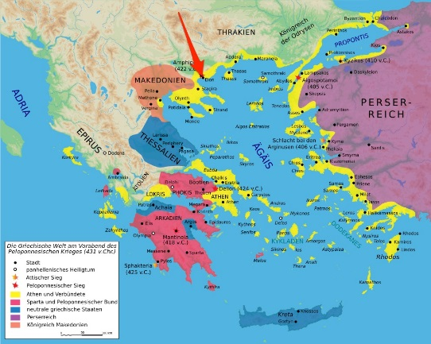

17 Under the command of Cimon, the son of Miltiades, they captured this place and made slaves of the inhabitants. Then they turned to the island of Scyros in the Aegean, which was populated by Dolopians. They enslaved the inhabitants and colonized the island themselves. Next there was a war with the Carystians, who were not supported by the rest of Euboea. In the end Carystus surrendered on terms.

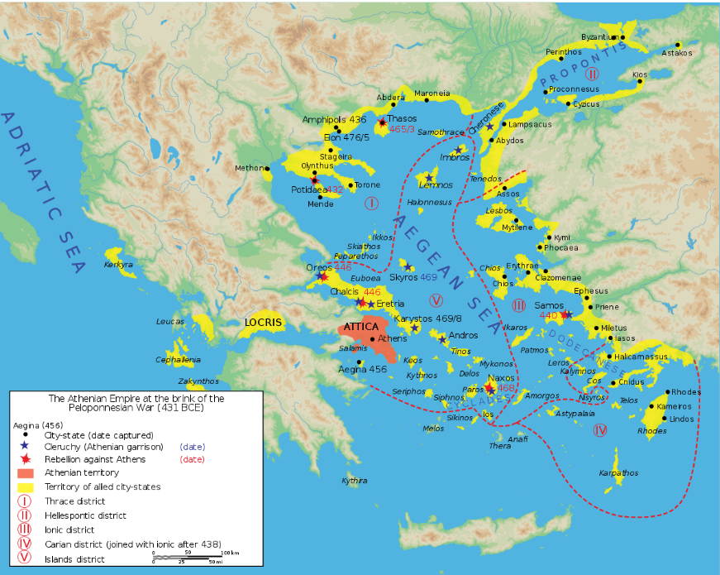

After this Naxos left the League and the Athenians made war on the place. After a siege Naxos was forced back to allegiance. This was the first case when the original constitution of the League was broken and an allied city lost its independence, and the process was continued in the cases of the other allies as various circumstances 99 arose. The chief reasons for these revolts were failures to produce the right amount of tribute or the right numbers of ships, and sometimes a refusal to produce any ships at all. For the Athenians insisted on obligations being exactly met, and made themselves unpopular by bringing the severest pressure to bear on allies who were not used to making sacrifices and did not want to make them. In other ways, too, the Athenians as rulers were no longer popular as they used to be: they bore more than their fair share of the actual fighting, but this made it all the easier for them to force back into the alliance any state that wanted to leave it. For this position it was the allies themselves who were to blame. Because of this reluctance of theirs to face military service, most of them, to avoid serving abroad, had assessments made by which, instead of producing ships, they were to pay a corresponding sum of money. The result was that the Athenian navy grew strong at their expense, and when they revolted they always found themselves inadequately armed and inexperienced in war. 100

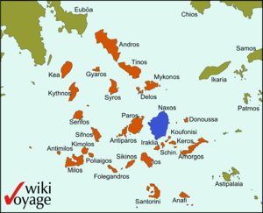

 Next came the battles of the river Eurymedon in Pamphylia, fought on land and on sea by the Athenians and their allies against the Persians. In both battles the Athenians won the victory on the same day under the command of Cimon, the son of Miltiades, and they captured or destroyed the entire Phoenician fleet of 200 triremes.        Some time later occurred the revolt of Thasos.18 This was caused by a dispute over the markets on the mainland opposite in Thrace, and over the mine under the control of the Thasians. The Athenians sailed to Thasos with their fleet, won a naval engagement, and landed on the island.

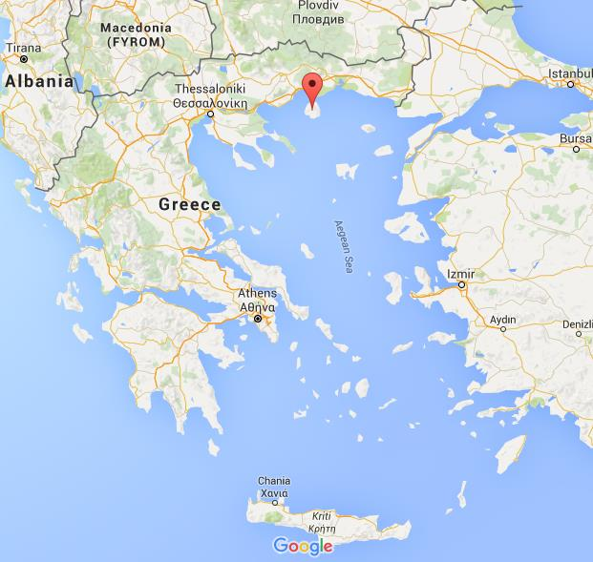

About the same time they sent out to the river Strymon 10,000 colonists from their own citizens and from allied states to settle in the place then known as Nine Ways, but now called Amphipolis. They occupied Nine Ways, driving out the Edonians who held the place, but when they advanced farther into the interior of Thrace their force was cut to pieces at the Edonian town of Drabescus by a combined army of Thracians, who regarded the founding of a colony at Nine Ways as an act of hostility against themselves. 101    Meanwhile the people of Thasos, who had been defeated in battle and were now besieged, appealed to Sparta and urged her to come to their help by invading Attica. The Spartans, without informing Athens of their intentions, promised to do so, and would have done so if they had not been prevented by the earthquake which happened then and by the simultaneous revolt and secession to Ithome of the helots and of some of the perioeci,19 the Thuriats and the Aethaeans. The helots were mostly descendants of the ancient Messenians, who had been enslaved in the famous war. Thus they all came to be called Messenians. So Sparta had a war on her hands against the rebels in Ithome, and the Thasians, in the third year of the siege, had to accept the Athenian terms: their walls were demolished and their navy surrendered; they were ordered to pay an indemnity immediately and to pay tribute in future; they surrendered their rights on the mainland and also the mine there.

Thucydides. History of the Peloponnesian War (Kindle Locations 1573-1611). Penguin Books Ltd. Kindle Edition.

Make a list of the actions of the League Here

………………………………………………………………………………………………………………………………………………………………………………………………………………………………………………………………………………………………………………………………………………………………………………………………………………………………………………………………………………………………………………………………………………………………………………………………………………………………………………………………………………………………………………………………………………………………………………………………………………………………………………………………………………………………………………………………………………………………………………………………………………………………………………………………………………………………………………………………………………………………………………………………………………………………………………………………………………………………………………………………………………………………………………………………………………………………………………………………………………………………

Diodorus 11.60

60 1 When Demotion was archon in Athens, the Romans elected as consuls Publius Valerius Publicola and Gaius Nautius Rufus. In this year the Athenians, electing as general Cimon the son of Miltiades and giving him a strong force, sent him to the coast of Asia to give aid to the cities which were allied with them and to liberate those which were still held by Persian garrisons. 2 And Cimon, taking along the fleet p281which was at Byzantium and putting in at the city which is called Eïon, 27 took it from the Persians who were holding it and captured by siege Scyros, which was inhabited by Pelasgians and Dolopes; and setting up an Athenian as the founder of a colony he portioned out the land in allotments. 28 3 After this, with a mind to begin greater enterprises, he put in at the Peiraeus, and after adding more triremes to his fleet and arranging for general supplies on a notable scale, he at that time put to sea with two hundred triremes; but later, when he had called for additional ships from the Ionians and everyone else, he had in all three hundred. 4 So sailing with the entire fleet to Caria he at once succeeded in persuading the cities on the coast which had been settled from Greece to revolt from the Persians, but as for the cities whose inhabitants spoke two languages29 and still had Persian garrisons, he had recourse to force and laid siege to them; then, after he had brought to his side the cities of Caria, he likewise won over by persuasion those of Lycia. 5 Also, by taking additional ships from the allies, who were continually being added, he still further increased the size of the fleet. Now the Persians had composed their land forces from their own peoples, but their navy they had gathered from both Phoenicia and Cyprus and Cilicia, and the commander of the Persian armaments was Tithraustes, who was an illegitimate son of Xerxes. 6 And when Cimon learned that the Persian fleet was p283lying off Cyprus, sailing against the barbarians he engaged them in battle, pitting two hundred and fifty ships against three hundred and forty. A sharp struggle took place and both fleets fought brilliantly, but in the end the Athenians were victorious, having destroyed many of the enemy ships and captured more than one hundred together with their crews. 7 The rest of the ships escaped to Cyprus, where their crews left them and took to the land, and the ships, being bare of defenders, fell into the hands of the enemy.

Siculus, Diodorus. Bibliotheca Historica: (Historical Library) (Kindle Locations 20988-20996). Kindle Edition.

Plutarch Cimon: 6-8

6. After the Medes had been driven from Greece, Cimon was sent out as one of the commanders of the Greek expeditionary force, 1 at a time when the Athenians had not yet won their supremacy at sea and were still under the orders of Pausanias and the Spartans. During these campaigns the soldiers whom Cimon sent out on operations were not only a byword for their discipline, but also far excelled the others in the enterprise they showed. At that time, too, Pausanias was carrying on treasonable negotiations with the barbarians and writing letters to the king of Persia, but treating his own allies harshly and arrogantly and scattering insults far and wide with his officiousness and absurd pretensions. Cimon, on the other hand, had a kind word for all who brought grievances to him and dealt with them so sympathetically that almost before people knew what was happening he had taken over the command of the Greeks, and he achieved this not by force of arms but simply by virtue of his character and his skill in handling men. Most of the allies, finding they could not endure the harshness and contempt with which they were treated by Pausanias, put themselves under the orders of Aristides and Cimon, who as soon as they had won this following, sent word to the ephors to recall Pausanias, since he was bringing dishonour to Sparta and disunity to Greece. There is a story that Pausanias sent for a Byzantine girl of noble family named Cleonice to seduce her, and that her parents, believing they had no choice, and too frightened to refuse, abandoned their daughter to him. Cleonice begged the attendants outside his door to take away the lights, and crept silently in the darkness to him at night in his sleep, remorselessly repeating the words Go to the doom which pride and lust prepare. This outrageous affair provoked the allies beyond endurance and under Cimon’ leadership they drove Pausanias out of the city. He fled from Byzantium, but finding himself still haunted by the apparition, so the story goes, he consulted the oracle of the dead at Herac-leia. There he summoned up the spirit of Cleonice and implored her to pardon him. She then appeared to him and declared that he would soon be delivered from his troubles once he reached Sparta, in this way mysteriously hinting, it seems, at his approaching death. This, at any rate, is the story which many authors tell. 7. Now that the allies had come over to his side, Cimon assumed command and sailed to Thrace, 1 as he had heard that the Persians, led by For this reason when Cimon captured the city he found nothing of any value, as almost everything had been destroyed in the fire along with the barbarians. On the other hand the surrounding country was beautiful and extremely fertile, and this land he handed over to the Athenians to found a colony there. So the people authorized him to dedicate three stone statues of Hermes at Athens, the first of which bears the inscription: They too were men of stout heart, who beside the swift current of Strymon Under Eīon’s walls fought with the sons of the Mede: Pitiless famine and fire they brought to beleaguer the city, Death-dealing Ares they followed, and harried their foes to despair, the second: Leading his army to war on the divine plains of Troy. None knew better than he, of the bronze-armoured Greeks, Homer tells us, How to manoeuvre the line or draw up the battle array. So the proud title has clung ever since to the children of Athens, Masters of warlike arts and leaders of valiant men. 8. Although Cimon’ name does not appear in any of these inscriptions, his contemporaries regarded this memorial as a supreme mark of honour for him. Neither Themistocles nor Miltiades could boast of any comparable distinction; indeed, when the latter asked for nothing more than a crown of olive, Sophanes of Decelea rose to his feet in the Assembly and protested. His speech was ungracious, but it won the people’ applause at that moment. ‘When you have fought and conquered the barbarians by yourself,

Plutarch. The Rise and Fall of Athens: Nine Greek Lives (Classics) (pp. 148-149). Penguin Books Ltd. Kindle Edition.

Plutarch Cimon: Battle of Eurymedon.

<http://www.livius.org/articles/battle/eurymedon/>

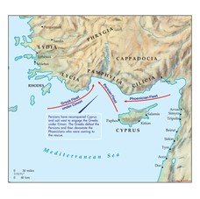

12-13

12. It is certain that no man did more than Cimon to humble the pride of the Great King himself. He never relaxed the pursuit, so as to let the Persians escape from Greece at their leisure, but followed close at their heels, and before the barbarians could halt or draw breath, he had sacked or destroyed some cities, and induced others to revolt or annexed them, until not a single Persian soldier was left on the mainland of Asia Minor from Ionia to Pamphylia. He got word that the king’s generals were lying in wait for him with a

large army and fleet on the coast of Pamphylia, and he thereupon resolved to make the waters to the west of the Chelidonian Islands so formidable to them that they would not dare to venture out there. So he sailed from Cnidus and Triopium with 200 triremes. 1 These ships had been built under Themistocles and were especially well constructed from the point of view of speed and manoeuvrability, but Cimon now widened their beam and built bridges between their decks, so that when they attacked the enemy they could make more effective use of the large number of hoplites they carried. He put in at the city of Phaselis, but the people, although they were Greeks, refused to admit his fleet or to revolt against the king, and so he devastated their land and attacked the city’s walls. However, the Chians who were serving in his fleet and were old friends of the people of Phaselis tried to pacify Cimon, and at the same time shot arrows over the walls with papers attached to them telling the people inside what they were doing. Finally, Cimon came to terms with them, on condition that they paid him ten ten talents and took part in his campaign against the barbarians.

According to the historian Ephorus, Tithraustes was in command of the royal fleet and Pherendates of the land forces. However, Callisthenes’ version is that Arimandes, the son of Gobryas, was in command of the whole force, that he stayed at anchor with the fleet off the mouth of the Eurymedon and was not at all anxious to engage the Greeks, but was waiting for eighty Phoenician ships to arrive from Cyprus. Cimon planned to attack before this contingent could reach him and put to sea prepared to bring the enemy to battle if they tried to avoid it. At first the Persians retired up the river to avoid being forced into an action, but when the Athenians bore down on them they sailed out to meet Cimon. Phanodemus credits them with 600 ships and Ephorus with 350. At any rate, in the naval battle they certainly achieved nothing worthy of such a strong force, in fact, they immediately turned tail and ran for the shore. The leading crews abandoned their ships and took refuge with the land forces, which were drawn up close by, while the rest were overtaken and killed and their ships destroyed. From this it is clear that the number of the barbarians’ ships which went into action must have been very great, since although many probably escaped and many were destroyed, the Athenians still captured 200 prizes.

13. When the Persian land forces moved down to the shore against him, Cimon thought that the prospect of forcing a landing and then leading the exhausted Greeks against fresh troops many times their number was altogether too formidable. But then he saw that his men were buoyed up by the strength and courage that victory had given them and were eager to come to grips with the barbarians. So he landed his hoplites, still hot from their fighting in the naval battle, and they raised a loud shout and charged the enemy at a run. The Persians stood their ground and met the attack resolutely and a furious battle developed, in which the Athenians lost some of the bravest and highest in rank of their soldiers. But at last, after a fierce struggle, they threw back the barbarians with great slaughter and captured the army and its camp which was full of all kinds of spoil. In this way Cimon, like a champion athlete, carried off two victories in a single day. But although he had already surpassed the triumph of Salamis with a land battle and that of Plataea with another at sea, he went on to compete for yet another success. He learned that the eighty Phoenician ships which had taken no part in the battle had put in at Syedra, and so he sailed there at full speed, before the enemy commanders had learned of the fate of the main fleet and were still in a state of anxious suspense. For this reason they were all the more panicstricken when he attacked. All their ships were destroyed and most of the crews perished with them. This blow so dashed the king’s hopes that he accepted the terms of that notorious peace, whereby he agreed to stay away the distance of a whole day’s ride from the Greek seaboard of Asia Minor and not to let a single warship or armoured vessel1 sail west of the Cyanean and the Chelidonian Islands. Callisthenes, however, maintains that the Persians never agreed to observe any such terms. He says that this was merely how they behaved in practice, because of the fear which the victory of the Eurymedon had implanted in them; and, indeed, they kept so far away from Greece that Pericles with a squadron of fifty and Ephialtes with no more than thirty ships sailed far beyond the Chelidonian Islands without meeting anything resembling a barbarian fleet. On the other hand the collection of Athenian decrees made by Craterus includes in its proper place a copy of the articles of this treaty, as though it had actually been concluded. 2 It is said, too, that the Athenians built an altar to Peace to commemorate this event and conferred high honours upon Callias who negotiated the treaty. So much money was raised from the sale of the captured spoils that the Athenians were enabled to meet various public expenses and in particular to construct the southern wall of the Acropolis, all out of the treasure which they won from this campaign. It is said, too, that while the building of the Long Walls, known as ‘The Legs’, was completed at a later date, yet the original foundations were securely laid by Cimon: the work was obstructed by swamps and marshy ground, but he had huge quantities of rubble and heavy stones tamped down and paid for all this himself. He was also the first to adorn the city with those spacious and elegant places of public resort, which not long after became popular to the point of abuse; he did this by planting the market-place with plane-trees and by transforming the Academy from a parched and barren wilderness into a well-watered grove, which he provided with shady paths to walk in and clear tracks for races.

Plutarch. The Rise and Fall of Athens: Nine Greek Lives (Classics) (pp. 155-156). Penguin Books Ltd. Kindle Edition.

………………………………………………………………………………………………………………………………………………………………………………………………………………………………………………………………………………………………………………………………………………………………………………………………………………………………………………………………………………………………………………………………………………………………………………………………………………………………………………………………………………………………………………………………………………………………………………………………………………………………………………………………………………………………………………………………………………………………………………………………………………………………………………………………………………………………………………………………………………………………………………………………………………………………………………………………………………………………………………………………………………………………………………………………………………………………………………………………………………………………

**The Eurymedon vase**

One of the most remarkable "monuments" of this battle is a small vase that can now be seen in the Museum für Kunst und Gewerbe in Hamburg (Germany). It shows an Athenian in heroic nudity, approaching a Persian on the other side, who is bent forward, as the *pathicus*, i.e. the man who is being penetrated during a [homosexual](http://www.livius.org/ho-hz/homosexuality/homosexuality.html) intercourse. On the vase is written: "My name is Eurymedon. I am getting screwed."

|  |  |
| --- | --- |
|  |  |

Cimon the only Athenian general who treated the allies well?

Plutarch Cimon 11

Cimon, however, when he was general, did exactly the opposite. He did not bring force to bear upon any of the Greeks and he accepted money or empty ships from all those peoples who were unwilling to serve abroad. In this way he let the allies yield to the temptation of taking their ease and attending to nothing but their private affairs, until they had lost all their military qualities and become unwarlike farmers and traders through their own folly and love of comfort. On the other hand he obliged a large part of the Athenian population to take turns in manning their ships and hardened them on his various expeditions, and thus in a short while, using the funds the allies had contributed, he made the Athenians the rulers of the very men who paid them. Those Greeks who did no military service came to fear and even to flatter men who were regularly at sea or constantly training or under arms, and so before they knew it, they had sunk into the position of tributaries and subjects instead of allies.

Plutarch. The Rise and Fall of Athens: Nine Greek Lives (Classics) (p. 153). Penguin Books Ltd. Kindle Edition.

………………………………………………………………………………………………………………………………………………………………………………………………………………………………………………………………………………………………………………………………………………………………………………………………………………………………………………………………………………………………………………………………………………………………………………………………………………………………………………………………………………………………………………………………………………………………………………………………………………………………………………………………………………………………………………………………………………………………………………………………………………………………………………………………………………………………………………………………………………………………………………………………………………………………………………………………………………………………………………………………………………………………………………………………………………………………………………………………………………………………

The First example of the League being used in oppression?

98    The first action of the Athenians was the siege of Eion, a town on the Strymon occupied by the Persians.17 Under the command of Cimon, the son of Miltiades, they captured this place and made slaves of the inhabitants. Then they turned to the island of Scyros in the Aegean, which was populated by Dolopians. They enslaved the inhabitants and colonized the island themselves. Next there was a war with the Carystians, who were not supported by the rest of Euboea. In the end Carystus surrendered on terms. After this Naxos left the League and the Athenians made war on the place. After a siege Naxos was forced back to allegiance. This was the first case when the original constitution of the League was broken and an allied city lost its independence, and the process was continued in the cases of the other allies as various circumstances

Thucydides. History of the Peloponnesian War (Kindle Locations 1581-1587). Penguin Books Ltd. Kindle Edition.

………………………………………………………………………………………………………………………………………………………………………………………………………………………………………………………………………………………………………………………………………………………………………………………………………………………………………………………………………………………………………………………………………………………………………………………………………………………………………………………………………………………………………………………………………………………………………………………………………………………………………………………………………………………………………………………………………………………………………………………………………………………………………………………………………………………………………………………………………………………………………………………………………………………………………………………………………………………………………………………………………………………………………………………………………………………………………………………………………………………………

The Delian League was set up to free the Greeks from Persia.

10    ‘Justice and honesty are the first subjects with which we shall deal, especially as we are here to ask for your alliance, and we know that there can never be a firm friendship between man and man or a real community between different states unless there is a conviction of honesty on both sides and a certain like-mindedness in other respects; for if people think differently they will act divergently. ‘The alliance between us and Athens dates from the end of the Persian war, when you withdrew from the leadership and the Athenians stayed to finish what was left to do. But the object of the alliance was the liberation of the Hellenes from Persia, not the subjugation of the Hellenes to Athens. So long as the Athenians in their leadership respected our independence, we followed them with enthusiasm. But when we saw that they were becoming less and less antagonistic to Persia and more and more interested in enslaving their own allies, then we became frightened. Because of the multiple voting system, the allies were incapable of uniting in self-defence, and so they all became enslaved except for us and for Chios. We, supposed to be independent and nominally free, furnished our own contingents in the allied forces. But with the examples before us of what had already happened, we no longer felt any confidence in Athenian leadership. It seemed very unlikely that, after having brought under their control the states who were fellow members with us, they would refrain from acting towards us, too, in the same way, if ever they felt strong enough to do so.

Thucydides. History of the Peloponnesian War (Kindle Locations 3347-3352). Penguin Books Ltd. Kindle Edition.

Plutarch Aristeides 25

In general, as Theophrastus tells us, Aristides was scrupulously fair in his private dealings and relations with his fellow-citizens, but in public affairs he often followed whatever policy his country had adopted, recognizing that this must involve a good deal of injustice on occasion. He mentions, for example, that when, on the motion of the Samians, the question of transferring the funds of the confederacy from Delos to Athens – which was contrary to the terms of the alliance – was being debated, Aristides said that the proposal was unjust, but that it was to Athens’ advantage. And yet this man who finally established the sovereignty of his city over so many Greeks himself remained in a state of poverty, and indeed continued to prize his reputation as a poor man as much as any distinction he had won from his triumphs in the field. This fact is evident from the following story. Callias, the Torchbearer1 in the Eleusinian Mysteries, who was related to him, was being prosecuted by his enemies on a capital charge. At first his accusers stated their case in moderate terms, but then they stepped right outside the scope of their indictment and appealed to the jury as follows: ‘You know Aristides, the son of Lysimachus, and how he is the admiration of all Greece. How do you suppose he lives at home, when you see him coming into the Assembly with the threadbare cloak he wears? Is it not likely that a man who shivers in public also goes hungry in his own house and cannot afford even the bare necessities of life? But Callias, who is the richest man in Athens, allows his own cousin, to say nothing of his wife and children, to suffer want, although he has often made use of Aristides and profited from his influence with you.’ Callias saw that this appeal had made a deep impression on the jury and had gone far to turn them against him. So he called Aristides into court and demanded that he should testify that although Callias had frequently offered him help and pressed him to accept it, he had always refused and replied that he had better cause to be proud of his poverty than Callias of his wealth. There were plenty of rich men to be seen who used their money well or badly, but it was not easy to find a man who could support poverty with honour. In fact, the only people who should be ashamed of poverty are those who are poor against their will. When Aristides had confirmed Callias’s evidence, there was not one of his audience who did not leave the court feeling that he would rather be poor with Aristides than rich with Callias. This, at any rate, is the story which Aeschines the Socratic has recorded. Plato, too, gives his opinion that of all the men who enjoyed great names and reputations at Athens, Aristides is the only one who deserves our praise. Themistocles and Cimon and Pericles, he tells us, filled the city with colonnades and treasures and all kinds of nonsense, but Aristides tried to lead the city to virtue. 1 There is no stronger proof of his fairmindedness than his treatment of Themistocles. Themistocles had been his enemy at almost every stage of his political career, and Aristides’ ostracism was directly due to his efforts. Yet when Themistocles was publicly accused and his opponent had the chance to turn the tables, Aristides bore him no malice. In fact, when Alcmaeon and Cimon and many others joined in denouncing and prosecuting him, Aristides was the only man who neither did nor said anything mean, and just as earlier he had never grudged his success, so now he refused to take advantage of his enemy’s downfall.

Plutarch. The Rise and Fall of Athens: Nine Greek Lives (Classics) (pp. 136-137). Penguin Books Ltd. Kindle Edition.

………………………………………………………………………………………………………………………………………………………………………………………………………………………………………………………………………………………………………………………………………………………………………………………………………………………………………………………………………………………………………………………………………………………………………………………………………………………………………………………………………………………………………………………………………………………………………………………………………………………………………………………………………………………………………………………………………………………………………………………………………………………………………………………………………………………………………………………………………………………………………………………………………………………………………………………………………………………………………………………………………………………………………………………………………………………………………………………………………………………………

Expedition to Cyprus and Egypt.

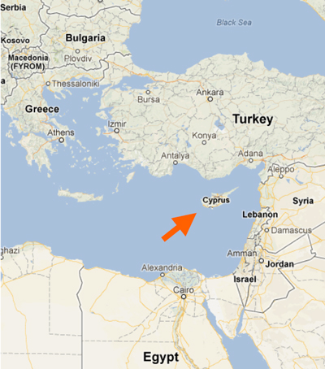

Death of Cimon.

Thucydides: 1.104

104    About this time Inaros, the son of Psammetichus, a Libyan and the King of the Libyans bordering on Egypt, starting out from Marea, the town south of Pharos, organized the revolt of nearly the whole of Egypt from the Persian King Artaxerxes. After taking over power himself he called in the Athenians to help him. The Athenians happened to be engaged in a campaign against Cyprus with 200 ships of their own and of their allies; they abandoned this campaign, came to Egypt, and sailed from the sea up the Nile. They gained control of the river and of two-thirds of Memphis, and then attempted to subdue the remaining third, which was called the White Castle and inside which were the Persians and Medes who had escaped and those of the Egyptians who had not joined in the revolt.

Thucydides. History of the Peloponnesian War (Kindle Locations 1632-1638). Penguin Books Ltd. Kindle Edition.

1. 109-110

Meanwhile the Athenian and allied force in Egypt was still engaged, and suffered all the chances and changes of war. At first the Athenians were masters of Egypt, and the King of Persia sent to Sparta a Persian named Megabazus with money to bribe the Spartans to invade Attica and so force the Athenians to recall their fleet from Egypt. These negotiations, however, were unsuccessful, and as the money was being spent without any results, Megabazus and what remained of it were recalled to Asia. The King then sent out to Egypt another Persian, Megabazus, the son of Zopyrus, with a large army. He arrived by land, defeated the Egyptians and their allies in battle, and drove the Hellenes out of Memphis. In the end he penned them up on the island of Prosopitis and besieged them there for eighteen months. Finally he drained the channels round the island by diverting the water elsewhere. The ships were thus left high and dry; most of the island was connected with the mainland, 110 and he captured it by marching across to it on foot. So, after six years of war, this great venture of the Hellenes came to nothing. Out of the whole great force a few managed to make their way through Libya and find safety in Cyrene, but nearly all were destroyed. Egypt once more passed into the control of the King of Persia, except that Amyrtaeus, the King in the marshes, still kept his independence. Because of the size of the marshes it was impossible to capture him: also the Egyptians who live in the marshes are the most warlike of their race. Inaros, the King of the Libyans, who had been the person responsible for the Egyptian revolt, was betrayed to the Persians and crucified. Meanwhile fifty triremes from Athens and the rest of the League had sailed out to relieve the forces in Egypt. They put in at the Mendesian mouth of the Nile, having no idea of what had happened. Here they were under attack from the land by the Persian army and from the sea by the Phoenician fleet. Most of the ships were lost, though a few managed to escape. This was the end of the great expedition against Egypt made by the Athenians and their allies.

Thucydides. History of the Peloponnesian War (Kindle Locations 1687-1693). Penguin Books Ltd. Kindle Edition.

………………………………………………………………………………………………………………………………………………………………………………………………………………………………………………………………………………………………………………………………………………………………………………………………………………………………………………………………………………………………………………………………………………………………………………………………………………………………………………………………………………………………………………………………………………………………………………………………………………………………………………………………………………………………………………………………………………………………………………………………………………………………………………………………………………………………………………………………………………………………………………………………………………………………………………………………………………………………………………………………………………………………………………………………………………………………………………………………………………………………

Diodorus 11.71-74

71 1 When Tlepolemus was archon in Athens, the Romans elected as consuls Titus Quinctius and Quintus Servilius Structus. This year Artaxerxes, the king of the Persians, who had just recovered the throne, 18 first of all punished those who had had a part in the murder of his father and then organized the affairs of the kingdom to suit his own personal advantage. 2 Thus with respect to the satraps then in office, p311those who were hostile to him he dismissed and from his friends he chose such as were competent and gave the satrapies to them. He also concerned himself with both the revenues and the preparation of armaments, and since in general his administration of the entire kingdom was mild, he enjoyed the favour of the Persians to a high degree. 3 But when the inhabitants of Egypt learned of the death of Xerxes and of the general attempt upon the throne and the disorder in the Persian kingdom, they decided to strike for their liberty. At once, then, mustering an army, they revolted from the Persians, and after expelling the Persians whose duty it was to collect the tribute from Egypt, they set up as king a man named Inarôs. 4 He at first recruited soldiers from the native Egyptians, but afterwards he gathered also mercenaries from the other nations and amassed a considerable army. He dispatched ambassadors also to the Athenians to effect an alliance, promising them that, if they should liberate the Egyptians, he would give them a share in the kingdom and grant them favours many times greater than the good service they had rendered. 5 And the Athenians, having decided that it was to their advantage to humble the Persians as far as they could and to attach the Egyptians closely to themselves against the unpredictable shiftings of Fortune, voted to send three hundred triremes to the aid of the Egyptians. 6 The Athenians, therefore, with great enthusiasm set about the preparation of the expedition. As for Artaxerxes, when he learned of the revolt of the Egyptians and their preparations for war, he concluded that he must surpass the Egyptians in the size of his armaments. So he at once began to enrol p313soldiers from all the satrapies, build ships, and give his attention to every other kind of preparation. These were the events of this year in Asia and Egypt.

72 1 In Sicily, as soon as the tyranny of Syracuse had been overthrown and all the cities of the island had been liberated, the whole of Sicily was making great strides toward prosperity. For the Sicilian Greeks were at peace, and the land they cultivated was fertile, so that the abundance of their harvests enabled them soon to increase their estates and to fill the land with slaves and domestic animals and every other accompaniment of prosperity, taking in great revenues on the one hand and spending nothing upon the wars to which they had been accustomed. 2 But later on they were again plunged into wars and civil strife for the following reasons. After the Syracusans had overthrown the tyranny of Thrasybulus, they held a meeting of the Assembly, and after deliberating on forming a democracy of their own they all voted unanimously to make a colossal statue of Zeus the Liberator and each year to celebrate with sacrifices the Festival of Liberation and hold games of distinction on the day on which they had overthrown the tyrant and liberated their native city; and they also voted to sacrifice to the gods, in connection with the games, four hundred and fifty bulls and to use them for the citizens' feast. 3 As for all the magistracies, they proposed to assign them to the original citizens, but the aliens who had been admitted to citizenship under Gelon they did not see fit to allow to share in this dignity, either because they judged them to be unworthy or because they were suspicious lest men who had been brought up in the way of tyranny and had served in war under a monarch might attempt a revolution. And that is what actually happened. For Gelon had enrolled as citizens more than ten thousand foreign mercenaries, and of these there were left at the time in question more than seven thousand.

73 1 These aliens resented their being excluded from the dignity attending magistracies and with one accord revolted from the Syracusans, and they seized in the city both Achradinê and the 73 1 These aliens resented their being excluded from the dignity attending magistracies and with one accord revolted from the Syracusans, and they seized in the city both Achradinê and the Island, both these places having their own well-built fortifications. 2 The Syracusans, who were again plunged into disorder, held possession of the rest of the city; and that part of it which faced Epipolae they blocked off by a wall and made their own position very secure; for they anyone easily cut off the rebels from access to the countryside and soon caused them to be in want of provisions. 3 But though in number the mercenaries were inferior to the Syracusans, yet in experience of warfare they were far superior; consequently, when attacks took place here and there throughout the city and isolated encounters, the mercenaries regularly had the upper hand in the combats, but since they were shut off from the countryside, they were in want of equipment and short of food. Such were the events in Sicily of this year.

Siculus, Diodorus. Bibliotheca Historica: (Historical Library) (Kindle Locations 21451-21458). Kindle Edition.

………………………………………………………………………………………………………………………………………………………………………………………………………………………………………………………………………………………………………………………………………………………………………………………………………………………………………………………………………………………………………………………………………………………………………………………………………………………………………………………………………………………………………………………………………………………………………………………………………………………………………………………………………………………………………………………………………………………………………………………………………………………………………………………………………………………………………………………………………………………………………………………………………………………………………………………………………………………………………………………………………………………………………………………………………………………………………………………………………………………………

Plutarch Cimon 18-19

18. At any rate, as soon as Cimon returned from exile, 1 he put an end to the war and arranged a settlement between the two cities. However, once peace had been established, it soon became clear to him that the Athenians were incapable of settling down quietly but were bent on a policy of constant activity and expansion of their empire through foreign expeditions. As he was anxious not to provoke the other Greek states or, by cruising with a large fleet around the islands or the Peloponnese, to incur the charge of starting a war, he had 200 triremes manned, with the object of making another expedition against Egypt and Cyprus. His plan was to keep the Athenians in constant training through their operations against the barbarians, and to allow them to profit as they deserved from the wealth they took from their natural enemies and brought into Greece. But when everything was ready and the troops on the point of embarking, Cimon had a dream, in which an angry bitch was baying at him and in the midst of its baying, it spoke in human tones and said: Go your way: I shall find you a friend both to me and my puppies. This was a difficult vision to interpret, but Astyphilus of Poseidonia, who possessed prophetic powers and was a close friend of Cimon’s, declared to him that it foretold his death and analysed it as follows. A dog is the enemy of the man it barks at: and one can do an enemy no greater service than to did. The blending of animal and human speech signifies that the enemy is the Mede, since their army is composed partly of Greeks and partly of barbarians. After this vision Cimon offered a sacrifice to Dionysus, and as the seer was cutting up the victim, swarms of ants seized upon the blood as it congealed. They carried it little by little over to Cimon and proceeded to cover his big toe with it for some time before he noticed them. Then just as he saw what they were doing, the priest came up and showed him that the victim’s liver was without that part known as the head. However, there could be no withdrawing from the expedition, so he set sail and after detaching a squadron of sixty ships to proceed to Egypt, he made for Cyprus with the remainder. He defeated the king’s fleet of Phoenician and Cilician ships in a sea battle and won over the cities in the neighbourhood. Then he waited for his opportunity to attack the cities of Egypt, for he had in mind nothing less than the complete destruction of Persia’s supremacy, and he was all the more resolved upon this because of the knowledge that Themistocles had built up a position of great power and prestige among the Persians, and had promised the king that if a war were launched against Greece, he himself would take command. At any rate it is said that one of the principal reasons which made Themistocles take his own life was his despair of fulfilling his undertakings against the Greeks, and the knowledge that he would never be able to rival Cimon’s military genius and good fortune. Cimon, on the other hand, while he was waiting with his fleet off Cyprus and turning over in his mind these vast schemes of conquest, sent a delegation to the shrine of Jupiter Ammon to put a secret question to the oracle there. What this was no one has ever discovered, nor did the god make any response: instead, as soon as they approached, the oracle commanded them to depart and said that Cimon himself was already with him. When they heard this, the messengers returned to the sea and no sooner had they arrived at the Greek camp, which was then on the Egyptian coast, than they learned that Cimon was dead. When they counted back the days to the moment when the oracle had replied to them, they understood that it had been alluding to the general’s death, since he was already with the gods. 19. According to most accounts, 1 Cimon died of sickness while he was besieging Citium, but others say that it was from a wound he received in a battle against the Persians. As he was dying, he ordered his companions to sail away at once and keep his death a secret. In this way it was contrived that neither the allies nor the enemy knew what had happened and the expedition was brought back safely ‘through Cimon’s generalship’, as Phanodemus puts it, although he had in fact been dead for thirty days. After his death no Greek general was to win another brilliant success against the barbarians. Instead, a succession of demagogues and warmongers arose, who proceeded to turn the Greek states against one another, and nobody could be found to separate or reconcile them before they met in the headlong collision of war. In this way the Persians gained a breathing-space, but the power of Greece was incalculably weakened. It was not until several generations afterwards that Agesilaus carried the Greek arms into Asia and fought a brief campaign against the king’s generals along the Ionian coast. 1 Yet even he achieved nothing of great consequence before he was overwhelmed in his turn by a flood of dissensions and disturbances within Greece and a second empire was swept from his grasp. In the end he had to return, leaving the tax-gatherers of the Persian empire still collecting tribute among the allied and friendly cities, whereas before not one of these functionaries, nor even so much as a Persian horse, was to be seen within fifty miles of the sea, so long as Cimon was general. His remains were brought home to Athens, as is proved by the monuments which are called after him to this day. But the people of Citium also pay homage to a so-called tomb of Cimon. Nausicrates the rhetorician tells us that once, during a period of plague and famine, the god charged them not to forget Cimon, but to revere and honour him as a superior being. Such was the nature of this Greek commander.

Plutarch. The Rise and Fall of Athens: Nine Greek Lives (Classics) (p. 164). Penguin Books Ltd. Kindle Edition.

…………………………………………………………………………………………………………………………………………………………………………………………………………………………………………………………………………………………………………………………………………………………………………………………………………………………………………………………………………………………………………………………………………………………………………………………………………………………………………………………………………………………………………………………………………………………………………………………………………………………………………………………………………………………………………………………………………………………………………………………………………………………………………………………………………………………………………………………………………………………………………………………………

Thuc 1.109 Persians attempt to bribe the Spartans.

109    Meanwhile the Athenian and allied force in Egypt was still engaged, and suffered all the chances and changes of war. At first the Athenians were masters of Egypt, and the King of Persia sent to Sparta a Persian named Megabazus with money to bribe the Spartans to invade Attica and so force the Athenians to recall their fleet from Egypt. These negotiations, however, were unsuccessful, and as the money was being spent without any results, Megabazus and what remained of it were recalled to Asia. The King then sent out to Egypt another Persian, Megabazus, the son of Zopyrus, with a large army. He arrived by land, defeated the Egyptians and their allies in battle, and drove the Hellenes out of Memphis. In the end he penned them up on the island of Prosopitis and besieged them there for eighteen months. Finally he drained the channels round the island by diverting the water elsewhere. The ships were thus left high and dry; most of the island was connected with the mainland,

Thucydides. History of the Peloponnesian War (Kindle Locations 1678-1685). Penguin Books Ltd. Kindle Edition.

………………………………………………………………………………………………………………………………………………………………………………………………………………………………………………………………………………………………………………………………………………………………………………………………………………………………………………………………………………………………………………………………………………………………………………………………………………………………………………………………………………………………………………………………………………………………………………………………………………………………………………………………………………………………………………………………………………………………………………………………………………………………………………………………………………………………………………………………………………………………………………………………

The Peace of Callias.

Herodotus 7.151

The story goes on to say that the Argives were much impressed by Xerxes’ message; they made no promises for the moment, and put forward no demand for a share in the command of the army; later, however, when the Greeks were trying to obtain their support, they did make the claim, because they knew that the Spartans would refuse to grant it, and that they would thus have an excuse for taking no part in the war. There are people [151] in Greece who say that this account is borne out by a remark made long afterwards by Artaxerxes. Callias, the son of Hipponicus, and a number of other Athenians were in Susa, the city of Memnon, on different business,44 and it so happened that their visit coincided with that of some representatives from Argos, who had been sent to ask Xerxes’ son Artaxerxes if the friendly relations, which the Argives had established with his father, still held good, or if they were now considered by Persia as enemies. ‘They do indeed hold good,’ Artaxerxes is said to have replied; ‘there is no city which I believe to be a better friend to me than Argos.’

Herodotus. The Histories (Penguin Classics) (Kindle Locations 8303-8305). Penguin Books Ltd. Kindle Edition.

………………………………………………………………………………………………………………………………………………………………………………………………………………………………………………………………………………………………………………………………………………………………………………………………………………………………………………………………………………………………………………………………………………………………………………………………………………………………………………………………………………………………………………………………………………………………………………………………………………………………………………………………………………………………………………………………………………………………………………………………………………………………………………………………………………………………………………………………………………………………………………………………