From the sender’s perspective (rear view):
Left side Right side

H (8) | G (7) | F (6) | E (5) | D (4) | C (3) | B (2) | A (1)

P | O | N | M | L | K | J (0) | I (9)

X | W | V | U | T | S | R | Q

 |  |  | Ready? | Letters follow | Numbers follow | Z | Y

From the receiver’s perspective (front view)
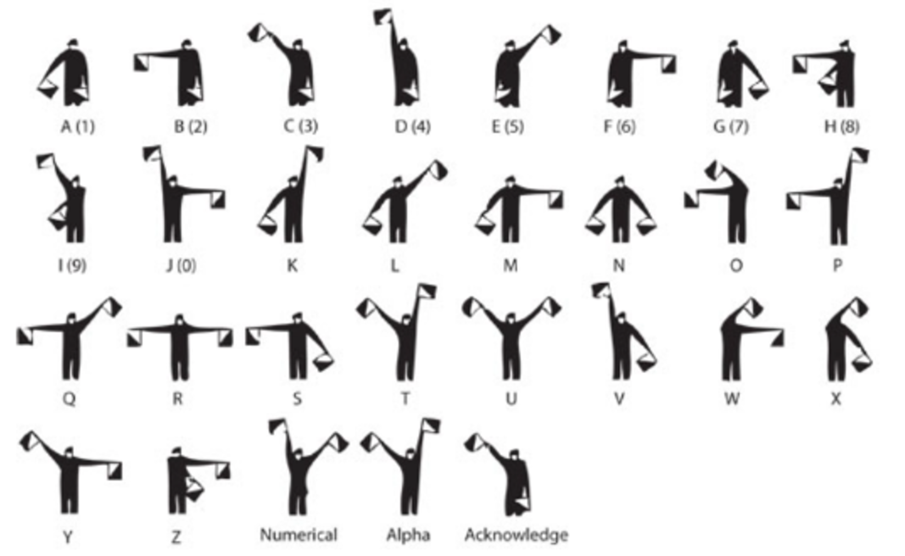
Remember that these images represent how the sender will look to you.
Arms should be straight and the flags held at the correct angles.
Attract attention by waving the flags at 45° angles.
Acknowledge/signal ready as shown.
New words are shown by holding both flags down in front of the body.
Mistakes are shown by signalling ‘E’ but waving the left hand flag.

