|  |  |  |  |
| --- | --- | --- | --- |
| **0** | **1** |  |  |

Use words from the box to complete the following sentences.

**concentration catalyst particles activation**

**mean bonds temperature rate**

When chemicals react, the must collide with enough energy to break . They have more energy when the of a reaction mixture increases. The minimum amount of energy needed to start a reaction is called the energy. This energy can be reduced by using a . (5 marks)

|  |  |  |  |
| --- | --- | --- | --- |
| **0** | **4** |  |  |

Ethene is a gas that reacts to form a polymer called poly(ethene):

ethene → poly(ethene)

The reaction rate can be altered by changing the temperature or pressure, or by using a catalyst.

Draw **one** line from each change to the **most** **complete** explanation of the change’s effect. (3 marks)

|  |  |  |
| --- | --- | --- |
| **Change** |  | **Explanation of effect** |
|  |  |  |
|  |  | larger gas volume |
| increasing the temperature of ethene |  |  |
|  |  | more collisions every second and more collisions with enough energy to react |
| adding a catalyst |  |  |
|  |  | particles have less energy |
|  |  |  |
| increasing the pressure of ethene |  | more collisions every second |
|  |  |  |
|  |  | more collisions every second with enough energy to react |

|  |  |  |  |
| --- | --- | --- | --- |
| **0** | **5** |  |  |

This question is about the effect of concentration on the rate of a reaction.

When hydrochloric acid is added to sodium thiosulfate solution it slowly becomes cloudy. The time taken for a cross under the solution to disappear can be used to monitor the rate of the reaction.

**Figure 2**

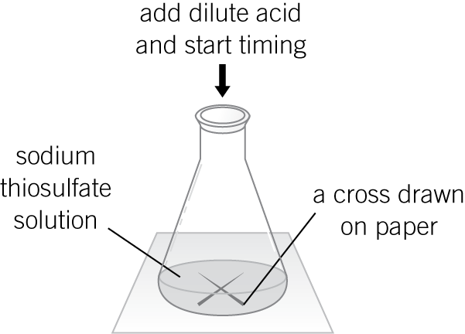

A student:

**1**  Measured 50 cm3 of sodium thiosulfate into a flask.

**2** Added 10 cm3 of dilute hydrochloric acid and started a stopwatch.

**3**  Stopped the clock when the cross disappeared and recorded the time taken.

**4** Repeated the experiment using different concentrations of sodium thiosulfate.

The results are shown in **Table 1**.

**Table 1**

|  |  |
| --- | --- |
| Concentration of sodium thiosulfate solution in g/dm3 | Time taken for cross to disappear in s |
| 5 | 85 |
| 10 | 45 |
| 15 | 29 |
| 20 | 21 |
| 25 | 13 |
| 30 | 15 |
| 35 | 14 |

|  |  |  |  |
| --- | --- | --- | --- |
| **0** | **5** | **.** | **1** |

Plot the results from **Table 1** on the grid below.

Draw a line of best fit. (3 marks)

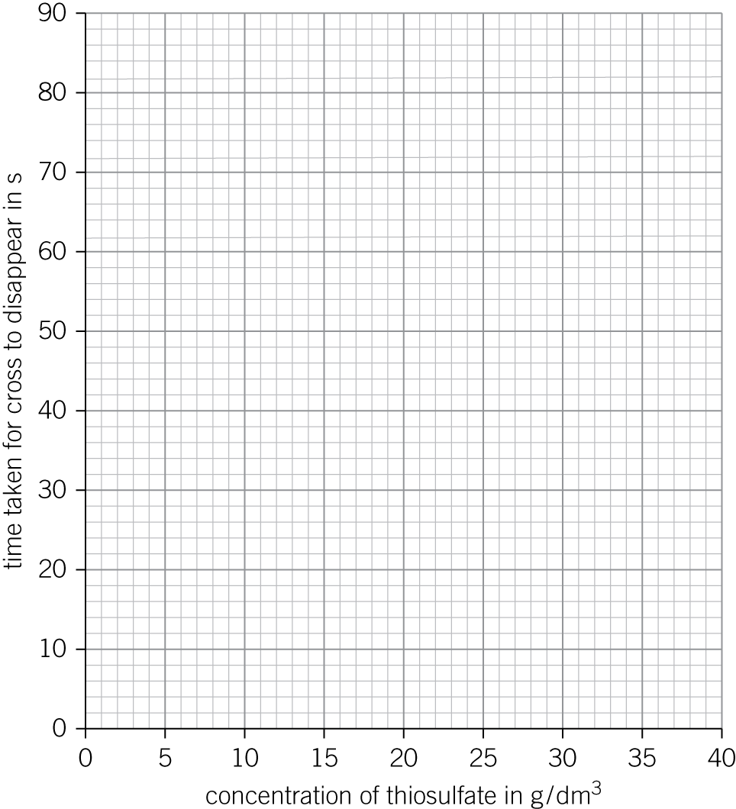

|  |  |  |  |
| --- | --- | --- | --- |
| **0** | **5** | **.** | **2** |

One of the points is anomalous.

Describe **one** error that could have been made in the experiment to cause this.

(*1 mark*)

|  |  |  |  |
| --- | --- | --- | --- |
| **0** | **5** | **.** | **3** |

Describe **and** explain, in terms of particles, the pattern in the results obtained.

(*3 marks*)

|  |  |  |  |
| --- | --- | --- | --- |
| **0** | **6** |  |  |

A student investigated the rate of reaction between marble chips (calcium carbonate) and dilute hydrochloric acid.

The equation for the reaction is:

CaCO3(s)  2HCl(aq) → CaCl2(aq)  H2O(l)  CO2(g)

The student:

**1** Added 10 g of marble chips to 100 cm3 of dilute hydrochloric acid.

**2** Measured the volume of carbon dioxide produced every 20 seconds.

**3** Repeated the experiment using 10 g of powdered marble.

**4** Plotted a graph of her results.

**Figure 3** shows the student’s results.

**Figure 3**

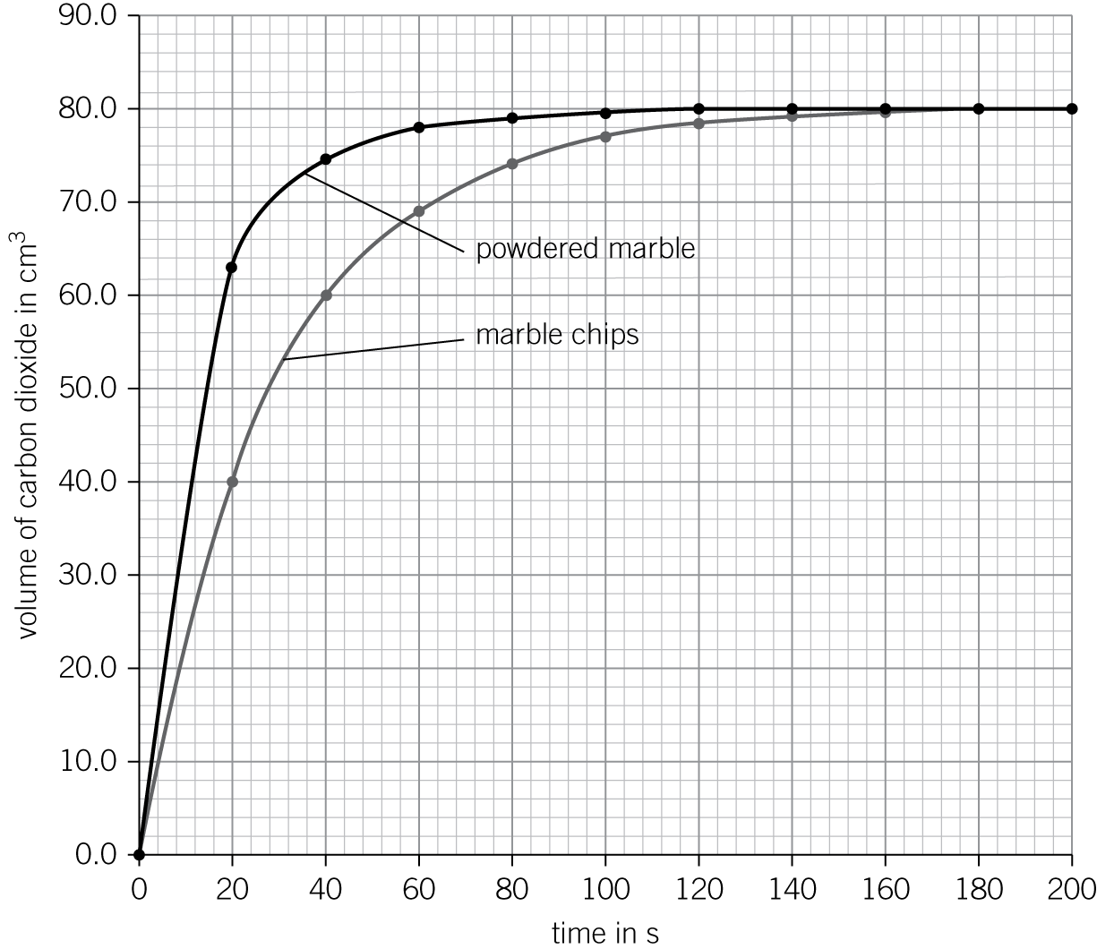

Compare **and** explain the results obtained for each type of marble.

(*6 marks*)