*Knowing what it takes to do really well in your exams/in preparation for university …*

The study of the chemicals that make up life is a wide and diverse area but it is essential to learn this in depth for a thorough understanding of every other topic.

Biological molecules can be divided up into carbohydrates, lipids, proteins and nucleic acids, but the properties of water should also be covered. An essential aspect of high grade answers is the ability to apply knowledge of the properties of biological molecules to novel situations and systems that may at first glance seem unfamiliar.

Questions

**1** The diagram below shows the structures of the R-groups of a variety of amino acids:

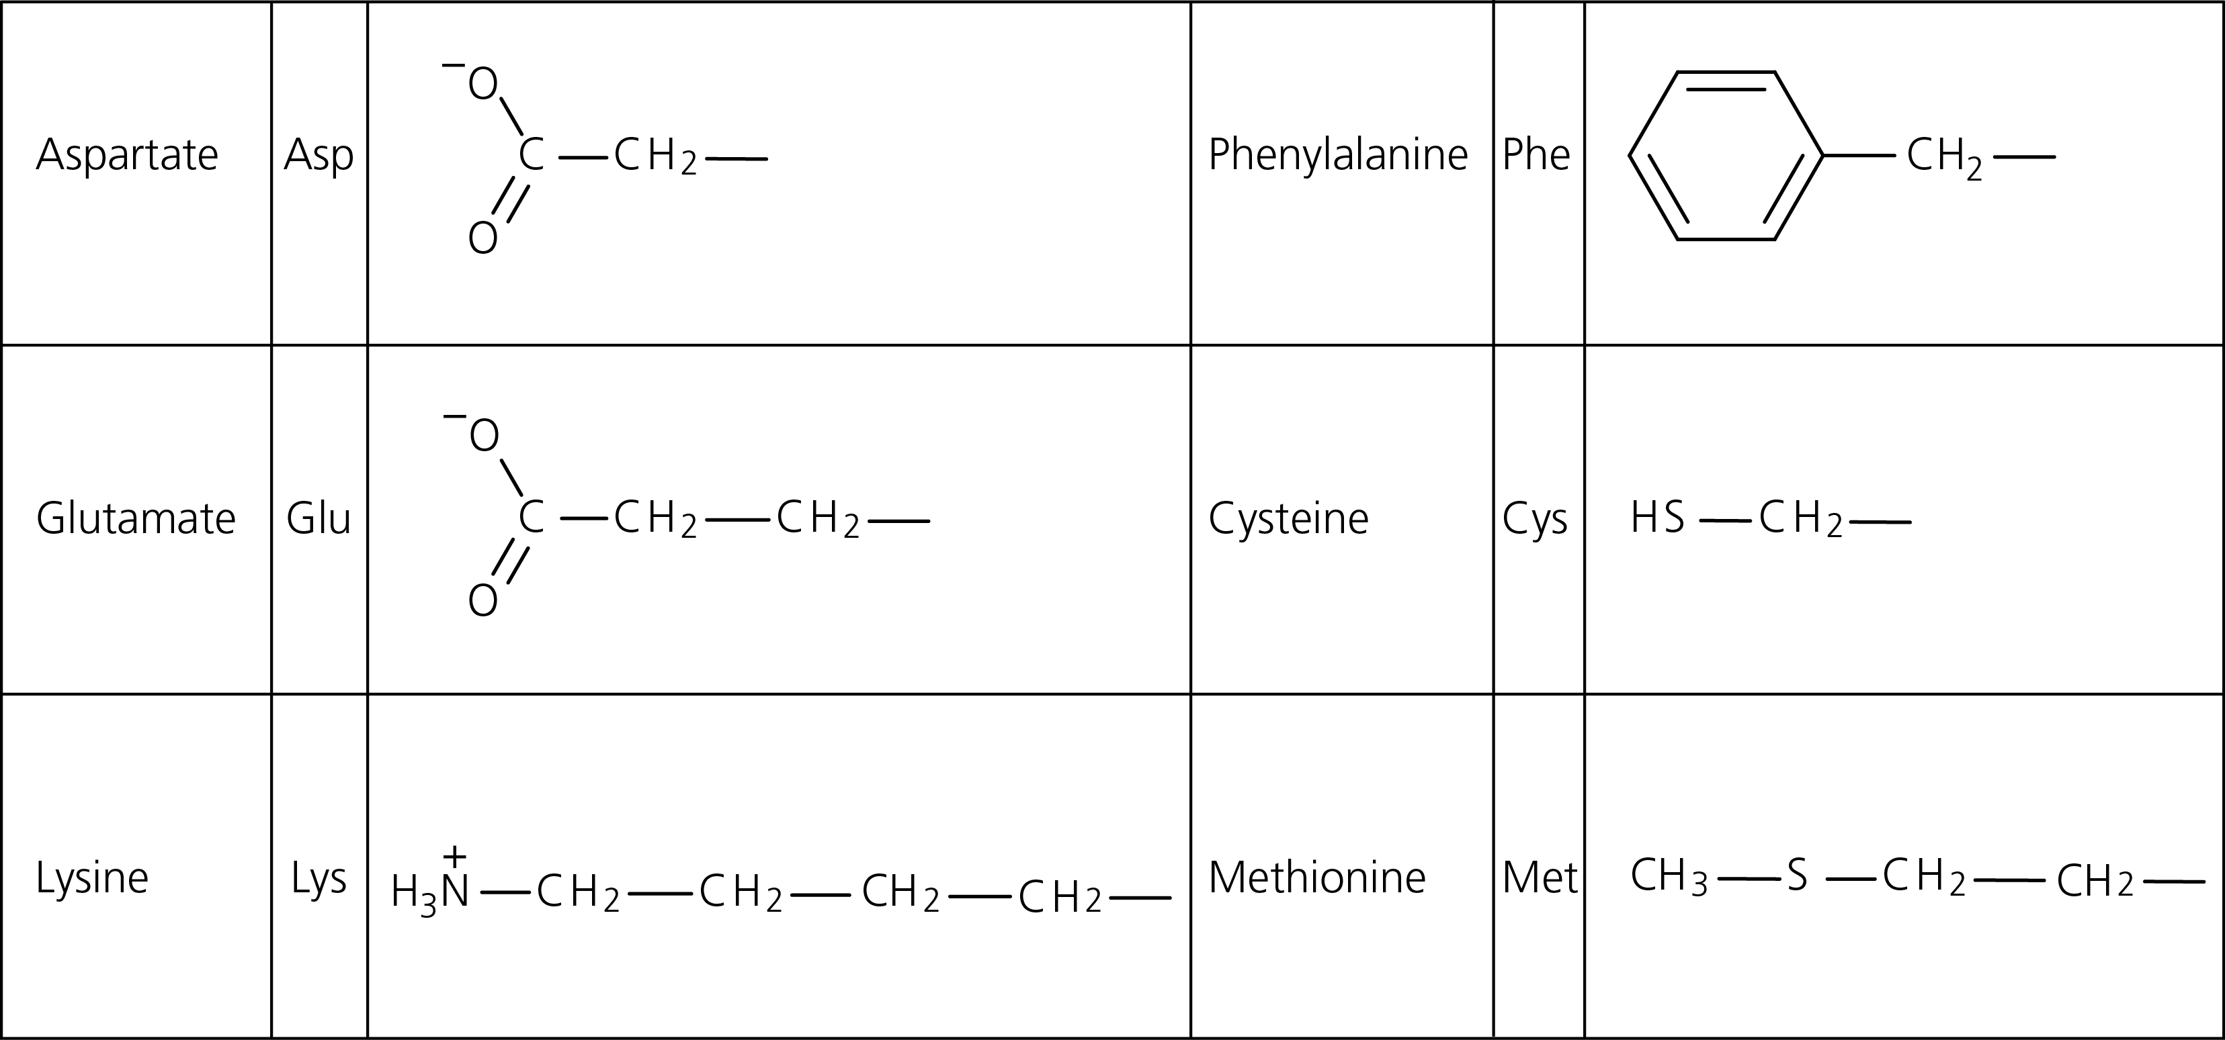

**a)** Draw the amino acid structure for the polypeptide Lys-Asp-Glu.

**b)** The pH of a solution of the tri-peptide Lys-Asp-Glu was measured. Suggest what the pH may have been and explain your answer in reference to the R-groups structure.

**c)** Explain the significance of the R-groups in the formation of:

**i)** secondary structure

**ii)** tertiary structure.

**d)** Two polypeptides have the following primary structures:

**Peptide 1: Asp-Cys-Lys-Glu-Cys-Cys-Asp-Cys-Phe-Asp-Cys**

**Peptide 2: Glu-Glu-Phe-Asp-Glu-Asp-Lys-Lys-Asp-Glu-Cys**

**i)** Predict what will happen to these two polypeptides when heated. Use your knowledge of bonding to explain your prediction.

**ii)** The mRNA used to code for protein 1 is found to be 45 bases long. Comment on this finding.

Question continues over the page….

**e)** The diagram shows a representation of the hormone insulin.

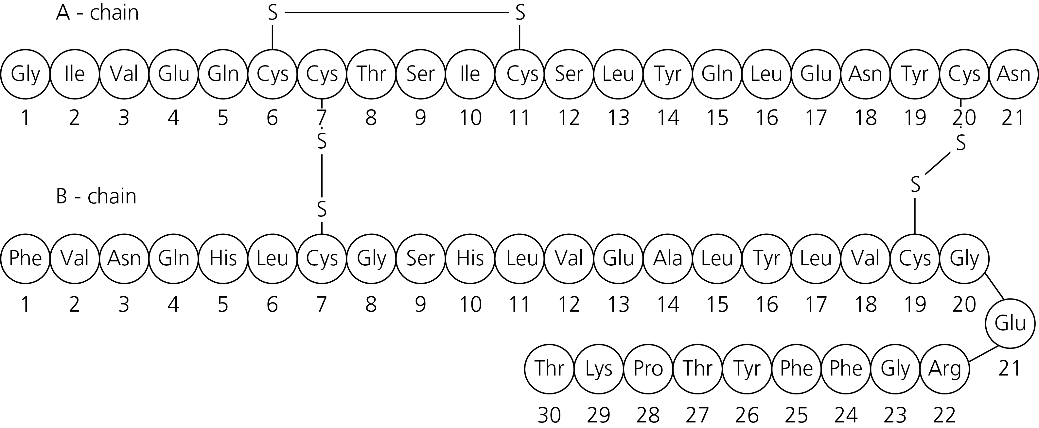

**i)** Describe the structure of insulin.

**ii)** A mutation occurs that affects just the 7th amino acids of the B-chain. Explain how this might affect the structure and the function of this protein.

**2** The diagram shows the structure of two fatty acids.

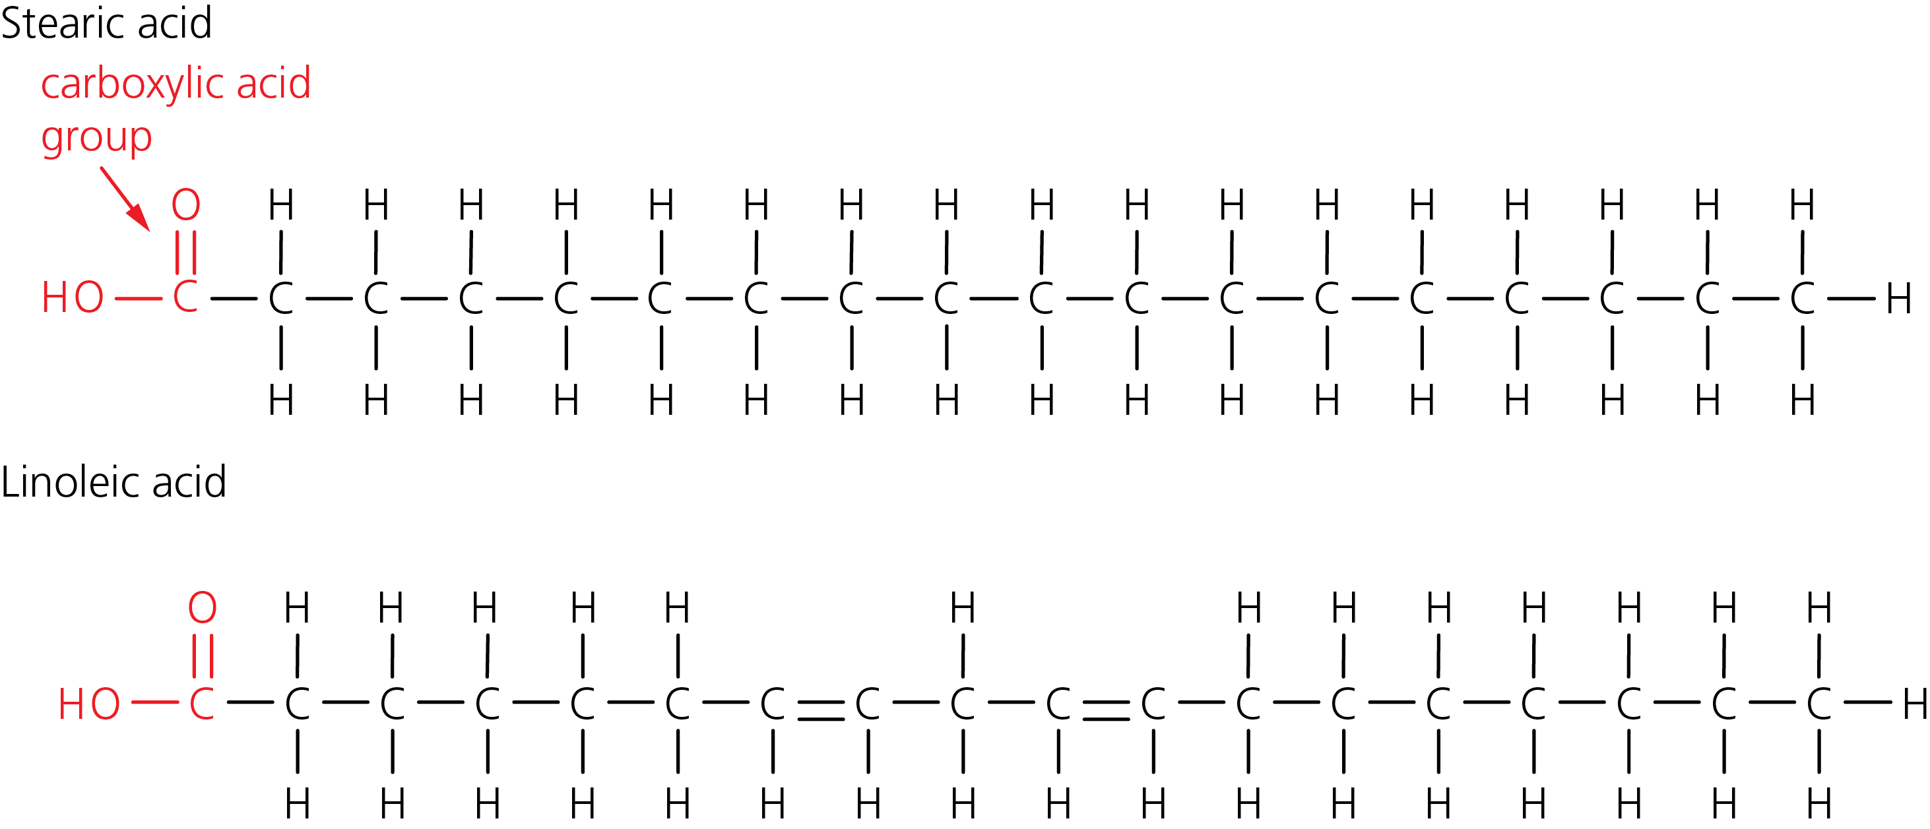

**a)** Describe any differences in characteristics of these two fatty acids and relate this to their structure.

**b)** Tristearin is a triglyceride made up of three stearic acid molecules. Draw the structure of tristearin.

**c)** Transmembrane proteins have a hydrophobic and a hydrophilic region. Explain the importance of this in terms of the fluid mosaic model of membrane structure.