Past Essay Questions on the Literature

2020

Specimen paper

**2021**

**EITHER**

**20** Who is the most heroic, Diomedes or Aeneas? Justify your response.

**OR**

**21** How important was the theme of fighting for your homeland in the texts you have read? Justify your response and refer to at least **two** texts.

**[15]**

2022

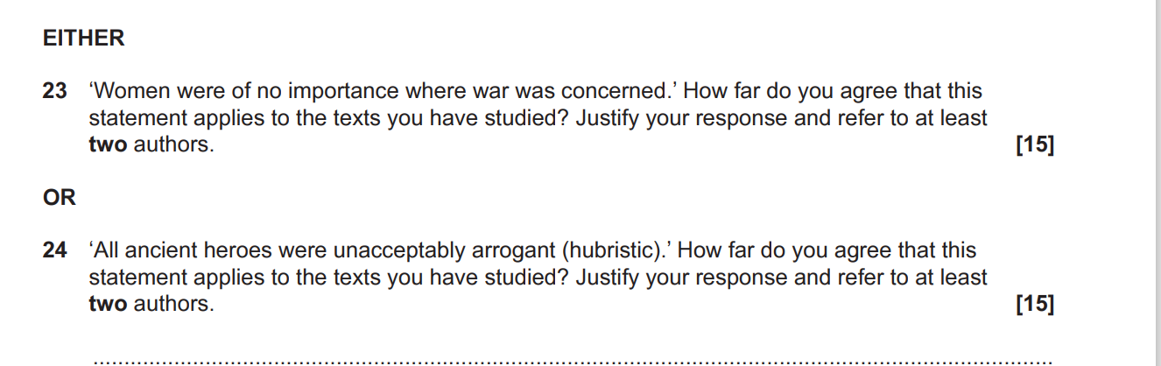

**[15]**