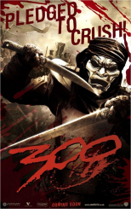TASK: Explain the difference between the Greek and Persian fighter.

Include:

A description of the armour and weapons of Persian and Greek fighters.

Description of the methods of fighting in battle

Primary and secondary sources-pictures of weapons

Modern pictures of what warriors would have looked like.

C grade: simple description of each type of warrior with some evidence of primary sources

B Grade: more detailed primary evidence-pictures and quotes from ancient sources. Show a

A grade-more detailed analysis of the evidence . Thorough understanding of the weapons and tactics.

A\* Wide and detailed reference. Your own personal opinion based on the sources.