**Name:** __________________________________________________________

1. What is the function of the guard cells on a leaf? [1 mark]

**a)** They help to control the amount of light that enters the plant during   
 photosynthesis.

**b)** They prevent bacteria from getting into the leaf.

**c)** They control the size of the stomata.

**d)** They allow water to condense on the leaf.

**2** Identify the products in the photosynthesis reaction. [1 mark]

**a)** glucose and oxygen

**b)** glucose and carbon dioxide

**c)** carbon dioxide and water

**d)** glucose and water

**3** Match the shape of the root systems to the function they are adapted to perform. [1 mark]

|  |  |  |
| --- | --- | --- |
| deep and narrow |  | support for large plants |
| shallow and spread out |  | obtaining water from fog and dew |
| above the ground |  | to gain water from the water table |
| swollen (tuberous) roots |  | catching surface water |
| thickened roots |  | food and water storage |

**4** Why are plants essential for humans? Choose two answers. [1 mark]

**a)** They can make sugars.

**b)** Without plants we would not have carbon dioxide.

**c)** Plants also take in nitrogen from the atmosphere.

**d)** We can use plants as food, medicine and fuels.

**5** The graph below shows that, as the light intensity received by a plant increases,   
the rate of photosynthesis changes.

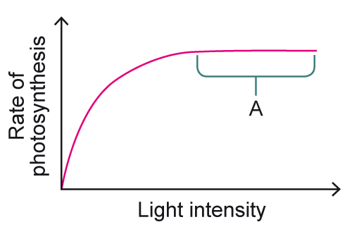

Which statement about region A on the graph is correct? [1 mark]

**a)** The plant is photosynthesising at its maximum rate.

**b)** The plant cannot photosynthesise any more.

**c)** The plant’s rate of photosynthesis has decreased.

**d)** The plant’s rate of photosynthesis has increased.

**6** An experiment was carried out to investigate the relationship between the rate of photosynthesis and the average amount of sucrose arrival in the roots. The results are displayed in the graph.

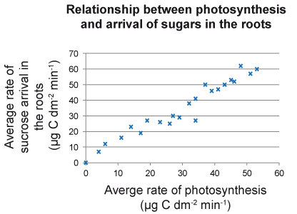

What pattern does the graph show? [1 mark]

**a)** no correlation between the average rate of photosynthesis and   
the arrival of sucrose in the roots

**b)** a positive correlation between the average rate of photosynthesis   
and the arrival of sucrose in the roots

**c)** a negative correlation between the average rate of photosynthesis   
and the arrival of sucrose in the roots

**d)** the arrival of sucrose in the roots was not affected by the average   
rate of photosynthesis

**7** How does having tiny hairs on the surface of a desert plant reduce water   
loss? [1 mark]

**a)** The hairs act as insulation during the cold desert nights.

**b)** The hairs reduce the surface area of the plant, so less water can   
evaporate.

**c)** The hairs are hollow and allow the storage of water.

**d)** The hairs reduce air flow close to the surface of the plant, which   
reduces the rate of evaporation of water vapour.

**8** Most plants open their stomata during the day and close it at night. Desert plants, such as the Ardon cactus, open their stomata at night.

Why do plants in the desert leave their stomata closed during the day and open them at night? What effect will this have on the rate of photosynthesis? [2 marks]

______________________________________________________________

______________________________________________________________

______________________________________________________________

______________________________________________________________

**9** Stomata allow gases to enter and leave a leaf. However, the plants need to avoid excessive water loss. Describe two features of a leaf that prevent the excessive loss of water vapour. [2 marks]

______________________________________________________________

______________________________________________________________

______________________________________________________________

______________________________________________________________

**Total: ______/11**