**Earth’s Atmosphere Answer Booklet**

1. **Early Atmosphere**

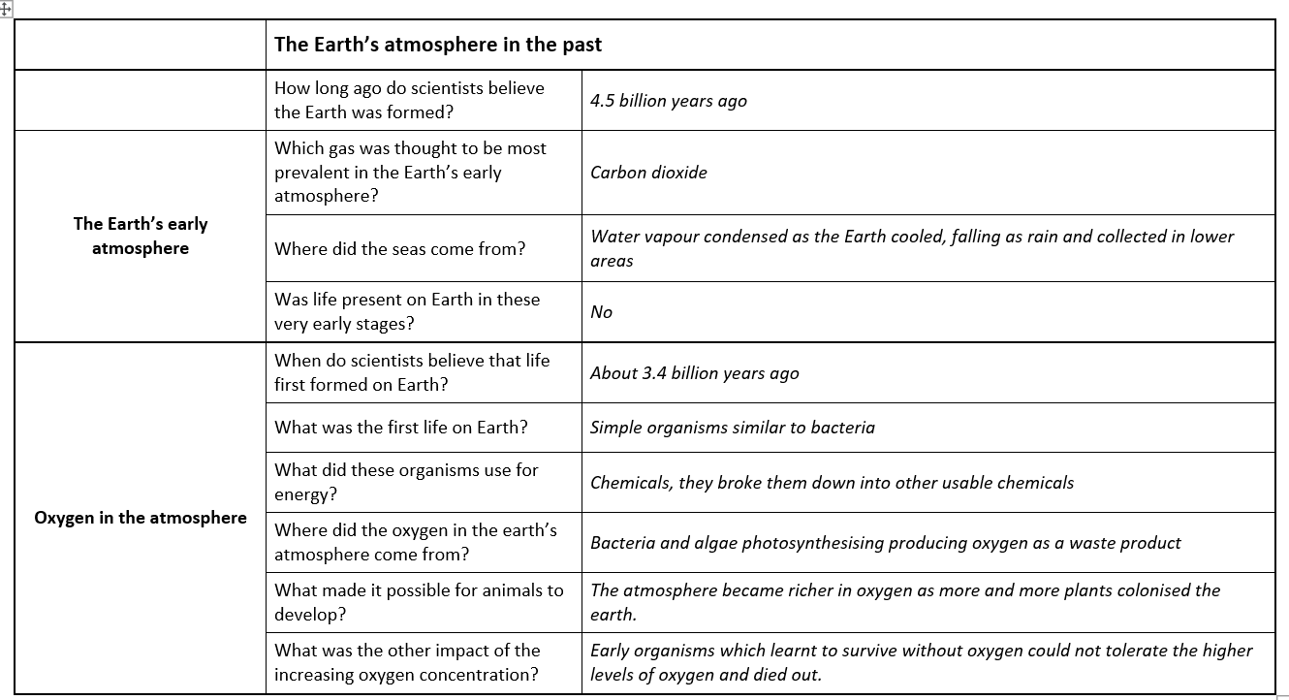

**Composition of the atmosphere**

The nature of the atmosphere has changed overtime. Here are the stages in that development:

* Earth is a very hot molten ball of rock, all gases produced escape into space.
* Earth begins to cool and then forms a thin solid crust, volcanoes are very active.
* An atmosphere begins to form around **4** billion years ago because the gases no longer have so much energy that they escape into space. That is because the Earth has carried on cooling.
* The first atmosphere is mainly made up of **carbon dioxide,** little or no **oxygen** gas, possibly some **water** vapour and small amounts of methane and ammonia.
* Over the next 3 billion years, up to around 1 billion years ago, the level of **nitrogen** increases (from chemical reactions).
* Eventually the surface of the Earth cools to below 100˚C and so water vapour condenses and **oceans** form.
* In these oceans, life begins.
* This life is plant life so the process of **photosynthesis** begins.
* The level of carbon dioxide begins to decrease dramatically and the gas **oxygen** is formed, at firstly it is only dissolved in the oceans.
* The carbon dioxide is locked up in **fossil** fuels and **carbonate** rocks. Some carbon dioxide is dissolved in the **ocean**s. The amount of carbon dioxide dissolved in the **oceans** affects the marine environment.
* **Oxygen** begins to build up in the atmosphere (O2).
* Some of this oxygen eventually forms **ozone** (O3).
* This allows plant and animal life to move to land as they are now protected from harmful UV rays by the **ozone** layer.

For the last 200 million years the composition has been much the same as they are today. **78**% nitrogen, **21**% oxygen, small proportions of other gases including **carbon dioxide**, and a varying amount of **water vapour** which depends on the weather, plus lots of other things including noble gases.

Recently, in the last 200 years, carbon dioxide is being released faster than ever before by burning **fossil fuels**. Carbon dioxide levels in the atmosphere have actually **increased** in the last 200 years time even though levels are still much lower than when the Earth’s atmosphere was first formed. It is thought that these increases are causing **global warming/climate change** because carbon dioxide is a **greenhouse** gas.

The Earth’s climate has changed naturally over the billions of years it has been around. There are always periods of time when the Earth is **warming** up and **cooling** down. Many people believe that there is a link that the Earth is currently warming up a lot (global warming) because of the fact that people are burning fossil fuels which is **releasing** more carbon dioxide into the atmosphere. A result of these climate changes is **droughts** or **violent/tropical** storms which we hear about in the news.

The Kyoto agreement was signed in 1997 so that world leaders would try to **reduce** the amount of carbon dioxide their countries produce.

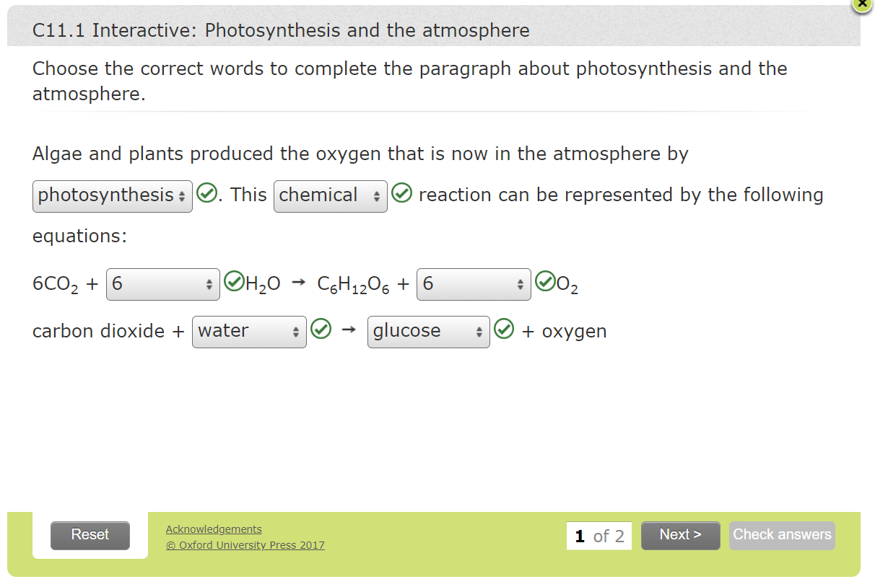

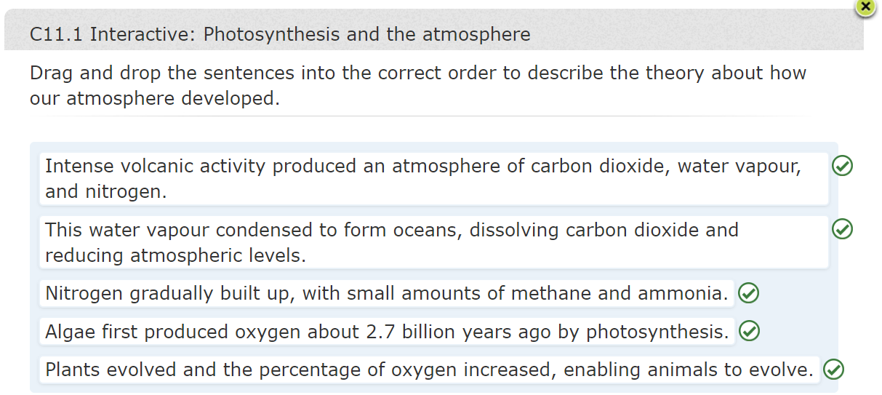

|  |  |  |
| --- | --- | --- |
| 1. Early Atmosphere, Q4 | Explain how the levels of oxygen in our atmosphere increased and why this was significant in the history of the earth. Include any relevant chemical equations in your answer. [6] | The first organisms / algae (bacteria) to photosynthesise, using carbon dioxide and water made the first oxygen gas as by-product of producing glucose for energy.  carbon dioxide + water → glucose + oxygen or 6CO2 + 6H2O→ C6H12O6 + 6O2  these evolved into first marine plants and then land plants, rising numbers of organisms involved in photosynthesis further increased levels of oxygen in atmosphere,  eventually sufficient oxygen to support living organisms not directly relying on photosynthesis for energy.  These animals fed on algae and plants and could release energy stored in them by using oxygen gas in process of respiration. |
| 1. Early Atmosphere, Y11 HT only  Q4a | Over a period of time, the algae in an ancient sea made 270 tonnes of glucose during photosynthesis.  Express 270 tonnes in grams using standard form (1 tonne = 1000kg) | 270 x 1000 x 1000 =  2.7 × 108 g (1) |
| Q4b | Using the equation for photosynthesis at the top of this page, calculate the mass of oxygen gas produced by the algae over this period of time. Give this answer to 2 significant figures. | Above answer **divided by 180** (**1** mark for Mr of glucose)  = 1,500,000 moles glucose  Moles of oxygen is **6 times** the above = 9,000,000 moles oxygen (**1**)  Moles x rams of oxygen (**x 32**) (**1** mark)  **2.88 × 108 g** or 288/290 tonnes (to 2sf) (**1** mark). Right answer scores 4. |

**2. Our Evolving Atmosphere**

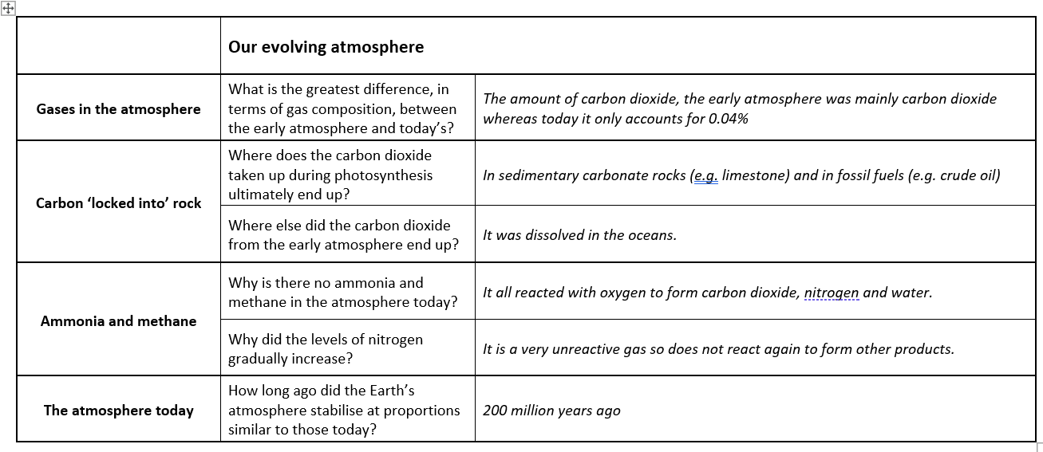

**3. Greenhouse Gases**

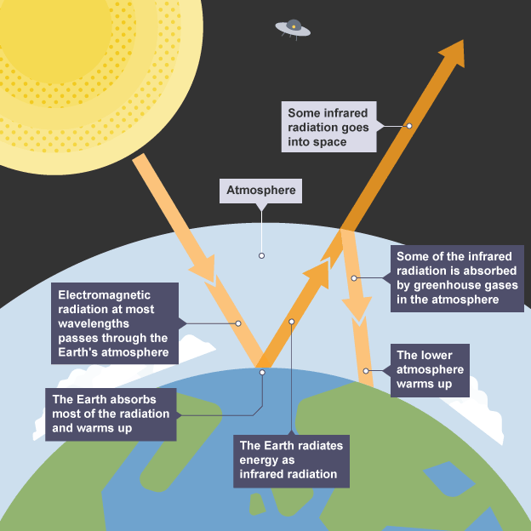

|  |  |  |
| --- | --- | --- |
| 2. Our Evolving Atmosphere, Q3 | Explain how most of the carbon dioxide in the Earth’s early atmosphere was removed to arrive at the level of around 0.04% of today’s atmosphere. [4] | Once algae and plants had evolved (1),  they decreased percentage of carbon dioxide in early atmosphere (1) through process of photosynthesis (1). Levels of carbon dioxide also decreased by formation of sedimentary carbonate rocks such as limestone (1),  and fossil fuels containing carbon / hydrocarbons (1). Any four points. |

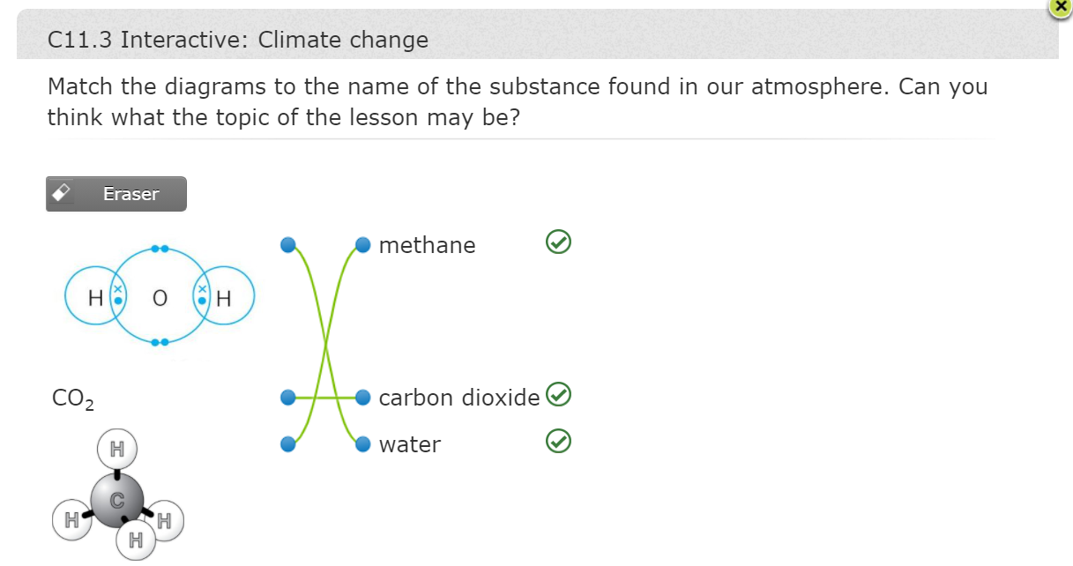

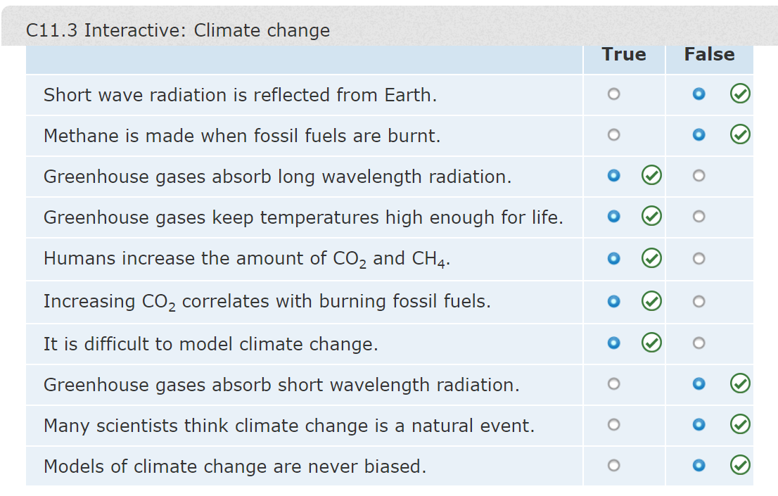

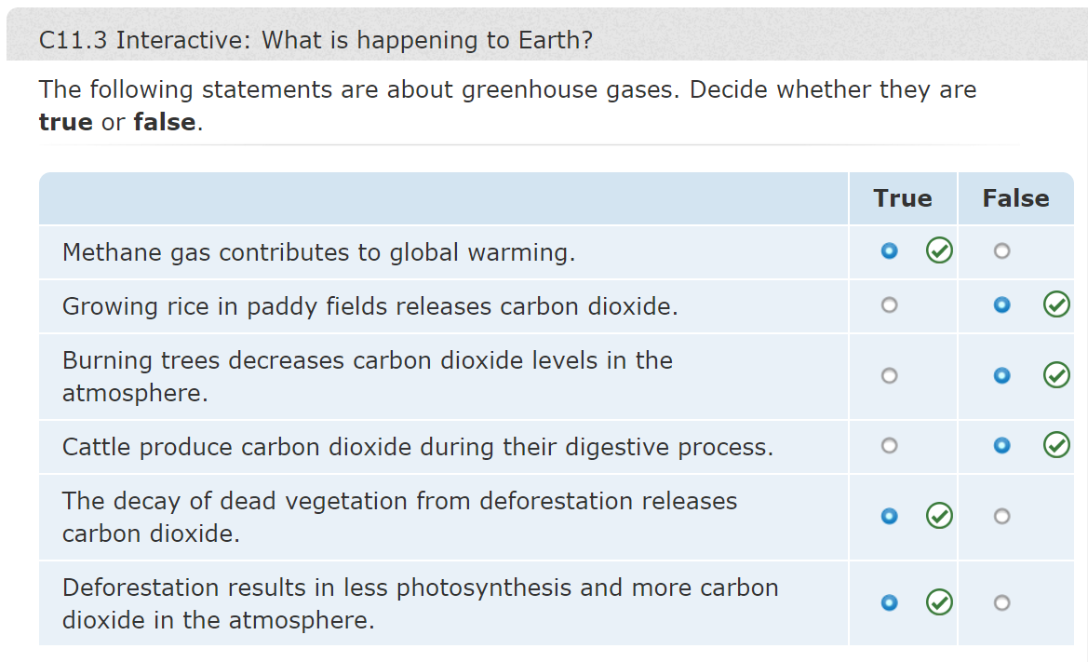

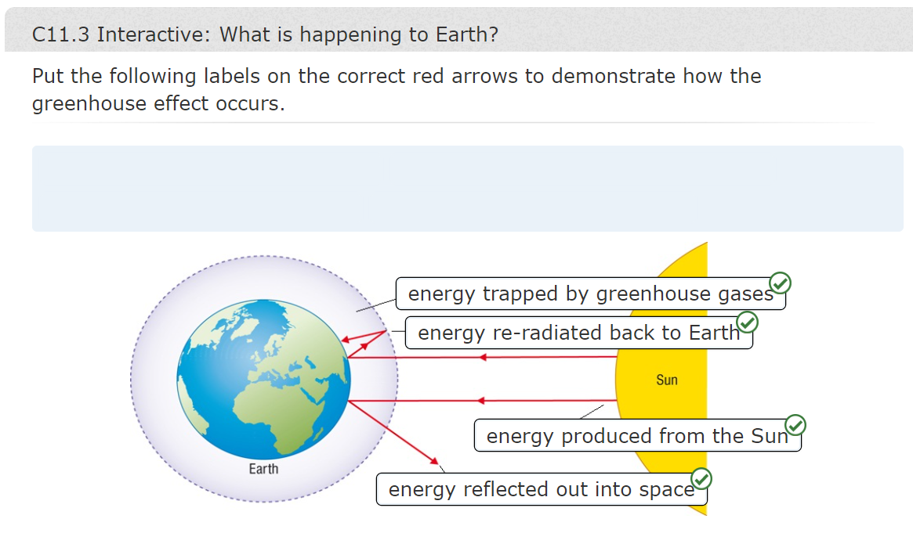

|  |  |  |
| --- | --- | --- |
| 3. Greenhouse Gases, Q1a | Name three greenhouse gases (3) | • carbon dioxide,  • methane,  • water vapour |
| Q1b  Years 9 - 11 | Explain how increasing the levels of these gases in the atmosphere can result in a rise in the temperature of the Earth’s atmosphere. (6) | When Earth heated by Sun (1),  greenhouse gases in atmosphere let short wavelength electromagnetic radiation pass through (1).  At night, surface of Earth cools down (1)  by emitting longer wavelength radiation (1)  Greenhouse gases absorb this radiation (1),  so some energy radiated from surface of Earth gets trapped in atmosphere / cannot be dissipated out of atmosphere and temperature rises (1) |
| Q2  Years 9 – 11 | Explain how boiling an electric kettle may increase the amount of carbon dioxide in the Earth’s atmosphere. | If electricity used to boil kettle is generated in fossil fuel power station (1) fuel burned gives off carbon dioxide as one of product (1) |
| Q3  Years 9 – 11 | List three reasons why the amount of carbon dioxide in the Earth’s atmosphere has increased so much in the recent past. | Any three e.g.  • massive increase in combustion of fossil fuels  • increasing deforestation  • warming of oceans |
| Q4a.  Years 10 – 11  More able Y9 | Look at the graph in Figure 2. A closer look at the data would show annual variations to a peak and trough in each year. Explain these variations. | small troughs caused by greater rate of photosynthesis (1)  in summer when more sunlight / warmer temperatures / more plants in leaf (1)  reducing levels of carbon dioxide (1),  conversely, in winter rate of photosynthesis decreases (1), resulting in slightly higher level of carbon dioxide (1) |
| Q4b. | Describe the overall trend shown by the data. | since 1960, carbon dioxide level increasing (1) at accelerating rate (1) |
| Q5a  Year 11 and more able Y9&Y10 | Why should media reports about global warming be treated with caution? | biased, only reporting on certain parts of scientific article (1) |
| Q5b | Comment on the uncertainty of any conclusions drawn from the data in Fig 3. | data show link between Earth’s temperature and levels of carbon dioxide in atmosphere (1),  assumes gases trapped in ice core are accurate record of ancient air samples (1),  does not say whether increase in temperature of Earth caused by some other factor that then caused increase in carbon dioxide levels (1), or whether increased level of carbon dioxide caused rise in temperatures (1) |

**4. Climate Change**

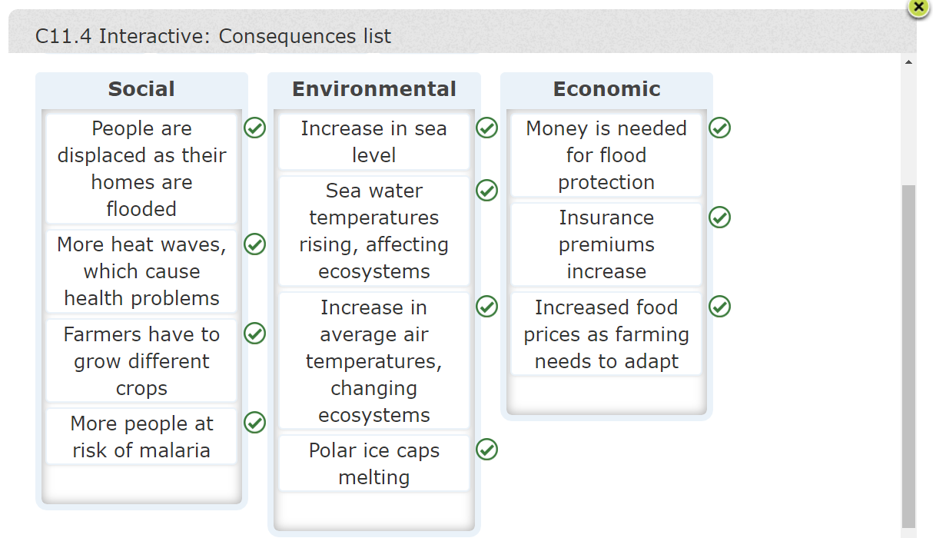

**5. Atmospheric Pollutants**

